Rakesh Shrestha
CSD325-T301 Advanced Python - Module 4.2 Assignment | Date : 07/04/2026
The original flowchart and the revised flowchart for the Sitka weather program.

Summary of Program Changes
- Added a menu that lets the user choose Highs, Lows, or Exit.
- Collected low temperatures from the CSV file in addition to high temperatures.
- Displayed high temperatures in red and low temperatures in blue.
- Used a loop so the menu continues until the user selects Exit.
- Printed an exit message before the program ends.

Flowchart Revision Notes
The revised flowchart avoids implementation details such as Call plot_temperatures(...). Instead, the steps describe what the program does, such as Display high temperature graph and Display low temperature graph. This makes the flowchart easier to read and better aligned with the algorithm.

Flowchart 1: Original sitka_highs.py
This flowchart models the original program before changes. The program opens the weather data file, reads each date and high temperature, creates a red high-temperature graph, adds labels, and displays the graph.
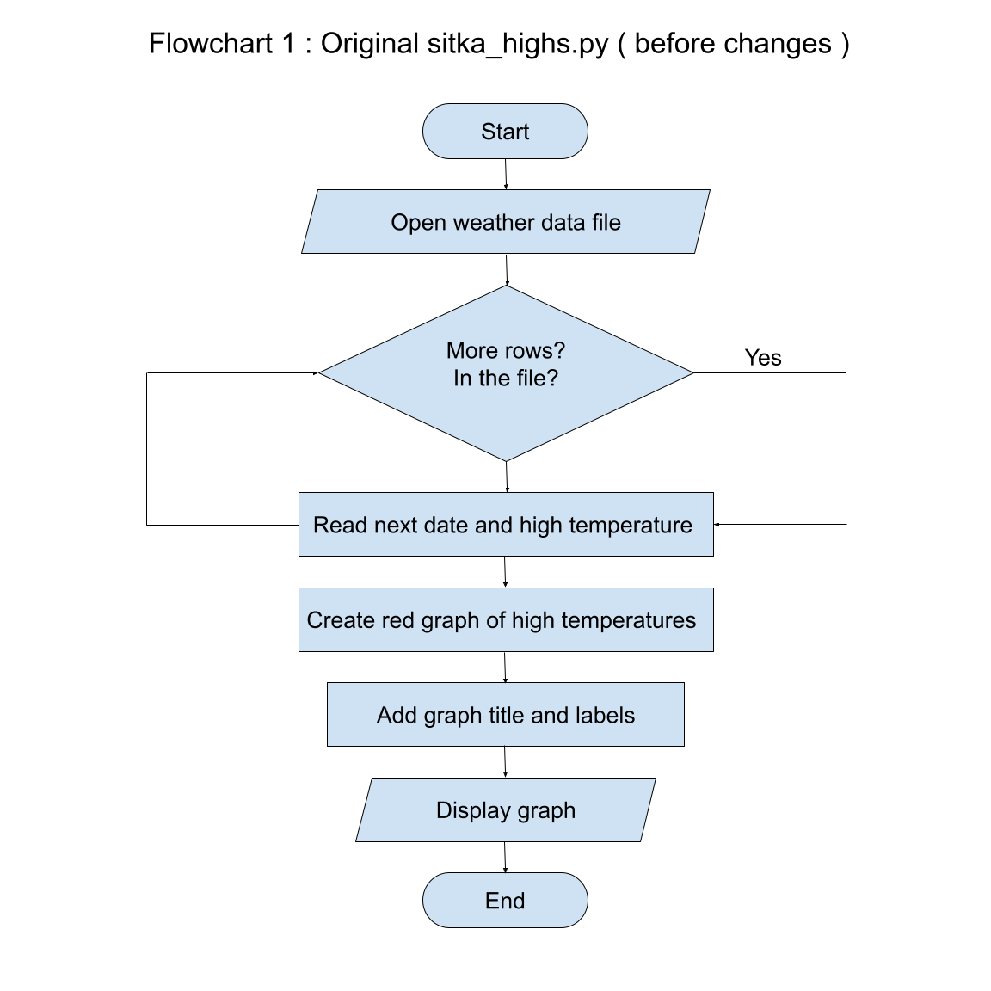

Flowchart 2: Revised sitka_high_low_rs.py
This flowchart models the revised menu-driven program. After the weather data is loaded, the user can view highs, view lows, enter another choice, or exit. Invalid choices display a message and return to the menu.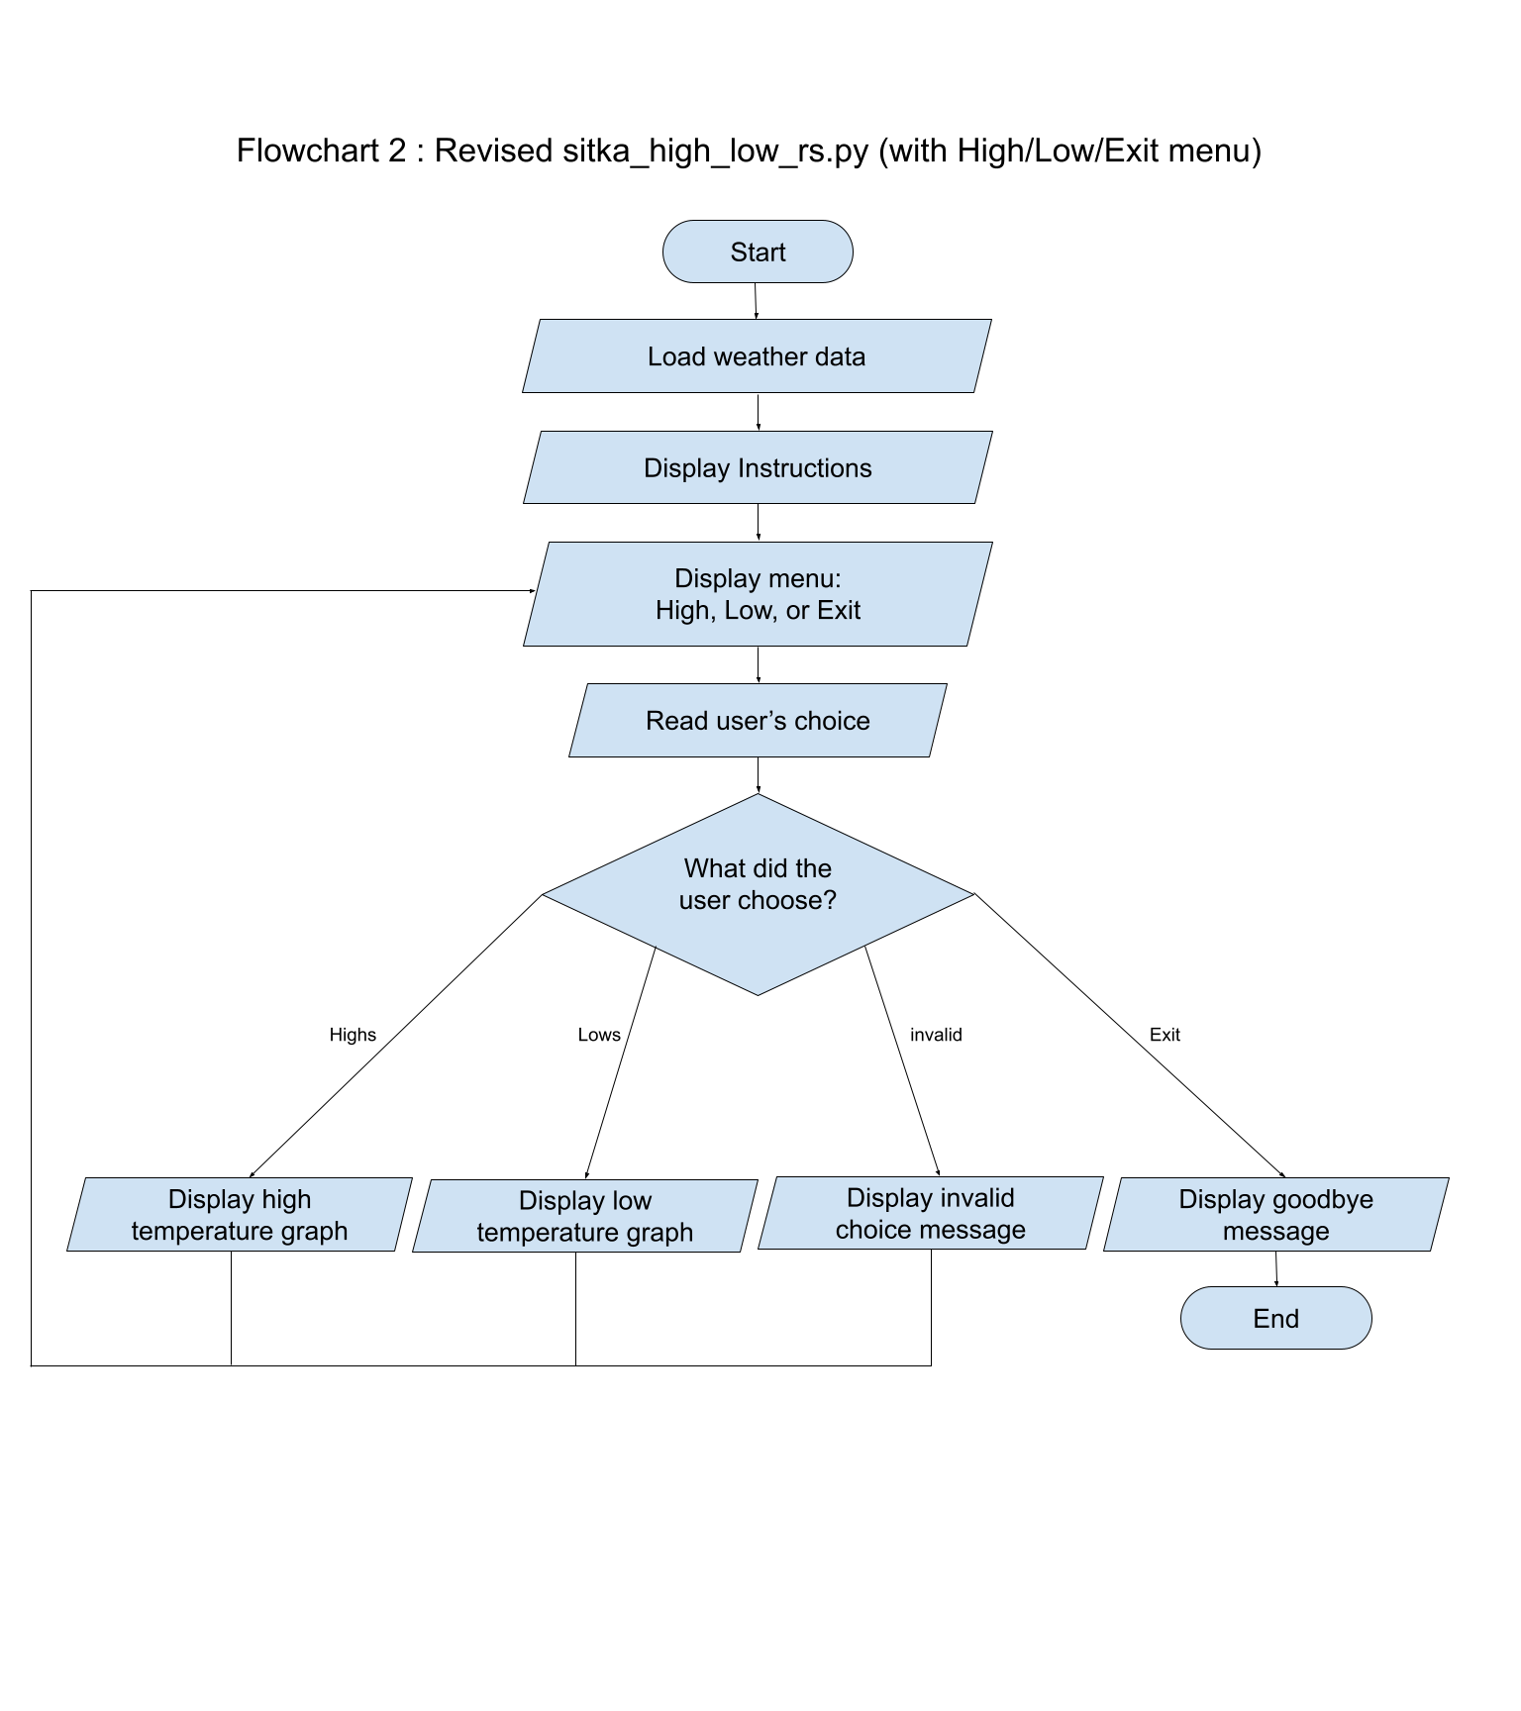
Return to menu

Python File Documentation Summary
The final Python file is saved as sitka_high_low_rs.py. It includes comments documenting the major changes: importing sys, loading the weather data, plotting highs or lows, displaying the menu, validating input, looping until exit, and printing a goodbye message.

