Value Stream Mapping Analysis: My Weekly Coursework
Rakesh Shrestha
CSD380 DevOps, Module 5.2: Value Stream Mapping
Bellevue University
October 11, 2026

1. What did I learn from mapping the process?
Creating these maps helped me see that completing coursework takes longer than I thought. A lot of the total time comes from waiting between tasks. In my current-state map, the estimated lead time is 157.5 hours, but the estimated process time is only 13.5 hours. This means that about 91% of the total lead time is waiting. Stiling (2020) explains how value stream mapping can help identify delays and opportunities to improve a process.
2. Where is the waste, and what causes it?
The biggest source of waste is the waiting time between assignments and discussion activities. Another problem is rework caused by checking the rubric too late. If I discover a missing requirement after completing an assignment, I have to go back and fix it. Switching between reading, writing, and coding can also interrupt my concentration and make it harder to stay focused.
3. What changes could improve the process?
I will start each week by reviewing the module instructions and rubric before I begin. I will also write my initial discussion post earlier in the week, then use the time while I wait for classmates to post to work on the assignment. Keeping my notes organized and committing code to GitHub as I make progress will help me avoid last-minute work. This approach also connects to continuous integration in DevOps. Making small, frequent changes and checking them as I go can help me find problems earlier, rather than discovering several issues near the deadline (Kim et al., 2021).
4. How will I measure whether the changes work?
I will compare my actual working time and waiting time with the estimates in both maps over the next few weeks. My future-state target is to reduce lead time from 157.5 hours to 96.5 hours and waiting time from 144 hours to 84 hours. I will also track whether I submit work on time and how often I need to revise assignments because I missed a requirement. These results will help me determine whether the changes improve my workflow without reducing the quality of my learning.

References
Kim, G., Humble, J., Debois, P., Willis, J., & Forsgren, N. (2021). The DevOps handbook: How to create world-class agility, reliability, & security in technology organizations (2nd ed.). IT Revolution Press.
Stiling, T. (2020, October 29). 3 easy steps for using VSM in everyday life. Value Stream.
Figure 1
Current-State Value Stream Map of My Weekly Coursework
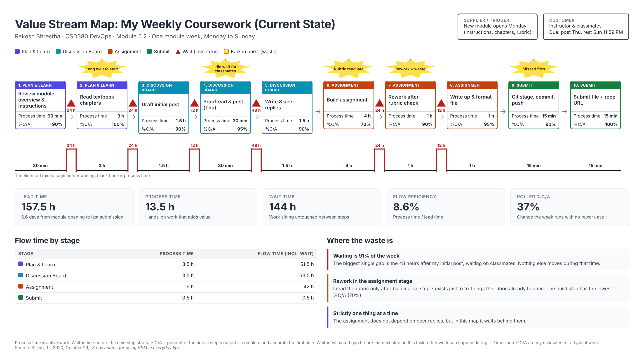

Figure 2
Future-State Value Stream Map of My Weekly Coursework (Targets)
