Project: | Todo Application Test Plan
Course: | CSD 380 DevOps
Description: | Functional testing of the Todo web application based on the provided business requirements
Date: | 2026/09/30

Lane Dorscher – Module 4.2 Assignment – Test Plan Discussion
TABLE OF CONTENTS
Test 1 - View Todo List 2
View Todo List 2
Test 2 - Create a Todo Item 3
Create a Todo Item 3
Test 3 - Edit a Todo Item 4

Edit Existing Todo Task 4
Test 4 – Delete a Todo Item 5
Delete Existing Todo Task 5
Test 5 – Prevent an Empty Task 6
Prevent Empty Todo Submission 6

Test 1 - View Todo List
Test 1 | View Todo List
 | Test Objective: Verify that a user can access the Todo application and view the Todo list | Developer: Lane Dorscher  Date tested: 2026/09/30 | Peer tester: Rakesh Shrestha  Date tested: 2026/10/03
Step | Action | Expected results: | Developer pass/fail | Tester pass/fail  + Screenshot
1 | Open a supported web browser | Browser opens successfully | yes | Yes  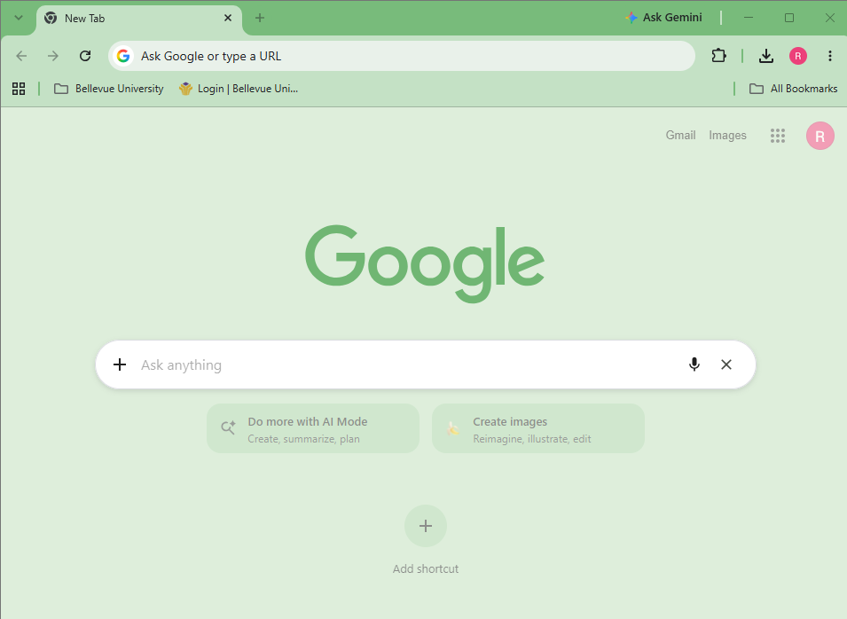
2 | Navigate to https://buwebdev.github.io/todo/. | Todo application loads without errors. | Yes | Yes  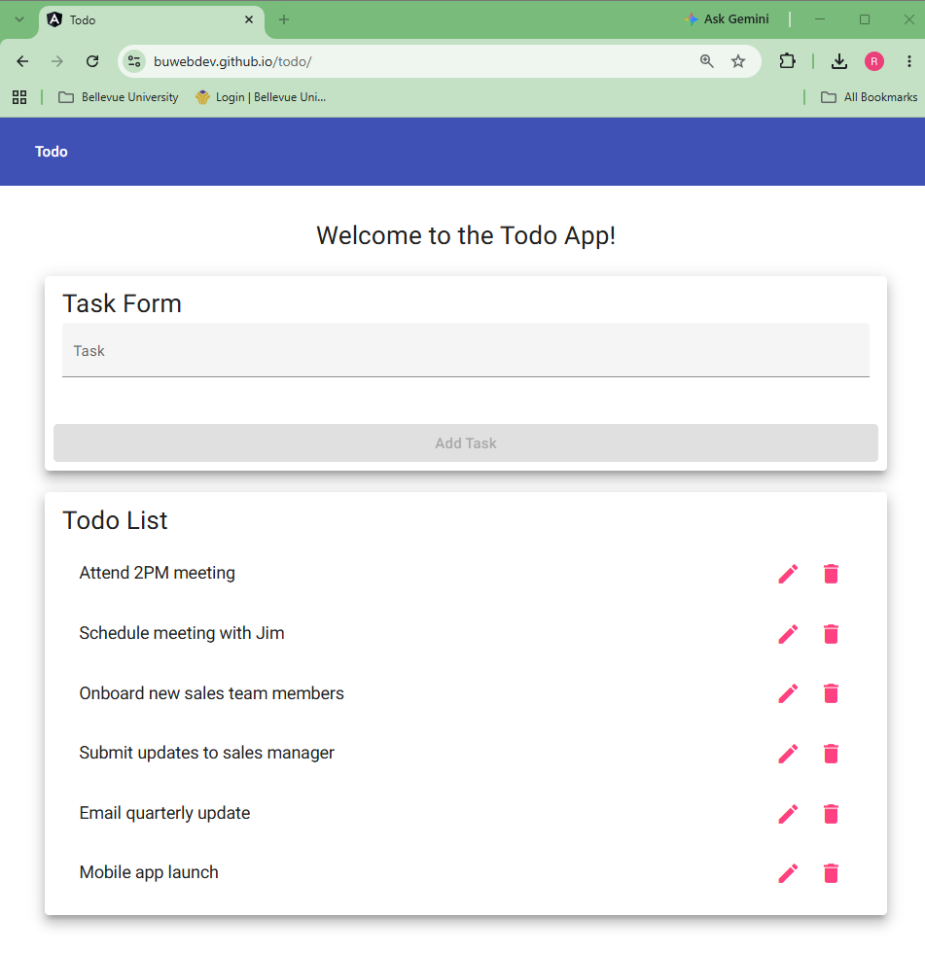
3 | Locate the Todo List section. | Todo List section is visible on the page. | Yes | Yes
4 | Review the existing task items. | Existing Todo items are displayed in the list. | Yes | Yes
5 | Refresh the browser. | Application reloads and the Todo List is displayed correctly. | Yes | Yes
Comments | All five steps passed. The browser opened to a new tab, the app loaded at https://buwebdev.github.io/todo/ with no errors, and the Todo List card showed all six default tasks. After refreshing, the page reloaded and the same six tasks came back. One suggestion: the expected result for Step 4 just says "Existing Todo items are displayed in the list," which would still pass even if only one or two tasks showed up. Changing it to "Six default tasks are displayed, starting with 'Attend 2PM meeting'" would give the tester an exact result to check.
Requirement 1: View a list of todo task items.

Test 2 - Create a Todo Item
Requirement 2: Create a new todo task item
Test 2 | Create a Todo Item
 | Test Objective: Verify that a user can enter a new Todo item and add it to the Todo list. | Developer: Lane Dorscher  Date tested: 2026/09/30 | Peer tester: Rakesh Shrestha  Date tested: 2026/10/03
Step | Action | Expected results: | Developer pass/fail | Tester pass/fail  + Screenshot
1 | Navigate to the Todo application. | Todo application loads successfully. | Yes | Yes
2 | Click inside the Task Form text field. | Text field receives focus and allows input. | Yes | Yes  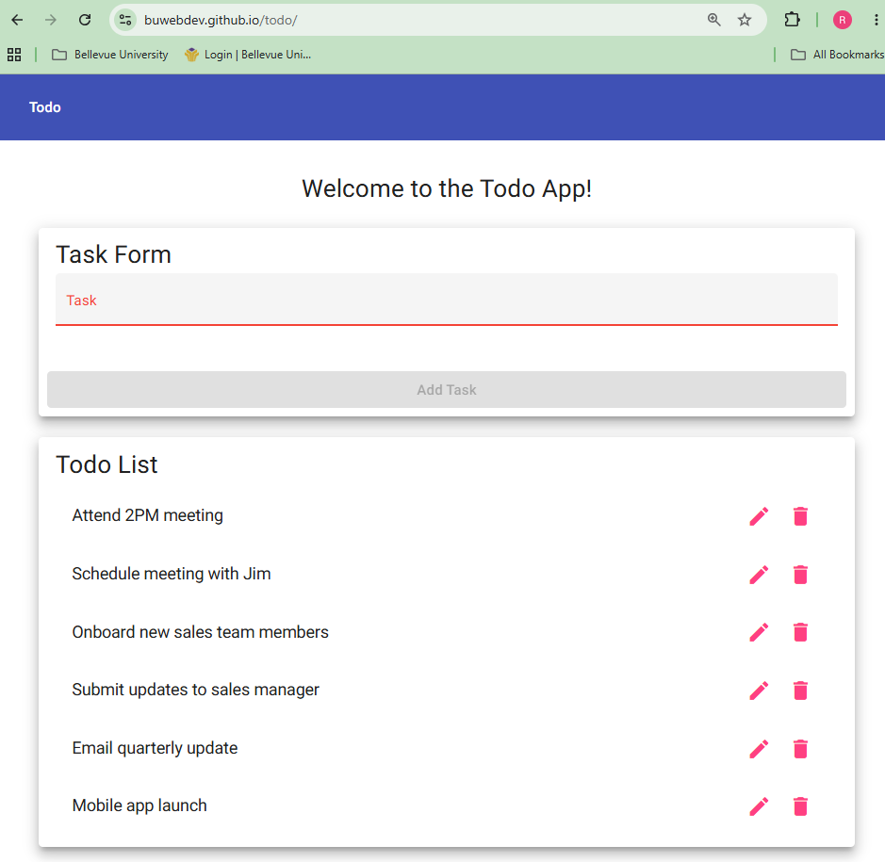
3 | Enter Complete DevOps Assignment. | Entered text appears correctly in the field. | Yes | Yes  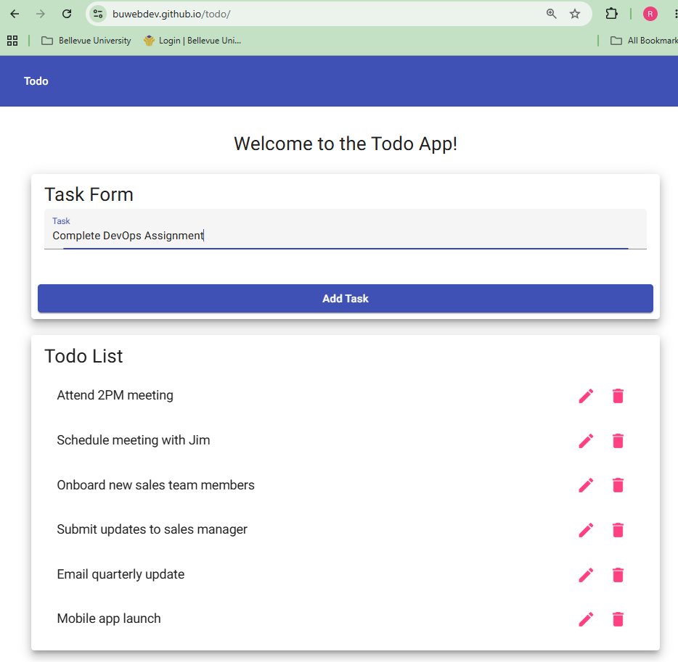
4 | Click Add Task. | Task is submitted without errors. | Yes | 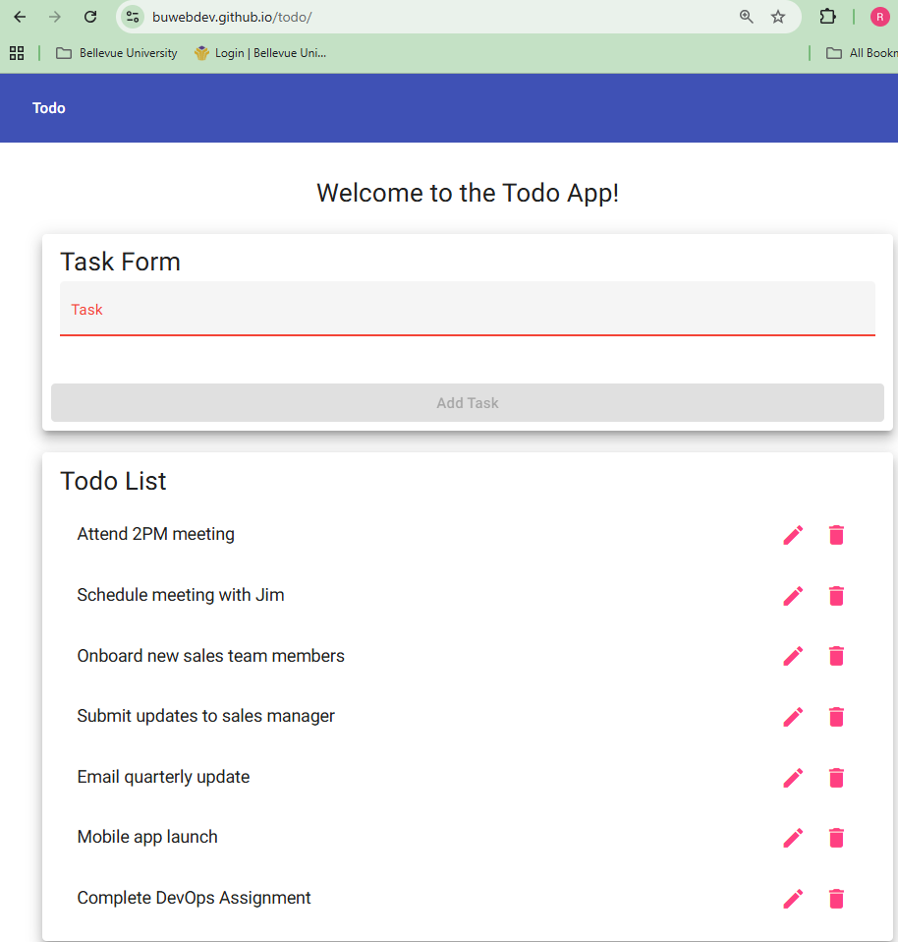  Yes
5 | Review the Todo List. | Complete DevOps Assignment appears as a new Todo item. | Yes | Yes
Comments | All five steps passed. The Task field took focus when I clicked it, “Complete DevOps Assignment” showed correctly as I typed it, and clicking Add Task submitted it with no errors and cleared the field. The new task showed up as the last item in the Todo List. For Step 5, saying where the new item should appear (at the bottom of the list) would make the expected result more exact.

Test 3 - Edit a Todo Item
Requirement 3: Edit a todo task item.
Test 3 | Edit Existing Todo Task
 | Test Objective: Verify that a user can modify an existing Todo item and save the updated value. | Developer: Lane Dorscher  Date tested: 2026/09/30 | Peer tester: Rakesh Shrestha  Date tested: 2026/10/03
Step | Action | Expected results: | Developer pass/fail | Tester pass/fail  + Screenshot
1 | Navigate to the Todo application. | Todo application loads successfully. | Yes | Yes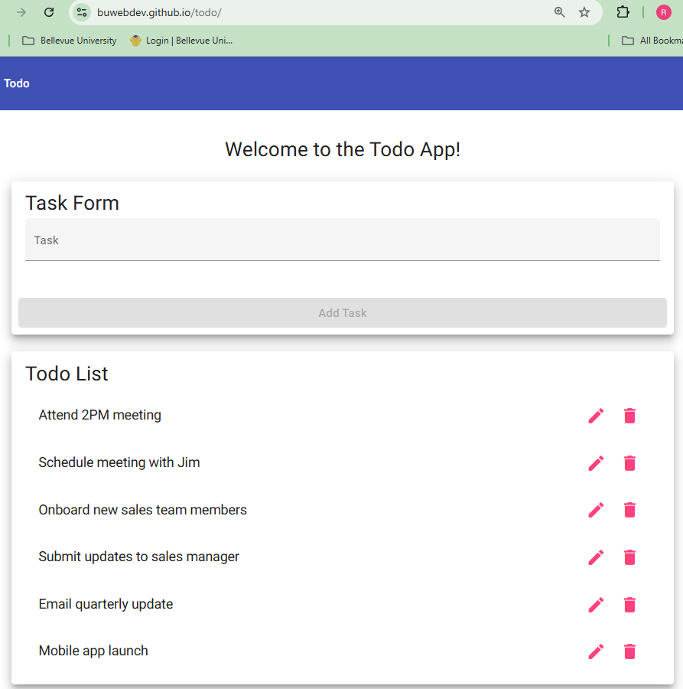
2 | Locate an existing Todo item. | Locate an existing Todo item. | Yes | Yes
3 | Select the Todo item to edit it. | Edit form opens for the selected Todo item. | Yes | Yes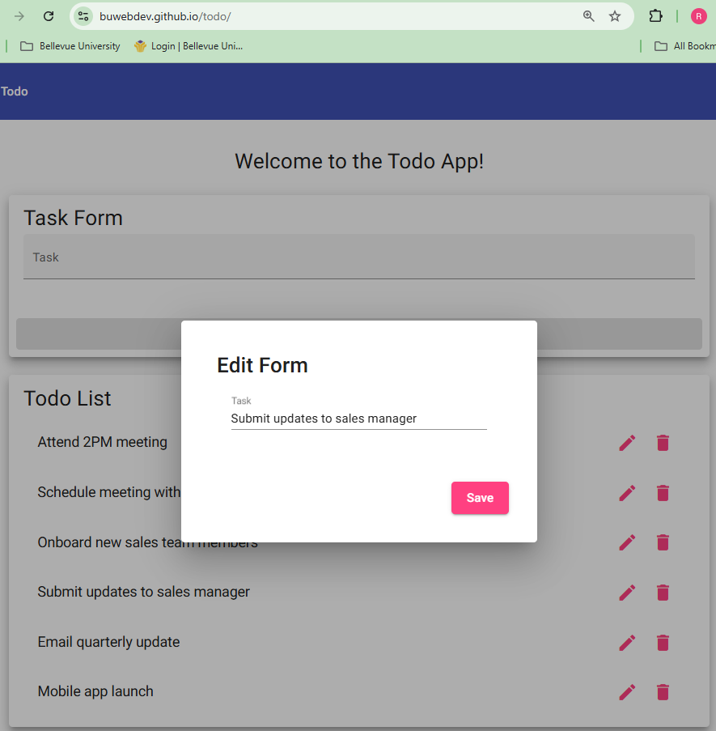
4 | Replace the existing text with Complete CSD 380 Assignment. | New text appears in the edit field. | Yes | Yes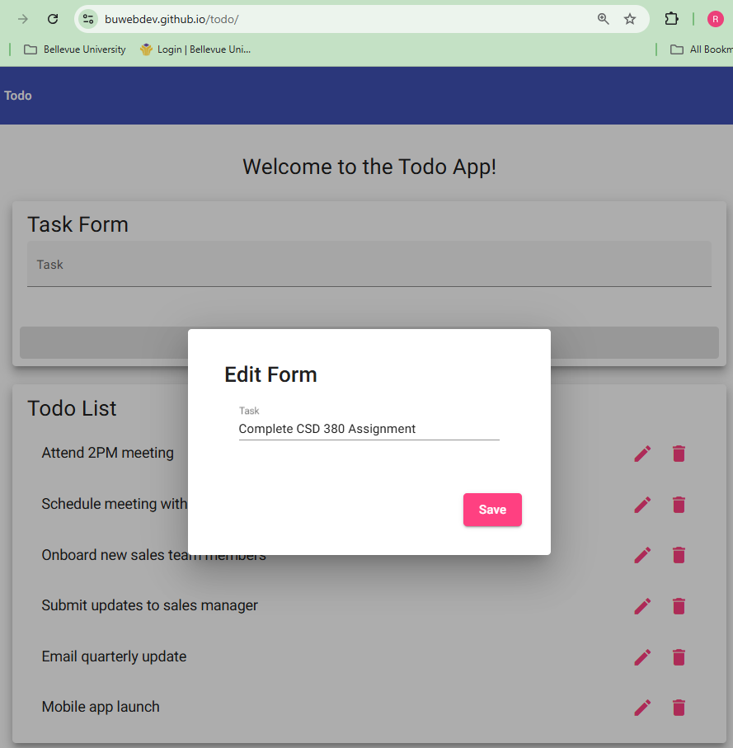
5 | Click Save. | Updated Todo item is saved without errors. | Yes | Yes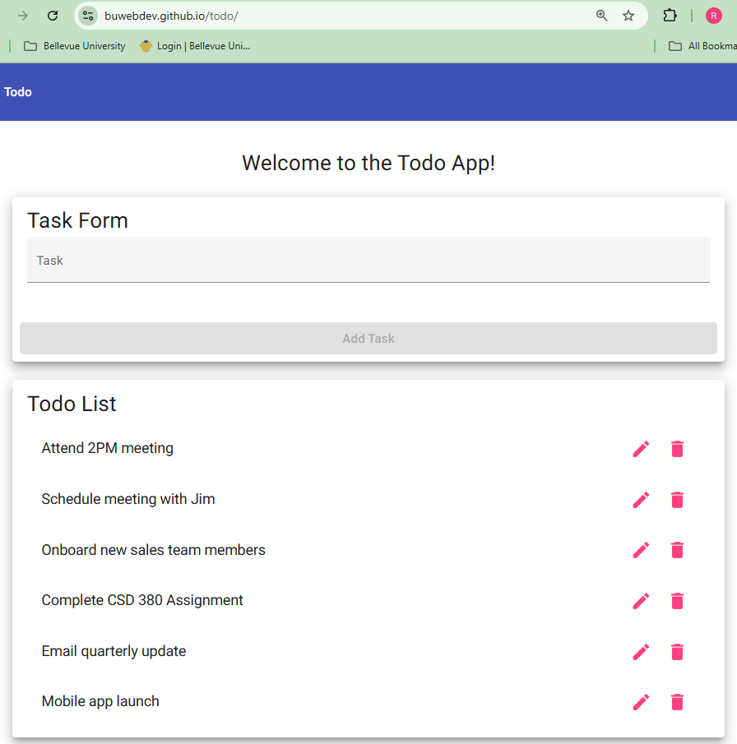
6 | Review the Todo List. | Updated text is displayed and the previous value is no longer shown. | Yes | Yes
Comments | All six steps passed. I used “Submit updates to sales manager” as the task, since the plan does not name one. Step 3 says to select the Todo item, but clicking the task text does nothing, and the Edit Form only opens from the pencil icon, so naming the pencil icon in that step would remove any guessing. Step 2 also repeats the action as its expected result, and it could say something like “the task and its pencil and trash icons are visible” instead. After saving, “Complete CSD 380 Assignment” replaced the old text in the same position and the old value was gone.

Test 4 – Delete a Todo Item
Requirement 4: Delete a todo task item.
Test 4 | Delete Existing Todo Task
 | Test Objective: Verify that a user can delete an existing Todo item without removing other tasks. | Developer: Lane Dorscher  Date tested: 2026/09/30 | Peer tester: Rakesh Shrestha  Date tested: 2026/10/03
Step | Action | Expected results: | Developer pass/fail | Tester pass/fail  + Screenshot
1 | Navigate to the Todo application. | Todo application loads successfully. | Yes | 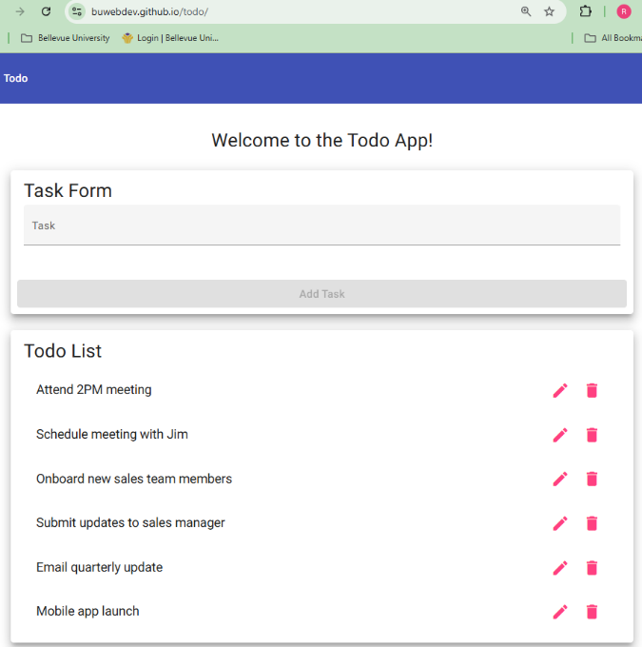  Yes
2 | Add a new task named Delete Test Task. | Task appears in the Todo List. | Yes | Yes  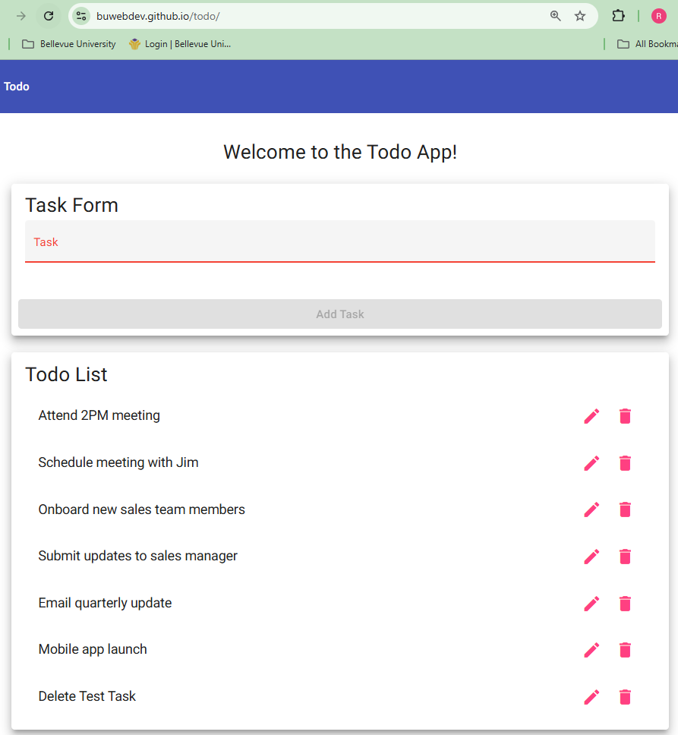
3 | Locate Delete Test Task in the list. | Correct Todo item is visible and selectable. | Yes | Yes  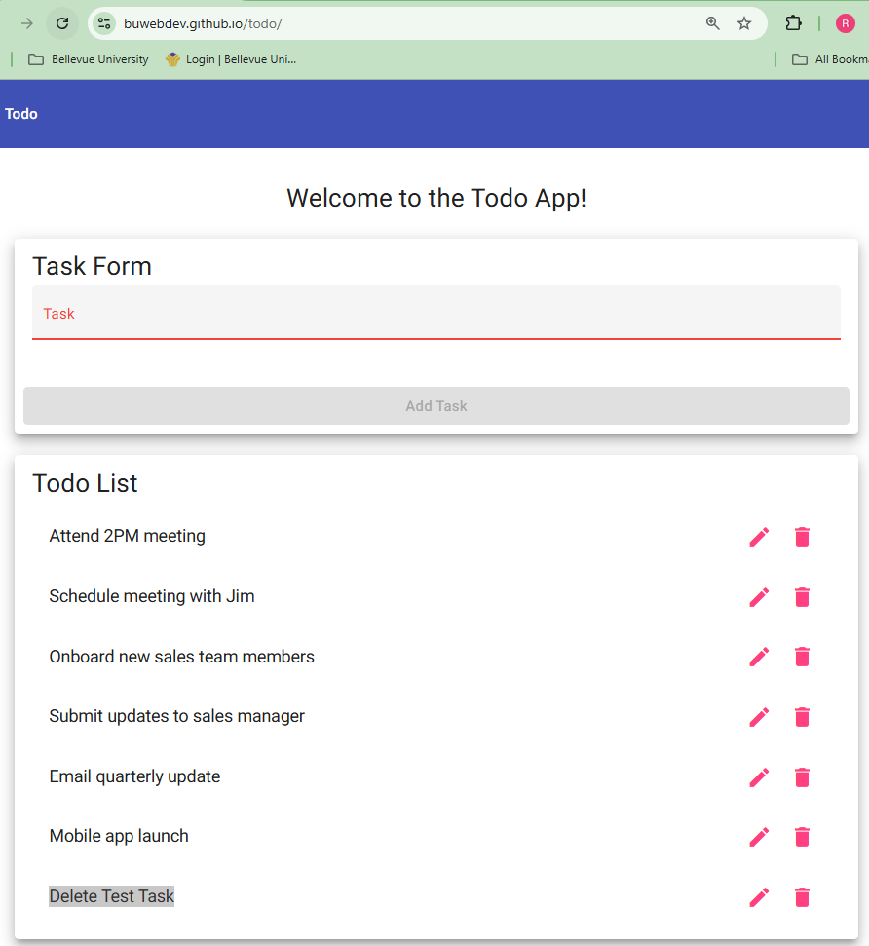
4 | Select the delete option for Delete Test Task. | Application processes the delete request. | Yes | Yes (Bottom task removed)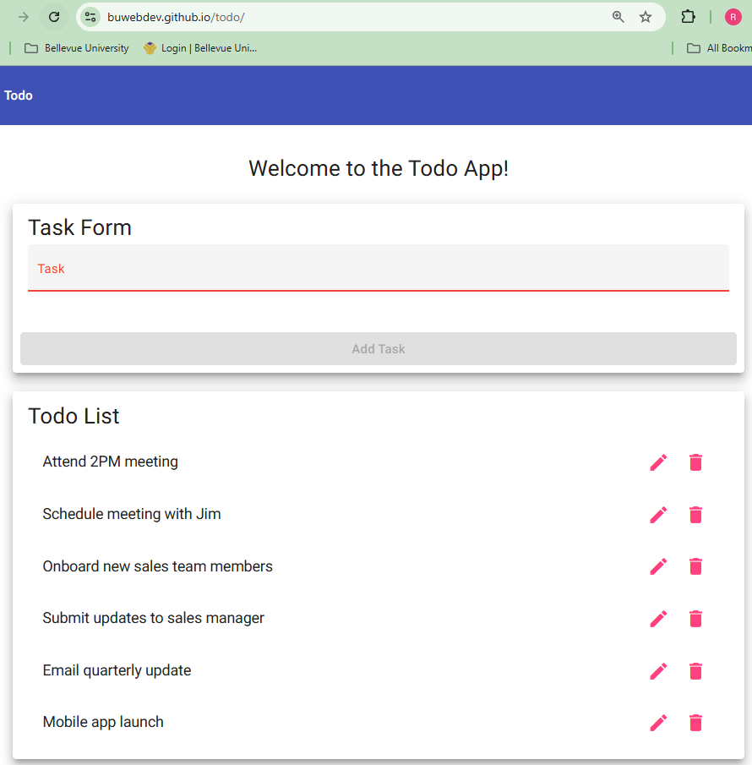
5 | Review the Todo List. | Delete Test Task is no longer displayed. | Yes | Yes  \
6 | Review the remaining Todo items. | Other Todo items remain in the list and are unchanged. | Yes | Yes
Comments | All six steps passed. “Delete Test Task” was added to the bottom of the list, the trash icon next to it removed it right away, and the six original tasks stayed in the same order. Adding your own task first and then deleting it was a good choice because it keeps the default data the same for the next test. The expected result for Step 4 (“processes the delete request”) is a little vague, so it might be clearer to say the task disappears from the list.

Test 5 – Prevent an Empty Task
Requirement 6: Prevent users from submitting a task form without entering a todo item.
Test 5 | Prevent Empty Todo Submission
 | Test Objective: Verify that the application does not allow a user to create a Todo item without entering task information. | Developer: Lane Dorscher  Date tested: 2026/09/30 | Peer tester: Rakesh Shrestha  Date tested: 2026/10/03
Step | Action | Expected results: | Developer pass/fail | Tester pass/fail  + Screenshot
1 | Navigate to the Todo application. | Todo application loads successfully. | Yes | Yes  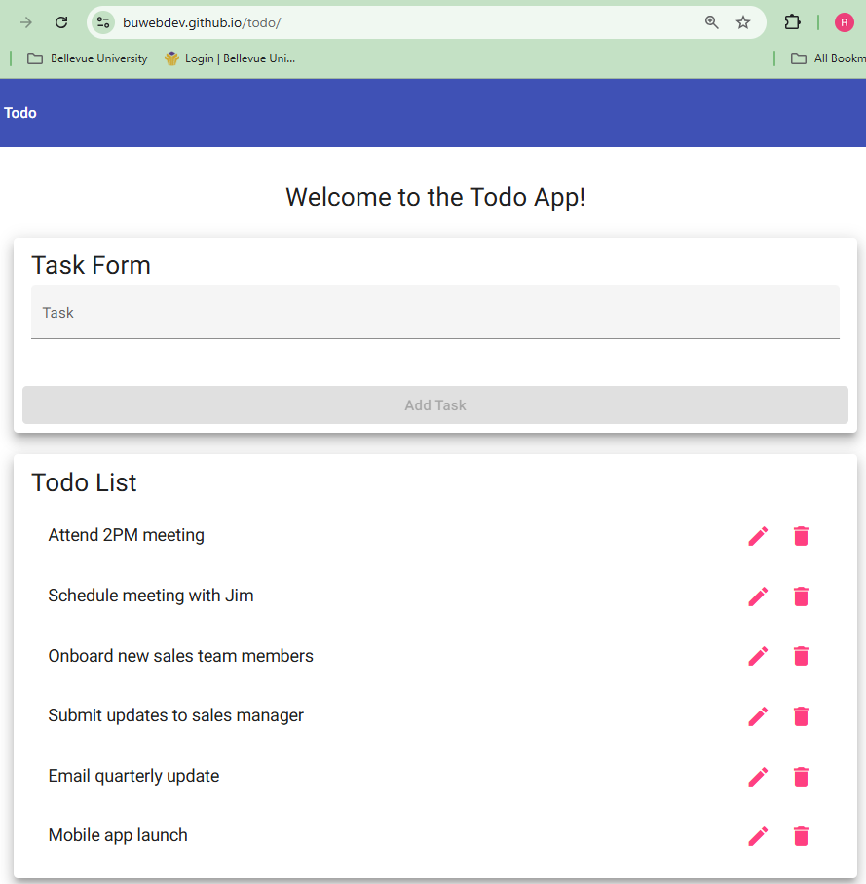
2 | Locate the Task Form. | Task Form and Add Task button are displayed. | Yes | Yes (Add Task button is greyed out)
3 | Leave the task text field empty. | Text field remains empty. | Yes | Yes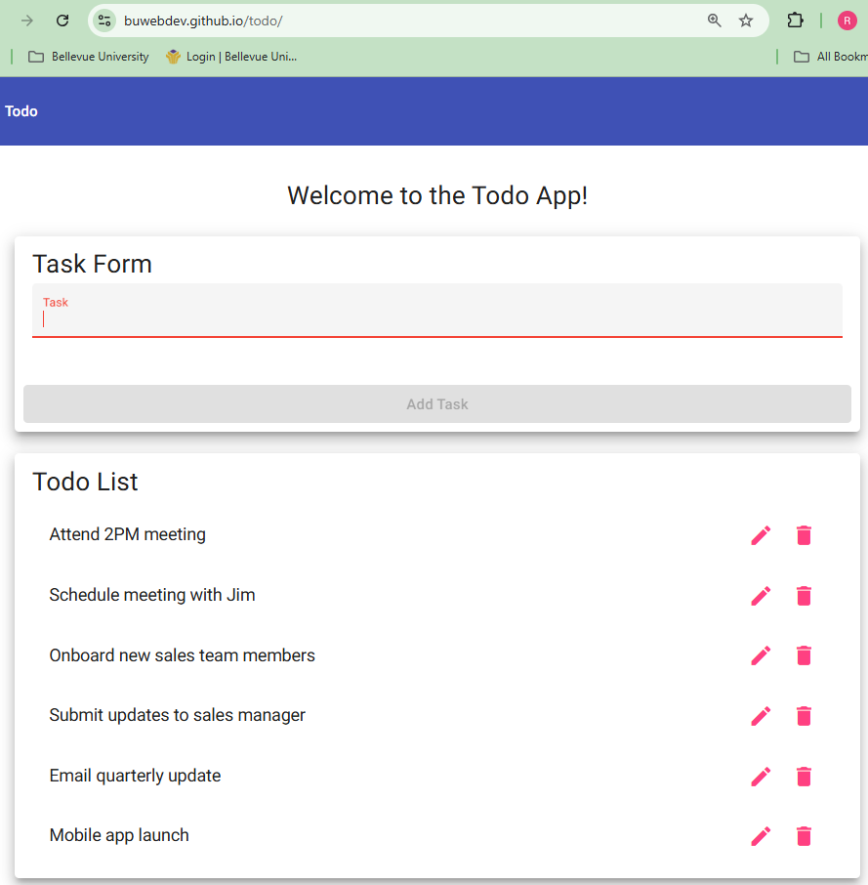
4 | Click Add Task. | Application prevents the empty task from being submitted. | Yes | Yes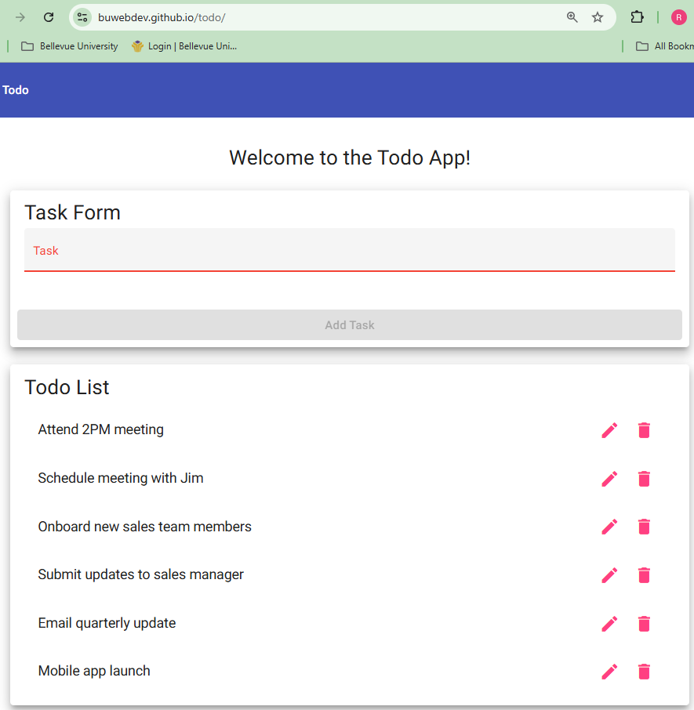
5 | Review the Todo List. | No blank Todo item is added to the list. | Yes | Yes
Comments | All five steps passed. With the Task field left empty, the Add Task button was grayed out, clicking it did nothing, and the list still had six tasks with no blank entry. This confirms Requirement 6 for a completely empty field. While testing another classmate’s plan, though, I found that typing only spaces enables Add Task and adds a blank task, so a whitespace step would be worth adding here to fully cover the requirement.

