Project: Todo Application
Course: CSD 380
Description: Functional test plan for the Todo web application covering all ten requirements in the Todo Business Requirements document.
Date: 2026/10/01
To complete the test case plan, fill out the information for Project, Course, Description and Date in the header below.
.

Tanner Elston – Module 4.2 Assignment – Test Plan Discussion

TABLE OF CONTENTS
Test 1. Access the Todo Application and Handle Invalid URLs 2
Test 2. Create a Task and Prevent an Empty Task Form 3
Test 3. Edit a Task and Prevent an Empty Edit Form 4
Test 4. Delete a Task 5
Test 5. Display Mobile and Tablet Views 6

For each test, the developer should: provide a test description, a test objective, the developer name and date tested. For each step, fill out the actions to be taken and describe the expected results, and indicate yes or no for each step depending upon the result. The peer tester should provide their name, date tested, indicate yes or no for each step depending upon the result, and a screenshot (thumbnail) of the result.

Test 1 | Access the Todo Application and Handle Invalid URLs
 | Test Objective: Covers Requirements 10, 1 and 5. Verifies users can reach the Todo application through its standard URL, view the list of todo task items, and see a custom 404 page for an invalid URL. | Developer: Tanner Elston  Date tested: 2026/10/01 | Peer tester: Rakesh Shrestha  Date tested: 2026/10/03
Step | Action | Expected results: | Developer pass/fail | Tester pass/fail  + Screenshot
1 | Open a new browser tab, type https://buwebdev.github.io/todo/ into the address bar, and press Enter. | The Todo application opens with the heading “Welcome to the Todo App!” | yes | Yes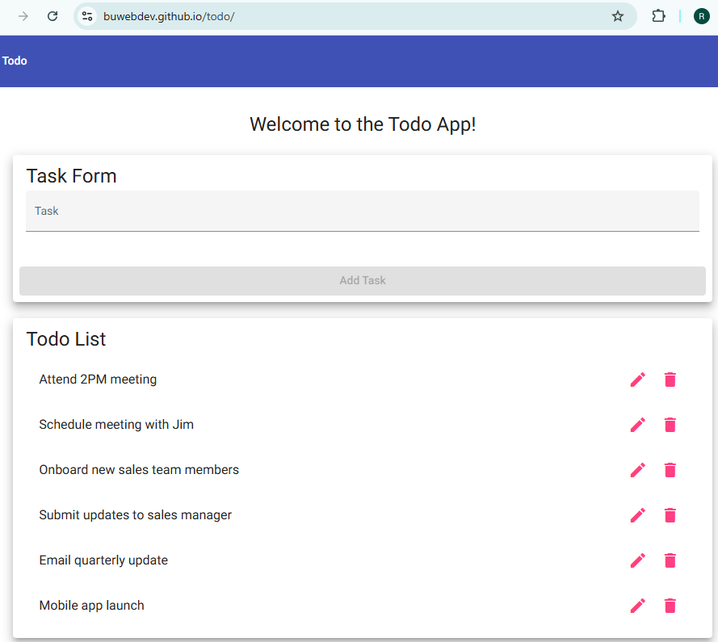
2 | Review the Todo List section. | The Todo List shows six task items, starting with “Attend 2PM meeting”, each with a pencil icon and a trash icon. | yes | Yes
3 | Compare the page to the landing page prototype in the requirements document. | The Task Form, Add Task button, and Todo List match the layout of the prototype. | yes | Yes
4 | Go to https://buwebdev.github.io/todo/invalid-page. | A custom 404 page clearly tells the user that the page could not be found. | no | No  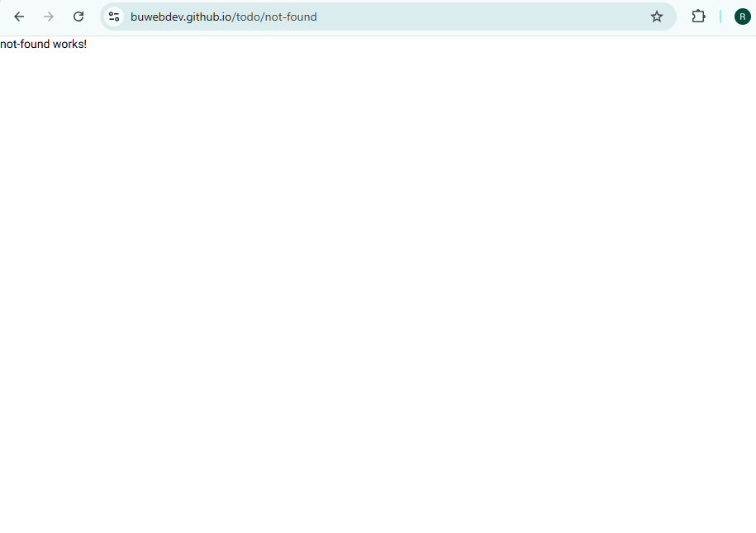
5 | Look for a way back to the home page. | The 404 page provides a link or button that returns the user to the Todo List. | no | No
Comments | Steps 1 through 3 passed. The app loaded at https://buwebdev.github.io/todo/ with the “Welcome to the Todo App!” heading, all six default tasks showed with pencil and trash icons, and the layout matched the landing page prototype. Steps 4 and 5 failed, which matches the developer results. Going to /invalid-page sends the browser to /not-found, and that page only shows the placeholder text “not-found works!” with no toolbar, no real message, and no link back to the Todo List. To meet Requirement 5, the not-found component needs a clear message such as “404: Page Not Found” and a routerLink back to the home page. Splitting the URL check and the 404 check into separate steps made the failure easy to pinpoint.

Test 2 | Create a Task and Prevent an Empty Task Form
 | Test Objective: Covers Requirements 2 and 6. Verifies a user can create a new todo task item and cannot submit the Task Form without entering one. Start from a freshly loaded page. | Developer: Tanner Elston  Date tested: 2026/10/01 | Peer tester: Rakesh Shrestha  Date tested: 2026/10/03
Step | Action | Expected results: | Developer pass/fail | Tester pass/fail
1 | Leave the Task field empty. | The Add Task button is disabled. | yes | Yes
2 | Type “Buy groceries” into the Task field. | The Add Task button becomes enabled. | yes | Yes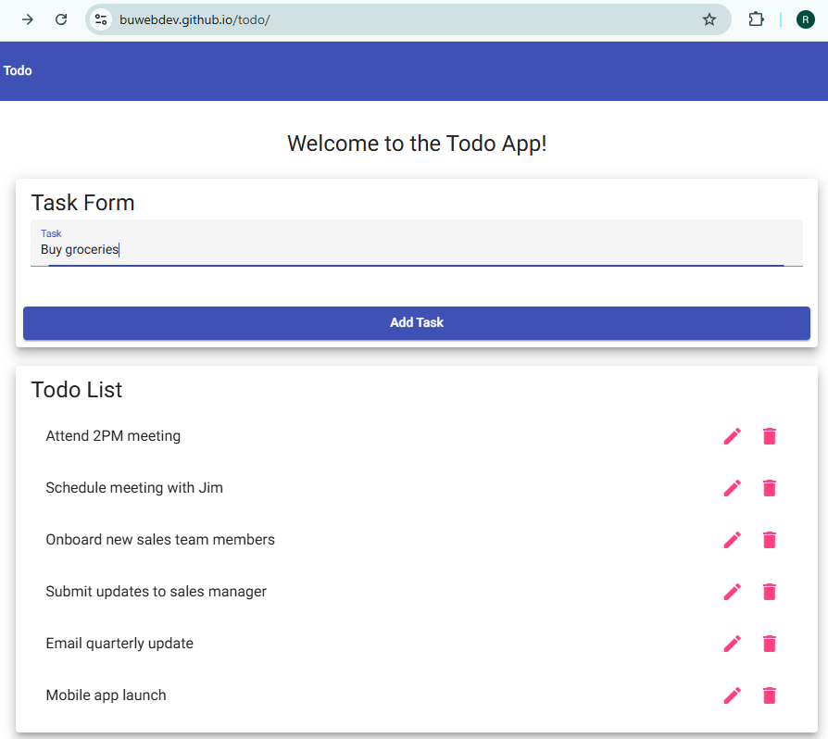
3 | Click the Add Task button. | “Buy groceries” appears at the bottom of the Todo List and the Task field is cleared. | yes | Yes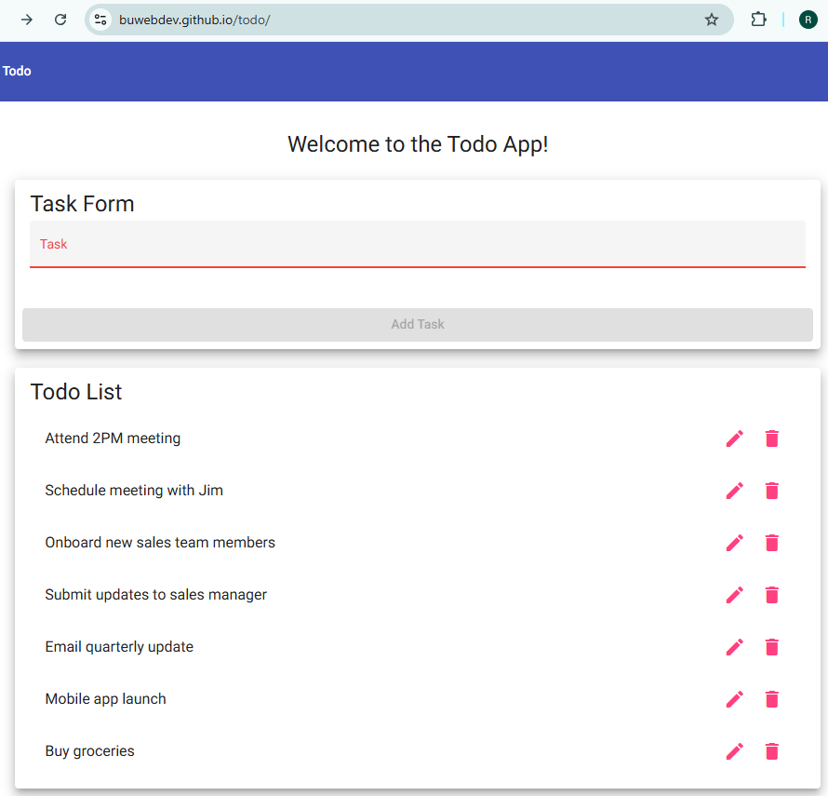
4 | Enter four spaces in the Task field. | The Add Task button stays disabled because spaces alone are not a todo item. | no | No (Add Task became enabled with four spaces) 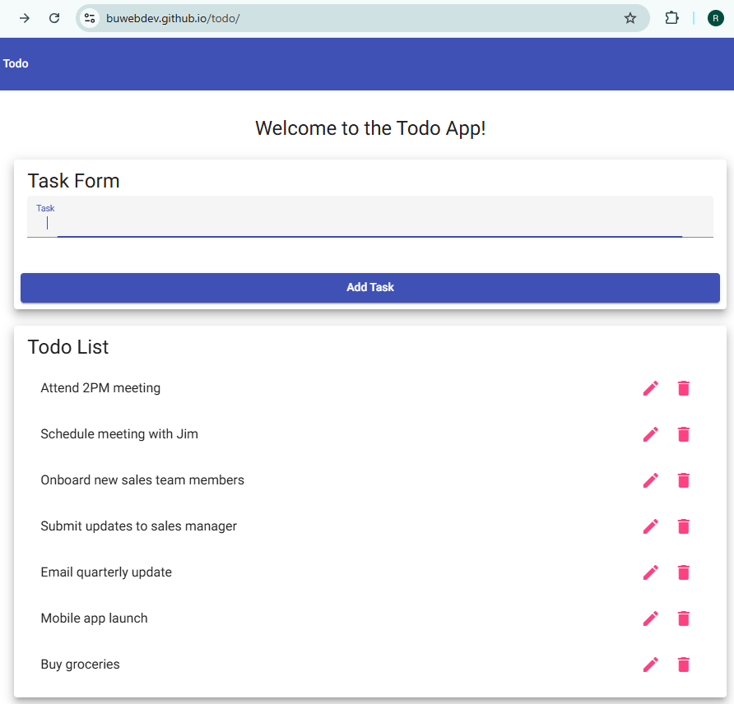
5 | With only spaces entered, click Add Task. | No blank task is added to the Todo List. | no | No (A blank task was added and the list now has 8 items)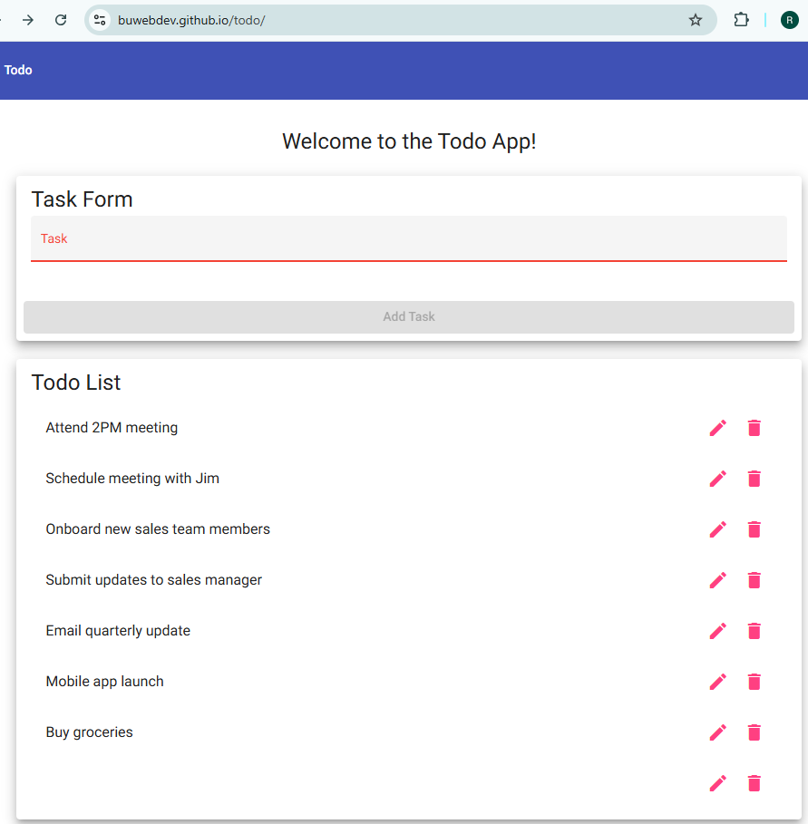
Comments | Steps 1 through 3 passed. Add Task stayed disabled while the field was empty, became active after I typed “Buy groceries,” and the new task was added to the bottom of the list with the field cleared. Steps 4 and 5 failed, same as the developer result. With four spaces in the field the Add Task button turned active, and clicking it added a blank row with only the edit and delete icons, so the list went to eight items. The form seems to rely only on a required check, so adding a whitespace check (a pattern validator, or trimming the value before saving) would close this gap for Requirement 6. Testing with spaces was a good edge case that I did not include in my own plan.

Test 3 | Edit a Task and Prevent an Empty Edit Form
 | Test Objective: Covers Requirements 3 and 7. Verifies a user can edit a todo task item and cannot submit the Edit Form without entering one. Start from a freshly loaded page. | Developer: Tanner Elston  Date tested: 2026/10/01 | Peer tester: Rakesh Shrestha  Date tested: 2026/10/03
Step | Action | Expected results: | Developer pass/fail | Tester pass/fail
1 | Click the pencil icon next to “Schedule meeting with Jim”. | The Edit Form opens and shows the current task text. | yes | Yes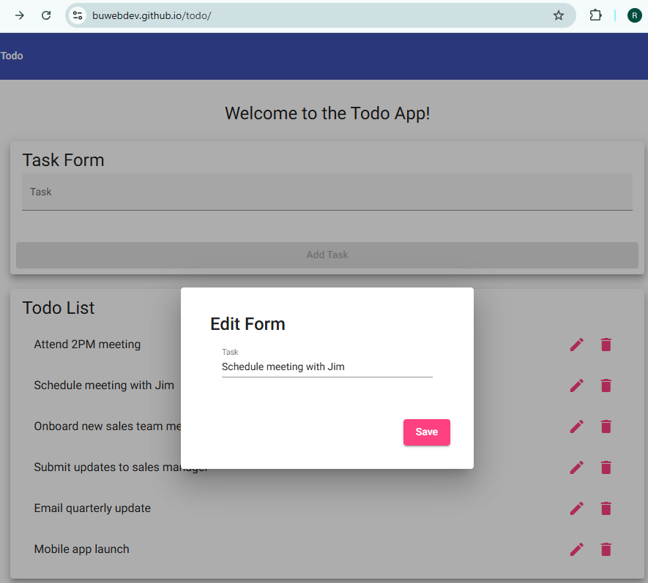
2 | Change the text to “Schedule meeting with Sarah” and click Save. | The Edit Form closes and the Todo List shows “Schedule meeting with Sarah” in the same position. | yes | Yes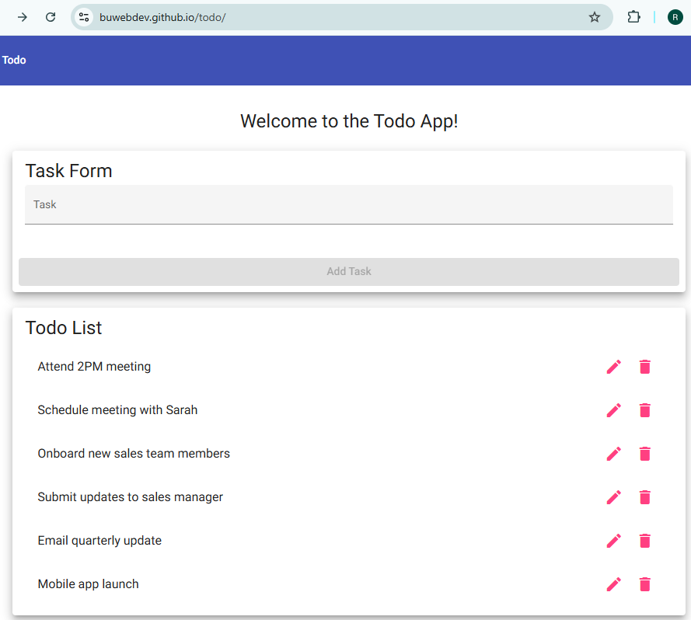
3 | Click the pencil icon next to “Onboard new sales team members” and delete all of the text. | The Save button becomes disabled or an error message appears. | no | No (Save stayed enabled and no error message showed) 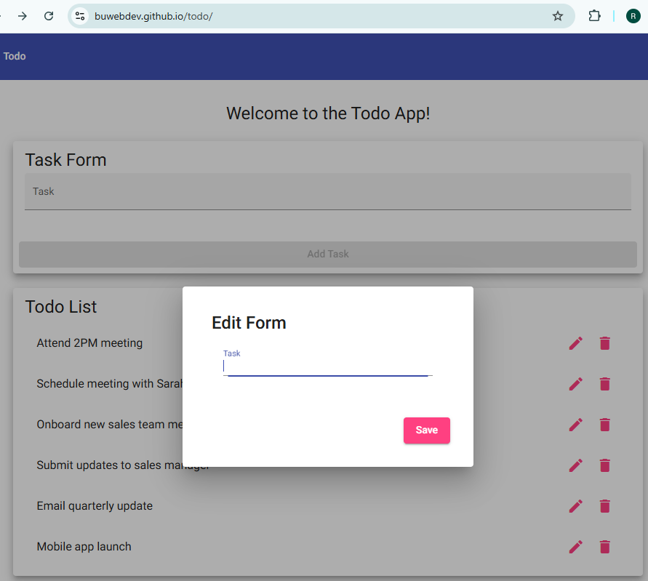
4 | Click Save. | The form is not submitted and the Edit Form stays open. | no | No (The Edit Form closed; task saved blank) 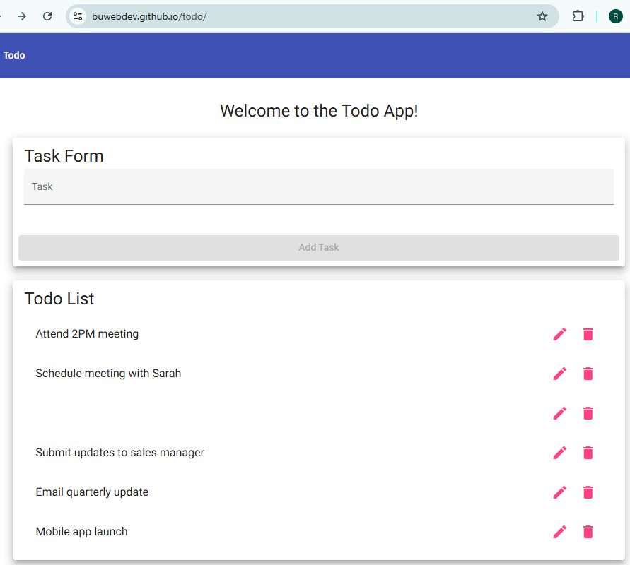
5 | Review the Todo List. | The task text still reads “Onboard new sales team members” and no blank row appears in the list. | no | No (Row 3 is now a blank task)
Comments | Steps 1 and 2 passed. The Edit Form opened with “Schedule meeting with Jim” already in the field, and after I changed it to “Schedule meeting with Sarah” and clicked Save, the updated task showed in the same second position. Steps 3 through 5 failed. After I cleared “Onboard new sales team members,” the Save button stayed active with no error message, clicking Save closed the dialog, and the third row was left blank. The edit field does not appear to have any validation, so Requirement 7 is not met yet. A required validator on that field, with Save disabled while it is empty, would fix this.

Test 4 | Delete a Task
 | Test Objective: Covers Requirement 4. Verifies a user can delete a todo task item and that only the selected task is removed. Start from a freshly loaded page. | Developer: Tanner Elston  Date tested: 2026/10/01 | Peer tester: Rakesh Shrestha  Date tested: 2026/10/03
Step | Action | Expected results: | Developer pass/fail | Tester pass/fail
1 | Locate “Email quarterly update” in the Todo List. | The task is visible with a pencil icon and a trash icon. | yes | Yes  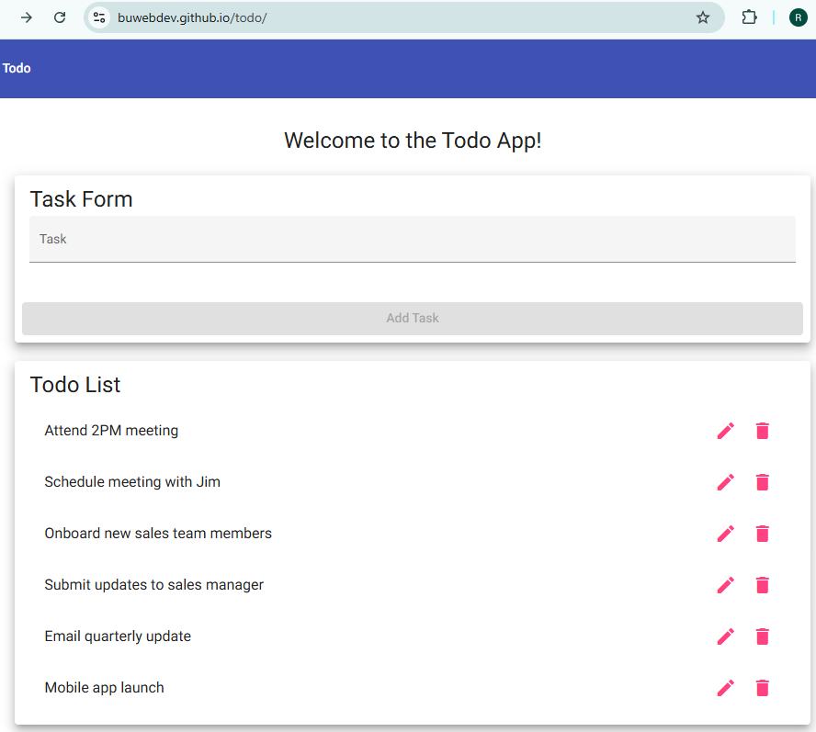
2 | Click the trash icon next to “Email quarterly update”. | “Email quarterly update” is removed from the Todo List. | yes | Yes  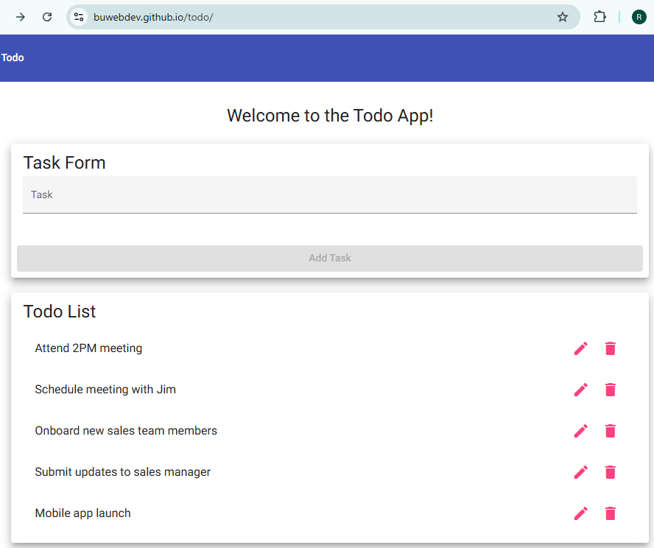
3 | Review the rest of the Todo List. | The other five tasks remain in their original order. | yes | Yes
4 | Add a task named “Test task”, then click its trash icon. | “Test task” is added to the list and then removed. | yes | Yes (@Top: “Test task” added @Bottom : after deletion)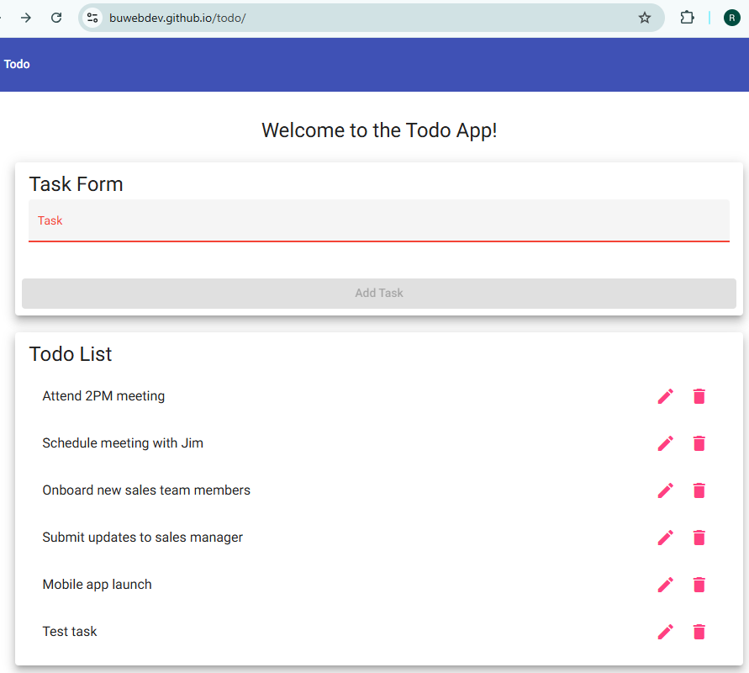  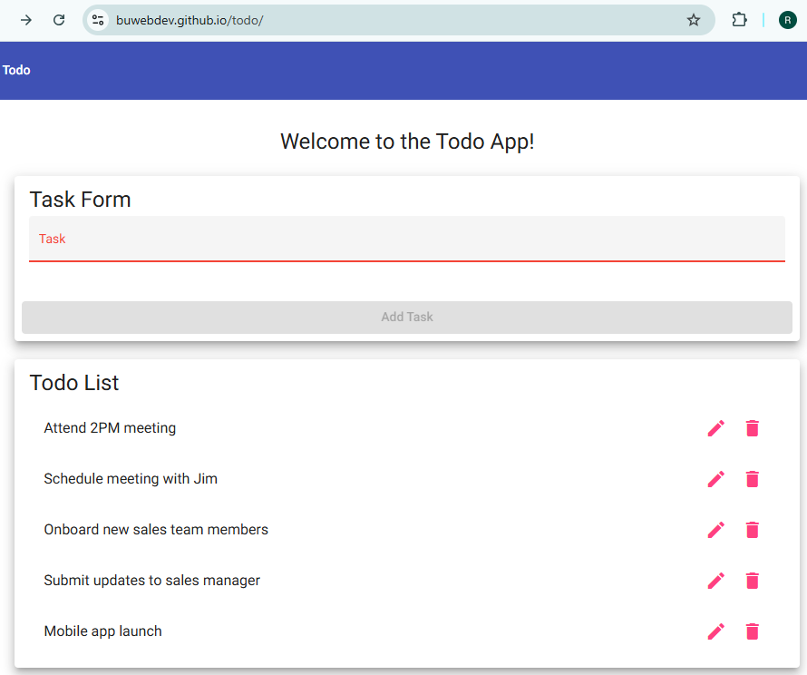
5 | Click the trash icon next to “Mobile app launch”. | “Mobile app launch” is removed and the Todo List shows four tasks. | yes | Yes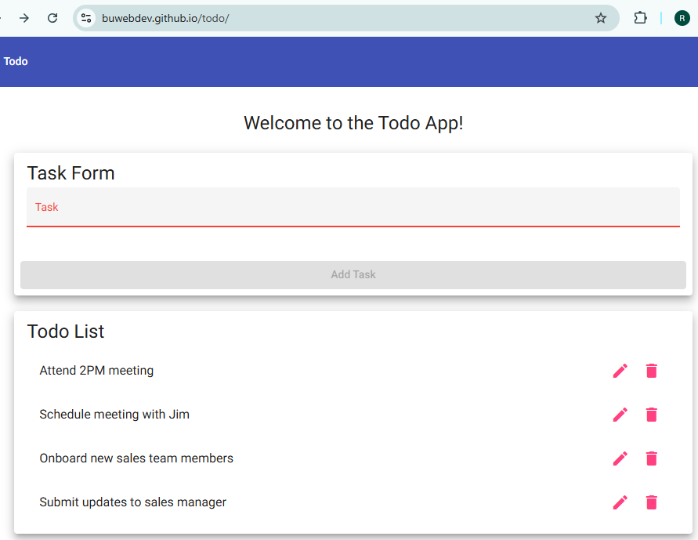
Comments | All five steps passed. Deleting “Email quarterly update” removed only that task, and the other five stayed in their original order. “Test task” was added and removed without touching anything else, and after I deleted “Mobile app launch” the list showed four tasks, which matches the expected count. One suggestion would be a confirmation prompt before deleting, since one mis-click on the trash icon removes a task with no undo. That is not part of the business requirements, so it did not affect the results.

Test 5 | Display Mobile and Tablet Views
 | Test Objective: Covers Requirements 8 and 9. Verifies the Todo application provides usable views on mobile and tablet devices. | Developer: Tanner Elston  Date tested: 2026/10/01 | Peer tester: Rakesh Shrestha  Date tested: 2026/10/03
Step | Action | Expected results: | Developer pass/fail | Tester pass/fail
1 | Open https://buwebdev.github.io/todo/ in Chrome, open DevTools (F12), turn on the device toolbar, and select iPhone SE (375 x 667). | The page fits the mobile screen with no horizontal scrolling. | yes | Yes  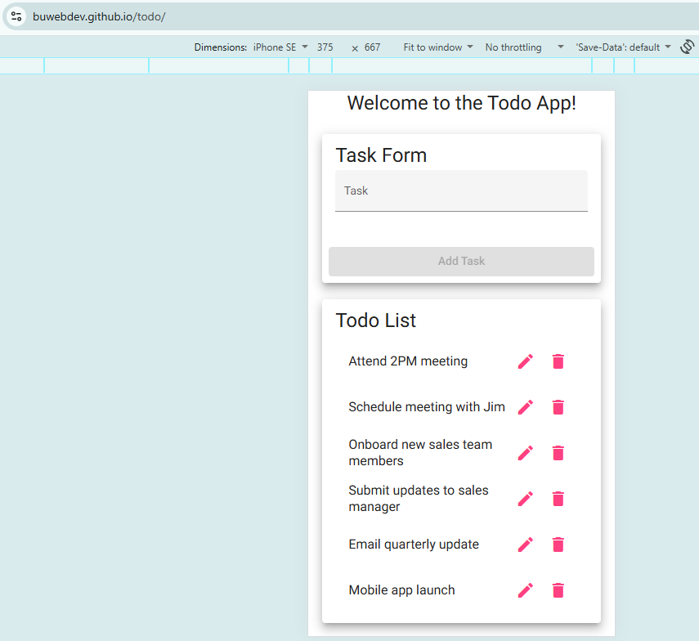
2 | Review the Task Form and Todo List in the mobile view. | Both sections stack in a single column and every task name and icon is visible. | yes | Yes
3 | Type “Mobile test” and tap Add Task. | “Mobile test” appears at the bottom of the Todo List. | yes | Yes  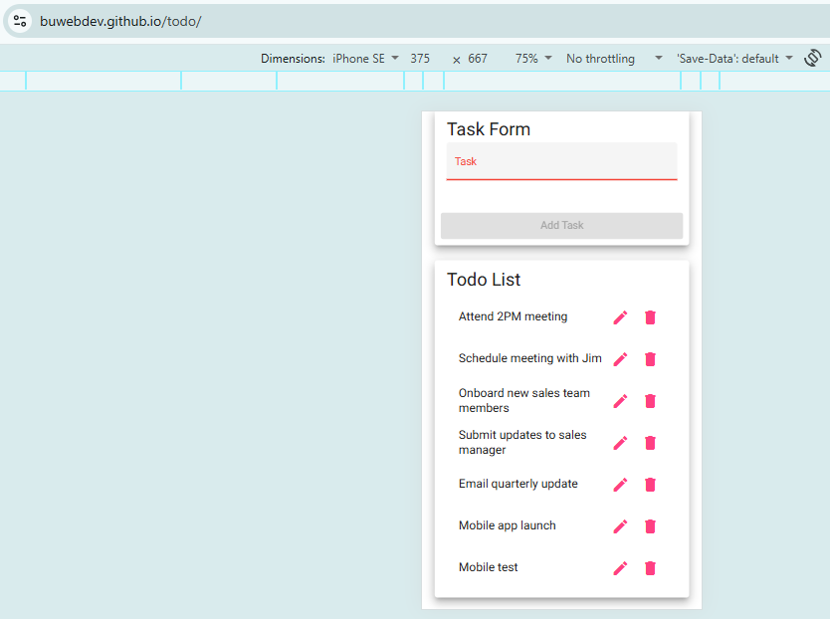
4 | Tap the pencil icon next to “Attend 2PM meeting”. | The Edit Form opens and fits within the mobile screen. | yes | Yes  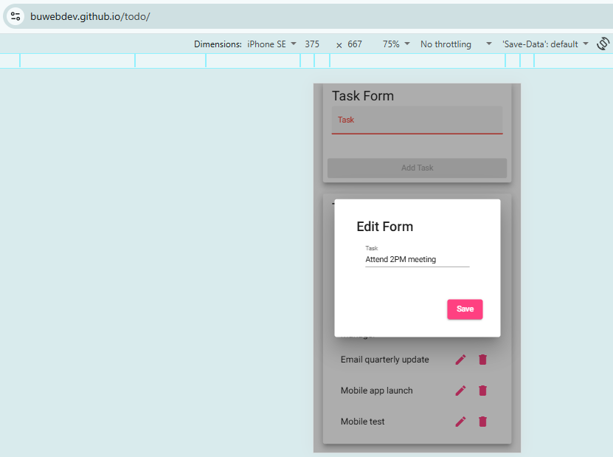
5 | Switch the device to iPad Mini (768 x 1024) and reload the page. | The page fits the tablet screen with no horizontal scrolling and all elements are visible. | yes | Yes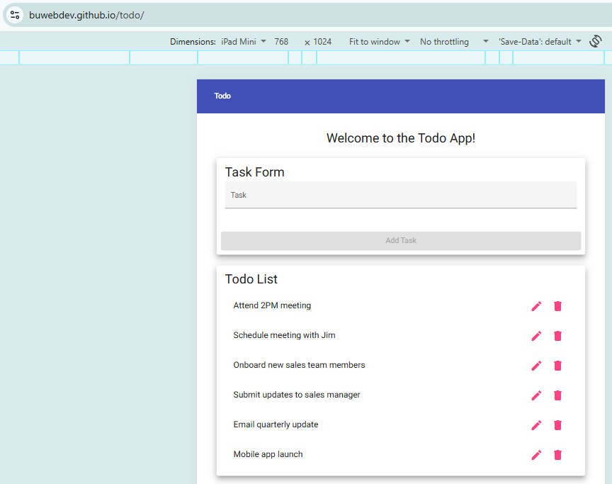
Comments | All five steps passed. I used the browser’s device emulation at the same sizes listed in your steps, iPhone SE (375 x 667) and iPad Mini (768 x 1024). In the phone view the Task Form and Todo List stacked in one column with no horizontal scrolling, longer task names wrapped to two lines while the icons stayed visible, “Mobile test” was added to the bottom of the list, and the Edit Form opened fully inside the screen. The tablet view also loaded with no horizontal scrolling and every element visible. The steps were easy to follow because each one named the exact device and size to use.

