Rakesh Shrestha
Module 1.3 Programming Assignment
CSD-402 - Java for Programmers
September 13, 2026
Java Version Check
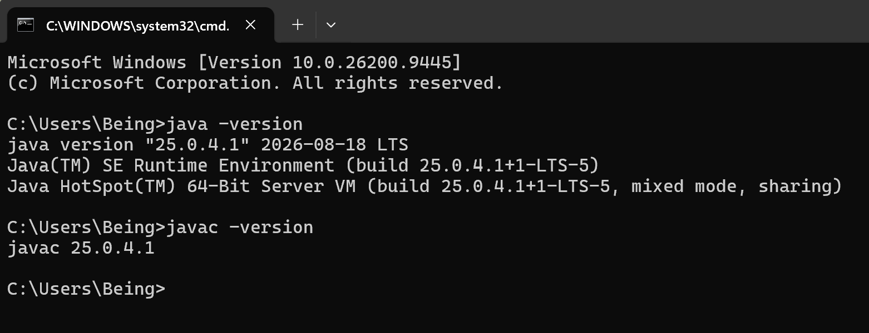

JavaFX Library Configuration
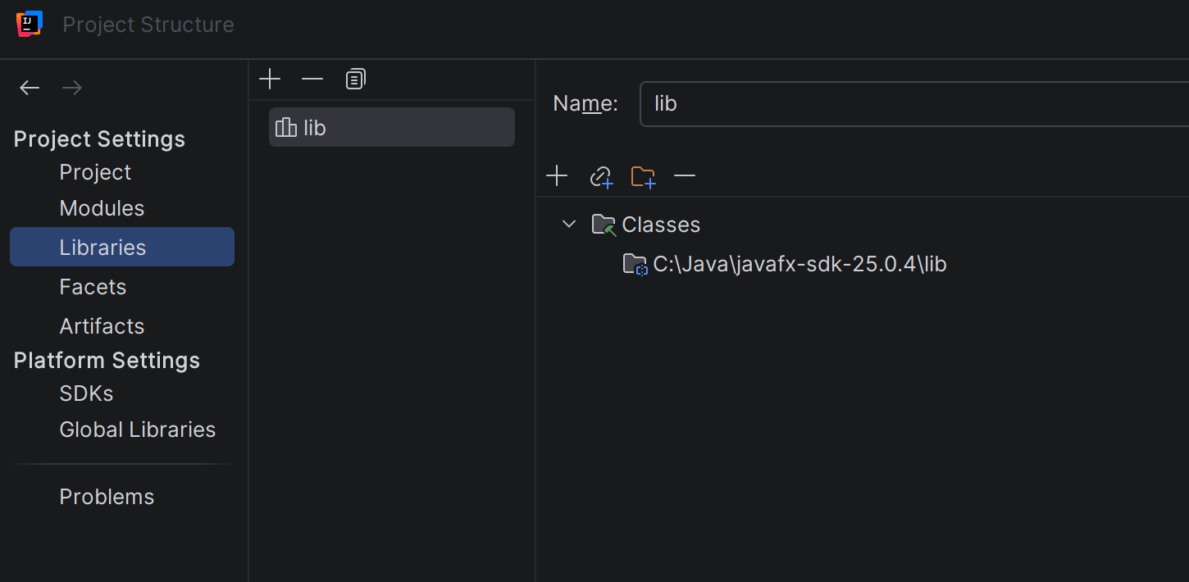

Program Output (WaterHeatingCalculator)
