Rakesh Shrestha
Module 1.2 Assignment — GitHub Repository Setup
September 12, 2026

GitHub Repository:
https://github.com/RockyShrestha/csd-402

Local Directory Setup
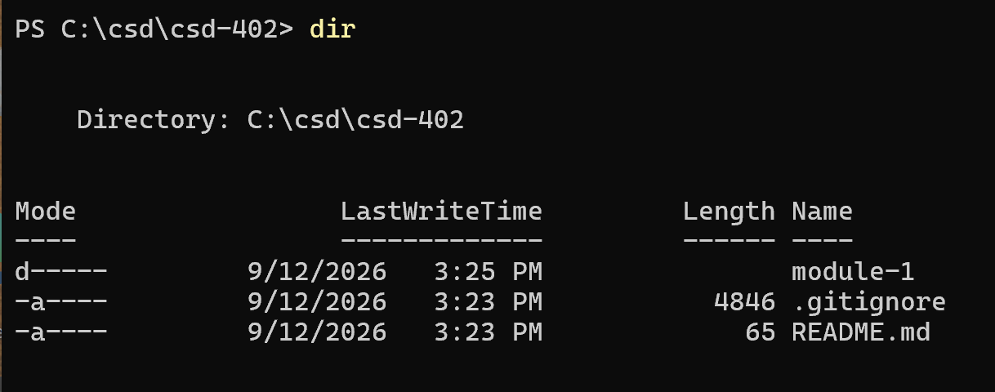

GitHub Repository
