Rakesh Shrestha
CSD420-T301 Advanced Java Programming
Module 5.2 Programming Assignment
October 11, 2026

Module 5.2: Non-Duplicate Words in Ascending and Descending Order
For this assignment, I wrote WordSorter.java, which reads the words in collection_of_words.txt, removes the duplicates by storing them in a TreeSet, and prints the unique words in ascending order and then in descending order using descendingSet(). I also wrote WordSorterTest.java, which runs ten tests to check duplicate removal, upper and lower case, punctuation, both sort orders, and reading the word file. Four of the tests check error handling: a missing file, an empty file, a null file, and a null line. Every caught exception is printed to the console and recorded with a Logger as shown in the screenshots.

1. Java and JavaFX Installation and Configuration
The first screenshots show that Java is installed and that JavaFX is configured in IntelliJ IDEA.
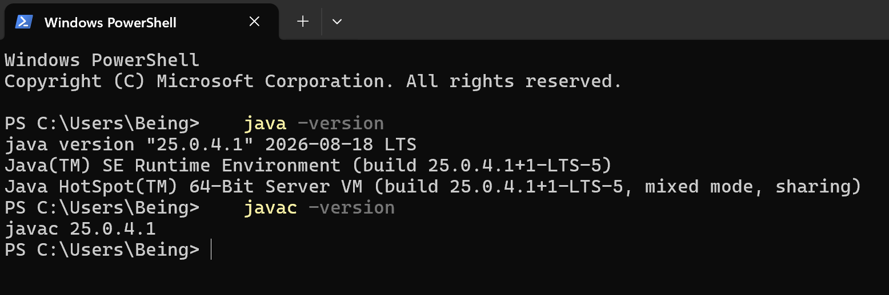
Figure 1. Java 25.0.4.1 runtime and compiler installed, verified with java -version and javac -version in PowerShell.

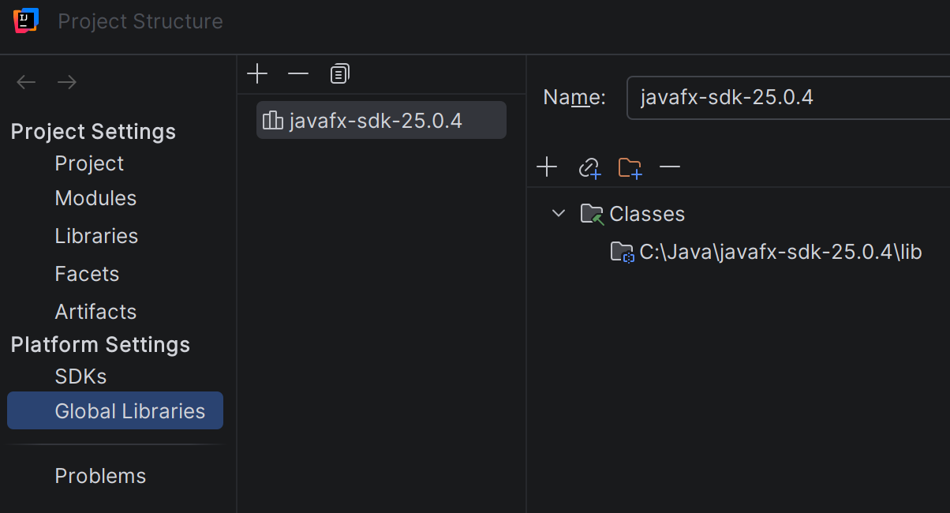
Figure 2. JavaFX SDK 25.0.4 configured as a global library in IntelliJ IDEA.

2. WordSorter Program Output
The program finds collection_of_words.txt, reports how many unique words it holds, and prints them in both orders. The file has 91 unique words.

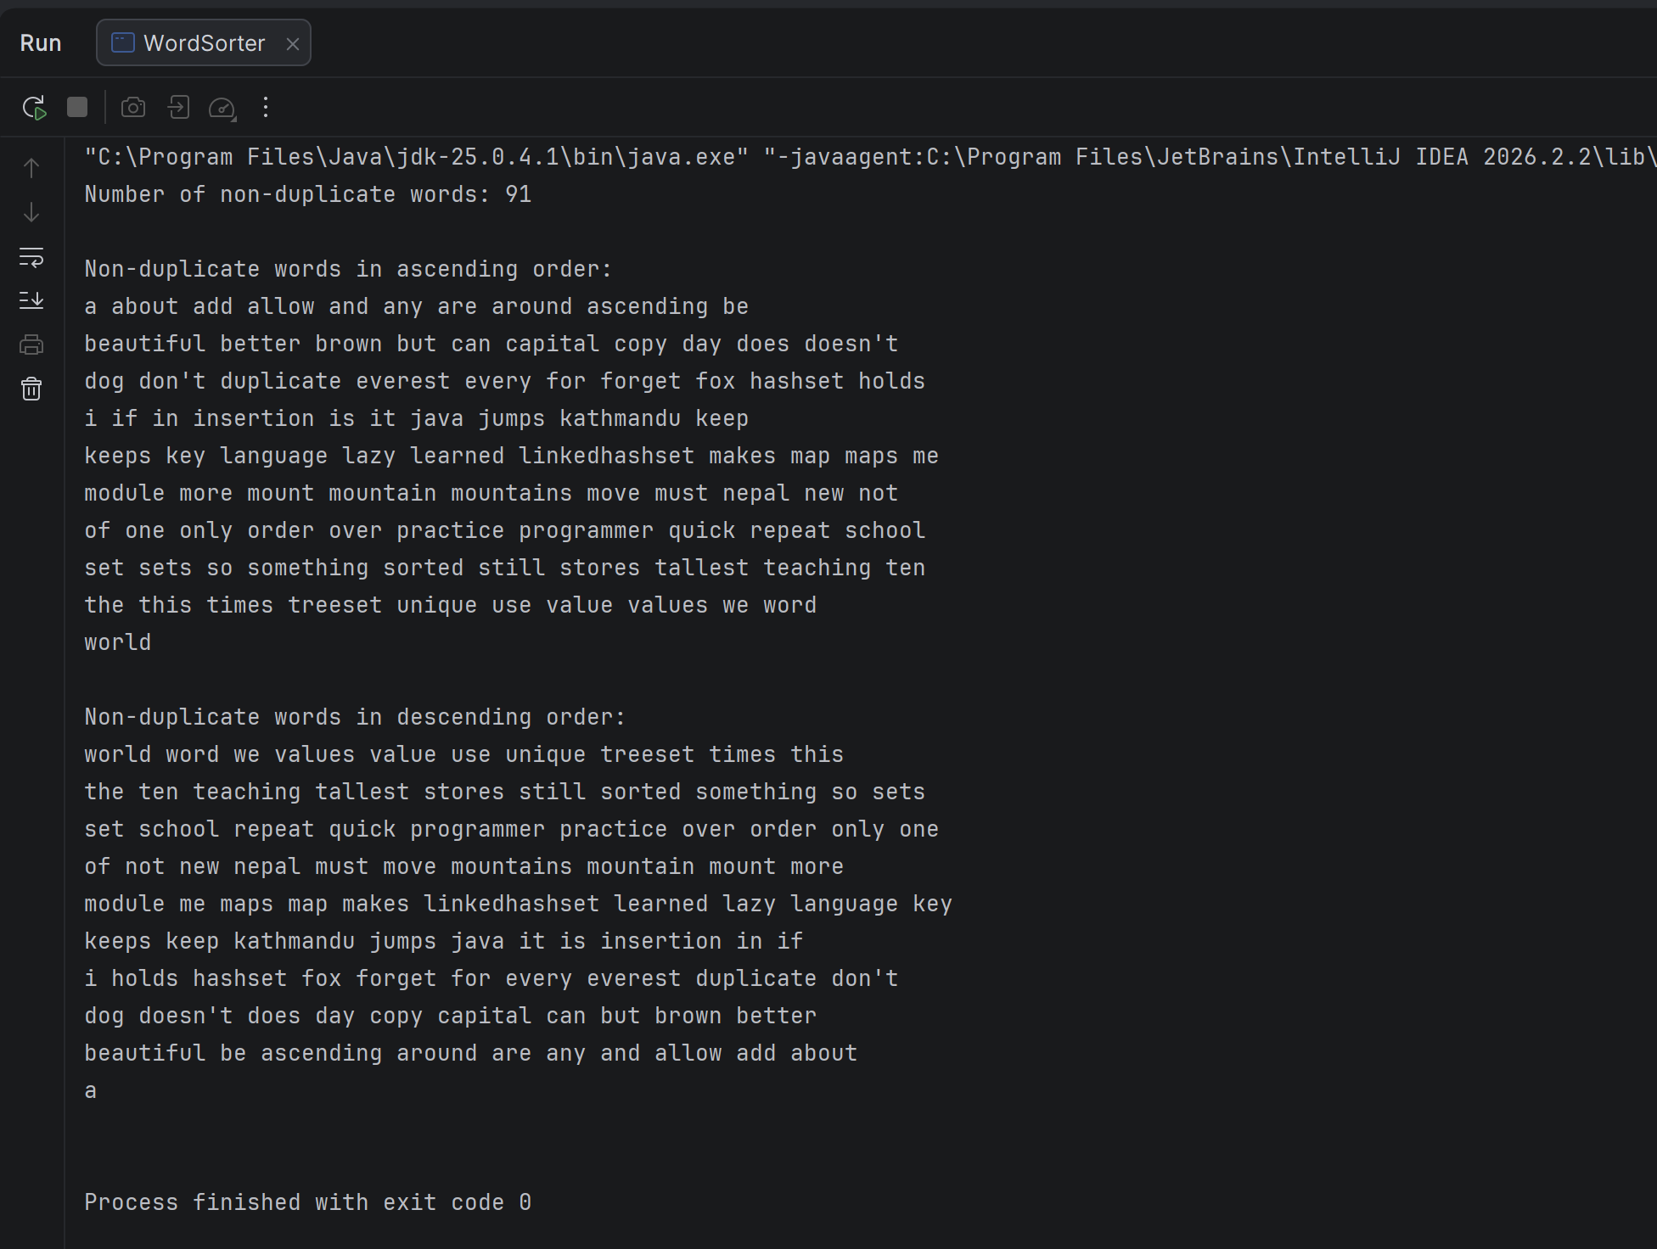
Figure 3. WordSorter output showing the 91 non-duplicate words in ascending order and then in descending order.

3. WordSorterTest Results
All ten tests pass. One of the tests asks for a file that does not exist to confirm that the program handles that error instead of crashing.

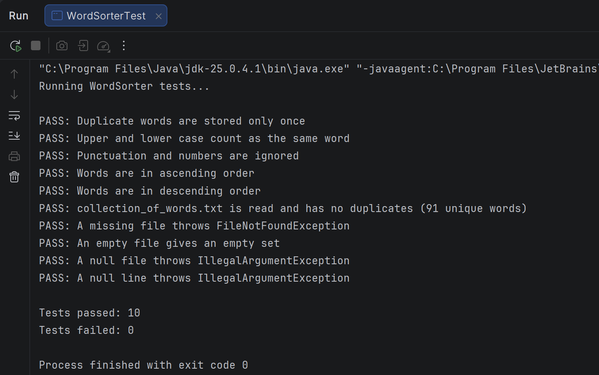
Figure 4. WordSorterTest results showing all 10 tests passed and 0 failed.
I also ran WordSorter once without collection_of_words.txt in the project folder to check the error handling. The program did not crash. It printed a clear error message to the console, and the Logger recorded the FileNotFoundException with its details.
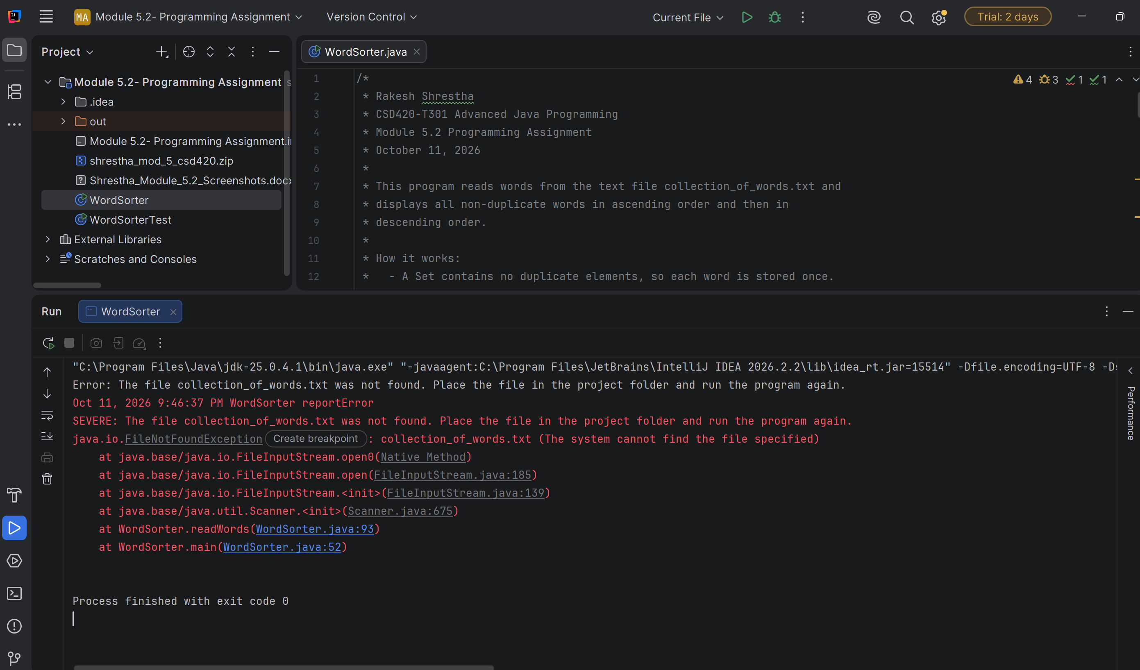
Figure 5. Error handling when collection_of_words.txt is missing: the message is printed to the console and the exception is logged.

4. GitHub Repository
The code, the word file, and this document were pushed to my CSD-420 repository in the module-5 folder.
GitHub repository: https://github.com/RockyShrestha/csd-420
---
Figure 6. Module 5.2 files pushed to the csd-420 GitHub repository.

References
Liang, Y. D. (2024). Introduction to Java programming and data structures (13th ed.). Pearson.

