Rakesh Shrestha
CSD420-T301 Advanced Java Programming
Professor Tedi Pano
Module 6.2 Programming Assignment
October 18, 2026
Generic Bubble Sort with Comparable and Comparator
For this assignment I wrote ShresthaBubbleSort.java, which has two generic bubble sort methods. The first method sorts by natural order using the Comparable interface, and the second sorts by any order that a Comparator defines. Both methods share the same swap and validation helpers, and each one stops early when a pass makes no swaps. The main method runs 18 tests using Integers, Strings, Doubles, and a custom Student class, plus edge cases and invalid input. Each result is checked against Arrays.sort so the program reports PASS or FAIL for every test.
GitHub repository: https://github.com/RockyShrestha/csd-420

Screenshot 1: Java installed
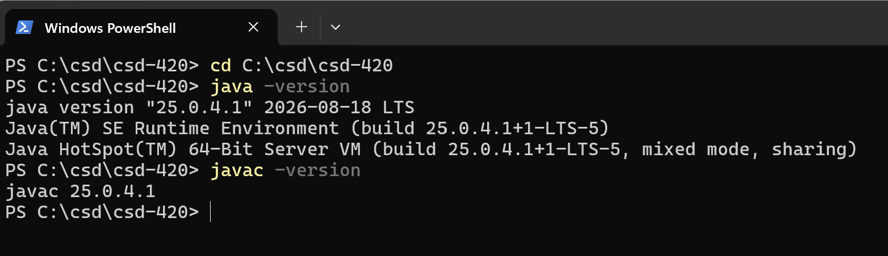

Screenshot 2: JavaFX configured in IntelliJ IDEA

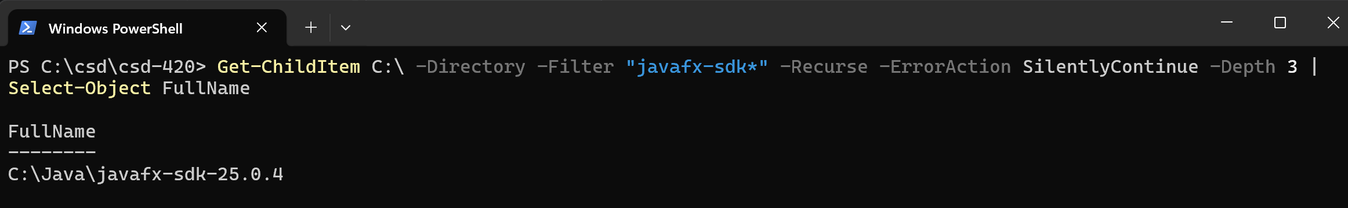
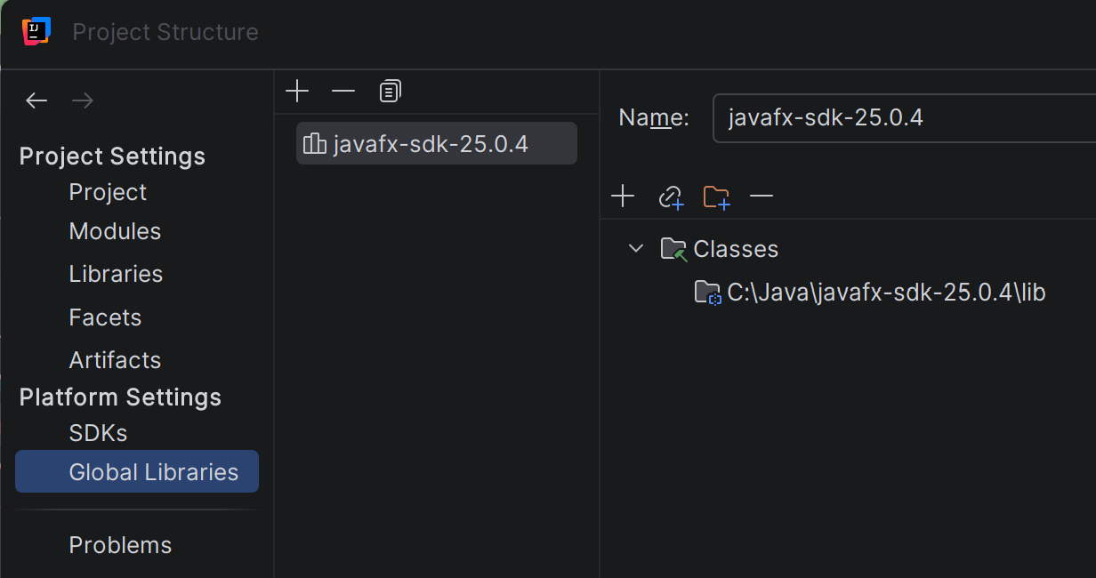

Screenshot 3: Program output, first half

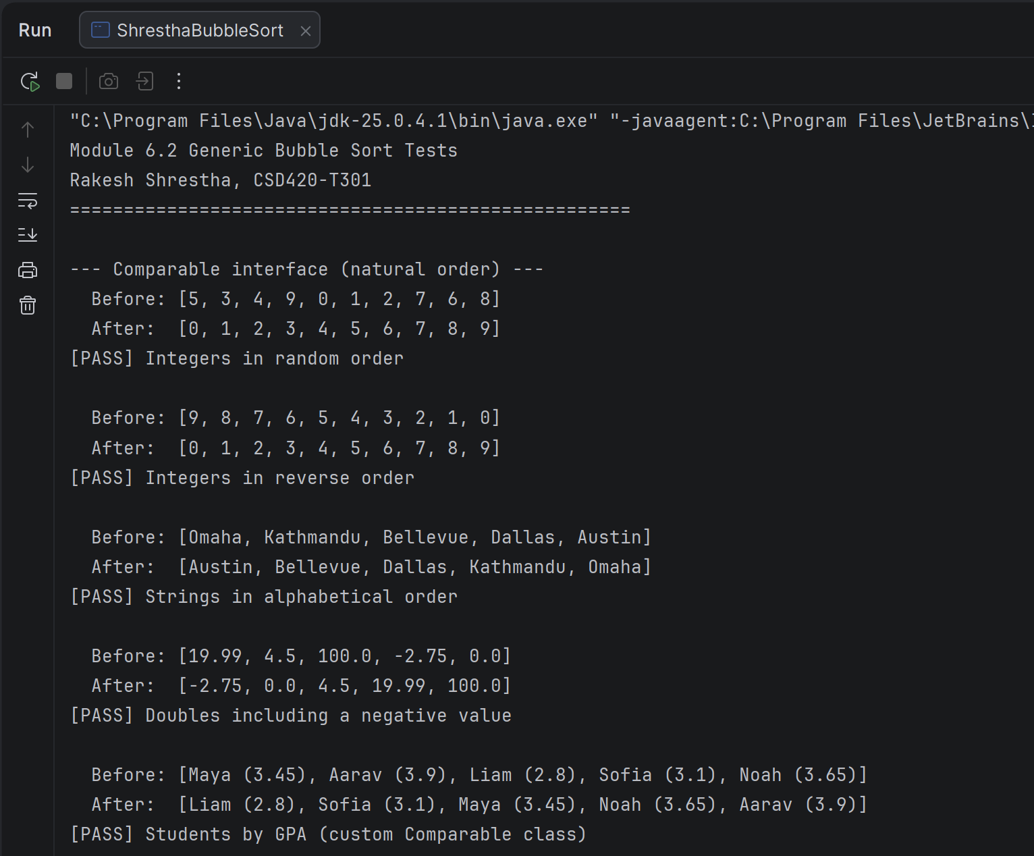

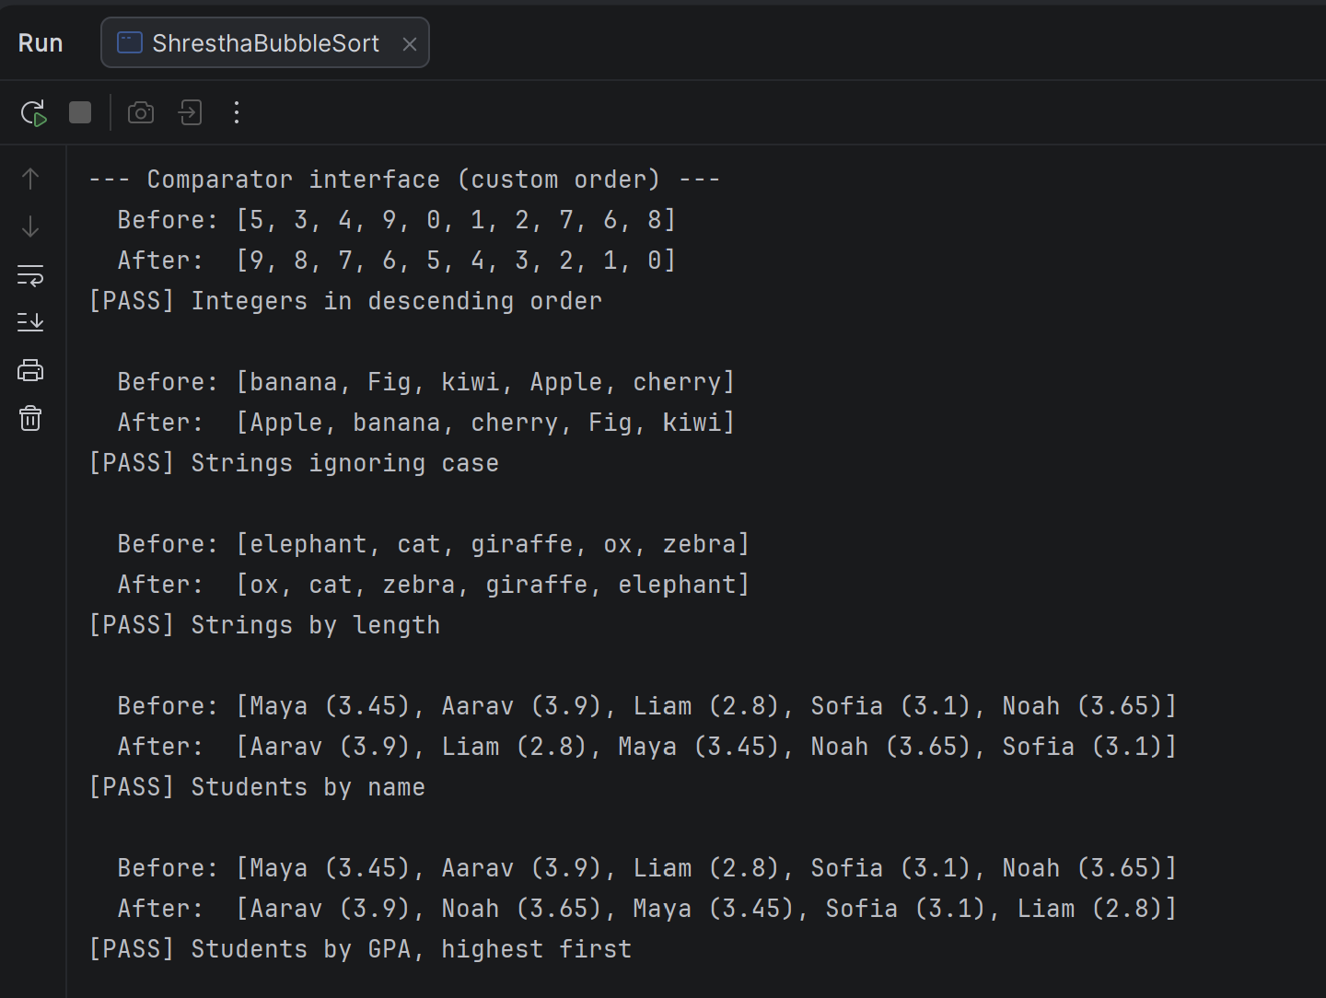

Screenshot 4: Program output, second half

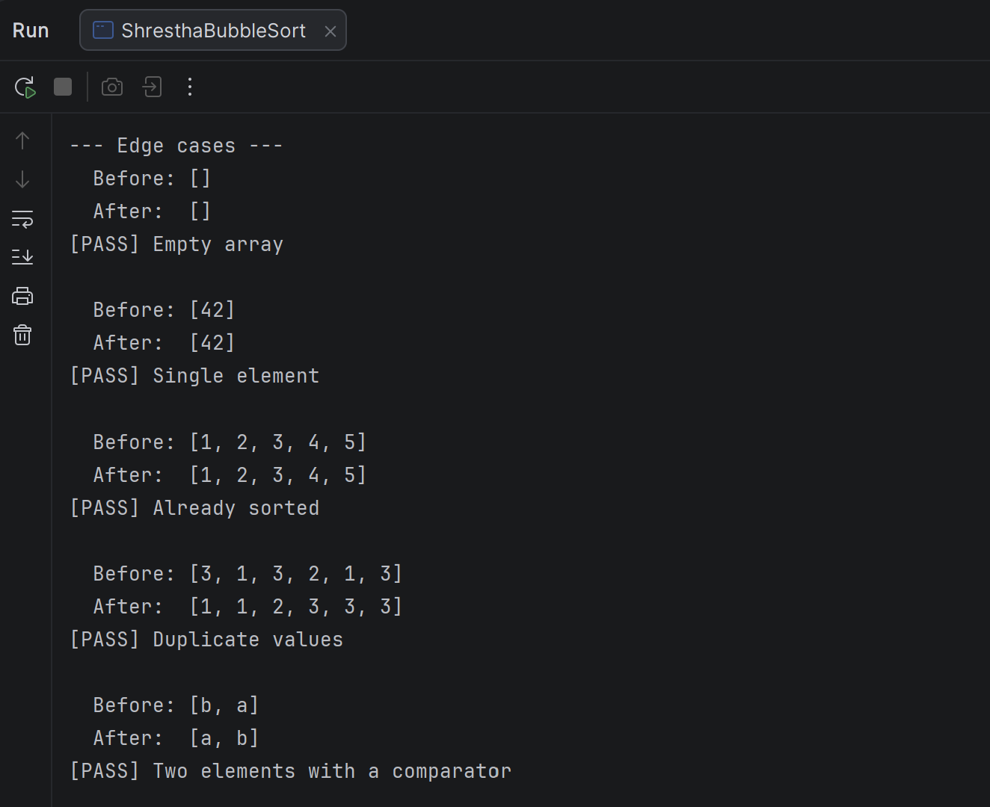

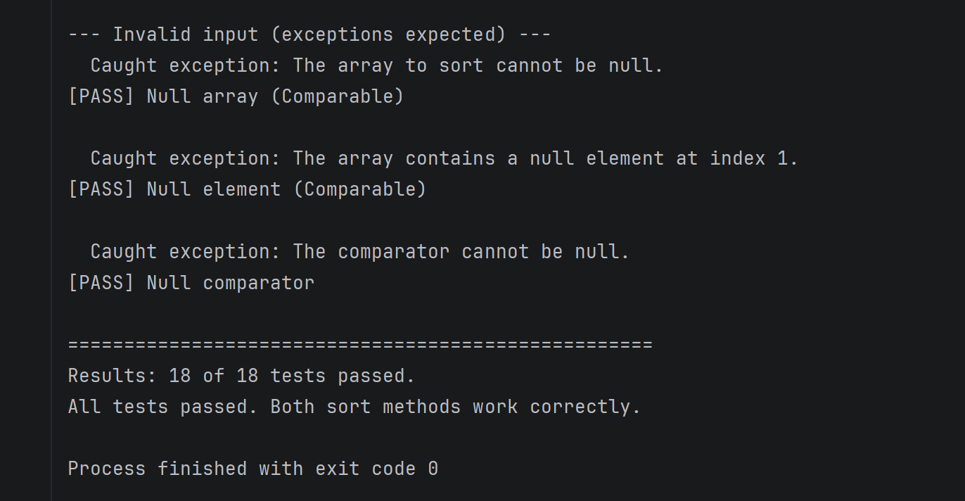

Screenshot 5: Code pushed to GitHub

