Rakesh Shrestha
Module 1.2 Assignment GitHub
September 13, 2026

GitHub Repository:
https://github.com/RockyShrestha/csd-420

Local Directory Screenshot
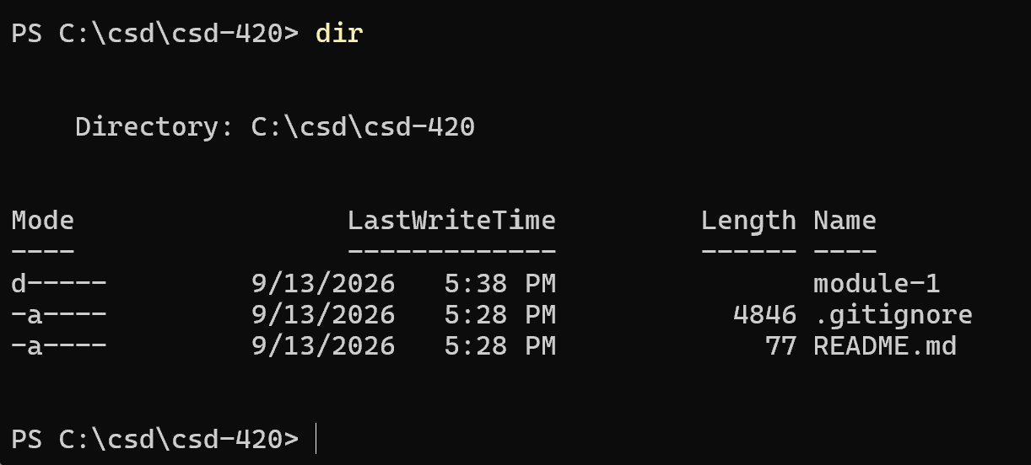

Git Configuration
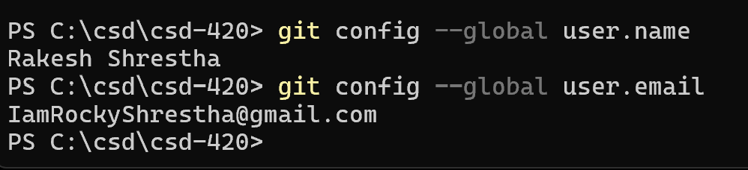

GitHub Repository Screenshot
