Rakesh Shrestha
CSD420-T301 Advanced Java Programming
Professor Tedi Pano | September 27, 2026
Module 3.2 Programming Assignment: Generic removeDuplicates Method
GitHub repository: https://github.com/RockyShrestha/csd-420 (folder: module-3)

Program Summary
RemoveDuplicatesTest.java fills an ArrayList with 50 random integers from 1 to 20 and passes it to the generic method public static <E> ArrayList<E> removeDuplicates(ArrayList<E> list). The method returns a new ArrayList that holds every distinct value once, in the order each value first appeared, and it leaves the original list untouched. It uses a LinkedHashSet, which rejects repeated values and keeps insertion order, so the work is done in a single pass. After the call, the program checks its own result: the original list must still hold 50 unchanged values, the new list must contain no repeats, and no value may be lost or added. A second test with a short list of Strings shows the method works with any type, not only Integer.
For error handling, removeDuplicates rejects a null list with an IllegalArgumentException, and createRandomList validates its size, range, and Random arguments. A third test passes a null list, a reversed range, and a negative size on purpose, and each exception is caught, printed to the console, and written to removeDuplicates.log using java.util.logging. The log file is recreated on each run so it always matches the console output, and it is closed properly when the program ends. If a verification check ever fails, the program reports it on the console and saves the full stack trace to the log.

Screenshot 1: Java Installation
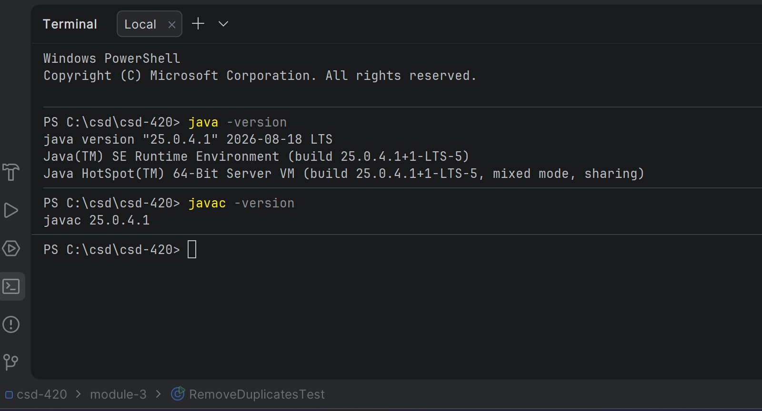

Screenshot 2: JavaFX Configuration
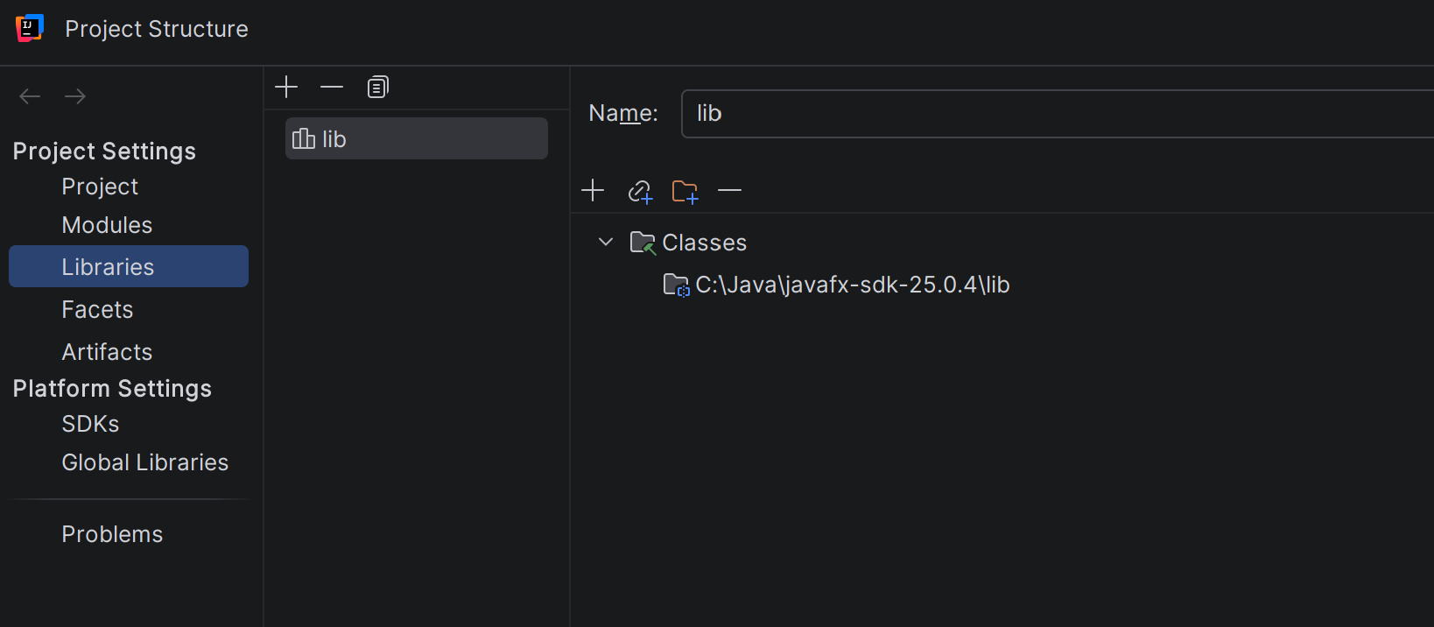

Screenshot 3: Program Output
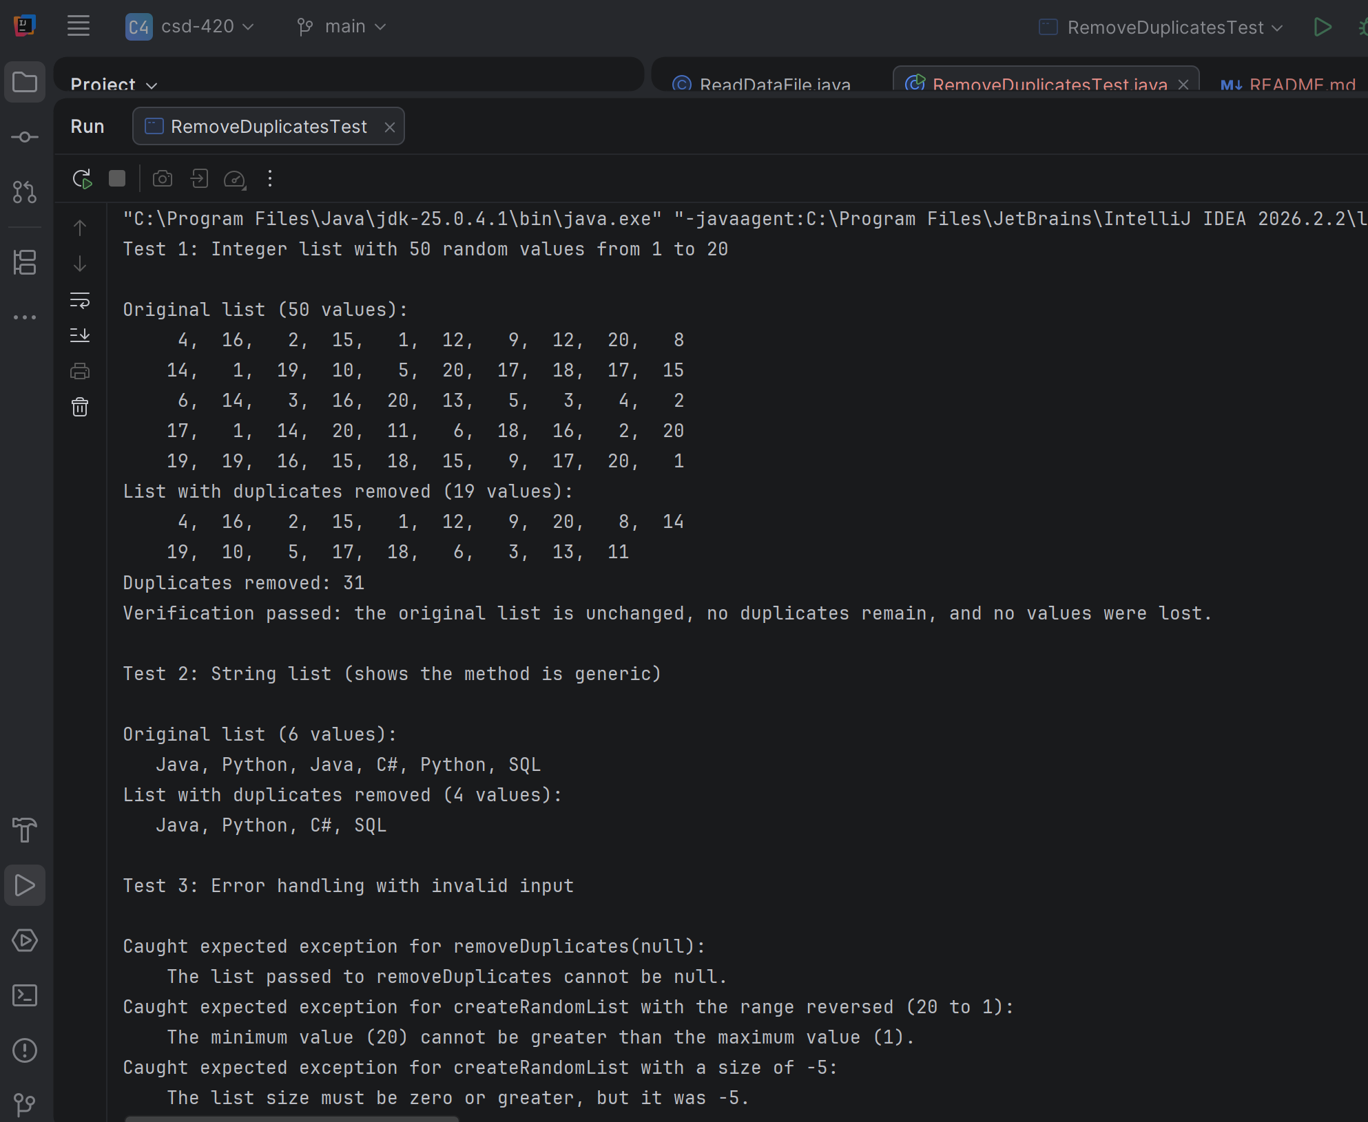
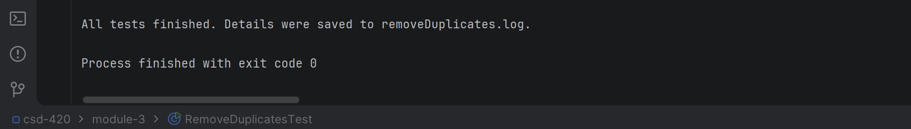

Screenshot 4: Log File
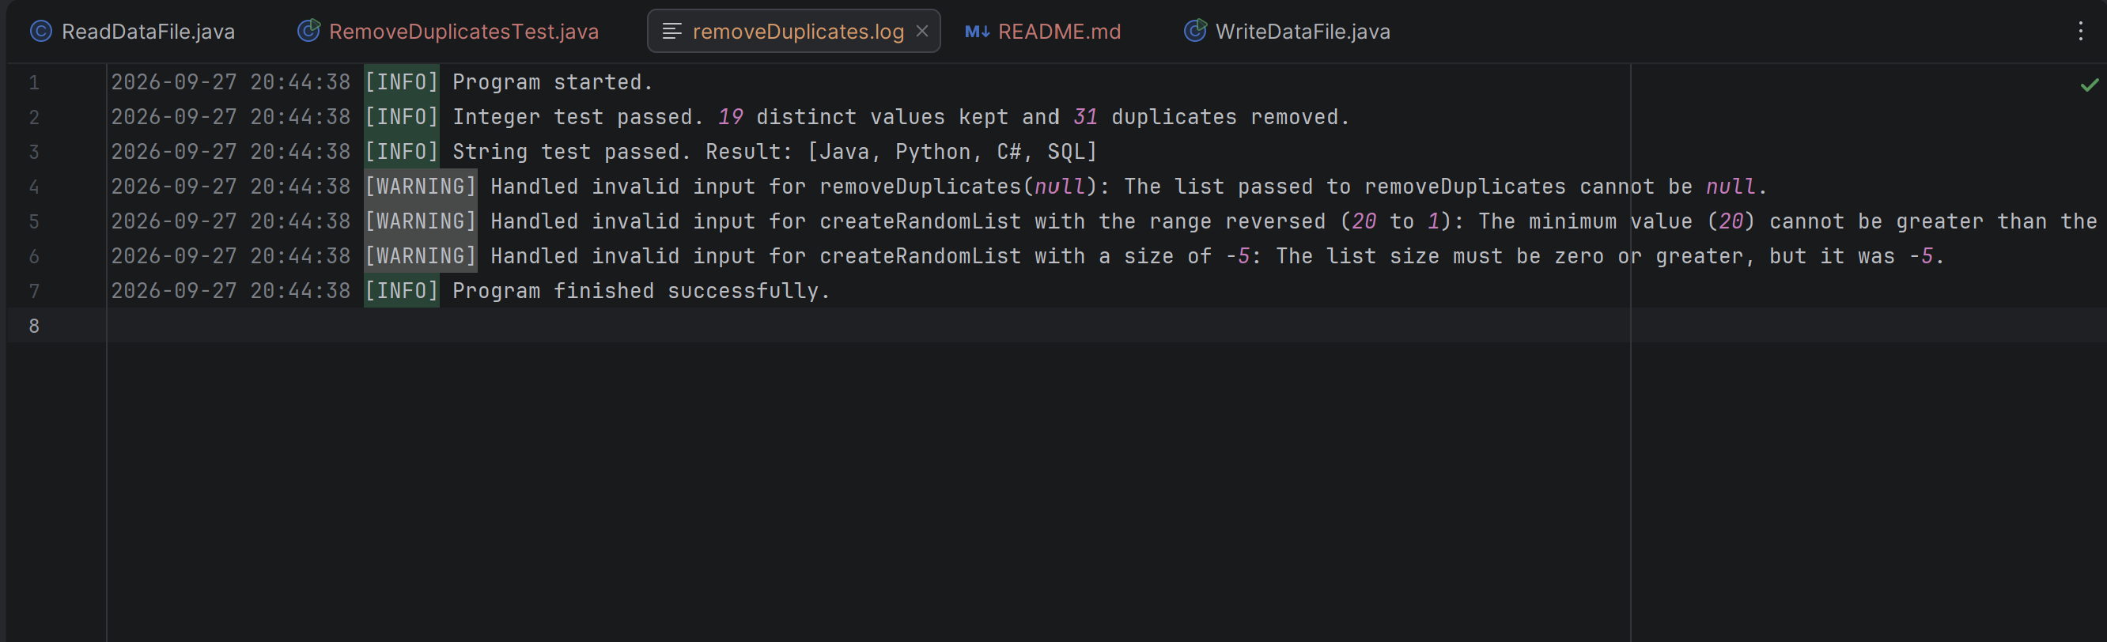

Screenshot 5: GitHub Repository

References
Liang, Y. D. (2024). Introduction to Java programming and data structures (13th ed.). Pearson.
Oracle. (n.d.-a). Java logging overview. https://docs.oracle.com/en/java/javase/21/core/java-logging-overview.html
Oracle. (n.d.-b). The Java tutorials: Generics. https://docs.oracle.com/javase/tutorial/java/generics/index.html
Payne, D. (n.d.). Module 3 generics examples [Source code]. Bellevue University.

