Rakesh Shrestha
CSD420-T301 Advanced Java Programming
Module 7.2 Programming Assignment
October 25, 2026

1. Java Installed
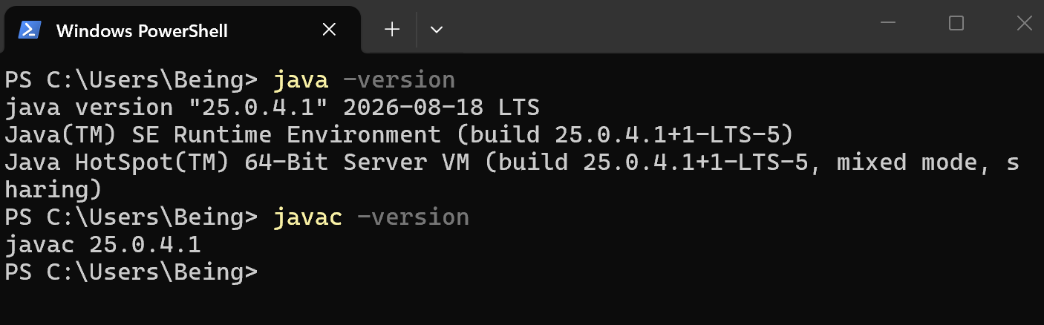
2. JavaFX Configured
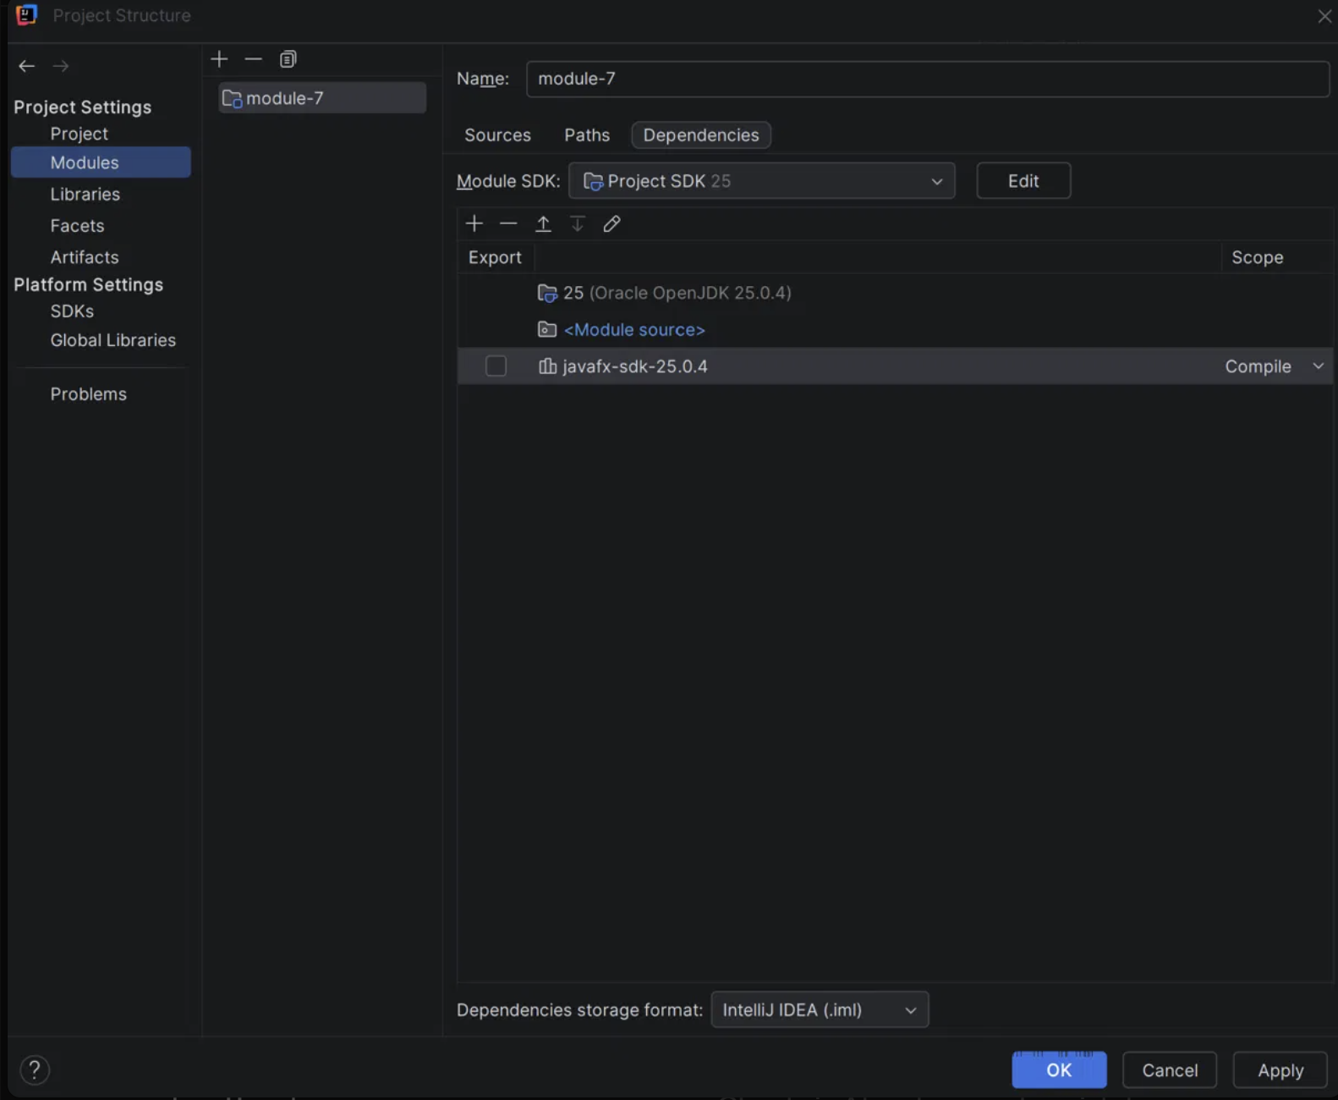
3. ShresthaStyledCircles Output
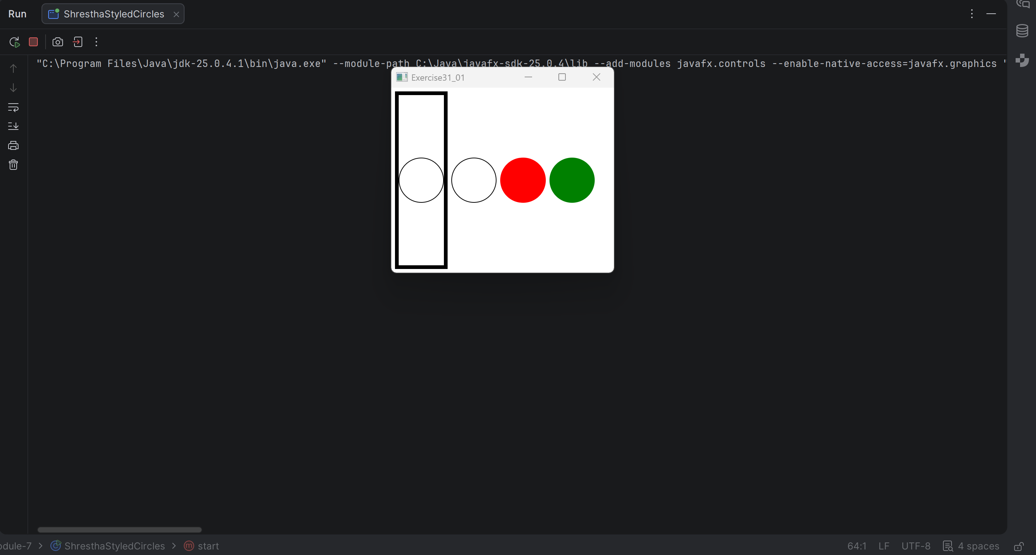
4. ShresthaStyledCirclesTest Output
