Rakesh Shrestha
CSD-420 Advanced Java Programming
Module 4.2 Programming Assignment
October 4, 2026
GitHub repository: https://github.com/RockyShrestha/csd-420

Overview
This assignment stores integers in a LinkedList and compares the time it takes to traverse the list with an Iterator against the time it takes with the get(index) method. The program is tested with 50,000 integers and then with 500,000 integers. It follows Section 20.3 (Iterators) and Section 20.5.2 (The ArrayList and LinkedList Classes) of the textbook, along with Professor Payne's Example_13.java and Example_15.java. The submission has two files: LinkedListTraversalTimer.java, which runs the timing test and contains the results discussion in its comments, and LinkedListTraversalTimerTest.java, which checks that the code works correctly.

Screenshot 1: Java and JavaFX Configuration
The java -version command shows Java SE 25.0.4.1 (LTS) is installed. The where.exe search shows the JavaFX SDK 25.0.4 is installed at C:\Java\javafx-sdk-25.0.4\lib. This assignment does not use JavaFX, since it only needs java.util.LinkedList and java.util.Iterator, but the JavaFX SDK is installed and available.
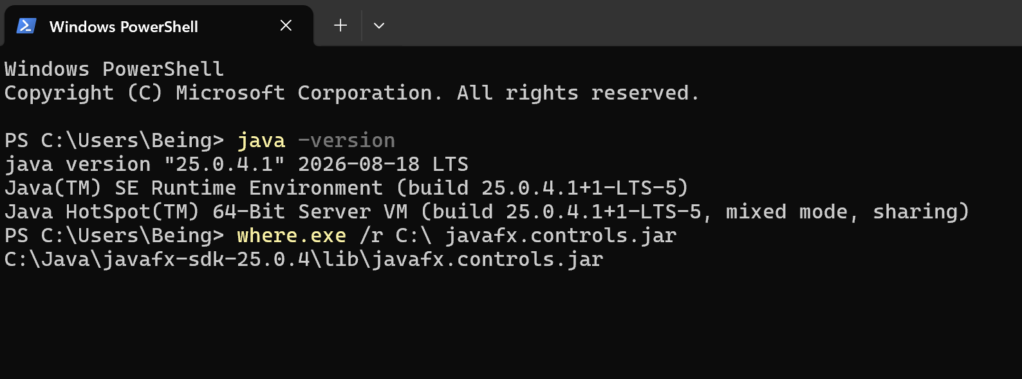

Screenshot 2: Timing Program Output (50,000 and 500,000 Integers)
LinkedListTraversalTimer builds the list, adds up every element with an Iterator using hasNext() and next() (Section 20.3, Example_13), and then adds up every element again with a for loop that calls get(index). Both sums match, which shows both loops visited the same values.
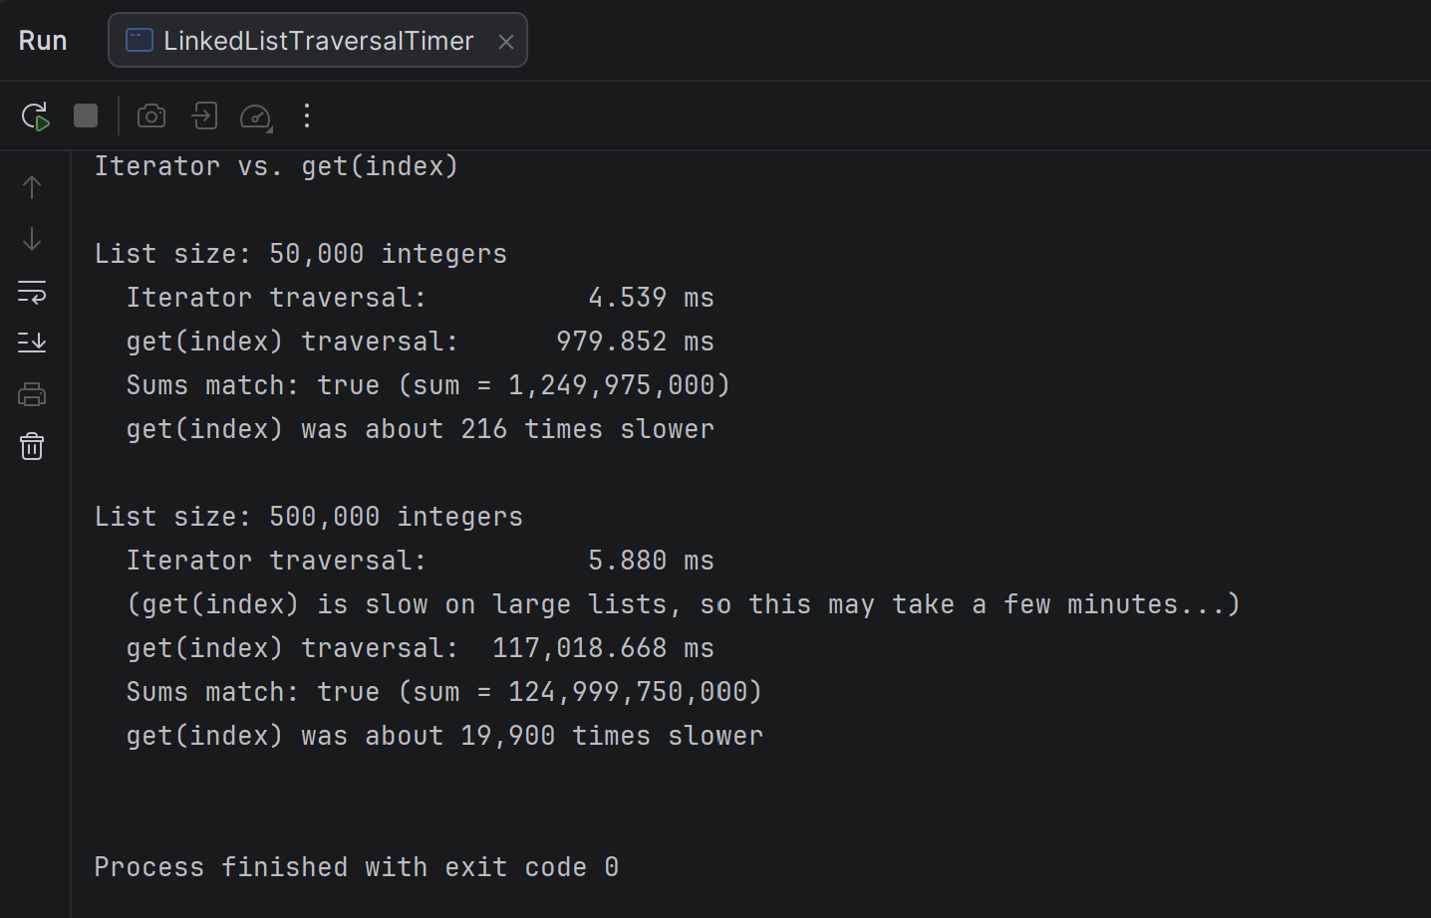

Size | Iterator | get(index) | get(index) vs. Iterator
50,000 | 4.5 ms | 980 ms (about 1 second) | about 216 times slower
500,000 | 5.9 ms | 117,019 ms (about 2 minutes) | about 19,900 times slower

The Iterator stayed under 10 milliseconds for both sizes because each call to next() moves only one node forward, so the traversal is O(n). The get(index) loop was much slower. Section 20.5.2 explains that a LinkedList stores elements in nodes, so every get(i) call has to walk from the closest end of the list to reach the index. Calling it for every index makes the traversal O(n^2). When the list grew 10 times larger, the get(index) time grew about 119 times, close to the 100 times that O(n^2) predicts, and the gap between the two methods grew from about 216 times to about 19,900 times. This matches the textbook's warning that using get(i) to traverse a linked list is very inefficient and that an Iterator or foreach loop should be used instead.

Screenshot 3: Test Code Output
LinkedListTraversalTimerTest checks that buildList() creates the correct number of elements in order, that both traversal methods return the correct sum for small lists and for 50,000 and 500,000 integers, that an empty list works, and that a negative size throws an IllegalArgumentException. All 9 tests passed.
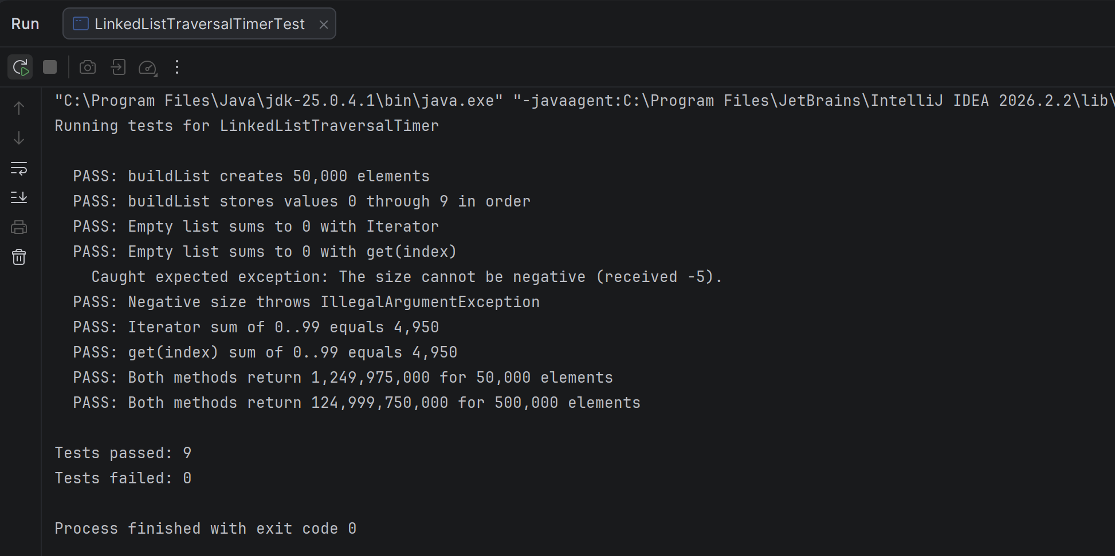

Screenshot 4: GitHub Repository
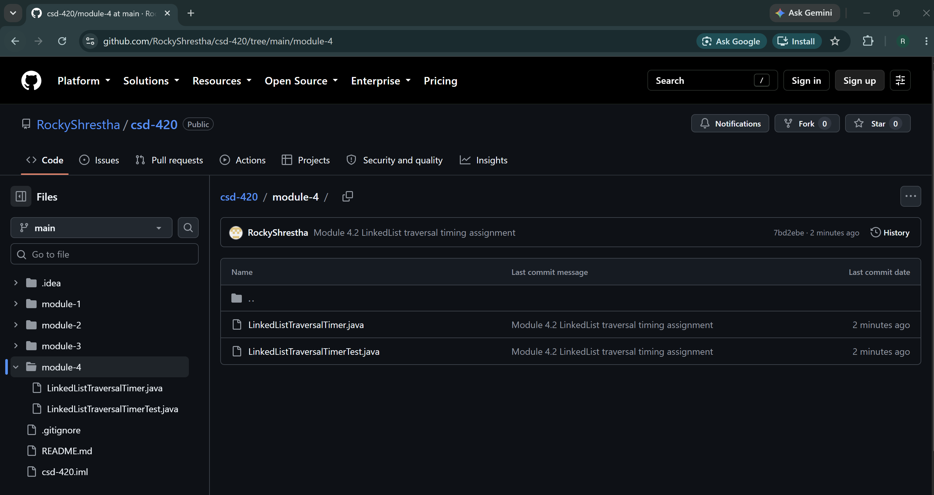

References
Liang, Y. D. (2024). Introduction to Java programming and data structures (13th ed.). Pearson. Chapter 20, Sections 20.3, 20.4, and 20.5.2.
Payne, D. (n.d.). Module 4 examples: Example_13.java and Example_15.java [Course materials]. Bellevue University.
Oracle. (n.d.). LinkedList (Java SE 25 & JDK 25). https://docs.oracle.com/en/java/javase/25/docs/api/java.base/java/util/LinkedList.html

