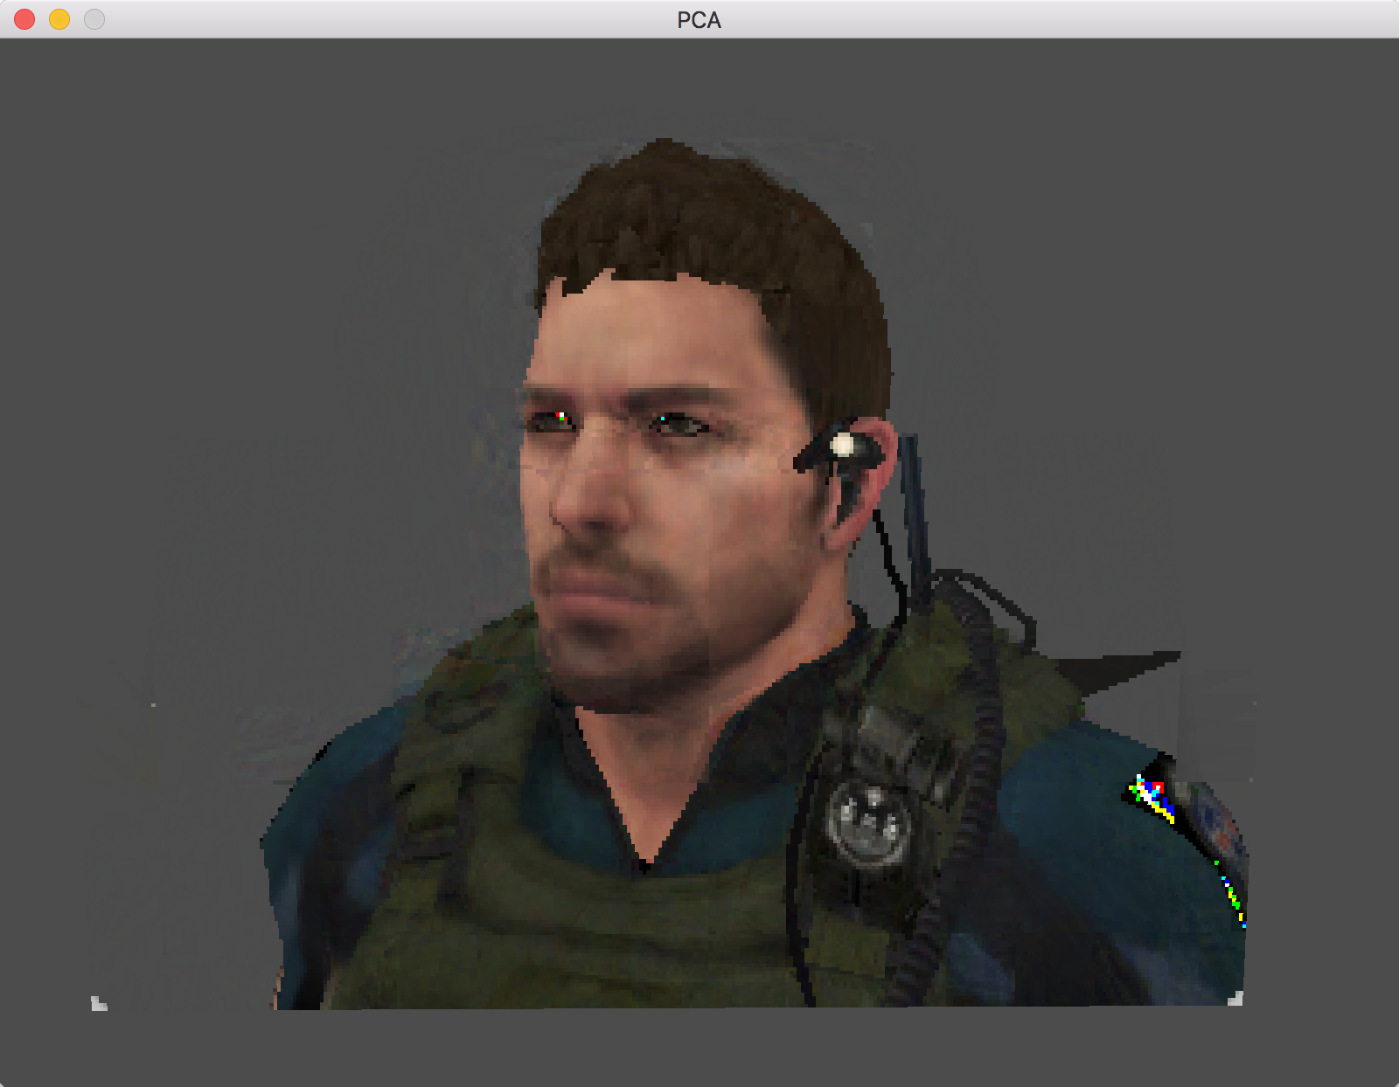

Figure 1 Using 15 eigenTextures

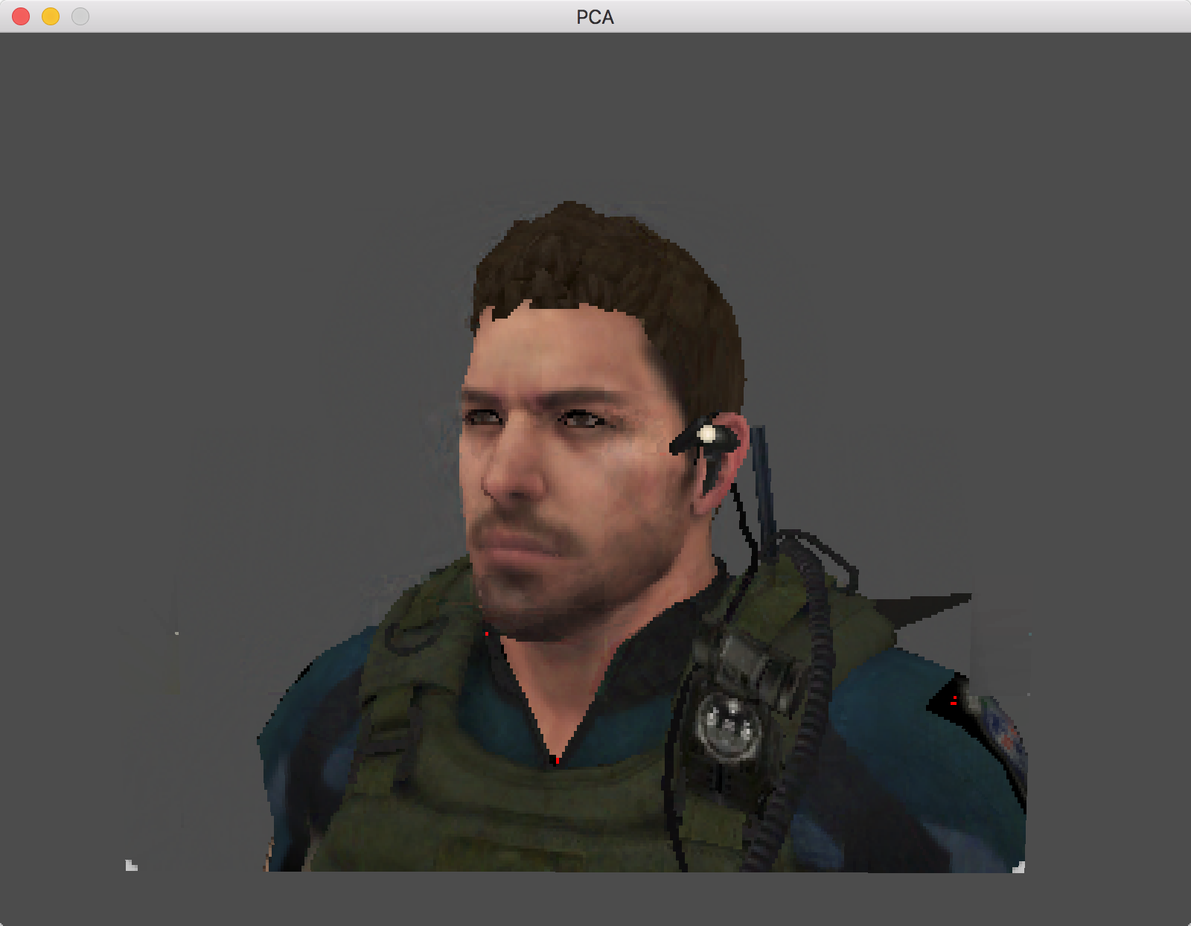

Figure 2 Using 20 eigenTextures

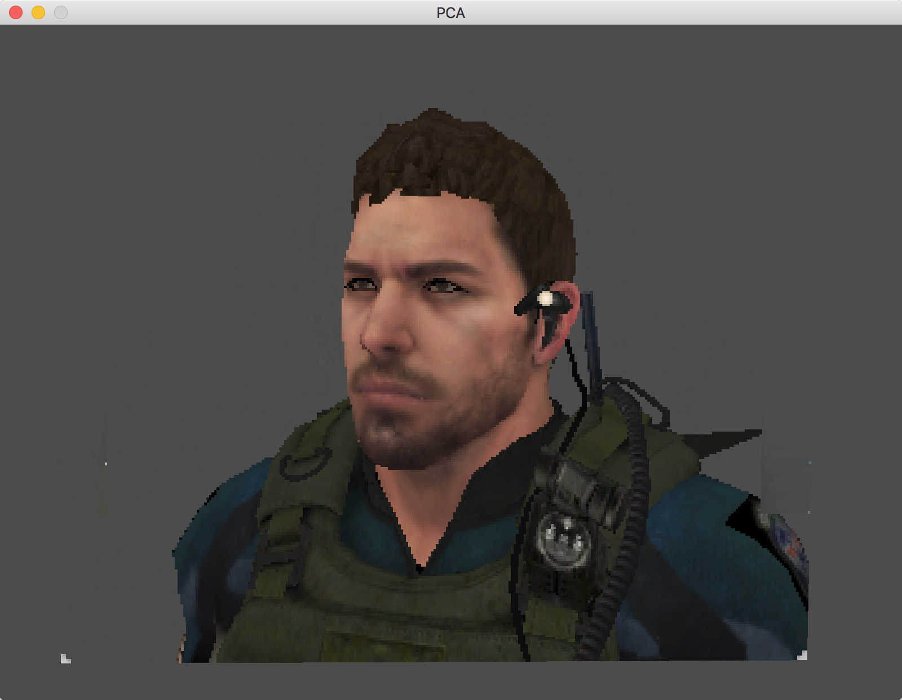

Figure 3 Using 30 eigenTextures

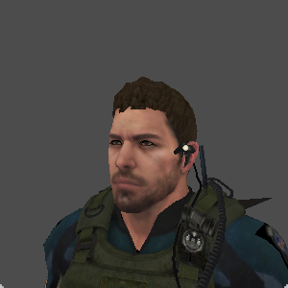

Figure 4 Original image

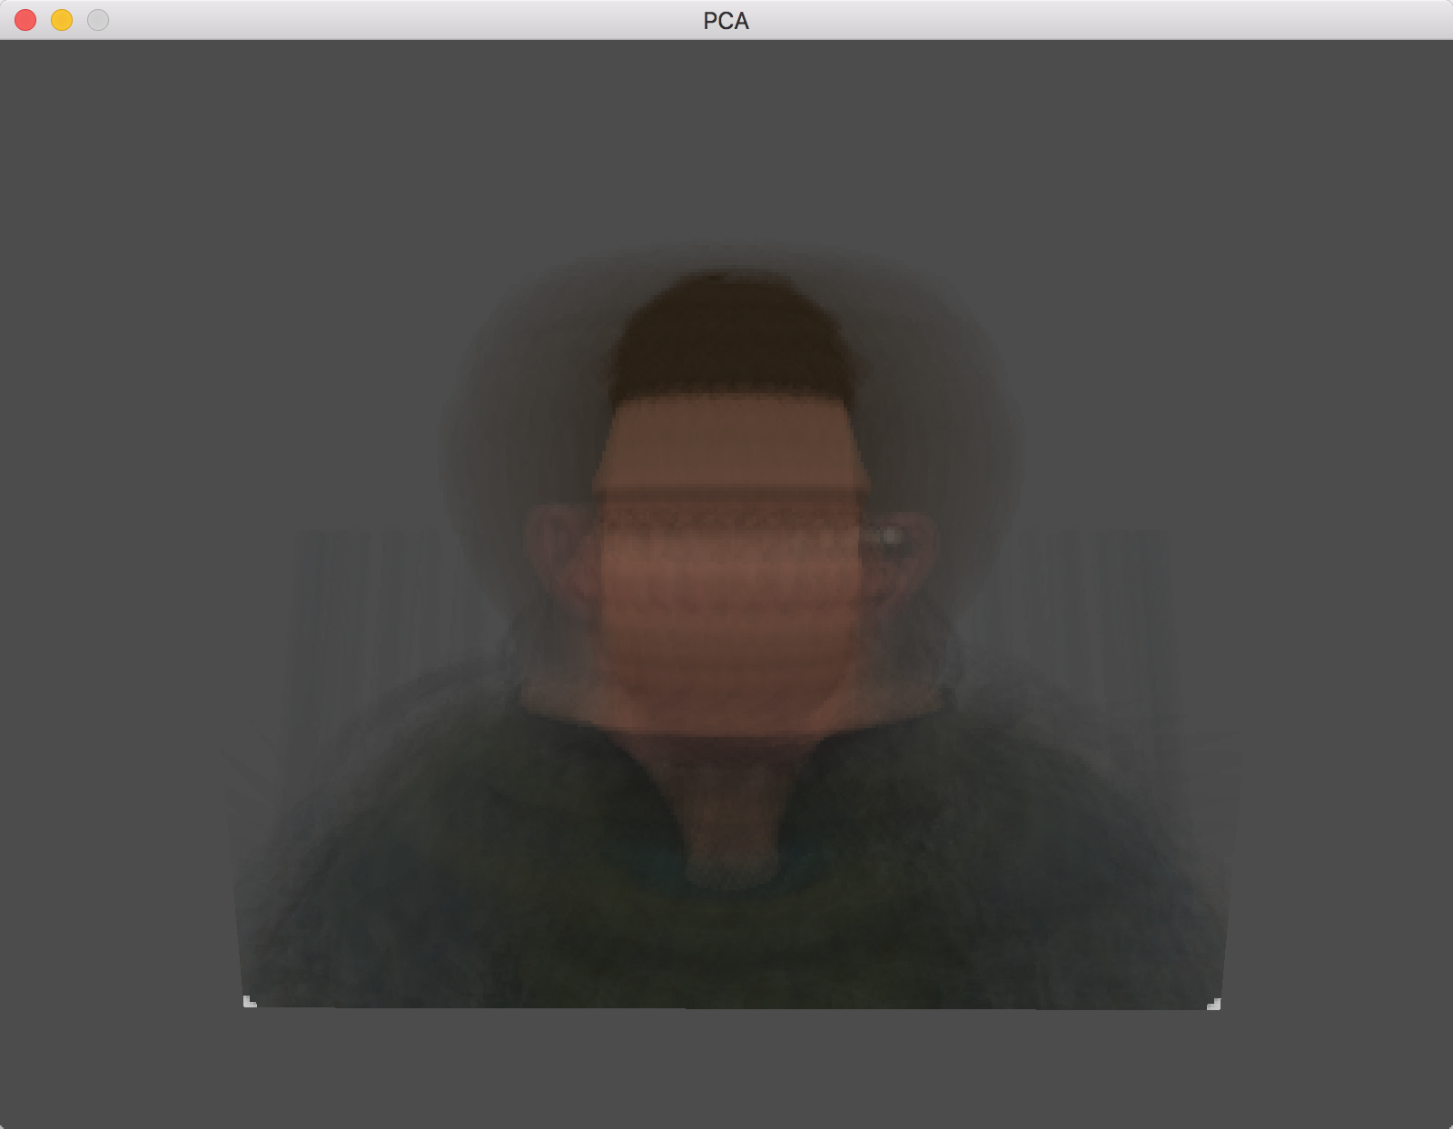

Figure 5 Mean image