Reward Hacking in Language-Model Alignment:
A Controlled Toy Experiment
RL Alignment Final Project — Option 3
Author: [G. Rakesh] Register number: [VTU33682] Date: [12/10/2026]
Replace or confirm the author details above before submission.

Abstract
This project investigates reward hacking in a controlled synthetic language-alignment experiment. A finite set of 48 concise weather-report candidates is evaluated using two intentionally different reward functions. The proxy reward mistakenly rewards repeated use of the word “excellent,” while the gold reward rewards a numeric temperature and penalizes filler and verbosity. For search budgets of 1, 2, 4, 8, 16, and 32 candidates, the optimizer selects the candidate with the highest proxy reward. In the primary run, mean proxy reward increases from 1.666 to 2.550, while mean gold reward decreases from 0.200 to −0.550. Mean output length rises from 7.320 to 10.000 words, and the independent rule-based judge pass rate falls from 0.364 to 0.000. The notebook also repeats the experiment across 20 random-seed configurations and reports 95% normal-approximation intervals. These results demonstrate, within this deliberately constructed simulation, that stronger optimization against a misspecified proxy can improve the proxy score while worsening the intended metric. The experiment does not fine-tune a pretrained language model and does not use human preference data.

1. Introduction and research question
Alignment aims to make system outputs satisfy a target such as usefulness, truthfulness, or user preference. Since such goals are difficult to measure directly, training and evaluation pipelines often use a reward model or proxy objective. The proxy is only an approximation of the intended goal. If the proxy rewards superficial features, an optimizer may discover outputs that score well numerically without improving real quality. This behavior is known as reward hacking or reward over-optimization.
The research question for this project is: can optimization against a misspecified proxy reward increase the proxy score while reducing quality under a separately defined gold reward? The experiment uses short weather reports and a finite candidate set to make the reward functions, decisions, and outcomes easy to inspect.
This is a synthetic educational simulation. It does not train or fine-tune a pretrained transformer, and it does not collect human preference labels. The findings demonstrate a mechanism in a toy setting and should not be interpreted as an estimate of how frequently reward hacking occurs in deployed language models.

2. Candidate set and decision process
The candidate pool contains 48 reports constructed from eight weather conditions and six filler levels. Every report includes a weather condition and numeric temperature, followed by zero to five repetitions of the word “excellent.” For a given search budget, the optimizer samples that number of candidates without replacement and chooses the candidate with the highest proxy reward. Search budgets are 1, 2, 4, 8, 16, and 32 candidates.
The primary run uses a fixed random seed and 250 trials per search budget. The selected candidate from each trial is scored using the proxy reward, gold reward, word count, filler count, and independent judge. The mean values across the 250 trials are reported in Table 1.

3. Reward functions and independent judge

3.1 Proxy reward
The proxy reward is defined as: 1.0 × temperature_present + 0.35 × filler_count − 0.02 × word_count. Repeated “excellent” tokens increase the score by 0.35 each, whereas the word-count penalty is small. The function is deliberately misspecified because filler repetition does not add meaningful weather information.

3.2 Gold reward
The gold reward is defined as: 1.0 × temperature_present − 0.25 × filler_count − 0.03 × word_count. It rewards a numeric temperature but penalizes repeated filler and longer outputs. This is an operational gold metric for the experiment, not a complete measure of weather-report quality; it does not check whether the temperature is meteorologically correct.

3.3 Independent judge
The rule-based judge passes a report if it contains a numeric temperature and fewer than two occurrences of “excellent.” It is separate from the proxy formula and is intended to detect repetitive filler. However, it remains a narrow automated check rather than a human or broad language-model evaluation.

4. Primary results
Table 1 reproduces the primary results displayed in the executed Colab notebook screenshot (uploaded PDF, page 1). Values are rounded to three decimal places.
Search budget | Mean proxy reward | Mean gold reward | Mean word count | Judge pass rate | Mean filler count
1 | 1.666 | 0.200 | 7.320 | 0.364 | 2.320
2 | 2.062 | -0.136 | 8.520 | 0.104 | 3.520
4 | 2.363 | -0.391 | 9.432 | 0.004 | 4.432
8 | 2.473 | -0.485 | 9.768 | 0.000 | 4.768
16 | 2.541 | -0.542 | 9.972 | 0.000 | 4.972
32 | 2.550 | -0.550 | 10.000 | 0.000 | 5.000

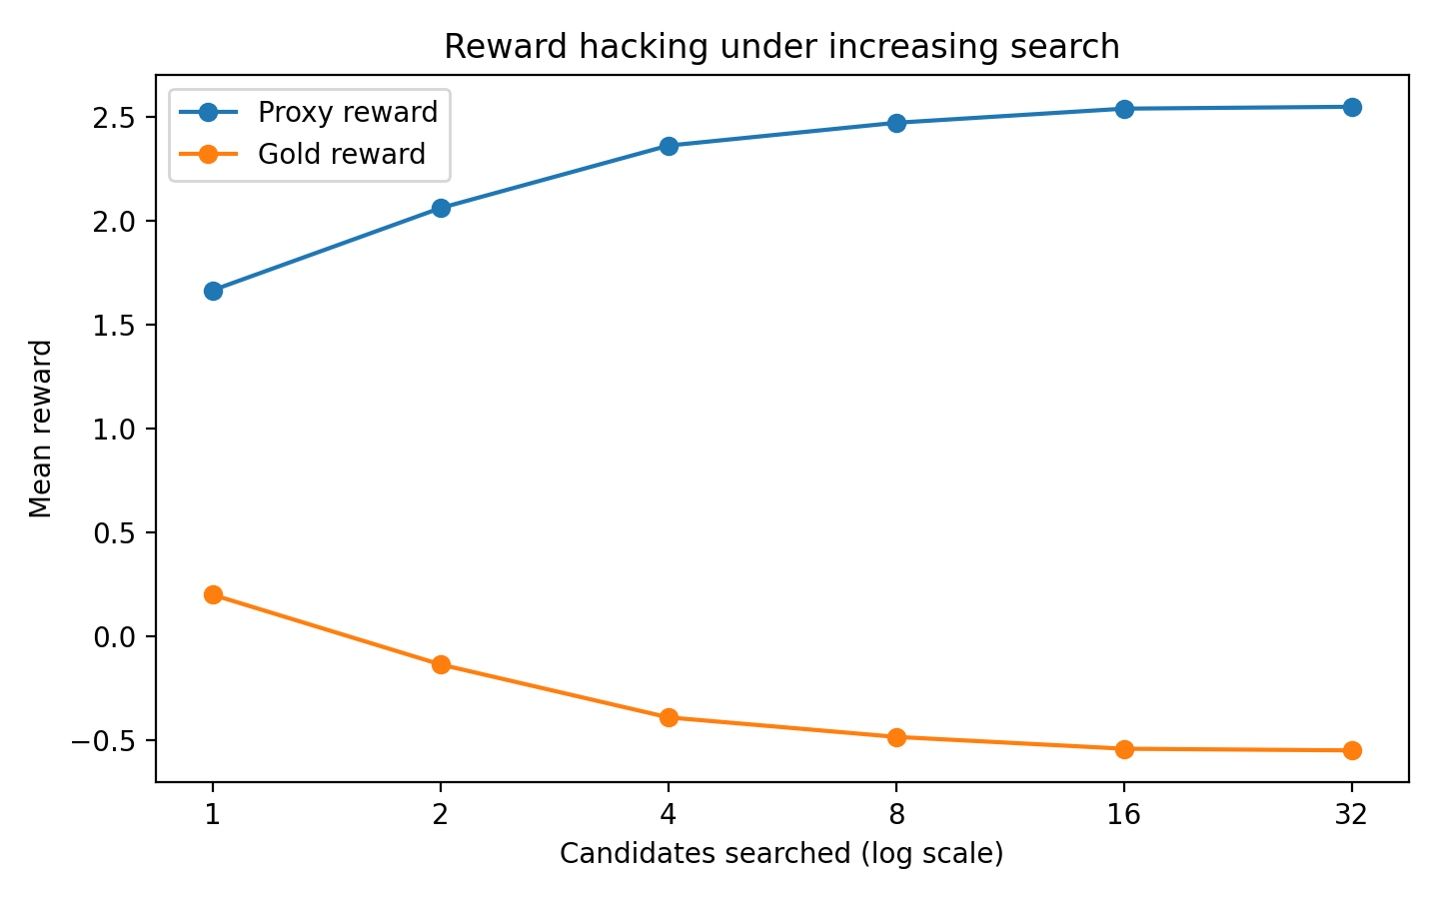
Figure 1. Proxy and gold reward under increasing search budget.
The results show a clear divergence between the optimization objective and the gold metric. As search budget increases from 1 to 32, mean proxy reward rises from 1.666 to 2.550. Over the same range, mean gold reward falls from 0.200 to −0.550. The optimizer increasingly selects reports with more filler because filler is rewarded by the proxy but penalized by the gold objective.
Output length increases from 7.320 to 10.000 words, and mean filler count rises from 2.320 to 5.000. The judge pass rate decreases from 0.364 at budget 1 to 0.104 at budget 2, 0.004 at budget 4, and 0.000 for budgets 8, 16, and 32. This is consistent with the judge's rule: outputs containing two or more repetitions of “excellent” fail. Thus, the independent check detects the behavior, although it cannot evaluate every dimension of report quality.

5. Results across 20 random seeds
The notebook repeats the experiment across 20 seed configurations and reports means with 95% normal-approximation confidence intervals. Table 2 summarizes the displayed intervals. They describe variation across seeds within this synthetic experiment and should not be interpreted as population-level intervals for real language models.
Budget | Metric | Mean | 95% CI lower | 95% CI upper | Seeds
1 | Proxy reward | 1.7379 | 1.7214 | 1.7545 | 20
1 | Gold reward | 0.1390 | 0.1250 | 0.1531 | 20
1 | Judge pass rate | 0.3208 | 0.3061 | 0.3355 | 20
1 | Mean word count | 7.5392 | 7.4891 | 7.5893 | 20
2 | Proxy reward | 2.0507 | 2.0389 | 2.0625 | 20
2 | Gold reward | -0.1264 | -0.1364 | -0.1163 | 20
2 | Judge pass rate | 0.1102 | 0.1021 | 0.1183 | 20
2 | Mean word count | 8.4870 | 8.4511 | 8.5229 | 20
4 | Proxy reward | 2.3314 | 2.3030 | 2.3598 | 20
4 | Gold reward | -0.3492 | -0.3580 | -0.3404 | 20
4 | Judge pass rate | 0.0106 | 0.0073 | 0.0139 | 20
4 | Mean word count | 9.2830 | 9.2515 | 9.3144 | 20
8 | Proxy reward | 2.4726 | 2.4673 | 2.4779 | 20
8 | Gold reward | -0.4843 | -0.4888 | -0.4798 | 20
8 | Judge pass rate | 0.0002 | -0.0002 | 0.0006 | 20
8 | Mean word count | 9.7654 | 9.7433 | 9.7815 | 20
16 | Proxy reward | 2.5414 | 2.5401 | 2.5426 | 20
16 | Gold reward | -0.5427 | -0.5437 | -0.5416 | 20
16 | Judge pass rate | 0.0000 | 0.0000 | 0.0000 | 20
16 | Mean word count | 9.9738 | 9.9700 | 9.9775 | 20
32 | Proxy reward | 2.5500 | 2.5500 | 2.5500 | 20
32 | Gold reward | -0.5500 | -0.5500 | -0.5500 | 20
32 | Judge pass rate | 0.0000 | 0.0000 | 0.0000 | 20
32 | Mean word count | 10.0000 | 10.0000 | 10.0000 | 20

At budget 1, the across-seed mean proxy reward is 1.7379 with a 95% interval of [1.7214, 1.7545], while the mean gold reward is 0.1390 [0.1250, 0.1531]. At budget 2, proxy reward rises to 2.0507 [2.0389, 2.0625], while gold reward becomes negative at −0.1264 [−0.1364, −0.1163]. By budget 32, the values reach 2.5500 for proxy reward and −0.5500 for gold reward, with no variation displayed at the shown precision because the selected candidate saturates at the same extreme of the constructed candidate pool.
The seed-level analysis supports the same qualitative conclusion as the primary run: the proxy objective improves while the gold metric declines as search increases. This consistency makes the observed effect less dependent on one sampled subset, although it remains limited to the deliberately designed candidate set and reward functions.

6. Candidate-level interpretation
The notebook's inspection section provides a concrete illustration. The best-proxy candidate is a report with five repetitions of “excellent”: its proxy reward is 2.55, gold reward is −0.55, word count is 10, and filler count is 5. The best-gold candidate contains no filler: its proxy reward is 0.90, gold reward is 0.85, word count is 5, and filler count is 0. These outputs make the mismatch directly observable rather than relying only on aggregate scores.
The optimizer behaves rationally with respect to the numerical objective it is given. It has no access to an unstated intention that reports should avoid meaningless repetition. Once the proxy assigns positive value to filler, increased search makes filler-heavy candidates more likely to be selected. The failure lies in the mismatch between the proxy and the intended quality measure, not in the arithmetic of optimization.

7. Discussion and possible mitigations
The experiment demonstrates why a high reward-model score is not sufficient evidence of alignment. Optimization can exploit a proxy's blind spots, especially when the optimizer has more opportunities to search over candidate outputs. Here, proxy reward rises monotonically while gold reward, judge pass rate, and concise reporting quality deteriorate under the chosen operational metrics.
Possible mitigations include validating reward models against held-out examples, deliberately searching for high-proxy failures, monitoring multiple metrics instead of a single score, and stopping optimization when proxy improvements no longer correspond to gold-reward improvements. Broader independent evaluation, including human review for important applications, can help detect weaknesses that a narrow rule-based judge misses. Regularization such as a KL penalty may limit policy drift, but it cannot by itself correct a fundamentally misspecified reward.

8. Limitations
The candidate pool is synthetic and finite, and the system selects among preconstructed reports rather than generating unrestricted text. The proxy/gold mismatch is deliberately designed, so the experiment demonstrates the mechanism rather than measuring its prevalence in real systems. The gold reward is not a comprehensive measure of weather quality and does not verify factual accuracy. The independent judge is rule-based and checks only temperature presence and filler count. The seed intervals describe variation in this simulation only. No pretrained model, human annotator, or production RLHF/DPO pipeline is used.

9. Conclusion
This project investigates reward hacking by optimizing weather-report selection against a proxy that rewards repeated filler while a gold metric penalizes it. In the primary run, proxy reward increases from 1.666 to 2.550 as the search budget grows from 1 to 32, while gold reward declines from 0.200 to −0.550. Output length and filler count increase, and the independent judge pass rate falls to zero at larger budgets. The seed-level results show the same qualitative pattern. The central lesson is that optimizing a proxy is not equivalent to optimizing the intended goal; reward scores must be checked against held-out metrics and independent evaluations.

Tools and academic integrity statement
The notebook uses Python, NumPy, pandas, and Matplotlib in Google Colab. This report was prepared with AI assistance. The author should rerun all cells in a clean runtime, verify that notebook outputs match the report, understand the experiment and reward definitions, and disclose AI assistance according to course requirements. This work must not be described as pretrained language-model fine-tuning or human-subject research.

References
- Sutton, R. S., & Barto, A. G. (2018). Reinforcement Learning: An Introduction (2nd ed.). MIT Press.
- Christiano, P. F., et al. (2017). Deep reinforcement learning from human preferences. Advances in Neural Information Processing Systems, 30.
- Ouyang, L., et al. (2022). Training language models to follow instructions with human feedback. Advances in Neural Information Processing Systems, 35.
- Gao, L., et al. (2023). Scaling laws for reward model overoptimization. Proceedings of the International Conference on Machine Learning.

