Raquel Adams

10/08/2024

**Write-up for Phase Three End Project**

1. Create a Spring Boot application in Eclipse EE

For this project, I am utilizing Spring Boot and Eclipse EE

2. Configure Spring web dependency in the project

For this project, I have two microservices that expose REST APIs and use controllers for handling HTTP requests. My pom.xml file has this dependency defined under dependencies.

The templateBookingCabMS is a microservice that interacts with the templateCalculateFare service via HTTP using the spring web dependency and @RestController to access the enpoints for booking.

The templateCalculateFare is also a microservice which exposes a REST API (/calculateFare) that templateBookingCabMS calls using a @RestController to expose the endpoint via Spring Web dependency.

Config Server Testing <http://localhost:8888/application/default>

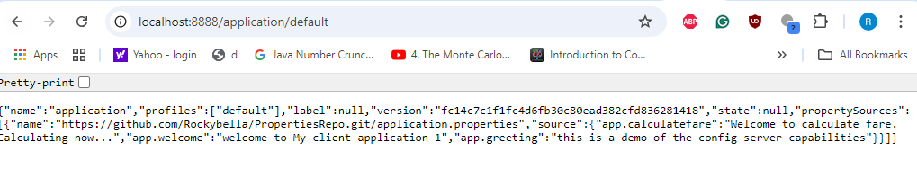

3. Develop HTML web pages for cab booking

4. Create a controller with annotations from Spring

5. Create a Microservice to book the cab

6. Create a Microservice to calculate the fare for the cab

7. Write unit test cases to test the Microservices

After packaging and testing templateBookingCabMS, the test documents were produced as seen below.



8. Build, run, and test the project on Postman

I used Postman throughout the development of this project. My most recent Post/Get requests are below along with the MySQL screenshot.

