Group:8

Ahlam Alrashidi

Baida Almansour

Rawan Alharbi

BTCar: It is an Android and IOS application that was prepared to help the average person with daily minor breakdowns caused by cars, such as batteries and tires. With the automobile industries constantly expanding, the need for vehicle maintenance is also increasing.

This also helps identify vehicle problems that can be dealt with with minimal vehicle repair experience, reducing reliance on a mechanic for minor problems with the vehicle.

Using SPSS to calculate the percentage of subjects in each group.

You can very quickly create summary percentages using the "frequencies" command, for example in the shoes file, what percentage of subjects were wearing each type of shoe? Clear any previous setting by clicking the "Reset" button then scoot the footwear variable into the variables box and just hit OK. The valid percent column is the one to read, it will ignore any empty cells.

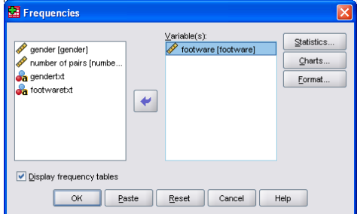

Does the percentage of footwear types differ in the different gender grouped; the bar charts seemed to imply this.

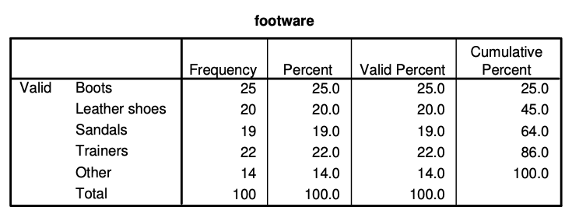

Lets get SPSS to do everything twice, once for males and once for females, we can do this using the split file command. Choose Data, Split file. Now calculate the percentages again as you did before.

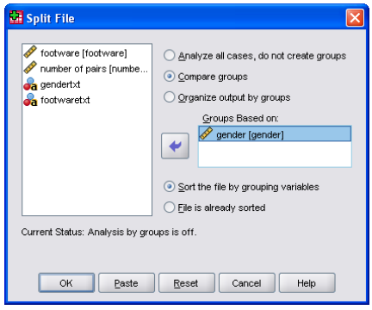

The output should now be split into two groups, one for Male and one for Female. Tables like this are rarely in the ideal format for inclusion in a dissertation or paper but can be copied and pasted into a word processor and manipulated there.

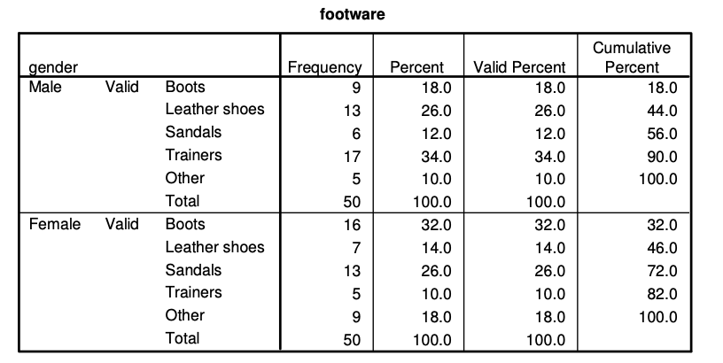

Remove the split once you have done with it. If you leave it on you may get some strange results. Choose Data, Split file. Then select the "Analyse all cases" option, then click OK. Don't forget to switch this feature off when you don't need it

