**WebStorm**

Proof of installation

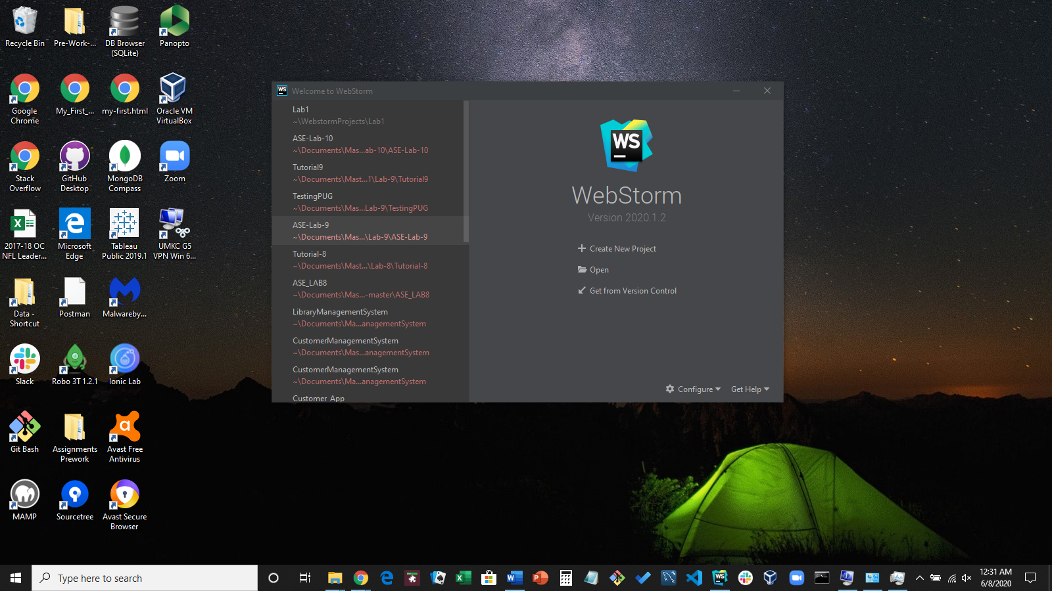

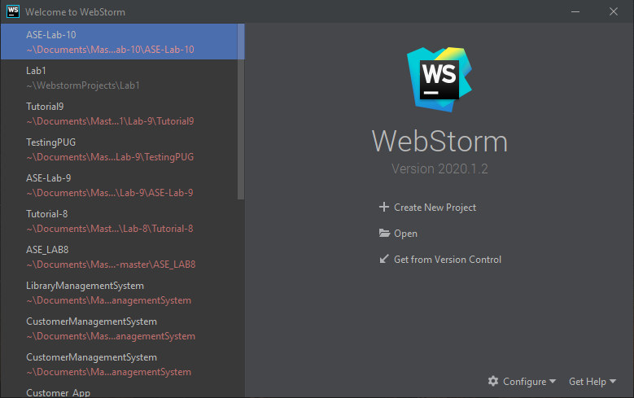

**GITHUB**

Account: Rod-Skoglund

Proof of GitHub account and the creation of the ICP1 repository

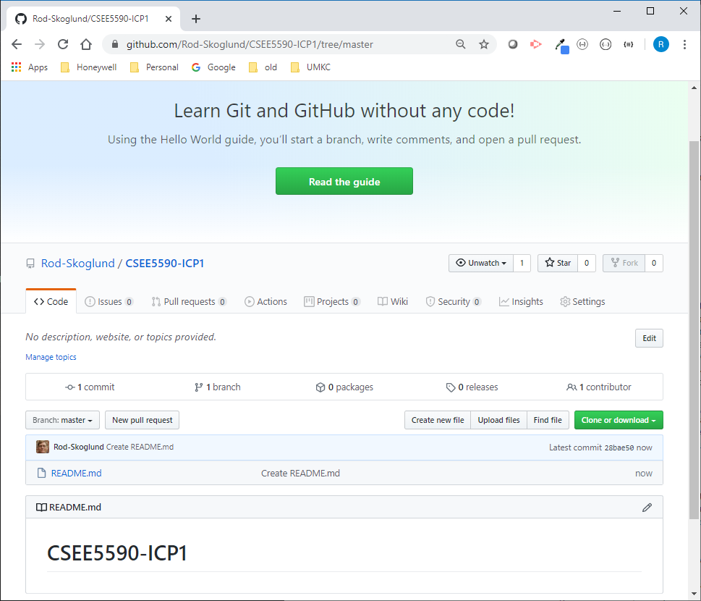

Cloning the GitHub repository to my local machine

