**WebStorm**

Proof of installation

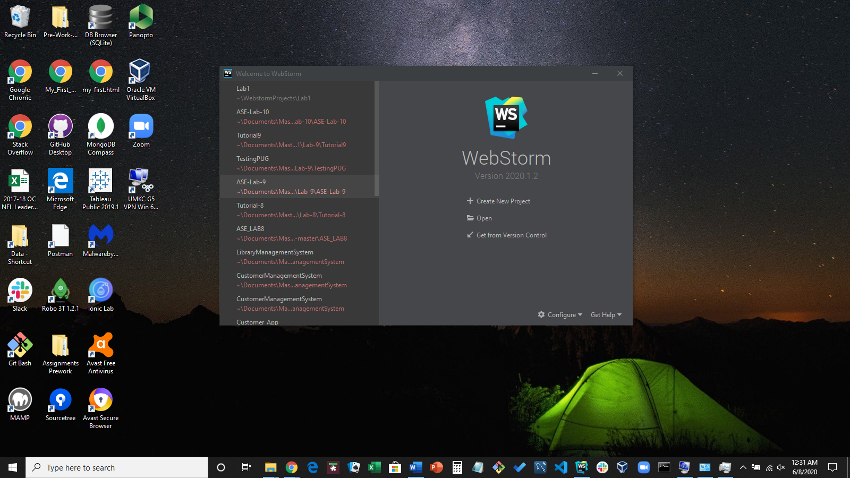

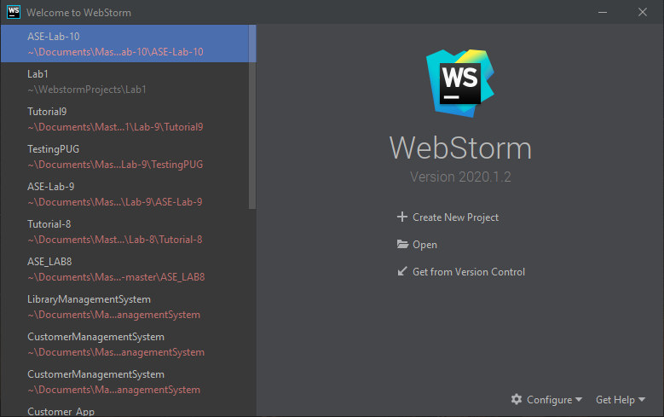

**GITHUB**

Account: Rod-Skoglund

Proof of GitHub account and the creation of the “WebMobile-2020Summer” repository

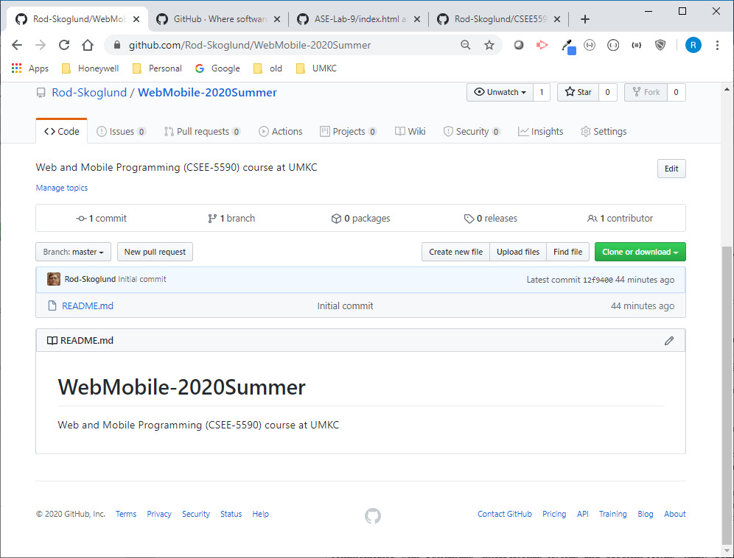

The following actions are described the following screenshots.

* Cloning the GitHub repository to my local machine
* Created a Web_Lesson1 directory with a Documentation and Source subdirectories
* Copied this file to the Documentation directory and created (touch) an index.html file in the Source directory

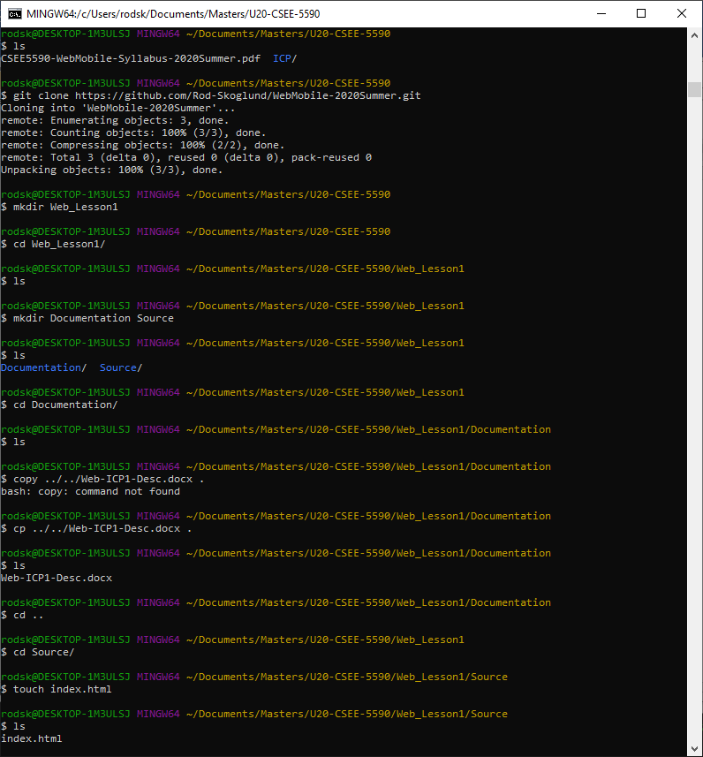

The following actions are described the following screenshots.

* Performed a git add, git commit and a git push to synchronize me additions from my local repo to GitHub repo.

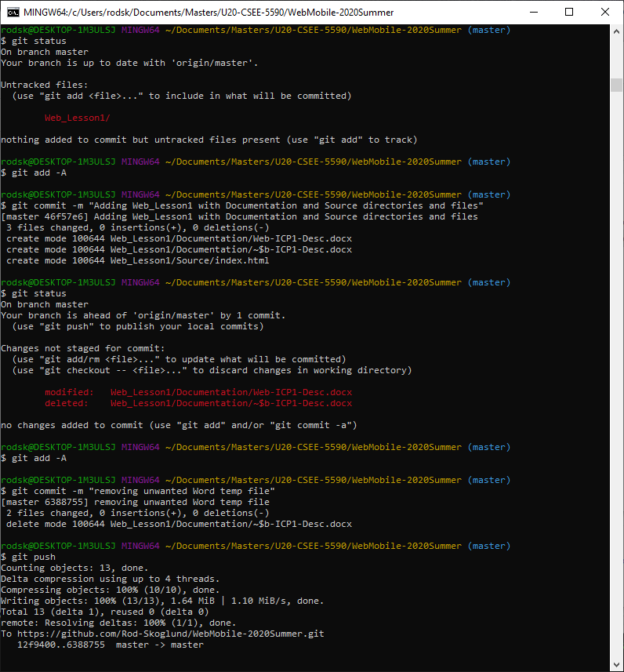

The following screenshot verifies that the Web_Lesson1 directory is now in GitHub

