**WebStorm**

Proof of installation

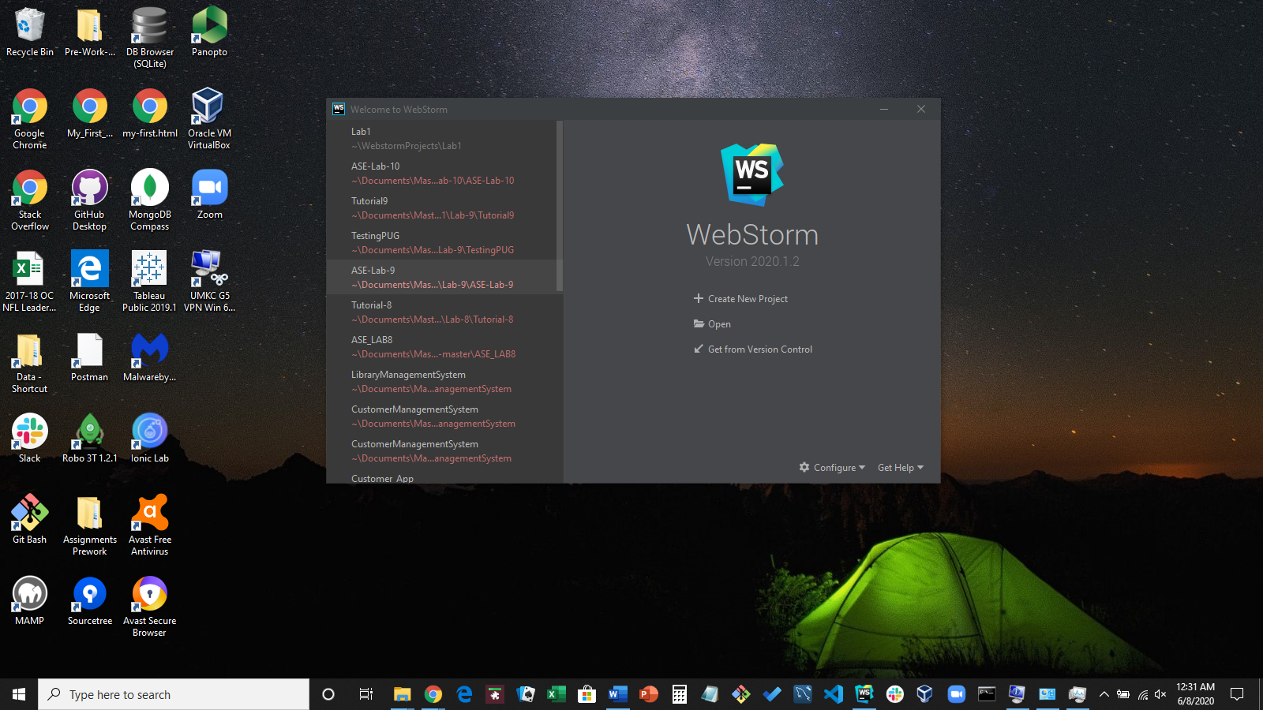

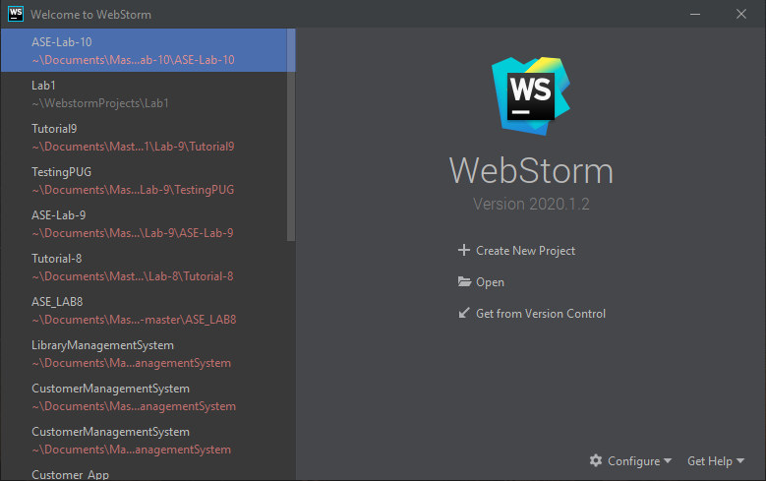

**GITHUB**

Account: Rod-Skoglund

Proof of GitHub account and the creation of the ICP1 repository

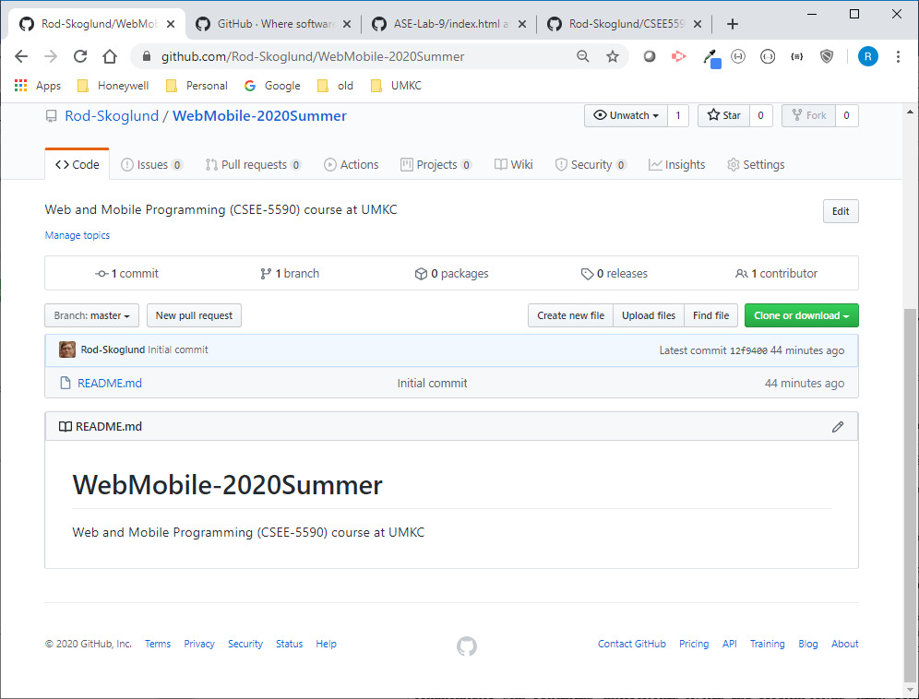

Cloning the GitHub repository to my local machine

Creating the two directories (Source and Documentation). Note that you cannot add new, empty directories from your remote repository

Moved this document into the Documentation directory and created an index.html in the Source directory. Performed a git add, git commit and a git push to get these changes rolled into the GitHub repository (See Below).

