**Question 1**

**(a)**

>> A = [1 1 3 1; 1 -1 -1 -1; 3 1 5 3; 1 5 11 8]

A =

1 1 3 1

1 -1 -1 -1

3 1 5 3

1 5 11 8

>> b = [1; 1; 1; -2]

b =

1

1

1

-2

**(b)**

>> A\b

Warning: Matrix is singular to working precision.

ans =

NaN

NaN

-Inf

Inf

**(c)**

>> det(A)

ans =

0

**(d)**

>> AUG = [A, b]

AUG =

1 1 3 1 1

1 -1 -1 -1 1

3 1 5 3 1

1 5 11 8 -2

>> rref (AUG)

ans =

1 0 1 0 1

0 1 2 0 1

0 0 0 1 -1

0 0 0 0 0

>> A\b + null(A)

Warning: Matrix is singular to working precision.

ans =

NaN

NaN

-Inf

Inf

>> pinv(A) * b

ans =

0.5000

0.0000

0.5000

-1.0000

>> linsolve(A, b)

Warning: Matrix is singular to working precision.

ans =

NaN

NaN

-Inf

Inf

>> null(A)

ans =

-0.4082

-0.8165

0.4082

0.0000

**Question 2**

**(a)**

| * 2

$$14y+14z=28 -14y+10z=-28$$

$$14y+14z-14y+10z=28-28$$

$$24z=0$$

$$z= 0$$

$-2y -2*0=-4$

$$y=2$$

$$x=7-2*2$$

$$x=3$$

(x, y, z) = (3, 2, 0)

**(b)**

>> [x,y]=meshgrid(0:4)

x =

0 1 2 3 4

0 1 2 3 4

0 1 2 3 4

0 1 2 3 4

0 1 2 3 4

y =

0 0 0 0 0

1 1 1 1 1

2 2 2 2 2

3 3 3 3 3

4 4 4 4 4

>> z=(7-3.*x+y)./5

z =

1.4000 0.8000 0.2000 -0.4000 -1.0000

1.6000 1.0000 0.4000 -0.2000 -0.8000

1.8000 1.2000 0.6000 0 -0.6000

2.0000 1.4000 0.8000 0.2000 -0.4000

2.2000 1.6000 1.0000 0.4000 -0.2000

>> mesh(x,y,z, "linestyle", "none", "facecolor", "red")

>> hold on

**(c)**

>> t = [0:2]

t =

0 1 2

>> x = 2*t+1

x =

1 3 5

>> y = -t+3

y =

3 2 1

>> z = t-1

z =

-1 0 1

>> plot3(x, y, z)

**(d)**

>> plot3(3,2,0,"ko" ,"markersize", 20, "MarkerFaceColor" , "k")

**(e)**

>> title("Question 2 graph")

>> xlabel("X")

>> ylabel("Y")

>> zlabel("Z axis")

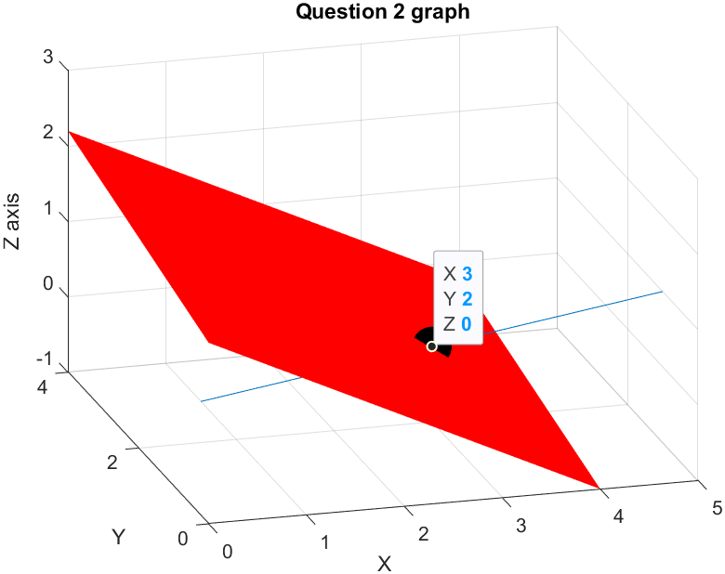

**Question 3**

**(a)**

$$f\left(x\right)=x^{2} g\left(x\right)= \sqrt{4-x^{2}}$$

Domain f(x) = (+inf, -inf) Domain g(x) = [2, -2] => Domain of composite function = [2, -2]

>> x = linspace(-2, 2);

>> y = (sqrt(4-x.^2)).^2;

**(b)**

>> plot(x, y, '-r')

**(c)**

>> title("Question 3 graph")

>> xlabel("X")

>> ylabel("Y axis")

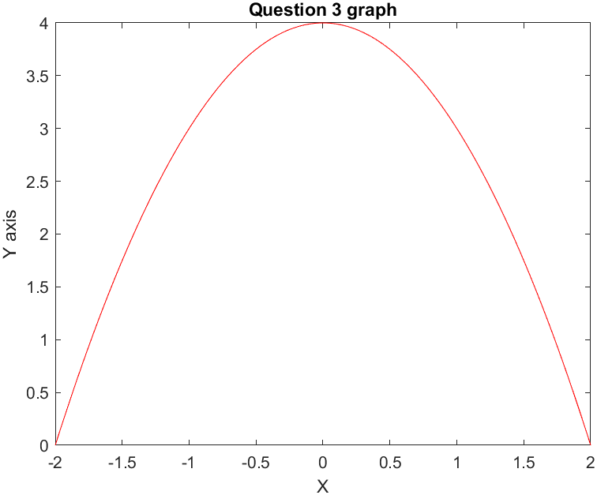

**Question 4**

**(a)**

>> syms b t

>> A = 2*b^2*t^4-2*t^2

A =

2*b^2*t^4 - 2*t^2

**(b)**

>> diff(A, t)

ans =

8*b^2*t^3 - 4*t

**(c)**

>> solve(diff(A, t)==0)

ans =

0

-2^(1/2)/(2*b)

2^(1/2)/(2*b)

**(d)**

>> subs(A, t, 5*b)

ans =

1250*b^6 - 50*b^2

**Question 5**

**(a)**

>> syms x

>> f=inline("tan(x)","x")

f =

Inline function:

f(x) = tan(x)

>> int(f(x))

ans =

-log(cos(x))

**(b)**

>> syms x

>> f=inline("log(x^2)","x")

f =

Inline function:

f(x) = log(x^2)

>> int(f(x))

ans =

x*(log(x^2) - 2)

**(c)**

>> syms x

>> f=inline("x^2*sin(2*x)","x")

f =

Inline function:

f(x) = x^2*sin(2*x)

>> int(f(x))

ans =

(x*sin(2*x))/2 + (2*sin(x)^2 - 1)*(x^2/2 - 1/4)