Proposal

# Purpose

The overall purpose of our application is to create a mini social media site where users can sign up entering their personal information. The web app will almost be similar to Facebook but with minor differences. Users will be able to give likes/ratings to other users, make posts and comment on others posts. The target audience of this application is wide and serves anyone that is looking for a social media to chat and share information with their friends.

# Interactions and Data

The interactions for this application will have multiple views, such as: login/signup view, viewing user profile view, writing new post view and a news feed view to see all posts from all users. Users to edit their own information, look at others information and give them a poke/like/score. There will be a way to search for users and display all the users on the system. Users will be able to make posts on others profiles where then they will displayed on that users profile. Also users will be able to add comments on the posts that will be attached to the post. Posts will also include the user who wrote the message and the post will be displayed on the other user’s profile page. Users will be able switch between all these view through a navigation menu.

# Sketches

## Login View

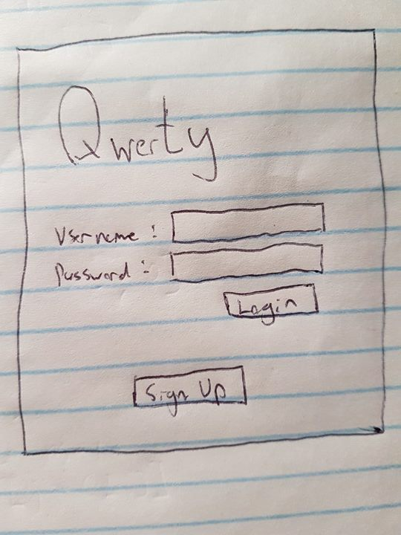

## News Feed

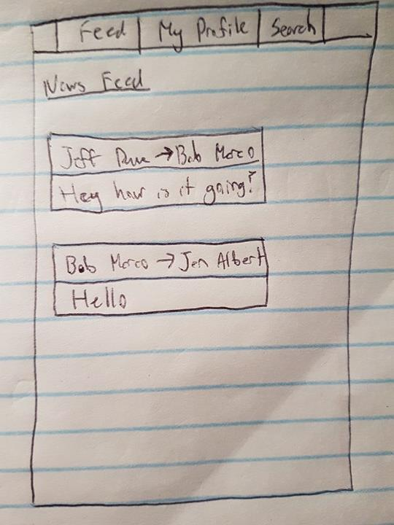

## Profile View

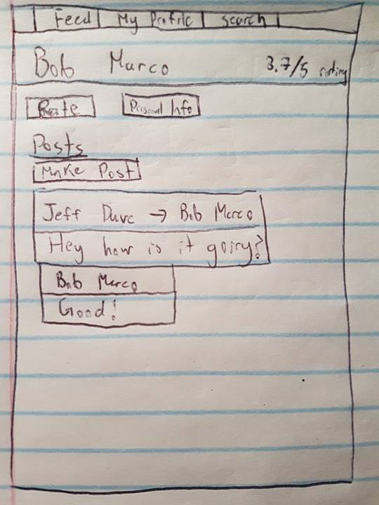

## New Post View

