**Project: AVR Butterfly Appliance Control Module**

**Reqirements Document**

**Team C**

**Computer Science**

**SS 2014**

**Project Guide: Prof. Dr-Ing. Thomas Seipmann**

**Dr –Ing Shankar Subramanian**

**Participants:**

**Amruta Bapat**

**Christoper Majda**

**Gaurav Dugge**

**Patrik Wissen**

**Piyusha Vasekar**

**Table of Contents**

|  |  |  |  |
| --- | --- | --- | --- |
| 1 |  | Customer Market……………………………………………………………………………………………………………………….. | 1 |
| 2 |  | Time Frame………………………………………………………………………………………………………………………………… | 1 |
| 3 |  | Goals………………………………………………………………………………………………………………………………………….. | 1 |
|  | 3.1 | Purpose……………………………………………………………………………………………………………………………………… | 1 |
|  | 3.2 | Benefit………………………………………………………………………………………………………………………………………. | 1 |
| 4 |  | Application of Product……………………………………………………………………………………………………………….. | 1 |
|  | 4.1 | Areas of Application……………………………………………………………………………………………………………………. | 1 |
|  | 4.2 | Users, Stakeholders………………………………………………………………………………………………………………….... | 1 |
|  | 4.3 | As-is Process……………………………………………………………………………………………………………………………….. | 1 |
|  | 4.4 | Supported to-be process…………………………………………………………………………………………………………….. | 1 |
| 5 |  | Product functionality………………………………………………………………………………………………………………….. | 2 |
|  | 5.1 | All functions……………………………………………………………………………………………………………………………….. | 2 |
|  | 5.2 | Detailed I/O interface…………………………………………………………………………………………………………………. | 2 |
|  | 5.3 | Use Case Diagram, Activity Diagram……………………………………………………………………………………………. | 3 |
| 6 |  | Product Data……………………………………………………………………………………………………………………………… | 6 |
|  | 6.1 | Quantity Structure……………………………………………………………………………………………………………………… | 6 |
|  | 6.2 | Demands on hardware software interface………………………………………………………………………………….. | 6 |
| 7 |  | Product performance…………………………………………………………………………………………………………………. | 6 |
|  | 7.1 | Response time, battery lifetime………………………………………………………………………………………………….. | 6 |
| 8 |  | Quality Specifications…………………………………………………………………………………………………………………. | 6 |

1. **Customer / Market:**

This product is intended to be used as intelligent device for home or office automation. The target market is domestic as well as industrial.

1. **Time Frame**  
   Start of project: 28th May 2014  
   End of project: 25th June 2014
2. **Goals**

**3.1 Purpose**

This product is designed to control the ON or OFF timing of up to two electrical appliances independently in synchronization with a real time clock or using a countdown timer.

**3.2 Benefit**

* Allows user to automatically switch an electrical device on or off
* Provides flexibility to user to control two different devices
* Provides flexibility by giving different modes (countdown or real time)
* Can be used to save energy

**4. Application of product**

**4.1 Area(s) of application**:

Can be used anywhere where electrical appliances running on 230V AC supply need to be controlled using real time clock or countdown timer  
Eg: Switching OFF light and printer in office after 7 pm everyday

**4.2 Users, stakeholders:**  
This device can be used by common people in day-to-day life as well as by industries for commercial premises.

**4.3 As – is processes**  
Presently, the process is manual. The user has to be physically present and needs to manually switch off the electrical appliance. Failure to perform this action leads to wastage of energy.

**4.4 Supported to-be processes:**  
 Automated systems which will switch the appliances on or off at user specified time.

**5. Product functionality**

* 1. **All functions**
* Reset the system.
* Set real time on the system.
* Select device to be controlled. (First or Second)
* Select operation – (It allows the user to select the device to be switched on or off.)
* Select mode and set time – (It allows the user to set real time at which or countdown time after which the device is to be switched on or off.)
  1. **Detailed IO, user interface**

Inputs –

1. Reset input
2. Keypad input for time setting
3. Joystick for device selection.

Outputs –

1. Relay to control external electrical appliances
2. LEDs as indicators.
3. LCD for user interface.

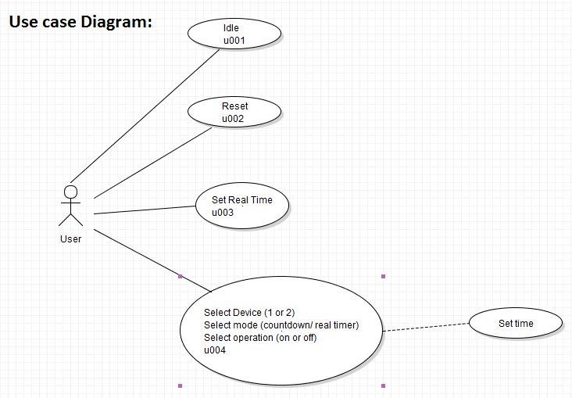

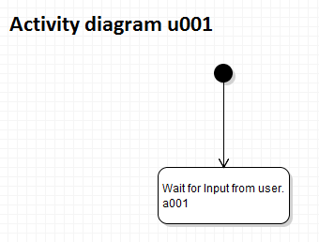

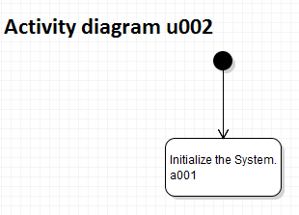

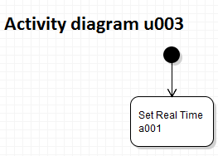

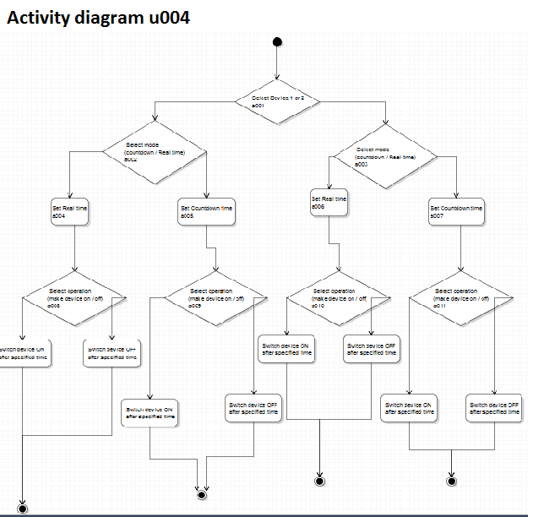

**6. Product data**

**6.1 Quantity structure**

|  |  |  |
| --- | --- | --- |
| Hardware | Pieces | Cost ( in euros) |
| AVR Butterfly board | 1 | 30,00 |
| External Keypad | 1 | 1,00 |
| Contact Relays (2 channel) | 1 | 5,00 |

**6.2 Demands on hardware, software, interface**

Following Hardware will be used:

1. AVR Butterfly board.
2. 2 channel relay supporting 230V 6 Amps electrical devices.
3. 4 X 4 keypad as a user interface.
4. No external software required.

**7. Product performance**

**7.1 Response times, battery life time**  
Moderate response time and battery life time of 100 working hours.

**8. Quality specifications**

* Usability – Keypad, joystick and LCD available for user interface.   
   Easy to use because of integration of keypad.
* Reliability- Depends on battery life and functioning of relays
* Efficiency – highly efficient.