Internet of Things (IoT) Progress Report

Resource / Key Personnel | Ern Francis A. Natividad
Project Name | Real-Time IoT Atmospheric Monitoring for Student Dining Areas
Progress Report No. | 1
Reporting Period | February 10 - 16, 2026

Summary of Activities

# | Activity | % Complete | Results / Issues
1 | Successfully simulated the ESP32 microcontroller logic | 75% | Complete
2 | Canvass of Hardware pricing and checking quality | 100% | Finished
3 | Successfully designed the wiring and pinouts for the sensor and display. | 100% | Finished

Section 1: Activities and Progress Report

Activity: Successfully simulated the ESP32 microcontroller logic
Description: Our team identifies the logic of the hardware connections and designs the components virtually. Mapped analog input (Potentiometer) to simulate PM2.5 air quality levels. Integrated and wired an I2C LCD 16x2 Display to show real-time data. Wrote and verified C++ code for "Good," "Moderate," and "Danger" air quality thresholds.
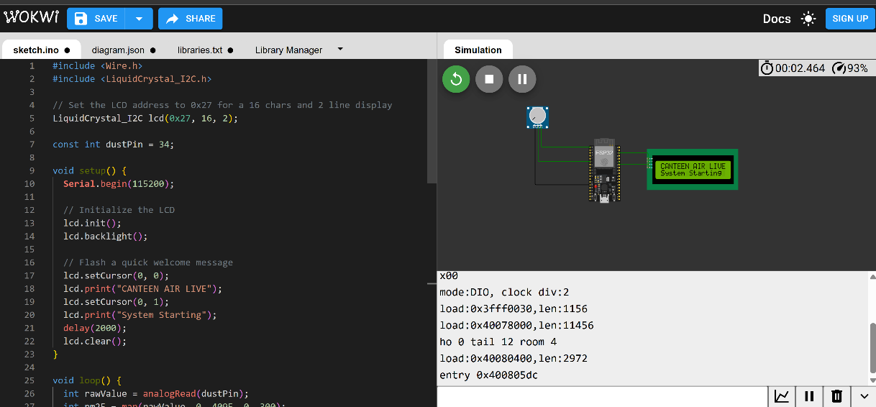

Activity: Canvass of Hardware pricing and checking quality
Description: Checks the price and Quality of the hardware components in the market.

Activity: Successfully designed the wiring and pinouts for the sensor and display.
Description: As above shown in the image we successfully display using the LCD IC2 using in wokwi.

Section 2: Risks, Issues, and Challenges

Issues
As a beginner in IoT hardware connections and wiring, We are currently in the early stages of learning. This may affect our initial progress as we take the time to build a solid foundation in IoT fundamentals.

Risks
Inconsistent and unstable internet.

Challenges

We got challenge in the connection and coding as we are not familiar to the fundamentals.

Section 3: Next Steps

The next step is to connect hardware physically and test if sensor are working.

Prepared by:

Ern Francis A. Nativiadad

