**Test Plan**

|  |  |
| --- | --- |
| Student Name | Rod Fant |
| Submission Date | 1/30/2023 |
| Course and Section | CPT-185-I01, I02 |
| Chapter Number |  |

|  |  |
| --- | --- |
| Include comments about anything that might not be working 100% in the program. Write none if all is working as instructed in the homework directions. | I had an issue uploading the code. I tried to download it from github to test it and I don’t think it worked. When I tried to reupload, I got a permissions error about unable to change file. I think this was because the folder was on my server, not my local PC. I moved the folder to my local pc and then pushed the whole thing to github. It seems to work now. I don’t know if I need to delete the older files? |
| Every project should be downloaded from GitHub on a different machine or on the original computer with the original project directory name changed, and then the project should be tested to ensure it uploaded cleanly and works correctly. Include a statement that this was done and whether it was done on a different computer or on the original computer with the original project folder name changed. | Tested, found issue. Retested, it seems to work, unless I’m accidentally loading a cached version. I downloaded it again and changed the name, I think it is good. I will now add this document update as well on github, in the folder. |

**Test Cases of Functionality**

No code yet.

**Final GitHub Commit Screenshot**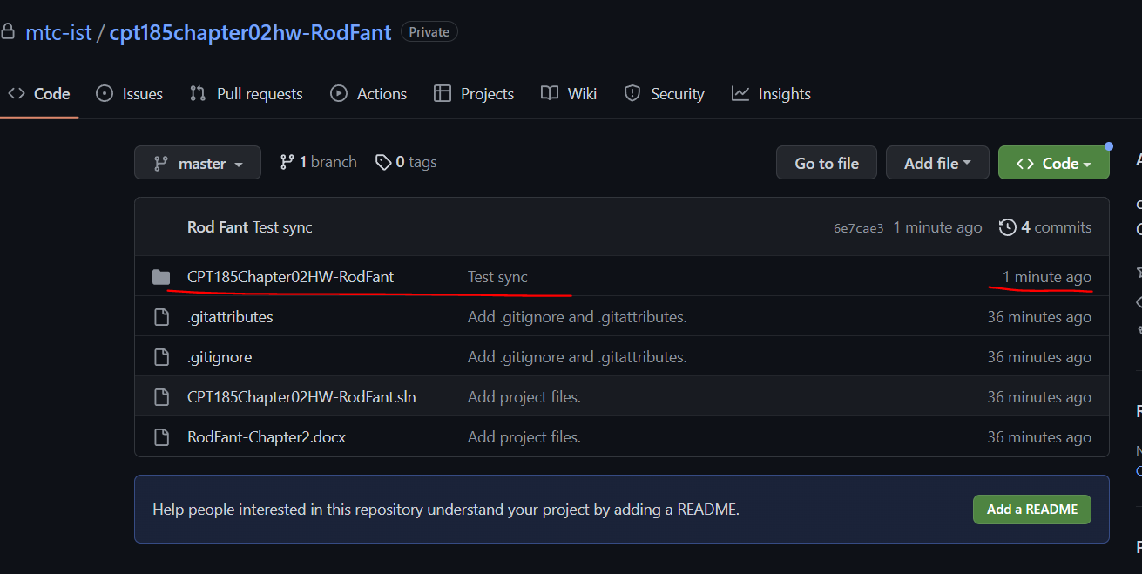

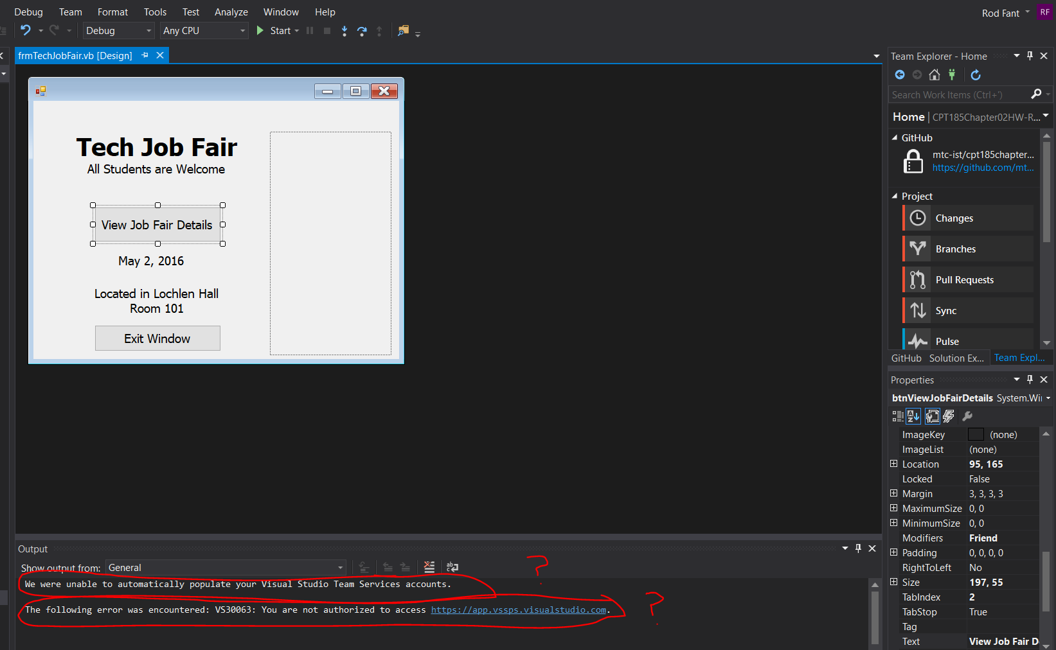

Do these errors matter?

**Copy of Code from Form(s)**

No code yet.