**Test Plan**

|  |  |
| --- | --- |
| Student Name | Rod Fant |
| Submission Date | 3/30/2023 |
| Course and Section | CPT-185-I01, I02 |
| Chapter Number | PROJECT |

|  |  |
| --- | --- |
| Include comments about anything that might not be working 100% in the program. Write none if all is working as instructed in the homework directions. | All is working as intended, so far. |
| Every project should be downloaded from GitHub on a different machine or on the original computer with the original project directory name changed, and then the project should be tested to ensure it uploaded cleanly and works correctly. Include a statement that this was done and whether it was done on a different computer or on the original computer with the original project folder name changed. |  |

**Test Cases of Functionality**

Test Case Scenario 1: Testing splash screen

Test Case Scenario 1 Screenshot(s):

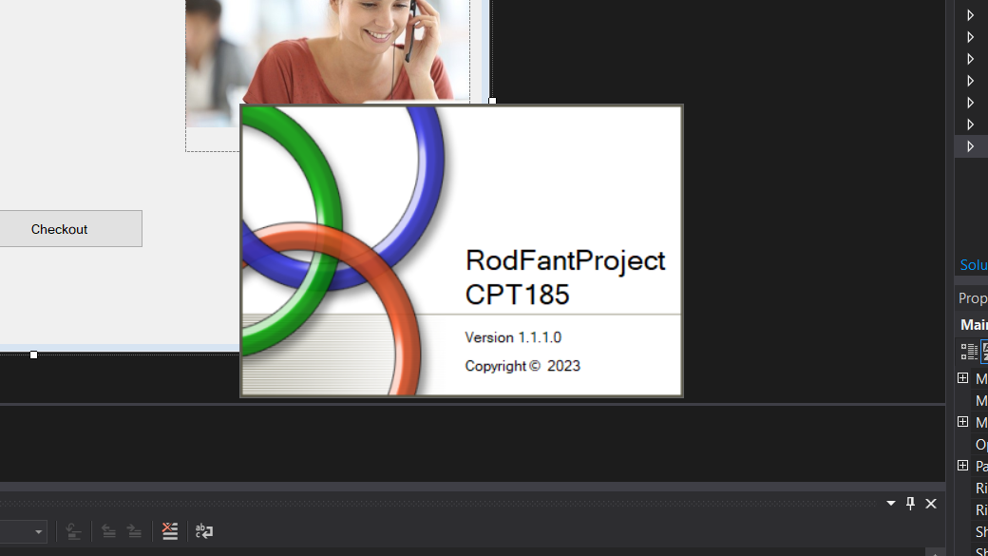

Test Case Scenario 2: Test home screen and buttons

Test Case Scenario 2 Screenshot(s):

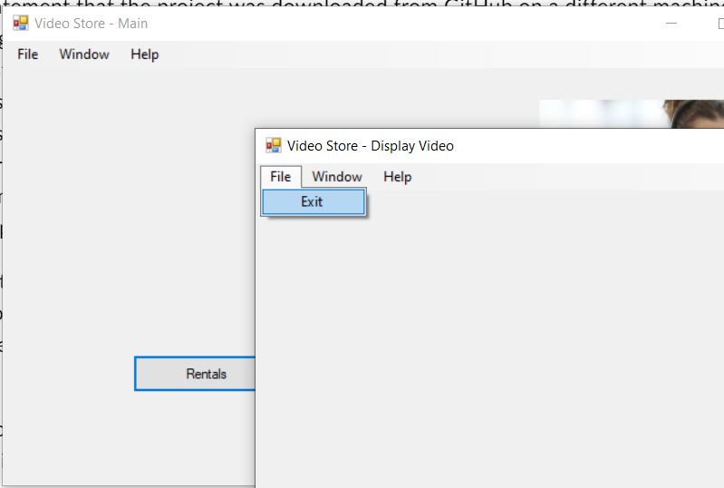

**Test Cases of Error Checking**

Test Case Scenario 1: Previously, clicking the “About” button while already on the About page would give an error. Disabled that button so it wouldn’t happen.

Test Case Scenario 1 Screenshot(s):  
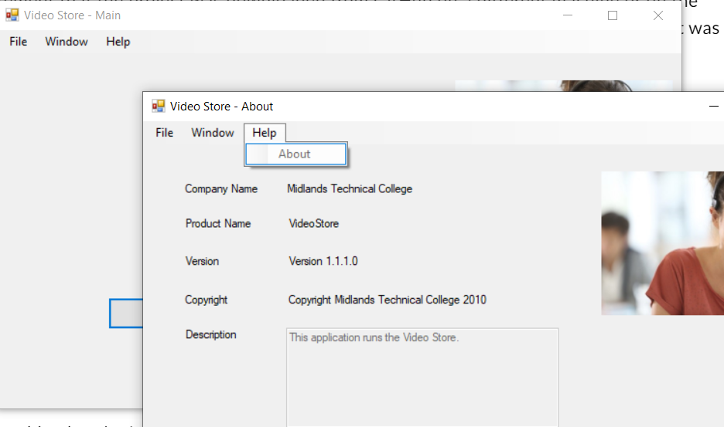

Test Case Scenario 2: Fixed the “Exit” button code

Test Case Scenario 2 Screenshot(s):

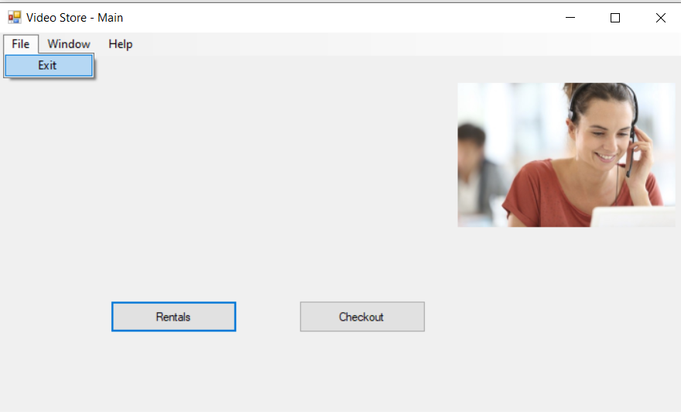

**Final GitHub Commit Screenshot**

**Copy of Code from Form(s)**