**Decision Tree**

**CSE 303: Machine Learning**

Submitted by

Name: Roda Chinthapalli

Roll No: AP22110011496

Section :M

Lab Bate: 10/09/24

End Date: 16/09/24

**Department Computer Science and Engineering**

**School of Engineering and Sciences**

**SRM University–AP**

**Amaravati, Andhra Pradesh – 522 240, India**

**DECISION TREE**

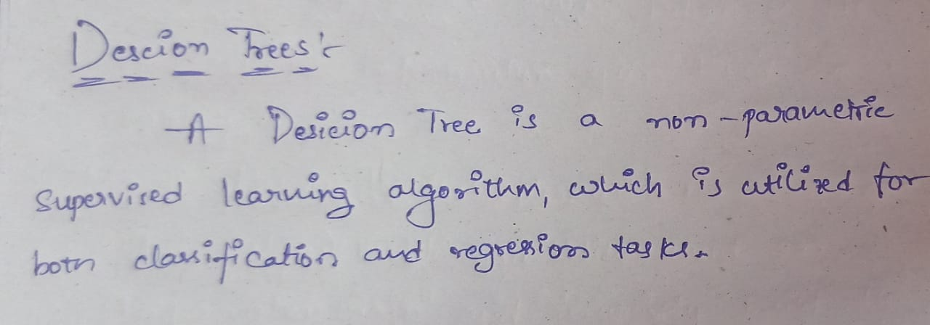

**1.Question:**

Implement Decision Tree Classifier for classification of EnjoySport dataset

a. Load the data set

b. Create a function for calculating entropy

c. Create a function for calculating InformationGain

d. write code for creating Discission Tree

**Problem Statement and Algorithm:**

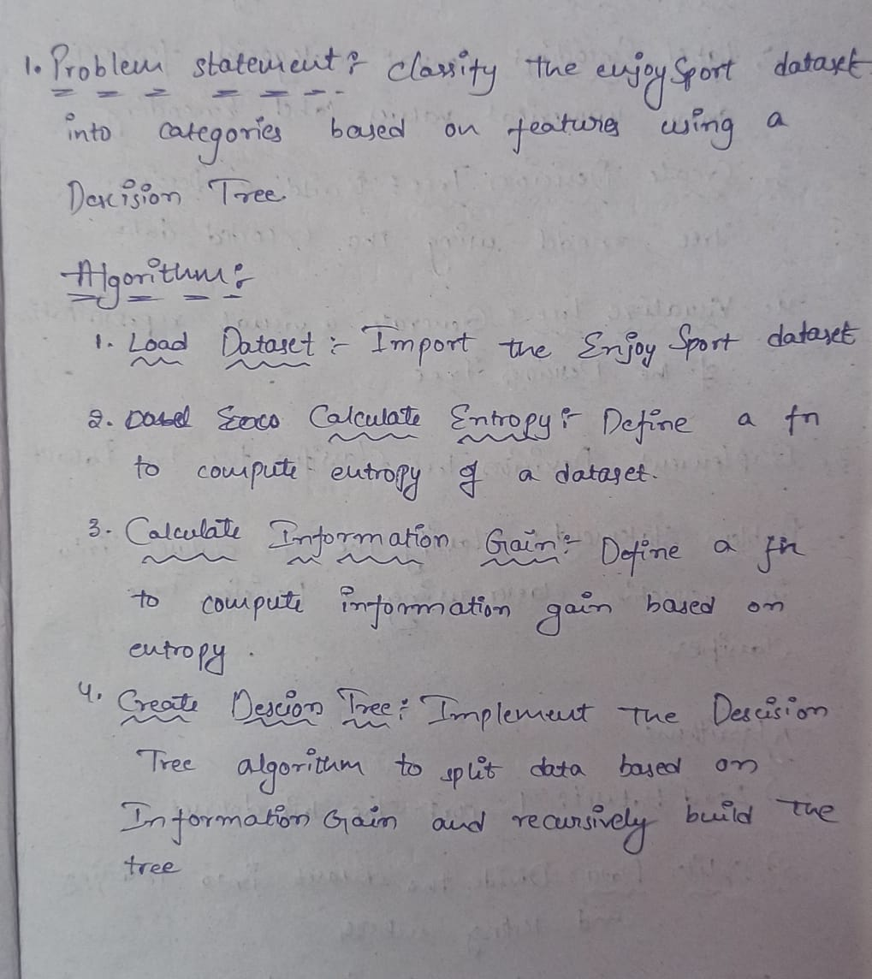

**Solution:**

import pandas as pd

# Load the dataset

df = pd.read_csv('/content/Enjoy sports.csv')

# Display the entire dataset

print(df)

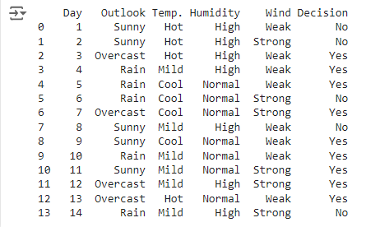

**a.Create a function for calculating entropy**

import numpy as np

import pandas as pd

def calculate_entropy(column):

    # Calculate frequency of each unique value in the column

    values, counts = np.unique(column, return_counts=True)

    probabilities = counts / len(column)

    # Calculate the entropy

    entropy = -np.sum(probabilities * np.log2(probabilities))

    return entropy

# Load the dataset

df = pd.read_csv('/content/Enjoy sports.csv')

# List of columns to compute entropy for

columns_to_check = ['Outlook', 'Temp.', 'Humidity', 'Wind', 'Decision']

# Calculate and display entropy for each column

for column in columns_to_check:

    if column in df.columns:

        entropy_value = calculate_entropy(df[column])

        print(f"Entropy of '{column}': {entropy_value}")

    else:

        print(f"Column '{column}' does not exist in the DataFrame.")

# Specific analysis for categorical columns

categorical_columns = ['Outlook', 'Temp.', 'Humidity', 'Wind']

for column in categorical_columns:

    if column in df.columns:

        unique_values = df[column].unique()

        for value in unique_values:

            filtered_df = df[df[column] == value]

            entropy_value = calculate_entropy(filtered_df['Decision'])

            print(f"Entropy of '{column}' = '{value}': {entropy_value}")

    else:

        print(f"Column '{column}' does not exist in the DataFrame.")

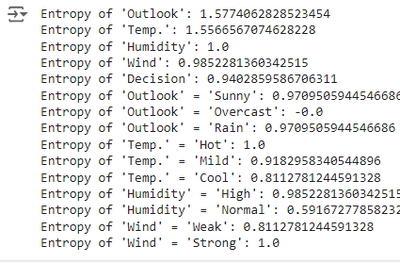

**C.Create a function for calculating Information Gain**

import numpy as np

import pandas as pd

def calculate_entropy(column):

    # Calculate frequency of each unique value in the column

    values, counts = np.unique(column, return_counts=True)

    probabilities = counts / len(column)

    # Calculate the entropy

    entropy = -np.sum(probabilities * np.log2(probabilities))

    return entropy

def calculate_information_gain(df, attribute, target):

    # Calculate the entropy of the original dataset

    original_entropy = calculate_entropy(df[target])

    # Calculate the weighted entropy after the split

    values, counts = np.unique(df[attribute], return_counts=True)

    weighted_entropy = 0

    total_count = len(df)

    for value, count in zip(values, counts):

        subset = df[df[attribute] == value]

        subset_entropy = calculate_entropy(subset[target])

        weighted_entropy += (count / total_count) * subset_entropy

    # Calculate information gain

    information_gain = original_entropy - weighted_entropy

    return information_gain

# Load the dataset

df = pd.read_csv('/content/Enjoy sports.csv')

# Calculate Information Gain for a specific attribute

attributes = ['Outlook', 'Temp.', 'Humidity', 'Wind']

for attribute in attributes:

    if attribute in df.columns:

        info_gain = calculate_information_gain(df, attribute, 'Decision')

        print(f"Information Gain for '{attribute}': {info_gain}")

    else:

        print(f"Column '{attribute}' does not exist in the DataFrame.")

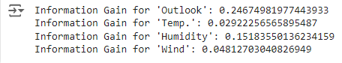

**d. Write a code for creation Decision Tree**

import pandas as pd

import numpy as np

from sklearn.tree import DecisionTreeClassifier, plot_tree

import matplotlib.pyplot as plt

# Load the dataset

df = pd.read_csv('/content/Enjoy sports.csv')

# Set pandas display options to show all columns and rows

pd.set_option('display.max_columns', None)  # Show all columns

pd.set_option('display.max_rows', None)     # Show all rows

pd.set_option('display.max_colwidth', None) # Show full column width

pd.set_option('display.expand_frame_repr', False) # Prevent truncation in wide DataFrames

# Print column names and first few rows to check for issues

print("Column names in the dataset:")

print(df.columns)

print("First few rows of the dataset:")

print(df)

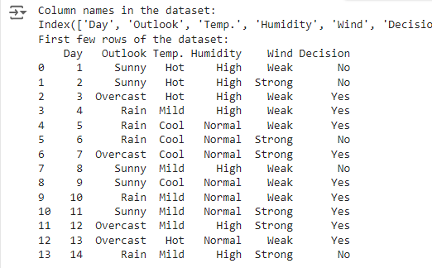

# Define the target column based on your dataset

target_column = 'Decision'

# Ensure the target column is present

if target_column not in df.columns:

    raise KeyError(f"The column '{target_column}' is not found in the dataset")

# Prepare the data

X = df.drop(columns=[target_column])

y = df[target_column]

# Convert categorical features to numerical values

X_encoded = pd.get_dummies(X)

# Initialize the Decision Tree Classifier

clf = DecisionTreeClassifier(criterion='entropy')

# Fit the model

clf.fit(X_encoded, y)

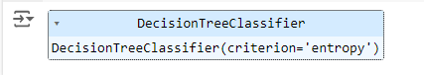

# Display the decision tree

def display_tree(clf, feature_names):

    plt.figure(figsize=(20,10))

    plot_tree(clf,

              feature_names=feature_names,

              class_names=clf.classes_,

              filled=True,

              rounded=True,

              fontsize=12)

    plt.show()

# Get feature names after encoding

feature_names = X_encoded.columns

# Display the tree

display_tree(clf, feature_names)

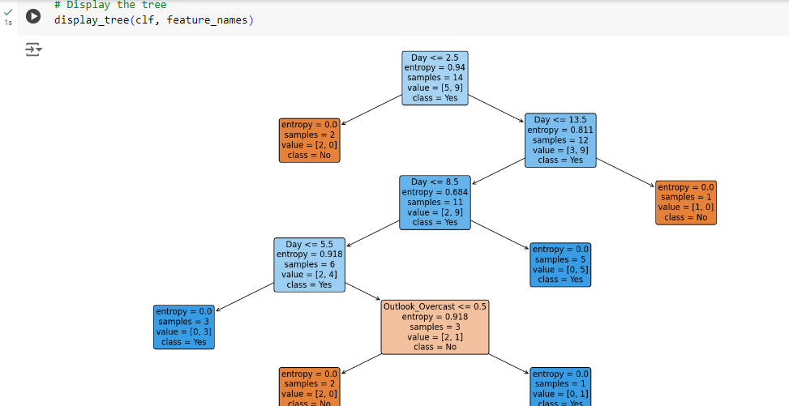

**2.Question**

Implement Decision Tree Classifier for classification of EnjoySport dataset

a. Load the data set

b. Use Label Encoding

c. create a Decision Tree

d. Visualize the tree

**Problem Statement and Algorithm:**

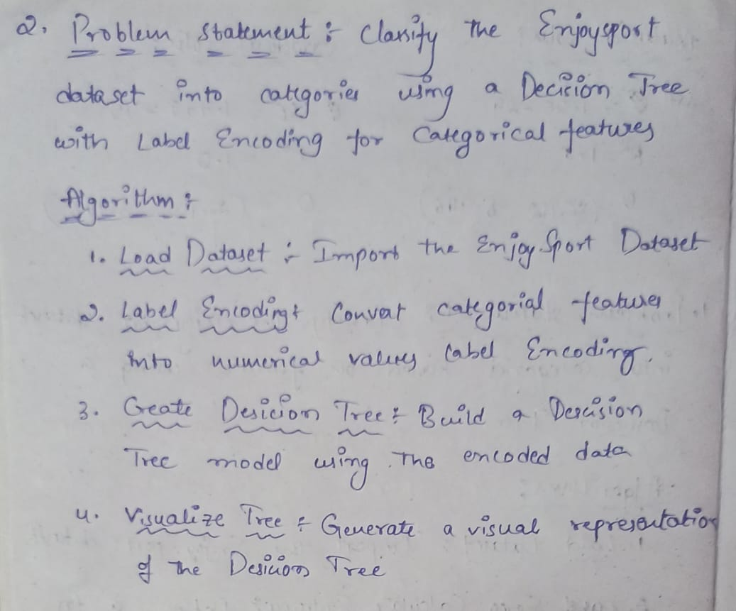

**Solution:**

**a.Load the Dataset**

import pandas as pd

# Load the dataset

file_path = '/content/Enjoy sports.csv'

data = pd.read_csv(file_path)

# show all rows and columns

pd.set_option('display.max_rows', None)

pd.set_option('display.max_columns', None)

# Display the entire DataFrame

print(data)

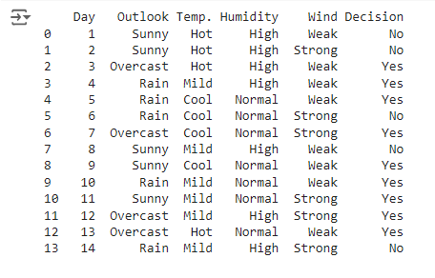

**b.Use Label Encoding**

from sklearn.preprocessing import LabelEncoder

import pandas as pd

# Initialize label encoders for each column

label_encoders = {}

for column in data.columns:

    le = LabelEncoder()

    data[column] = le.fit_transform(data[column])

    label_encoders[column] = le

# Display the entire transformed DataFrame

print(data)

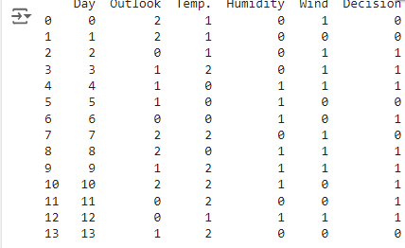

**c.Create a Decision Tree:**

import pandas as pd

from sklearn.model_selection import train_test_split

from sklearn.tree import DecisionTreeClassifier

from sklearn.metrics import accuracy_score

# Assuming `data` is your DataFrame and it has been properly loaded

# Separate features and target variable

X = data.drop('Decision', axis=1)  # Features

y = data['Decision']  # Target variable

# Split the dataset into training and testing sets

X_train, X_test, y_train, y_test = train_test_split(X, y, test_size=0.3, random_state=42)

# Initialize the Decision Tree Classifier

clf = DecisionTreeClassifier()

# Train the classifier

clf.fit(X_train, y_train)

# Make predictions

y_pred = clf.predict(X_test)

# Print accuracy

accuracy = accuracy_score(y_test, y_pred)

print(f'Accuracy: {accuracy}')



**d. Visualize the Tree:**

import matplotlib.pyplot as plt

from sklearn.tree import plot_tree

# Visualize the Decision Tree

plt.figure(figsize=(20,10))

plot_tree(clf, filled=True, feature_names=X.columns, class_names=['0', '1'], rounded=True)

plt.title("Decision Tree Visualization")

plt.show()

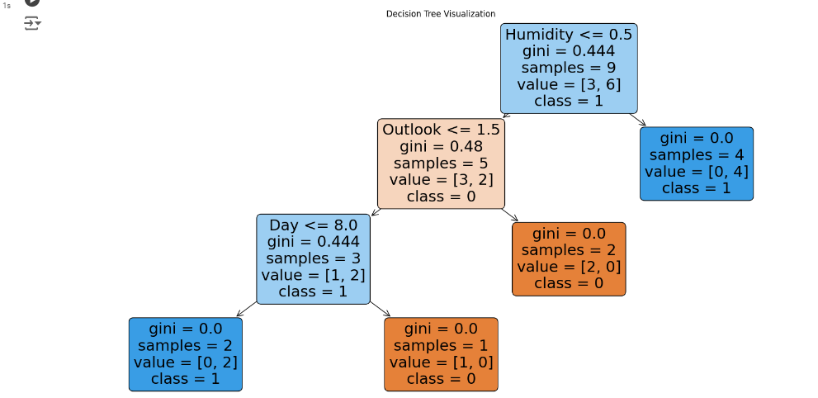

**3.Question:**

Implement Decision Tree Classifier for classification of Iris dataset

a. Load the data set

b. Split the data set to train and test sets

c. Train a Decision Tree using train set

d. Test the model using test set. Find accuracy and confusion Matrix.

**Problem Statement and Algorithm:**

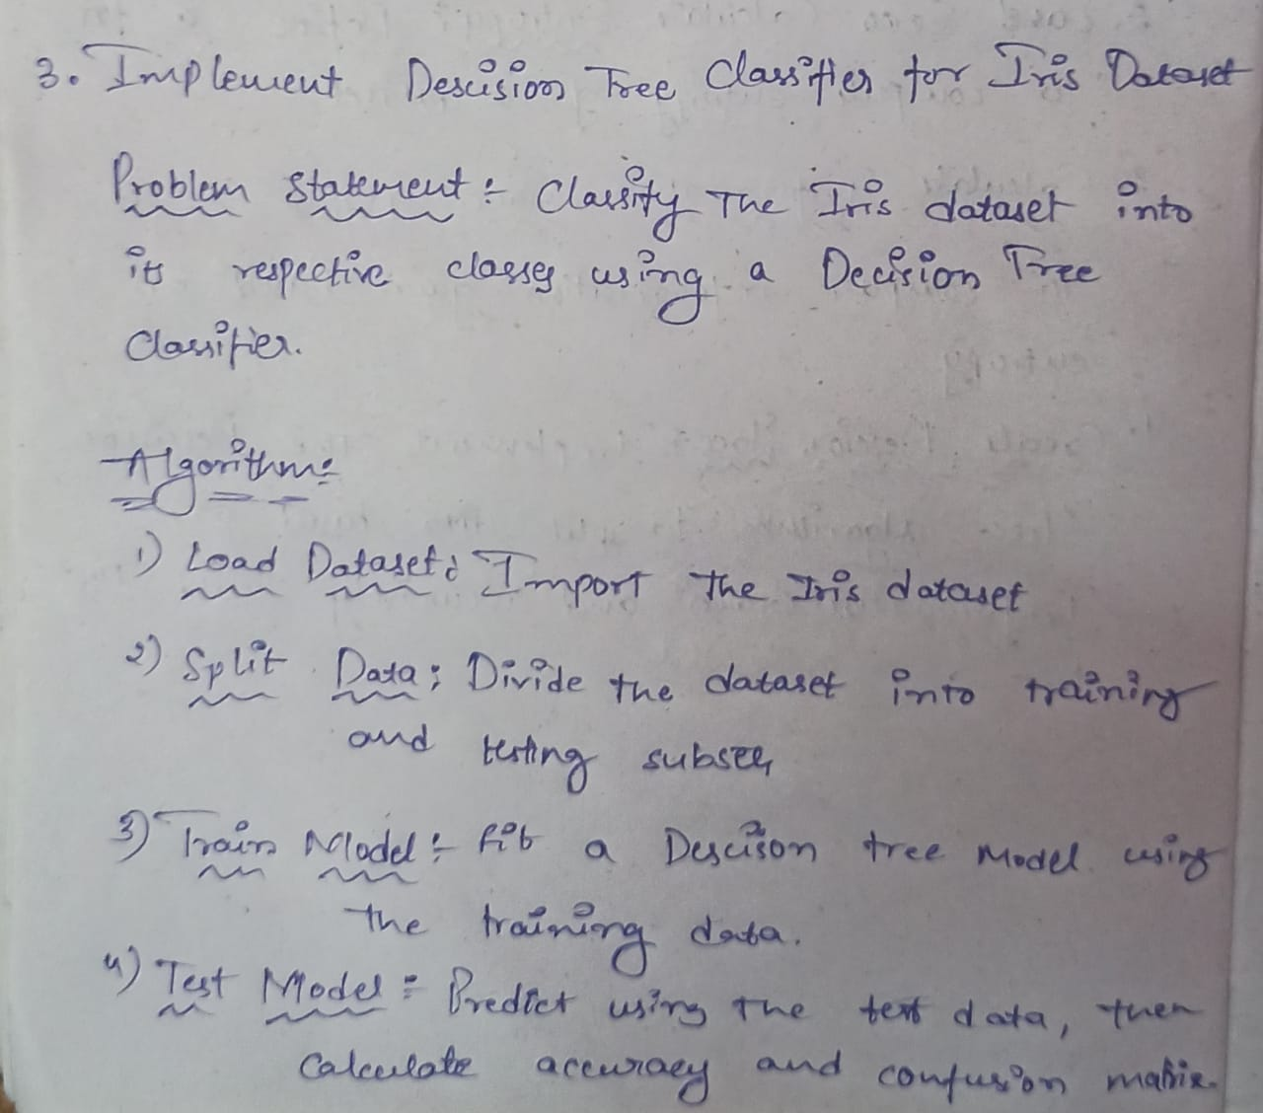

**Solution:**

**a.Load the dataset:**

import pandas as pd

from sklearn.model_selection import train_test_split

# Load the dataset

iris_data = pd.read_csv('/content/iris.csv')

# Define features and target

X = iris_data.iloc[:, :-1]  # Features

y = iris_data['Species']     # Target

**b.Split the data set to train and test sets**

# Split the data into training and testing sets

X_train, X_test, y_train, y_test = train_test_split(X, y, test_size=0.2, random_state=42)

**c.Train a Decision Tree Calssifier:**

from sklearn.tree import DecisionTreeClassifier

# Create and train the Decision Tree classifier

dt_classifier = DecisionTreeClassifier(random_state=42)

dt_classifier.fit(X_train, y_train)

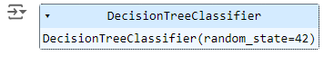

**d.Test the model and find the accuracy and confusion matrix:**

from sklearn.metrics import accuracy_score, confusion_matrix

# Make predictions

y_pred_dt = dt_classifier.predict(X_test)

# Calculate accuracy

accuracy_dt = accuracy_score(y_test, y_pred_dt)

print(f"Accuracy of Decision Tree Classifier: {accuracy_dt:.2f}")

# Confusion matrix

conf_matrix_dt = confusion_matrix(y_test, y_pred_dt)

print("Confusion Matrix for Decision Tree Classifier:\n", conf_matrix_dt)

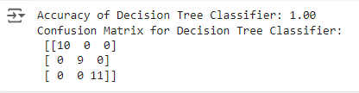

**4. Question :**

Implement Random Forest Classifier for classification of Iris dataset

a. Load the data set

b. Split the data set to train and test sets

c. Train a Random Forest model using train set

d. Test the model using test set. Find accuracy and confusion Matrix.

**Problem Statement and Algorithm:**

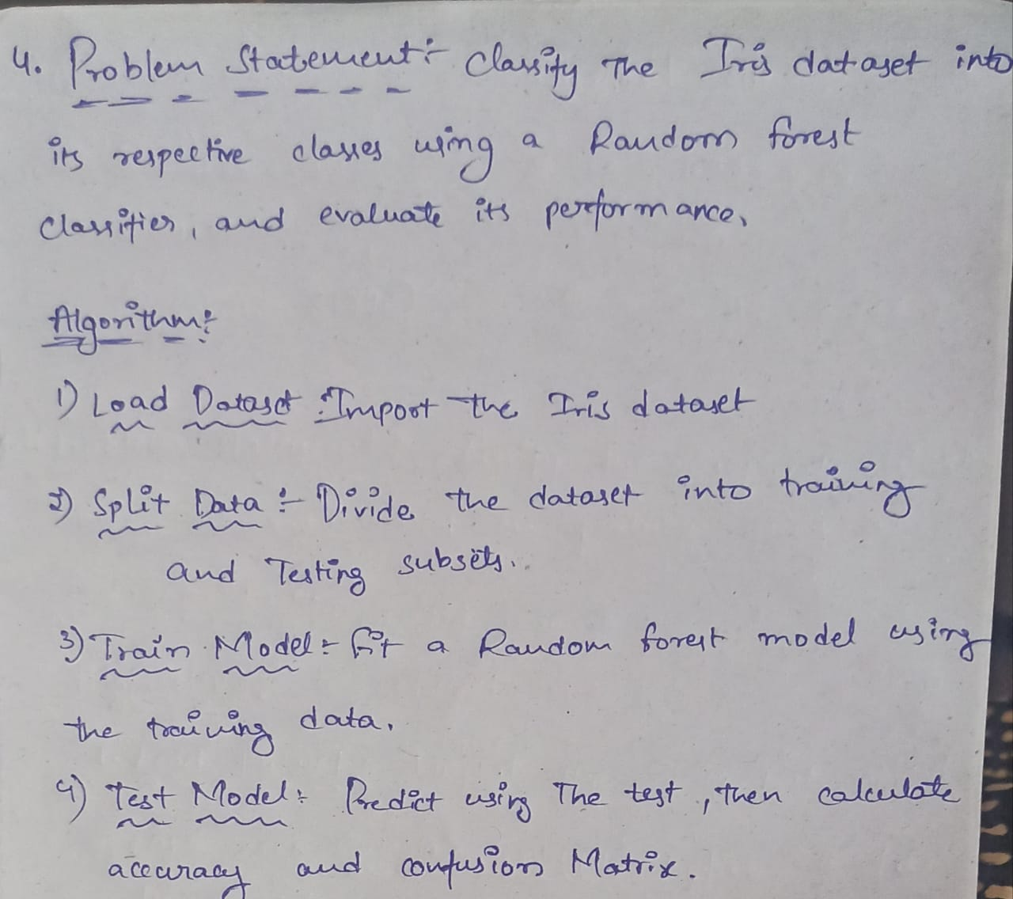

**Solution:**

**a.Load the Dataset:**

import pandas as pd

from sklearn.model_selection import train_test_split

# Load the dataset

iris_data = pd.read_csv('/content/iris.csv')

# Define features and target

X = iris_data.iloc[:, :-1]  # Features

y = iris_data['Species']     # Target

**b.Split the DAtaset into the Train and Test sets**

# Split the data into training and testing sets

X_train, X_test, y_train, y_test = train_test_split(X, y, test_size=0.2, random_state=42)

**c.Train a Random Forest Classifier**

from sklearn.ensemble import RandomForestClassifier

# Create and train the Random Forest classifier

rf_classifier = RandomForestClassifier(random_state=42)

rf_classifier.fit(X_train, y_train)

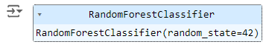

**d.Test and model and Find accuracy and confusion matrix:**

# Make predictions

y_pred_rf = rf_classifier.predict(X_test)

# Calculate accuracy

accuracy_rf = accuracy_score(y_test, y_pred_rf)

print(f"Accuracy of Random Forest Classifier: {accuracy_rf:.2f}")

# Confusion matrix

conf_matrix_rf = confusion_matrix(y_test, y_pred_rf)

print("Confusion Matrix for Random Forest Classifier:\n", conf_matrix_rf)

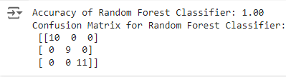

**Code Repository:**

**https://github.com/Roda1458/Decision-Tree**