**Feature Engineering/Preprocessing**

**CSE 303: Machine Learning**

Submitted by

Name: Roda Chinthapalli

Roll No: AP22110011496

Section: CSE-M

Lab Date: 26/08/24

Submission Date: 02/09/24

**Department Computer Science and Engineering**

**School of Engineering and Sciences**

**SRM University–AP**

**Amaravati, Andhra Pradesh – 522 240, India**

1. **Question**

(Provide problem statement with figures if available)

1. **Algorithm Description**

Corresponding concepts (theory -> handwritten, scanned)

(Provide detailed writeup with figures if possible)

1. **Solution**

Dataset used:  
data preprocessing if any

(Add all the code here: provide code and corresponding solution using markdown-cell style)

1. **Code Repository:**

Provide GitHub link for the assignment

**1.Problem statement:**Create a vector (array) of 1XN dimension representing N-dimensional feature vector of a sample. Write a program to compute the mean and variance of the elements present in the array.

Comment what the mean and variance of sample represents.

**code:**

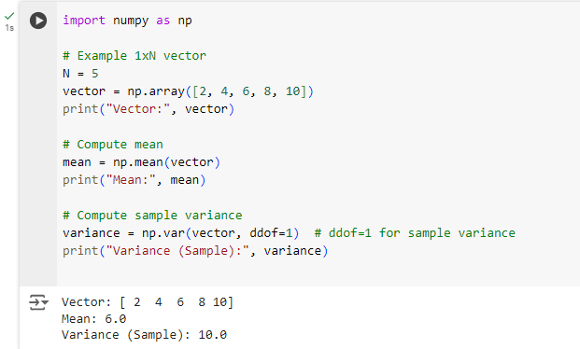

**Comment:**

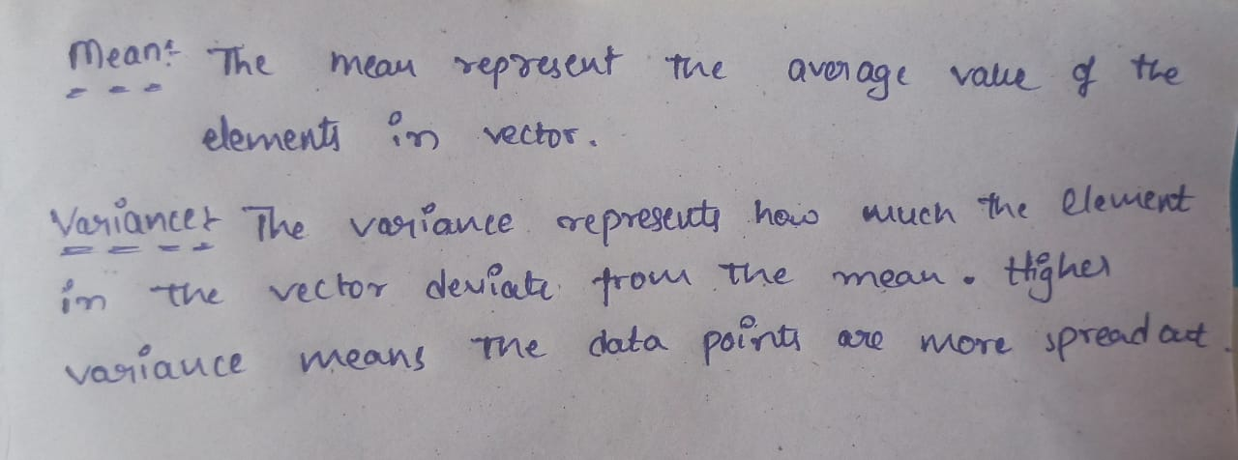

**2.Problem statement:** Create two vectors each of dimension 1XM each representing N-dimensional feature vector of a sample. Write a program to compute the Covariance between them.

Comment what Covariance between two vectors represents.

**Code:**

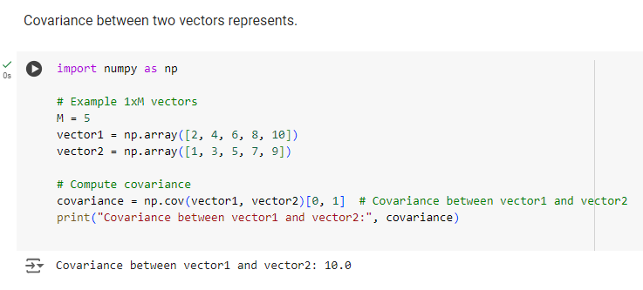

**Comment:**

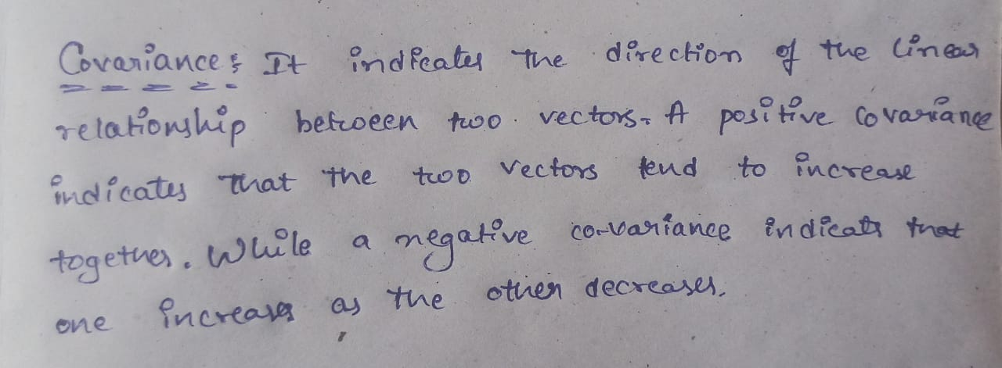

**3.Problem Statement:** Create two vectors each of dimension 1XN. Write a program to compute the Correlation between them.

Comment what the Correlation represents.

**Code:**

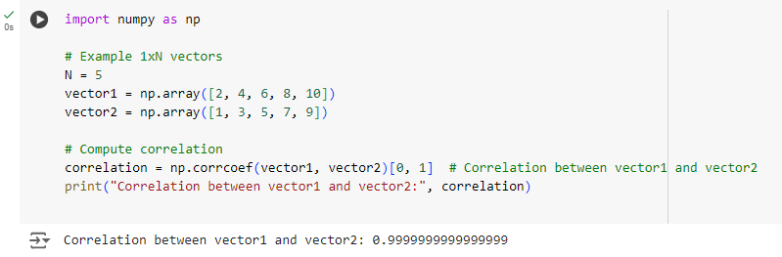

**Comment:**

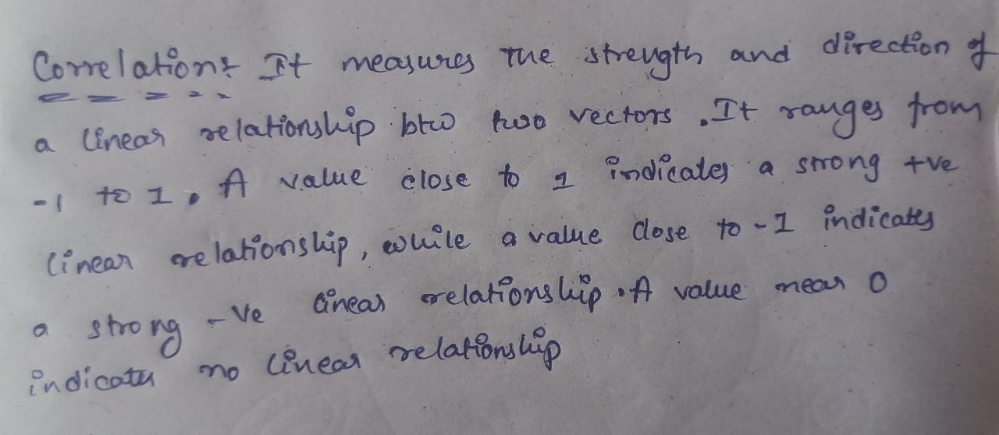

**4.Problem statement:** Create a Matrix of MXN dimension representing the M-dimensional feature vector for N number of samples i. e (i,j)th entry of the matrix represents the ith feature of jth sample. Write a program to compute

the covariance matrix and correlation matrix.

Comment on takeaways from these matrixes.

**Code:**

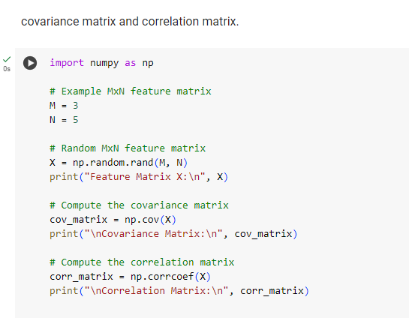

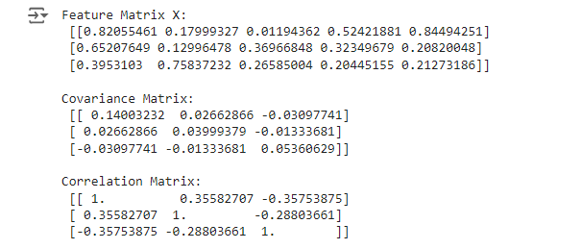

**Comment:**

