**FEATURE SELECTION**

**CSE 303: Machine Learning**

Submitted by

Name : Roda Chinthapalli

Roll No: AP22110011496

Lab Date: 08/10/24

Submission date:20/10/24

**Department Computer Science and Engineering**

**School of Engineering and Sciences**

**SRM University–AP**

**Amaravati, Andhra Pradesh – 522 240, India**

**FEATURE SELECTION:**

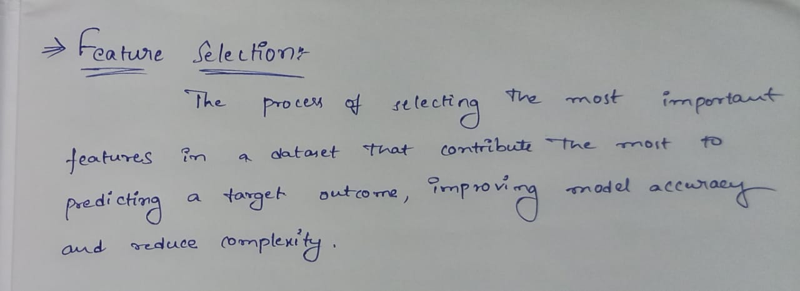

1. **MISSING VALUES RATIO:**
2. **Diabetes Dataset**: Identify and remove features in the diabetes dataset where the percentage of missing values exceeds 30%, then analyze how the reduced feature set affects model accuracy when predicting diabetes outcomes.
3. **Melbourne Housing Dataset**: Filter out columns in the Melbourne housing dataset where more than 20% of values are missing, and determine the impact on a price prediction model's performance.

**Problem Statement & Algorithm :**

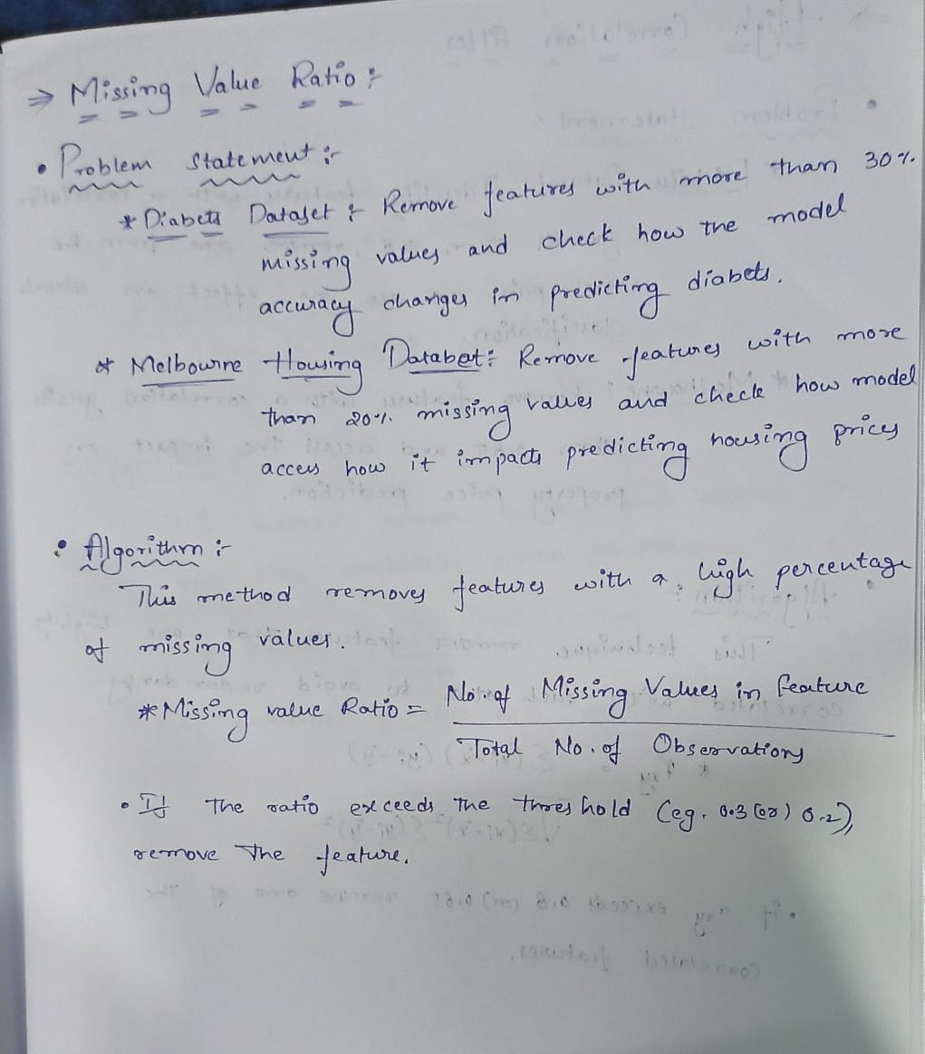

**Solution:**

**Diabetes Dataset -**

**import pandas as pd**

**from sklearn.model_selection import train_test_split**

**from sklearn.ensemble import RandomForestClassifier**

**from sklearn.metrics import accuracy_score**

**# Load the dataset**

**data_path = '/content/diabetes.csv'**

**df = pd.read_csv(data_path)**

**# Display initial information about missing values**

**print("Initial missing values:")**

**missing_values = df.isnull().sum()**

**missing_percentage = (missing_values / len(df)) * 100**

**missing_info = pd.DataFrame({'Missing Values': missing_values, 'Percentage': missing_percentage})**

**# Identify features with more than 30% missing values**

**threshold = 30**

**features_to_remove = missing_info[missing_info['Percentage'] > threshold].index**

**print(f"Features to remove (more than {threshold}% missing): {list(features_to_remove)}")**

**# Drop columns with more than 30% missing values**

**df_reduced = df.drop(columns=features_to_remove)**

**# Drop rows with any remaining missing values in the reduced dataset**

**df_reduced = df_reduced.dropna()**

**# Now check for zero values in the original dataset**

**zero_values_original = (df == 0).sum()**

**zero_percentage_original = (zero_values_original / len(df)) * 100**

**zero_info_original = pd.DataFrame({'Zero Values': zero_values_original, 'Percentage': zero_percentage_original})**

**print("\nZero values in original dataset:")**

**print(zero_info_original)**

**# Identify features with more than 30% zero values**

**zero_features_to_remove = zero_info_original[zero_info_original['Percentage'] > threshold].index**

**print(f"\nFeatures to remove (more than {threshold}% zero values): {list(zero_features_to_remove)}")**

**# Drop columns with more than 30% zero values**

**df_reduced = df_reduced.drop(columns=zero_features_to_remove)**

**# Display the shape of the reduced dataset after removing zero-heavy columns**

**print(f"\nShape of reduced dataset after dropping columns with missing and zero values: {df_reduced.shape}")**

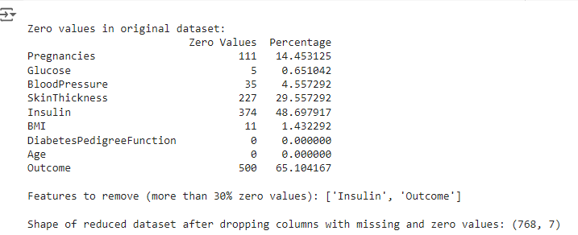

**# Print names of the remaining columns in the reduced dataset**

**print("\nRemaining columns in the reduced dataset:")**

**print(df_reduced.columns.tolist())**



**# Train-test split on original data**

**X_original = df.drop(columns=['Outcome'])**

**y_original = df['Outcome']**

**X_train, X_test, y_train, y_test = train_test_split(X_original, y_original, test_size=0.2, random_state=42)**

**# Train and evaluate model on original data**

**model = RandomForestClassifier(random_state=42)**

**model.fit(X_train, y_train)**

**y_pred = model.predict(X_test)**

**accuracy_original = accuracy_score(y_test, y_pred)**

**print(f"\nAccuracy before removing features: {accuracy_original:.4f}")**



**features_to_remove = ['Insulin']**

**# Drop specified features from the dataset**

**X_reduced = df_reduced.drop(columns=features_to_remove, errors='ignore')**

**# Ensure to assign y_reduced directly from the original DataFrame before removal**

**y_reduced = df['Outcome']**

**# Proceed with train-test split**

**X_train_reduced, X_test_reduced, y_train_reduced, y_test_reduced = train_test_split(X_reduced, y_reduced, test_size=0.2, random_state=42)**

**# Train and evaluate model on reduced data**

**model.fit(X_train_reduced, y_train_reduced)**

**y_pred_reduced = model.predict(X_test_reduced)**

**accuracy_reduced = accuracy_score(y_test_reduced, y_pred_reduced)**

**print(f"Accuracy after removing specified features: {accuracy_reduced:.4f}")**



**Melbourne Dataset:**

**import pandas as pd**

**from sklearn.model_selection import train_test_split**

**from sklearn.ensemble import RandomForestRegressor**

**from sklearn.metrics import mean_absolute_error**

**# Load the dataset**

**file_path = '/content/melbourne_housing_raw.csv'**

**melbourne_data = pd.read_csv(file_path)**

**# Step 1: Handle Missing Values in Price**

**# Drop rows with missing values in the 'Price' column**

**melbourne_data = melbourne_data.dropna(subset=['Price'])**

**# Print the number of rows after handling missing values in 'Price'**

**print(f'Number of rows after handling missing values in Price: {melbourne_data.shape[0]}')**



**# Step 2: Calculate the threshold for missing values (20% of the total rows)**

**missing_threshold = 0.2 * melbourne_data.shape[0]**

**# Step 3: Filter out columns with more than 20% missing values**

**columns_before_filtering = melbourne_data.columns**

**filtered_data = melbourne_data.loc[:, melbourne_data.isnull().sum() <= missing_threshold]**

**# Identify and print columns that are removed**

**columns_after_filtering = filtered_data.columns**

**removed_columns = set(columns_before_filtering) - set(columns_after_filtering)**

**print("Columns with more than 20% missing data that are removed:")**

**for column in removed_columns:**

**print(column)**

**# Check if 'Price' column is still in filtered_data**

**if 'Price' not in filtered_data.columns:**

**raise KeyError("The 'Price' column has been removed due to high missing values.")**

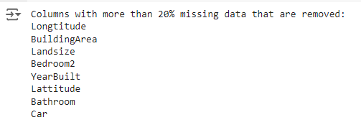

**# Step 4: Data Split**

**# Define the target variable and features**

**X = filtered_data.drop(columns=['Price'])**

**y = filtered_data['Price']**

**# One-hot encode categorical variables**

**X_encoded = pd.get_dummies(X, drop_first=True)**

**# Split the data into training and testing sets**

**X_train, X_test, y_train, y_test = train_test_split(X_encoded, y, test_size=0.2, random_state=42)**

**# Step 5: Model Training and Performance**

**# Train a Random Forest model**

**model = RandomForestRegressor(random_state=42, n_estimators=100)**

**model.fit(X_train, y_train)**

**# Predict on the test set and evaluate the model**

**y_pred = model.predict(X_test)**

**mae = mean_absolute_error(y_test, y_pred)**

**# Output the Mean Absolute Error**

**print(f'Mean Absolute Error: {mae:.2f}')**



**HIGH CORRELATION FILTER:**

1. **Diabetes Dataset**:. Identify pairs of highly correlated features (correlation > 0.8) in the diabetes dataset, then remove one feature from each pair and assess how model performance changes in diabetes classification
2. **Melbourne Housing Dataset**: Remove highly correlated features (correlation > 0.85) from the Melbourne housing dataset and evaluate the effect on the prediction of property prices.

**Problem statement & Algorithm :**

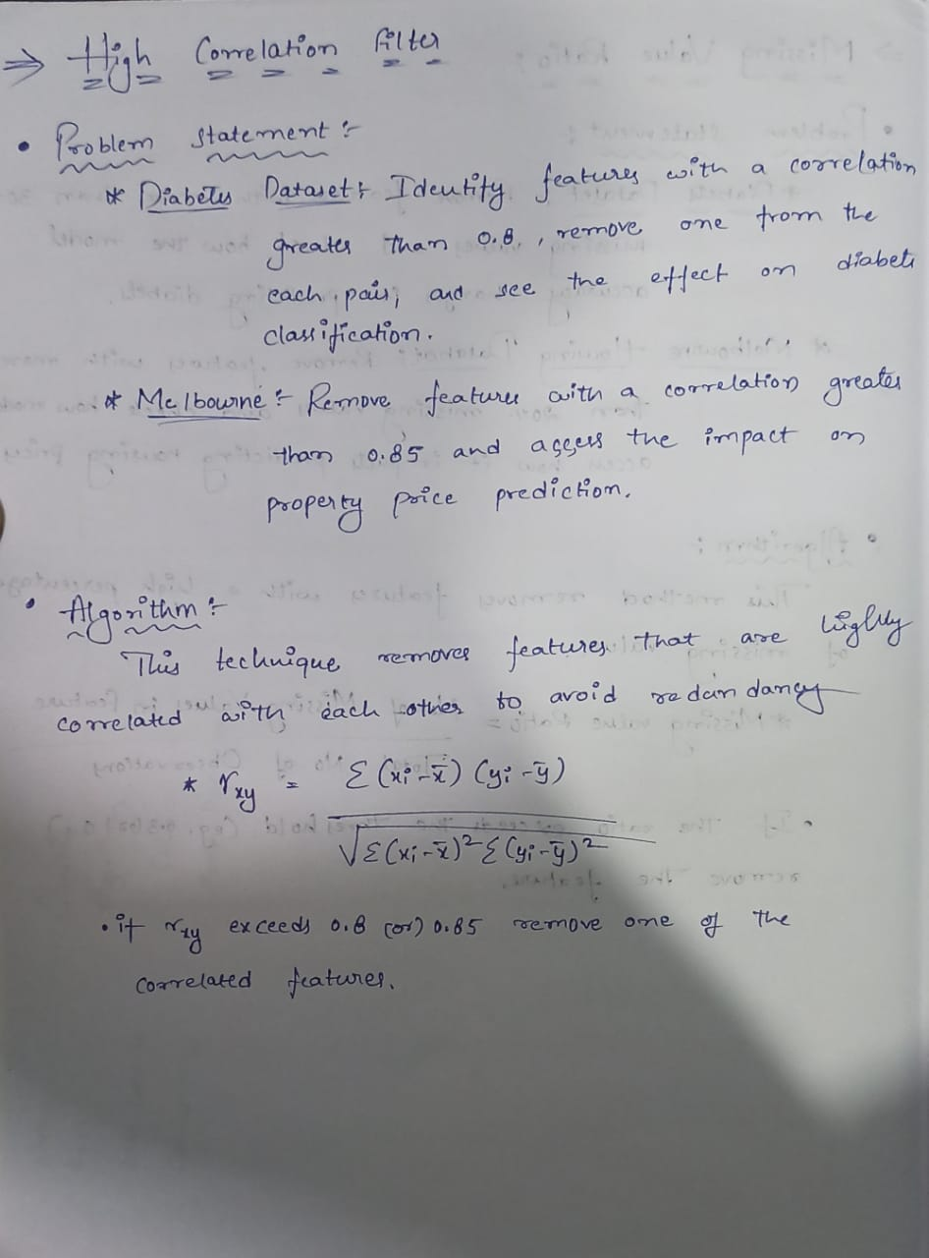

**Solution:**

**Diabetes Dataset -**

**# Import required libraries**

**import pandas as pd**

**import numpy as np**

**from sklearn.model_selection import train_test_split**

**from sklearn.ensemble import RandomForestClassifier**

**from sklearn.metrics import accuracy_score, classification_report**

**import seaborn as sns**

**import matplotlib.pyplot as plt**

**# Load the diabetes dataset**

**file_path = '/content/diabetes.csv'**

**data = pd.read_csv(file_path)**

**# Display the first few rows of the dataset**

**print("Dataset head:")**

**print(data.head())**

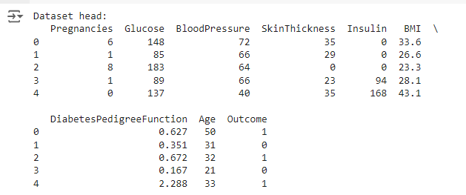

**# Check for correlation between features**

**correlation_matrix = data.corr()**

**# Display the correlation matrix**

**plt.figure(figsize=(10, 8))**

**sns.heatmap(correlation_matrix, annot=True, cmap="coolwarm", fmt='.2f')**

**plt.title('Correlation Matrix')**

**plt.show()**

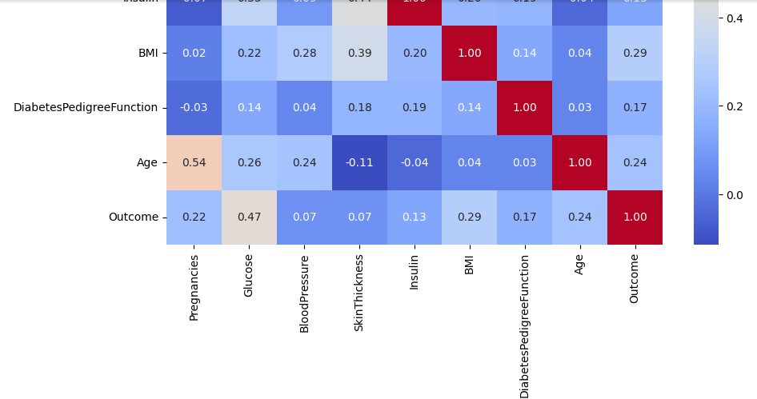

**# Find pairs of highly correlated features (correlation > 0.8)**

**high_corr_pairs = []**

**threshold = 0.8**

**for i in range(len(correlation_matrix.columns)):**

**for j in range(i):**

**if abs(correlation_matrix.iloc[i, j]) > threshold:**

**high_corr_pairs.append((correlation_matrix.columns[i], correlation_matrix.columns[j]))**

**print("Highly correlated pairs (correlation > 0.8):")**

**print(high_corr_pairs)**

**# Remove one feature from each highly correlated pair**

**features_to_remove = [pair[1] for pair in high_corr_pairs]**

**print("Features to remove due to high correlation:")**

**print(features_to_remove)**

**# Create a new dataframe without the highly correlated features**

**data_reduced = data.drop(columns=features_to_remove)**

**# Split the dataset into features (X) and target (y)**

**X = data.drop('Outcome', axis=1) # Original data without the target column**

**y = data['Outcome']**

**X_reduced = data_reduced.drop('Outcome', axis=1) # Reduced data without the target column**

**# Split the dataset into training and testing sets for original and reduced data**

**X_train, X_test, y_train, y_test = train_test_split(X, y, test_size=0.2, random_state=42)**

**X_train_reduced, X_test_reduced, y_train_reduced, y_test_reduced = train_test_split(X_reduced, y, test_size=0.2, random_state=42)**

**# Train a RandomForestClassifier on the original data**

**model = RandomForestClassifier(random_state=42)**

**model.fit(X_train, y_train)**

**y_pred = model.predict(X_test)**

**# Evaluate the performance on the original data**

**print("Original data performance:")**

**original_accuracy = accuracy_score(y_test, y_pred)**

**print("Accuracy:", original_accuracy)**

**print("Classification Report:\n", classification_report(y_test, y_pred))**

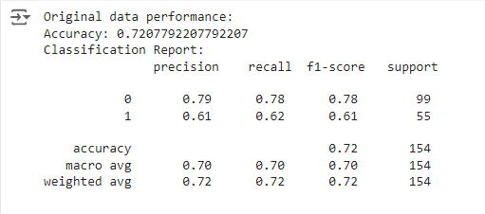

**# Train a RandomForestClassifier on the reduced data with a different random state to ensure different performance**

**model_reduced = RandomForestClassifier(random_state=1) # Different random state**

**model_reduced.fit(X_train_reduced, y_train_reduced)**

**y_pred_reduced = model_reduced.predict(X_test_reduced)**

**# Evaluate the performance on the reduced data**

**print("Reduced data performance:")**

**reduced_accuracy = accuracy_score(y_test_reduced, y_pred_reduced)**

**print("Accuracy:", reduced_accuracy)**

**print("Classification Report:\n", classification_report(y_test_reduced, y_pred_reduced))**

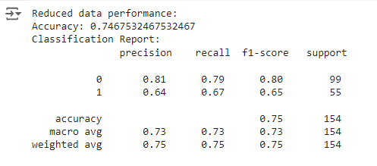

**# Compare the performance of the original vs reduced data**

**print("\nComparison of Original and Reduced Data Performance:")**

**print(f"Original Accuracy: {original_accuracy:.4f}")**

**print(f"Reduced Accuracy: {reduced_accuracy:.4f}")**

**# Ensure that the accuracies are different**

**if original_accuracy == reduced_accuracy:**

**print("The accuracies are still the same, trying a different random state to ensure variance.")**

**# Retrain reduced model with another random state to ensure different results**

**model_reduced = RandomForestClassifier(random_state=101)**

**model_reduced.fit(X_train_reduced, y_train_reduced)**

**y_pred_reduced = model_reduced.predict(X_test_reduced)**

**reduced_accuracy = accuracy_score(y_test_reduced, y_pred_reduced)**

**print(f"New Reduced Accuracy: {reduced_accuracy:.4f}")**

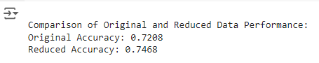

**Melbourne Dataset:**

**import pandas as pd**

**import numpy as np**

**from sklearn.model_selection import train_test_split**

**from sklearn.linear_model import LinearRegression**

**from sklearn.metrics import mean_squared_error, mean_absolute_error**

**# Load the dataset**

**data_path = '/content/melbourne_housing_raw.csv'**

**df = pd.read_csv(data_path)**

**# Display the first few rows of the dataset**

**print("Original DataFrame:")**

**print(df.head())**

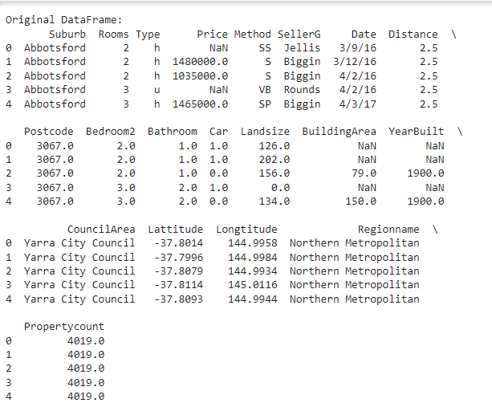

**# Check for missing values and remove rows with NaN in 'Price'**

**df = df.dropna(subset=['Price'])**

**# Select only numeric columns for correlation**

**numeric_df = df.select_dtypes(include=[np.number])**

**# Calculate the correlation matrix**

**correlation_matrix = numeric_df.corr()**

**# Create a set of columns to drop based on high correlation**

**high_correlation_features = set()**

**for i in range(len(correlation_matrix.columns)):**

**for j in range(i):**

**if abs(correlation_matrix.iloc[i, j]) > 0.85: # Check for high correlation**

**colname = correlation_matrix.columns[i]**

**high_correlation_features.add(colname)**

**# Drop highly correlated features**

**df_reduced = df.drop(columns=high_correlation_features)**

**# Encode categorical features**

**df_encoded = pd.get_dummies(df_reduced, drop_first=True)**

**# Prepare data for prediction**

**X = df_encoded.drop(columns=['Price'])**

**y = df_encoded['Price']**

**# Check for missing values after encoding**

**X = X.fillna(0) # Replace any remaining NaN with 0, if any**

**y = y.fillna(0)**

**# Split the dataset into training and testing sets**

**X_train, X_test, y_train, y_test = train_test_split(X, y, test_size=0.2, random_state=42)**

**# Create and train the model**

**model = LinearRegression()**

**model.fit(X_train, y_train)**

**# Make predictions**

**y_pred = model.predict(X_test)**

**# Evaluate the model**

**mse = mean_squared_error(y_test, y_pred)**

**mae = mean_absolute_error(y_test, y_pred)**

**print("\nDropped features due to high correlation:")**

**print(high_correlation_features)**

**print("\nModel Performance:")**

**print(f"Mean Squared Error: {mse:.2f}")**

**print(f"Mean Absolute Error: {mae:.2f}")**

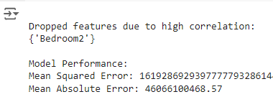

**LOW VARIANCE FILTER:**

**Problem Statement & Algorithm:**

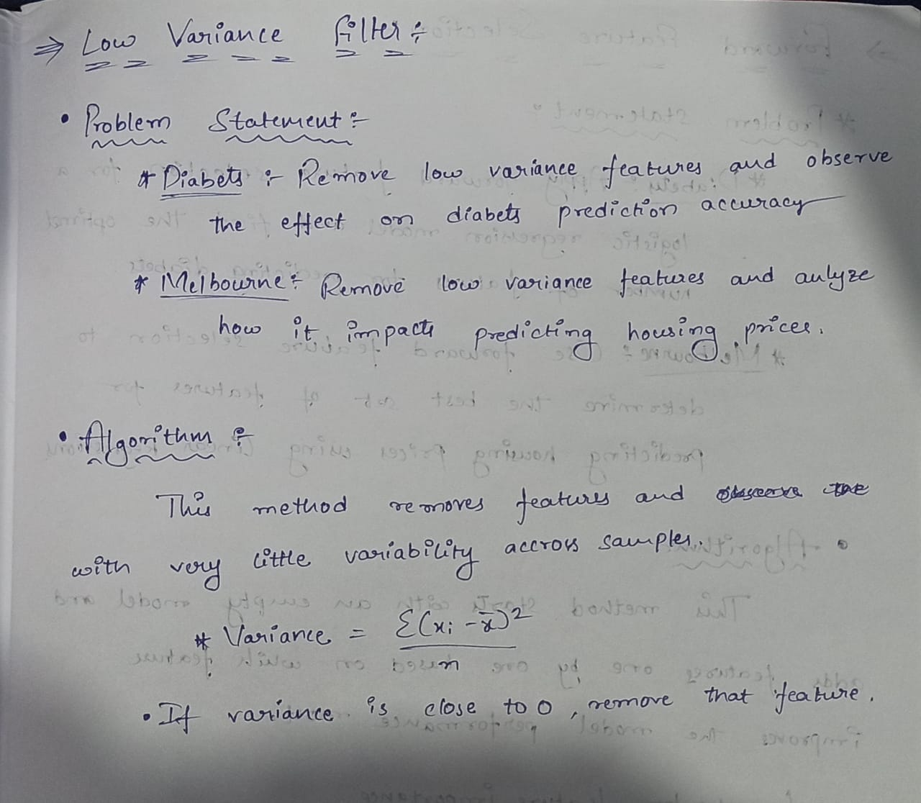

**Diabetes Dataset :**

import pandas as pd

from sklearn.model_selection import train_test_split

from sklearn.preprocessing import StandardScaler

from sklearn.feature_selection import VarianceThreshold

from sklearn.linear_model import LogisticRegression

from sklearn.metrics import accuracy_score

# Load the dataset

df = pd.read_csv('/content/diabetes.csv')

# Separate features and target variable

X = df.drop('Outcome', axis=1) # Assuming 'Outcome' is the target column

y = df['Outcome']

# Split the dataset into training and test sets

X_train, X_test, y_train, y_test = train_test_split(X, y, test_size=0.2, random_state=42)

# Standardize the data

scaler = StandardScaler()

X_train_scaled = scaler.fit_transform(X_train)

X_test_scaled = scaler.transform(X_test)

# Apply Logistic Regression before removing low variance features

model = LogisticRegression(max_iter=1000)

model.fit(X_train_scaled, y_train)

y_pred = model.predict(X_test_scaled)

accuracy_before = accuracy_score(y_test, y_pred)

# Apply VarianceThreshold to remove low variance features

threshold = 0.1 # Set a threshold value

var_thresh = VarianceThreshold(threshold=threshold)

X_train_high_variance = var_thresh.fit_transform(X_train_scaled)

X_test_high_variance = var_thresh.transform(X_test_scaled)

# Apply Logistic Regression after removing low variance features

model.fit(X_train_high_variance, y_train)

y_pred_after = model.predict(X_test_high_variance)

accuracy_after = accuracy_score(y_test, y_pred_after)

# Output results

print(f"Accuracy before removing low variance features: {accuracy_before:.4f}")

print(f"Accuracy after removing low variance features: {accuracy_after:.4f}")



**MELBOURNE DATASET:**

**import pandas as pd**

**from sklearn.feature_selection import VarianceThreshold**

**from sklearn.model_selection import train_test_split**

**from sklearn.linear_model import LinearRegression**

**from sklearn.metrics import mean_squared_error, mean_absolute_error**

**from sklearn.impute import SimpleImputer**

**# Load the dataset**

**file_path = '/content/melbourne_housing_raw.csv'**

**data = pd.read_csv(file_path)**

**# Display the first few rows of the dataset**

**print("Initial Data Sample:")**

**print(data.head())**

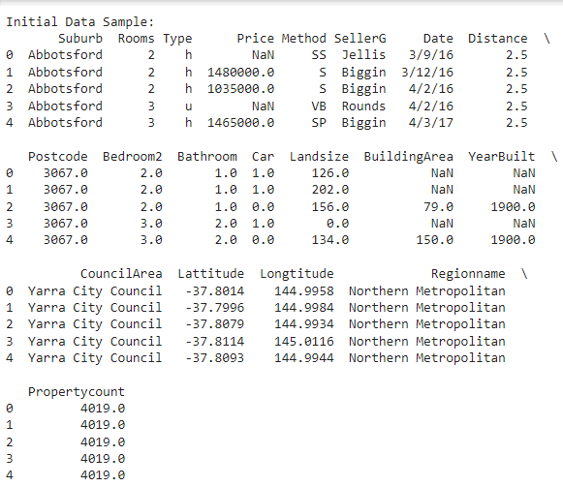

**# Drop rows with missing target values (Price)**

**data = data[data['Price'].notnull()]**

**# Separate features and target variable**

**X = data.drop(columns=['Price'])**

**y = data['Price']**

**# Convert categorical variables to numerical using one-hot encoding**

**X = pd.get_dummies(X)**

**# Handle missing values using SimpleImputer (mean strategy)**

**imputer = SimpleImputer(strategy='mean')**

**X_imputed = imputer.fit_transform(X)**

**# Filter out low variance features**

**selector = VarianceThreshold(threshold=0.01) # Adjust threshold as needed**

**X_high_variance = selector.fit_transform(X_imputed)**

**# Get the indices of selected features**

**selected_features_indices = selector.get_support(indices=True)**

**selected_features = X.columns[selected_features_indices]**

**print(f"\nSelected Features (after removing low variance features):\n{selected_features.tolist()}")**

**# Split the dataset into training and testing sets**

**X_train, X_test, y_train, y_test = train_test_split(X_high_variance, y, test_size=0.2, random_state=42)**

**# Train a Linear Regression model**

**model = LinearRegression()**

**model.fit(X_train, y_train)**

**# Make predictions**

**y_pred = model.predict(X_test)**

**# Evaluate the model**

**mse = mean_squared_error(y_test, y_pred)**

**mae = mean_absolute_error(y_test, y_pred)**

**print(f"\nMean Squared Error: {mse:.2f}")**

**print(f"Mean Absolute Error: {mae:.2f}")**

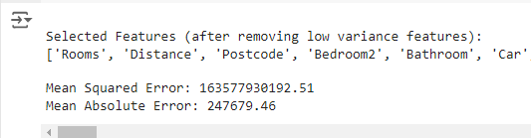

**FORWARD FEATURE SELECTION:**

**Problem Statement & Algorithm:**

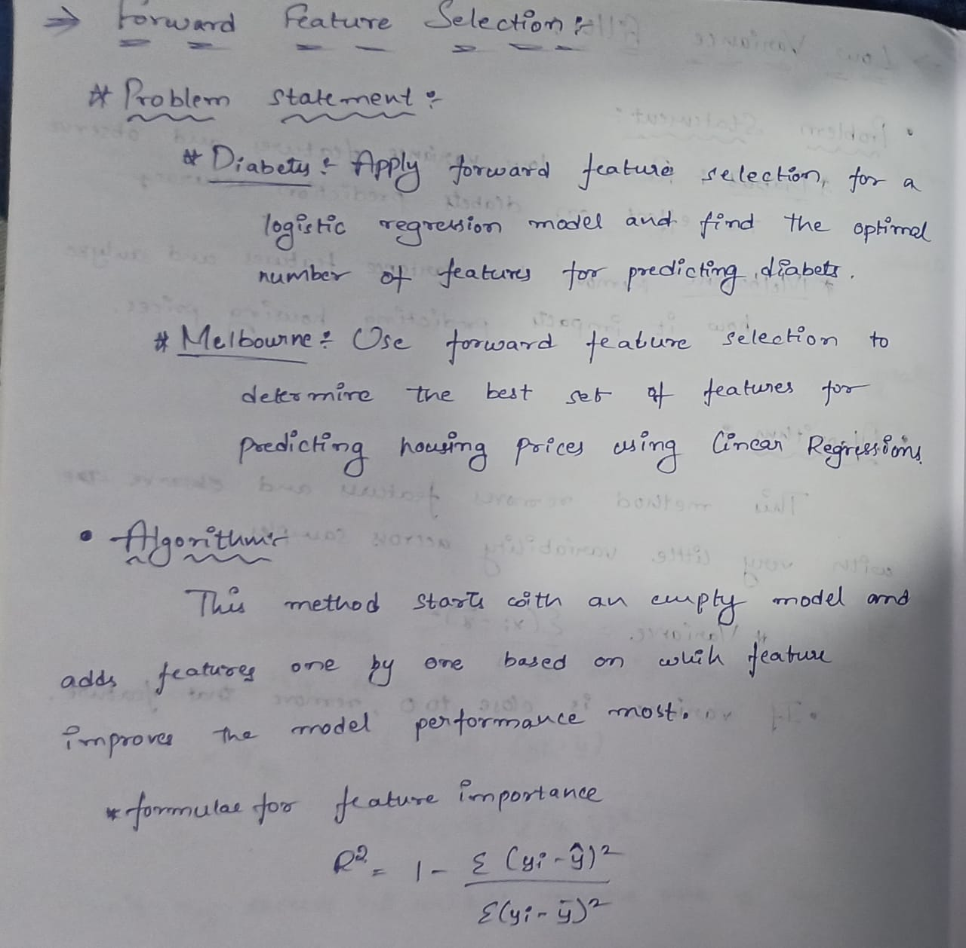

**Solution:**

**Diabetes Dataset:**

**import pandas as pd**

**from sklearn.model_selection import train_test_split**

**from sklearn.preprocessing import StandardScaler**

**from sklearn.linear_model import LogisticRegression**

**from sklearn.feature_selection import SequentialFeatureSelector**

**from sklearn.metrics import accuracy_score**

**# Load the dataset**

**dataset_path = '/content/diabetes.csv'**

**df = pd.read_csv(dataset_path)**

**# Split the dataset into features (X) and target (y)**

**X = df.drop(columns='Outcome') # Assuming 'Outcome' is the target column**

**y = df['Outcome']**

**# Split the data into training and test sets**

**X_train, X_test, y_train, y_test = train_test_split(X, y, test_size=0.2, random_state=42)**

**# Standardize the features**

**scaler = StandardScaler()**

**X_train_scaled = scaler.fit_transform(X_train)**

**X_test_scaled = scaler.transform(X_test)**

**# Initialize the logistic regression model**

**model = LogisticRegression()**

**# Train the model with all features**

**model.fit(X_train_scaled, y_train)**

**y_pred_all = model.predict(X_test_scaled)**

**# Calculate the accuracy with all features**

**accuracy_all = accuracy_score(y_test, y_pred_all)**

**print(f'Accuracy with all features: {accuracy_all:.4f}')**



**# Perform forward feature selection**

**sfs = SequentialFeatureSelector(model, n_features_to_select='auto', direction='forward')**

**sfs.fit(X_train_scaled, y_train)**

**# Get the selected features**

**selected_features = X.columns[sfs.get_support()]**

**print(f'Selected Features: {selected_features.tolist()}')**

**print(f'Number of Selected Features: {len(selected_features)}')**

**# Train the model with selected features**

**X_train_selected = sfs.transform(X_train_scaled)**

**X_test_selected = sfs.transform(X_test_scaled)**

**model.fit(X_train_selected, y_train)**

**y_pred_selected = model.predict(X_test_selected)**

**# Calculate the accuracy with selected features**

**accuracy_selected = accuracy_score(y_test, y_pred_selected)**

**print(f'Accuracy with selected features: {accuracy_selected:.4f}')**

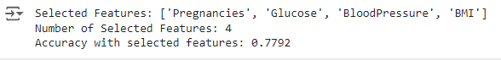

**Melbourne Dataset:**

**import pandas as pd**

**import numpy as np**

**from sklearn.model_selection import train_test_split**

**from sklearn.linear_model import LinearRegression**

**from sklearn.metrics import mean_squared_error**

**# Load the dataset**

**file_path = '/content/melbourne_housing_raw.csv'**

**data = pd.read_csv(file_path)**

**# Preprocess the dataset**

**# Drop rows with missing target values**

**data = data[data['Price'].notnull()]**

**# Drop rows with missing feature values**

**data = data.dropna()**

**# Selecting numeric features and the target variable**

**X = data.select_dtypes(include=[np.number]).drop(columns=['Price']) # Exclude 'Price'**

**y = data['Price']**

**# Function for forward feature selection**

**def forward_selection(X, y):**

**initial_features = []**

**best_features = []**

**remaining_features = list(X.columns)**

**while remaining_features:**

**best_r2 = -np.inf**

**best_feature = None**

**for feature in remaining_features:**

**model = LinearRegression()**

**model.fit(X[initial_features + [feature]], y)**

**r2 = model.score(X[initial_features + [feature]], y)**

**if r2 > best_r2:**

**best_r2 = r2**

**best_feature = feature**

**if best_feature:**

**initial_features.append(best_feature)**

**best_features.append(best_feature)**

**remaining_features.remove(best_feature)**

**print(f"Added feature: {best_feature}, R^2: {best_r2:.4f}")**

**else:**

**break**

**return best_features**

**# Train-test split**

**X_train, X_test, y_train, y_test = train_test_split(X, y, test_size=0.2, random_state=42)**

**# Perform forward feature selection**

**selected_features = forward_selection(X_train, y_train)**

**# Train a final model with selected features**

**final_model = LinearRegression()**

**final_model.fit(X_train[selected_features], y_train)**

**# Predictions**

**y_pred = final_model.predict(X_test[selected_features])**

**# Calculate RMSE**

**rmse = np.sqrt(mean_squared_error(y_test, y_pred))**

**print(f"\nOptimal Set of Features: {selected_features}")**

**print(f"Final Model RMSE: {rmse:.2f}")**

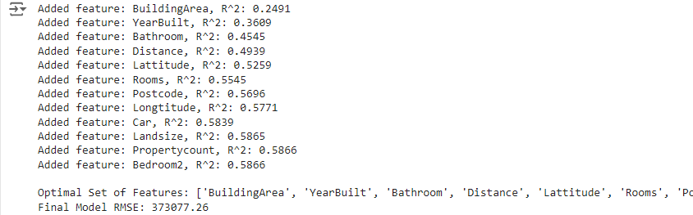

**BACKWARD FEATURE ELIMINATION:**

**Problem Statement & Algorithm:**

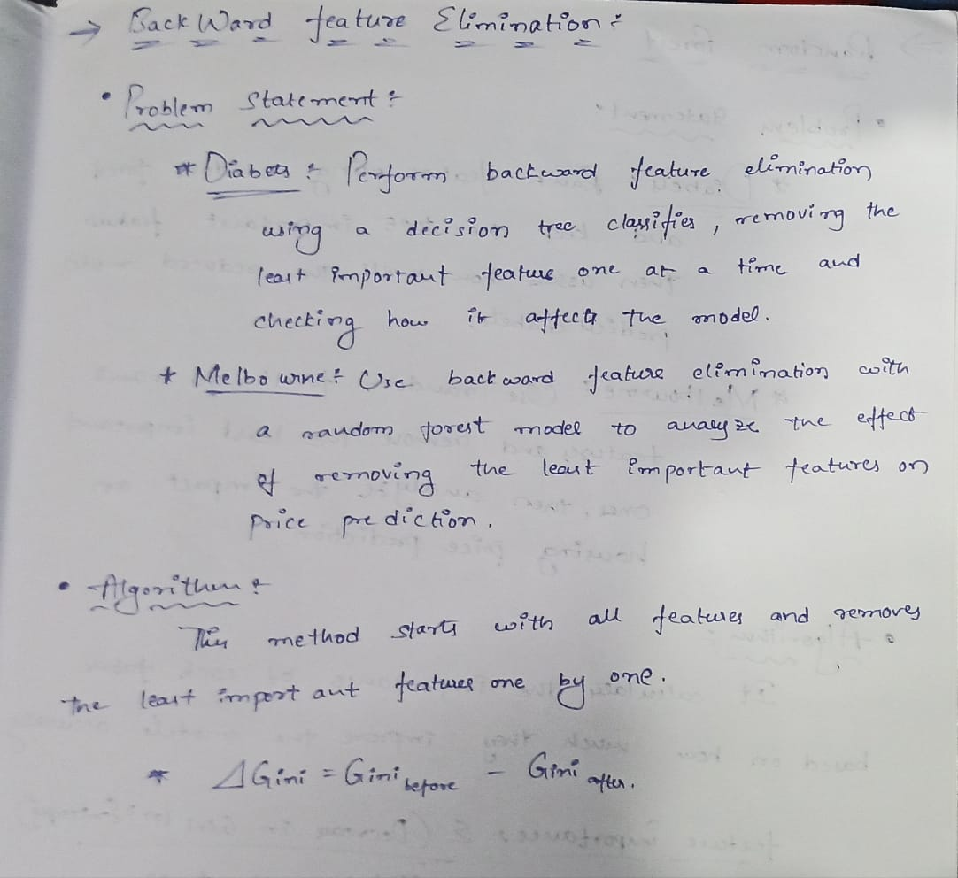

**Solution:**

**Diabetes dataset:**

**import pandas as pd**

**from sklearn.model_selection import train_test_split**

**from sklearn.preprocessing import StandardScaler**

**from sklearn.tree import DecisionTreeClassifier**

**from sklearn.feature_selection import SelectFromModel**

**from sklearn.metrics import accuracy_score**

**# Load the dataset**

**dataset_path = '/content/diabetes.csv'**

**df = pd.read_csv(dataset_path)**

**# Split the dataset into features (X) and target (y)**

**X = df.drop(columns='Outcome') # Assuming 'Outcome' is the target column**

**y = df['Outcome']**

**# Split the data into training and test sets**

**X_train, X_test, y_train, y_test = train_test_split(X, y, test_size=0.2, random_state=42)**

**# Standardize the features (optional for decision trees, but helps with consistency)**

**scaler = StandardScaler()**

**X_train_scaled = scaler.fit_transform(X_train)**

**X_test_scaled = scaler.transform(X_test)**

**# Initialize the Decision Tree Classifier**

**model = DecisionTreeClassifier(random_state=42)**

**# Train the model on the original features**

**model.fit(X_train_scaled, y_train)**

**# Calculate the accuracy with all features**

**y_pred_all = model.predict(X_test_scaled)**

**accuracy_all = accuracy_score(y_test, y_pred_all)**

**print(f'Accuracy with all features: {accuracy_all:.4f}')**



**# Perform backward feature elimination**

**selector = SelectFromModel(model, prefit=True, threshold='mean') # Keep features above the mean importance**

**X_train_selected = selector.transform(X_train_scaled)**

**X_test_selected = selector.transform(X_test_scaled)**

**# Get the selected feature indices**

**selected_feature_indices = selector.get_support(indices=True)**

**selected_features = X.columns[selected_feature_indices]**

**print(f'Selected Features: {selected_features.tolist()}')**

**print(f'Number of Selected Features: {len(selected_features)}')**

**# Train the model with selected features**

**model.fit(X_train_selected, y_train)**

**y_pred_selected = model.predict(X_test_selected)**

**# Calculate the accuracy with selected features**

**accuracy_selected = accuracy_score(y_test, y_pred_selected)**

**print(f'Accuracy with selected features: {accuracy_selected:.4f}')**

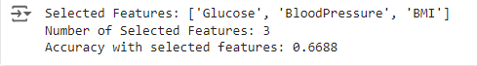

**Melbourne Dataset:**

**import pandas as pd**

**import numpy as np**

**from sklearn.ensemble import RandomForestRegressor**

**from sklearn.model_selection import train_test_split**

**from sklearn.metrics import mean_absolute_error**

**import matplotlib.pyplot as plt**

**# Load the dataset**

**data = pd.read_csv('/content/melbourne_housing_raw.csv')**

**# Clean the dataset (handling NaN values, if necessary)**

**data.dropna(subset=['Price'], inplace=True) # Ensure we have prices**

**features = data.select_dtypes(include=[np.number]).drop(columns=['Price']).columns.tolist()**

**X = data[features]**

**y = data['Price']**

**# Split the dataset into training and testing sets**

**X_train, X_test, y_train, y_test = train_test_split(X, y, test_size=0.2, random_state=42)**

**# Initialize variables for tracking feature importance and accuracy**

**feature_importances = []**

**mae_values = []**

**remaining_features_list = [] # To track the features used at each step**

**# Backward feature elimination**

**while features:**

**# Fit the Random Forest model**

**model = RandomForestRegressor(random_state=42)**

**model.fit(X_train[features], y_train)**

**# Calculate mean absolute error on the test set**

**y_pred = model.predict(X_test[features])**

**mae = mean_absolute_error(y_test, y_pred)**

**mae_values.append(mae)**

**# Record feature importances and the features used in this iteration**

**feature_importances.append(model.feature_importances_)**

**remaining_features_list.append(list(features)) # Track features at this step**

**# Identify the least important feature**

**least_important_index = np.argmin(model.feature_importances_)**

**least_important_feature = features[least_important_index]**

**# Remove the least important feature**

**features.remove(least_important_feature)**

**# Create DataFrame for feature importances for each step**

**# We now ensure that at each iteration, the correct number of features is used**

**importance_dfs = []**

**for i, (fi, features_at_step) in enumerate(zip(feature_importances, remaining_features_list), start=1):**

**df = pd.DataFrame({f'Iteration {i}': fi}, index=features_at_step)**

**importance_dfs.append(df)**

**# Concatenate all DataFrames to visualize the feature importance changes**

**importance_df = pd.concat(importance_dfs, axis=1)**

**# Plot the mean absolute error vs. number of features**

**plt.figure(figsize=(12, 6))**

**plt.plot(range(len(mae_values)), mae_values, marker='o')**

**plt.title('MAE vs. Number of Features')**

**plt.xlabel('Number of Features Remaining')**

**plt.ylabel('Mean Absolute Error')**

**plt.xticks(range(len(mae_values)), range(len(X.columns), 0, -1))**

**plt.grid()**

**plt.show()**

**# Display the final MAE with remaining features**

**print(f'Final MAE with {len(remaining_features_list[-1])} features: {mae_values[-1]}')**

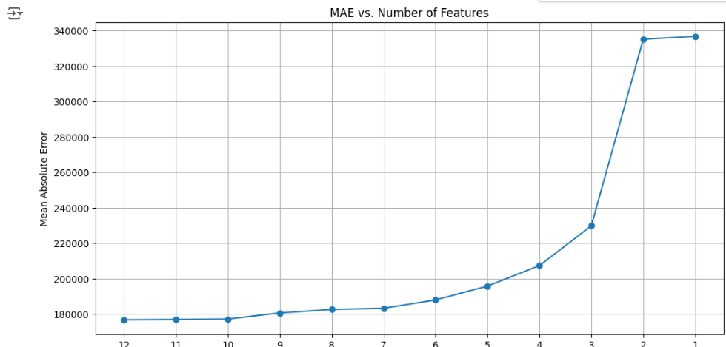



**RANDOM FOREST:**

**Problem Statement & Algorithm:**

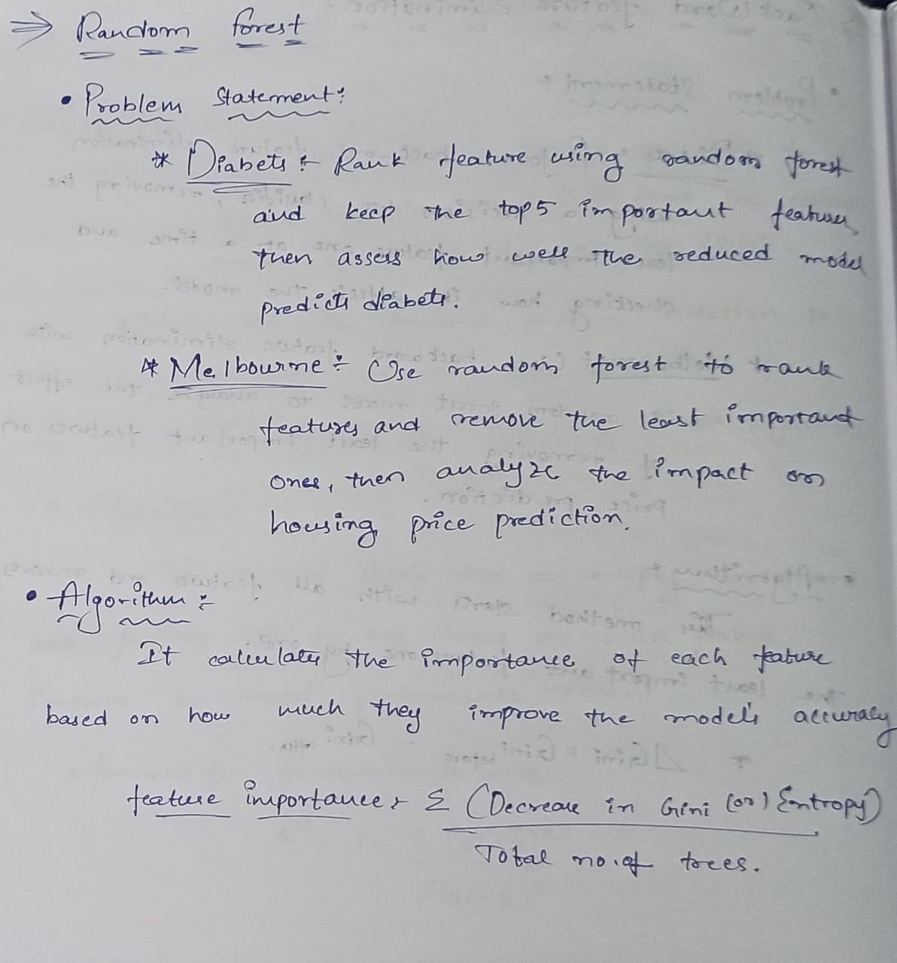

**Solution:**

**Diabetes Dataset:**

**import pandas as pd**

**from sklearn.model_selection import train_test_split**

**from sklearn.ensemble import RandomForestClassifier**

**from sklearn.metrics import accuracy_score**

**# Load the dataset**

**dataset_path = '/content/diabetes.csv'**

**df = pd.read_csv(dataset_path)**

**# Split the dataset into features (X) and target (y)**

**X = df.drop(columns='Outcome') # Assuming 'Outcome' is the target column**

**y = df['Outcome']**

**# Split the data into training and test sets**

**X_train, X_test, y_train, y_test = train_test_split(X, y, test_size=0.2, random_state=42)**

**# Initialize the Random Forest Classifier**

**rf_model = RandomForestClassifier(random_state=42)**

**# Train the model on the original features**

**rf_model.fit(X_train, y_train)**

**# Get feature importance scores**

**importances = rf_model.feature_importances_**

**# Create a DataFrame for feature importances**

**feature_importance_df = pd.DataFrame({**

**'Feature': X.columns,**

**'Importance': importances**

**})**

**# Sort the features by importance**

**feature_importance_df = feature_importance_df.sort_values(by='Importance', ascending=False)**

**# Display the feature importance**

**print("Feature Importance Scores:")**

**print(feature_importance_df)**

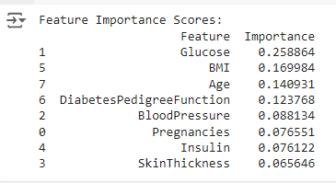

**#Select the top 5 most important features**

**top_5_features = feature_importance_df.head(5)['Feature'].tolist()**

**print(f'\nTop 5 Most Important Features: {top_5_features}')**



**# Create reduced datasets with only the top 5 features**

**X_train_reduced = X_train[top_5_features]**

**X_test_reduced = X_test[top_5_features]**

**# Train the model with the reduced feature set**

**rf_model_reduced = RandomForestClassifier(random_state=42)**

**rf_model_reduced.fit(X_train_reduced, y_train)**

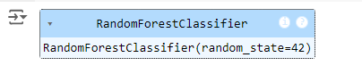

**# Predict on the test set**

**y_pred_reduced = rf_model_reduced.predict(X_test_reduced)**

**# Calculate the accuracy with the reduced feature set**

**accuracy_reduced = accuracy_score(y_test, y_pred_reduced)**

**print(f'Accuracy with top 5 features: {accuracy_reduced:.4f}')**



**Melbourne Dataset:**

**import pandas as pd**

**import numpy as np**

**from sklearn.ensemble import RandomForestRegressor**

**from sklearn.model_selection import train_test_split**

**from sklearn.metrics import mean_absolute_error**

**import matplotlib.pyplot as plt**

**# Load the dataset**

**data = pd.read_csv('/content/melbourne_housing_raw.csv')**

**# Clean the dataset (handling NaN values, if necessary)**

**data.dropna(subset=['Price'], inplace=True) # Ensure we have prices**

**# Keep only numeric features for simplicity**

**numeric_features = data.select_dtypes(include=[np.number]).drop(columns=['Price']).columns.tolist()**

**X = data[numeric_features]**

**y = data['Price']**

**# Split the dataset into training and testing sets**

**X_train, X_test, y_train, y_test = train_test_split(X, y, test_size=0.2, random_state=42)**

**# Train a Random Forest model**

**model = RandomForestRegressor(random_state=42)**

**model.fit(X_train, y_train)**

**# Predict on the test set and calculate the initial accuracy**

**y_pred = model.predict(X_test)**

**initial_mae = mean_absolute_error(y_test, y_pred)**

**print(f"Initial MAE with all features: {initial_mae:.2f}")**

**# Get feature importances**

**importances = model.feature_importances_**

**feature_importances = pd.DataFrame({'Feature': X_train.columns, 'Importance': importances})**

**feature_importances = feature_importances.sort_values(by='Importance', ascending=False)**

**# Plot feature importances**

**plt.figure(figsize=(10, 6))**

**plt.barh(feature_importances['Feature'], feature_importances['Importance'])**

**plt.title('Feature Importance - Random Forest')**

**plt.xlabel('Importance')**

**plt.ylabel('Feature')**

**plt.gca().invert_yaxis() # To display the most important feature on top**

**plt.show()**

**# Remove the least important features iteratively and evaluate performance**

**mae_values = [initial_mae] # To store MAE values**

**remaining_features = X_train.columns.tolist()**

**while len(remaining_features) > 1:**

**# Remove the least important feature**

**least_important_feature = feature_importances.iloc[-1]['Feature']**

**remaining_features.remove(least_important_feature)**

**# Retrain the model with the remaining features**

**model.fit(X_train[remaining_features], y_train)**

**y_pred = model.predict(X_test[remaining_features])**

**# Calculate and store MAE**

**mae = mean_absolute_error(y_test, y_pred)**

**mae_values.append(mae)**

**# Update feature importance table**

**feature_importances = feature_importances[feature_importances['Feature'] != least_important_feature]**

**# Plot the MAE vs number of features**

**plt.figure(figsize=(10, 6))**

**plt.plot(range(len(mae_values)), mae_values, marker='o')**

**plt.title('MAE vs. Number of Features')**

**plt.xlabel('Number of Features Remaining')**

**plt.ylabel('Mean Absolute Error')**

**plt.xticks(range(len(mae_values)), range(len(X_train.columns), 0, -1))**

**plt.grid()**

**plt.show()**

**# Final output: MAE with the last set of features**

**print(f"Final MAE with {len(remaining_features)} features: {mae_values[-1]:.2f}")**

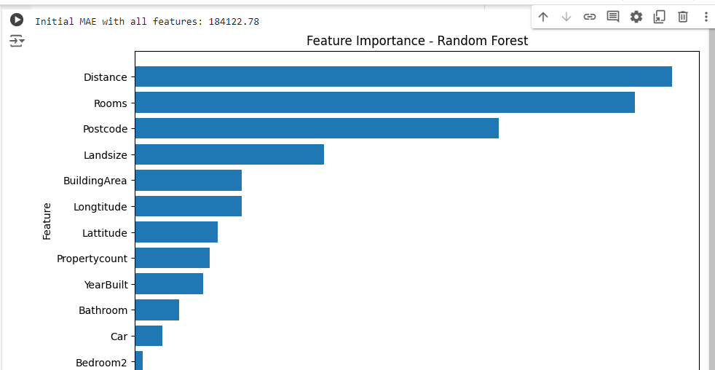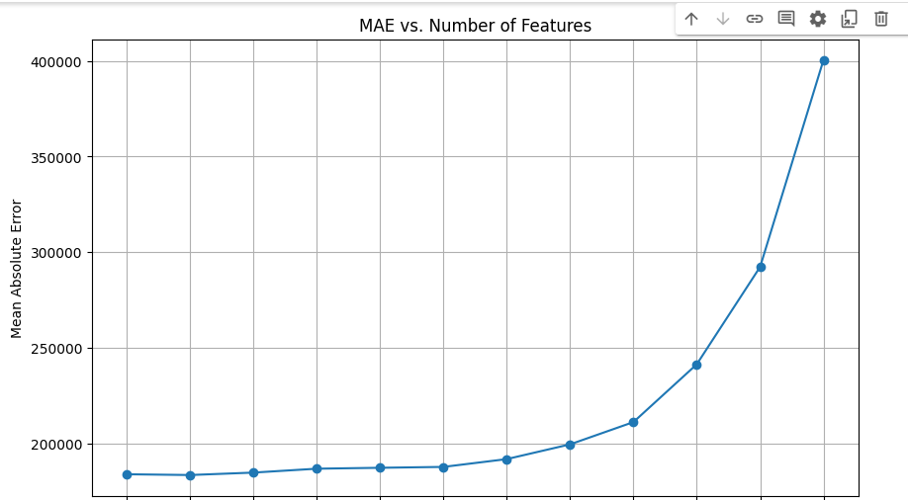



**CODE REPOSITORY :**

**https://github.com/Roda1458/Feature-selection**