**LINEAR DISCRIMINANT ANALYSIS(LDA)**

**CSE 303: Machine Learning**

Submitted by

Name:Roda Chinthapalli

Roll No: AP22110011496

Section -M

Lab Date: 22/10/24

Submission Date:28/10/24

**Department Computer Science and Engineering**

**School of Engineering and Sciences**

**SRM University–AP**

**Amaravati, Andhra Pradesh – 522 240, India**

**LINEAR DISCRIMINANT ANALYSIS(LDA)**

**LDA**

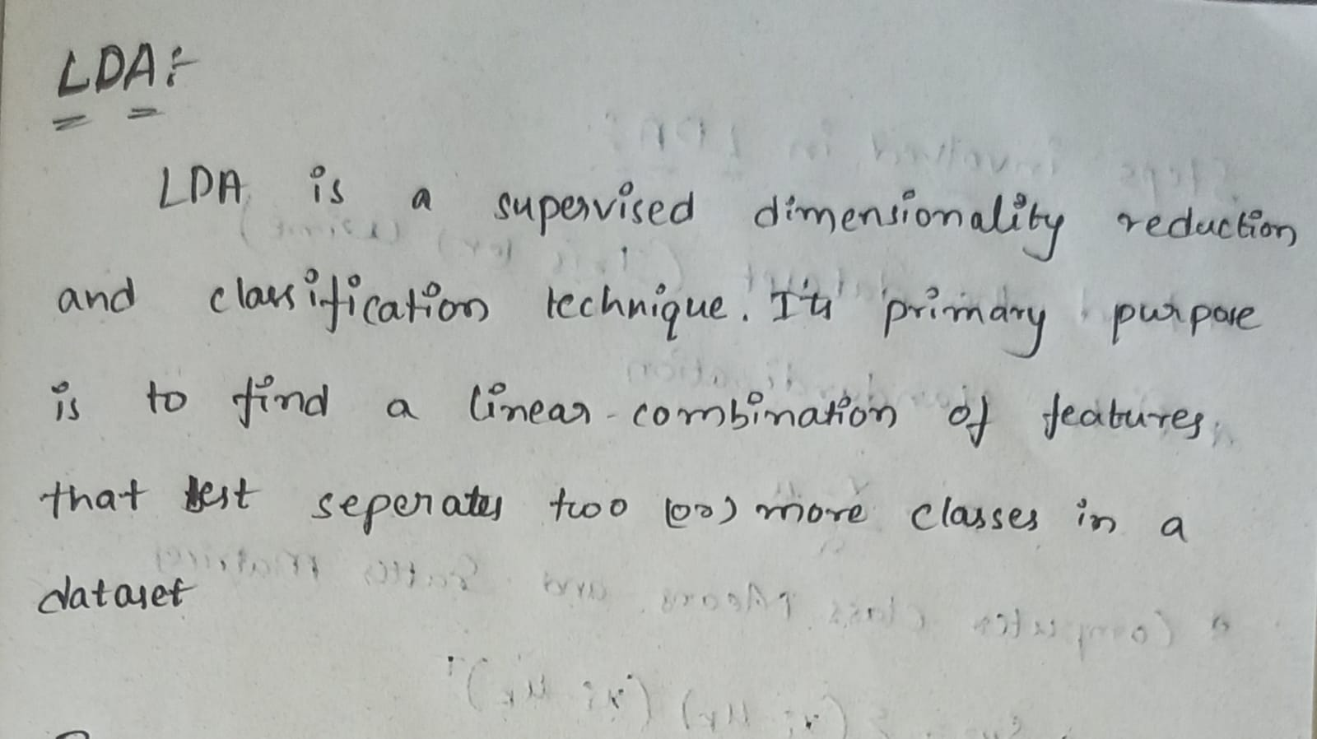

**STEPS INVOLVED IN LDA**

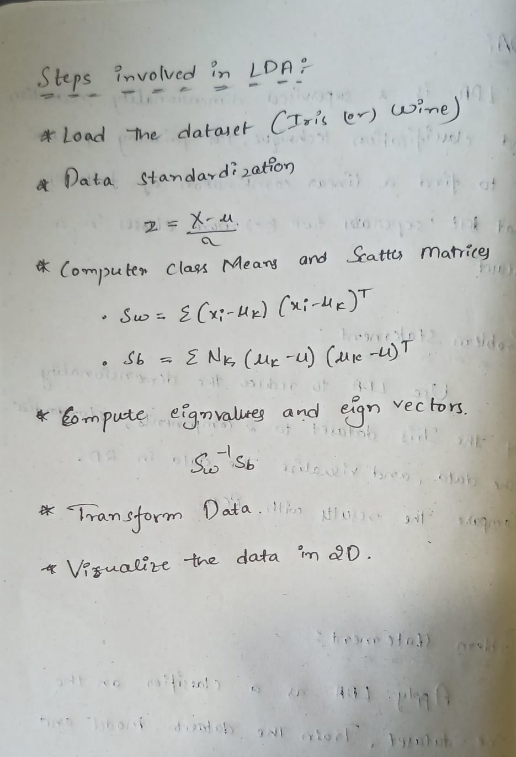

**Lab Exercise 1: Introduction to LDA for Dimensionality Reduction**

**Objective:** Understand the basic principles of LDA and apply it to reduce the dimensionality of a simple classification dataset.

**Instructions:**

**1. Load the Dataset:**

o Use the Iris dataset (available in sklearn or seaborn). The dataset has 4 features and 3 classes.

**2. Data Standardization:**

o Standardize the data so that it has a mean of 0 and a standard deviation of 1.

**3. Apply LDA:**

o Implement LDA using sklearn&#39;s LinearDiscriminantAnalysis class. Reduce the dimensionality of the dataset to 2

components.

**4. Visualization:**

o Create a 2D scatter plot of the transformed data, using different colors for each class.

**5. Compare LDA with PCA:**

o Plot the first two components from PCA (from the previous lab if done) on the same dataset and compare the

results with LDA.

**PROBLEM STATEMENT:**

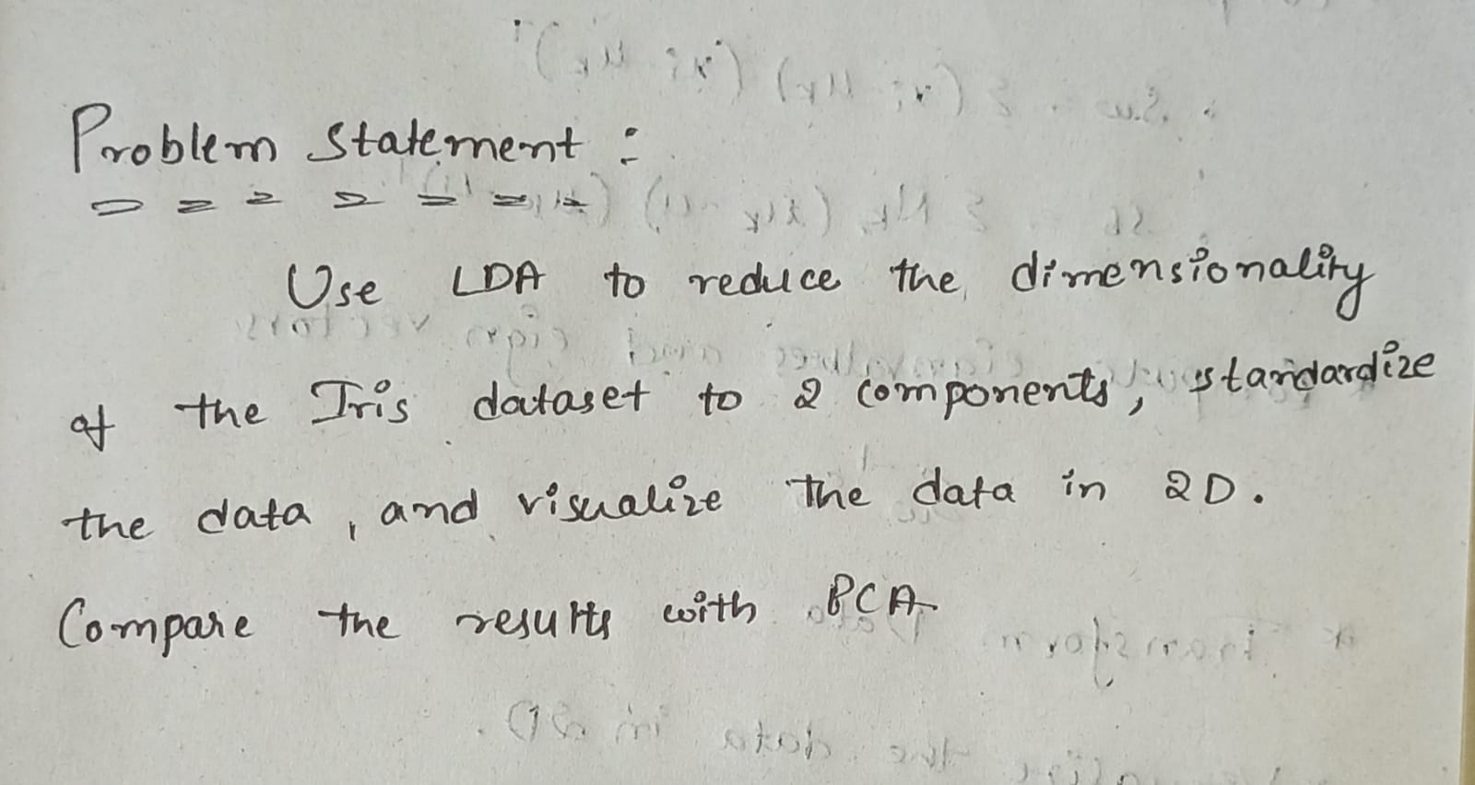

**SOLUTION:**

**Dataset: Iris**

**Load the Dataset**

**import pandas as pd**

**# Load dataset from your file path**

**iris = pd.read_csv('/content/iris.csv')**

**X = iris.iloc[:, :-1] # Features (first 4 columns)**

**y = iris.iloc[:, -1] # Target (last column for species)**

**Data Standardisation**

**from sklearn.preprocessing import StandardScaler**

**scaler = StandardScaler()**

**X_scaled = scaler.fit_transform(X)**

**Apply LDA**

**from sklearn.discriminant_analysis import LinearDiscriminantAnalysis as LDA**

**lda = LDA(n_components=2)**

**X_lda = lda.fit_transform(X_scaled, y)**

**Visulization**

**import matplotlib.pyplot as plt**

**import seaborn as sns**

**# Create a DataFrame for plotting**

**lda_df = pd.DataFrame(X_lda, columns=['LD1', 'LD2'])**

**lda_df['Target'] = y**

**# Plot the LDA components**

**sns.scatterplot(x='LD1', y='LD2', hue='Target', data=lda_df, palette='Set1')**

**plt.title('LDA: 2 components')**

**plt.show()**

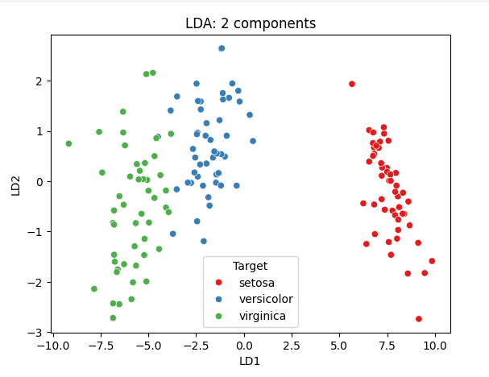

**Compare LDA with PCA**

**from sklearn.decomposition import PCA**

**pca = PCA(n_components=2)**

**X_pca = pca.fit_transform(X_scaled)**

**# Create a DataFrame for PCA plotting**

**pca_df = pd.DataFrame(X_pca, columns=['PC1', 'PC2'])**

**pca_df['Target'] = y**

**# Plot PCA components**

**sns.scatterplot(x='PC1', y='PC2', hue='Target', data=pca_df, palette='Set2')**

**plt.title('PCA: 2 components')**

**plt.show()**

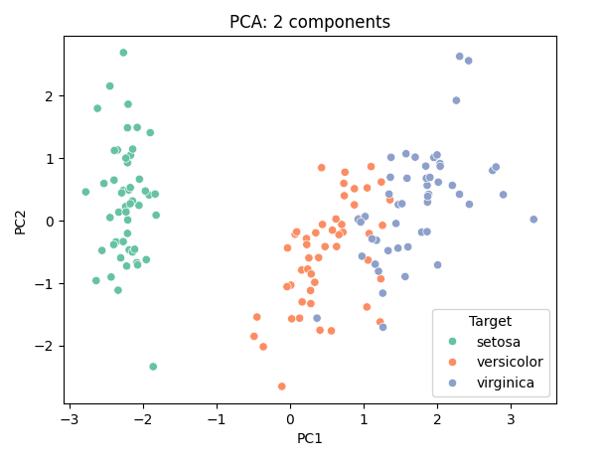

Lab Exercise 2: LDA for Classification

**Objective:** Learn how LDA can be used as a classifier by applying it to a multi-class classification problem.

**Instructions:**

**1. Load the Dataset:**

o Use the Wine dataset from sklearn, which contains 13 features and 3 classes.

**2. Split the Data:**

o Split the data into training and testing sets (e.g., 70% training, 30% testing).

**3. Train an LDA Model:**

o Use LDA as a classifier by training a LinearDiscriminantAnalysis model on the training data.

**4. Evaluate the Model:**

o Predict the labels on the test set and compute the model&#39;s accuracy, precision, recall, and confusion matrix.

**5. Compare with Logistic Regression:**

o Train a logistic regression model on the same dataset, and compare its performance with the LDA classifier.

**6. Visualize Decision Boundaries (Optional):**

o For an intuitive understanding, visualize the decision boundaries for both the LDA and logistic regression

models in a 2D space (you can reduce the dataset to 2 dimensions using LDA or PCA for visualization

purposes).

**PROBLEM STATEMENT:**

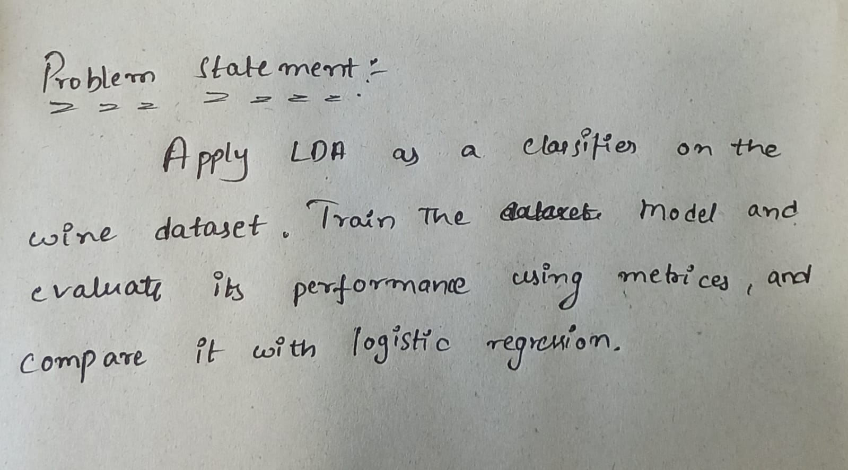

**SOLUTION:**

**Dataset: Wine**

**Load the Data**

**import pandas as pd**

**from zipfile import ZipFile**

**# Load dataset from zip file**

**with ZipFile('/content/wine.zip', 'r') as zip_ref:**

**zip_ref.extractall('/content')**

**# Read the dataset**

**wine = pd.read_csv('//content/winequality-red.csv')**

**X = wine.iloc[:, :-1] # Features (first 13 columns)**

**y = wine.iloc[:, -1] # Target (last column for wine class)**

**Split the Data**

**from sklearn.model_selection import train_test_split**

**X_train, X_test, y_train, y_test = train_test_split(X, y, test_size=0.3, random_state=42)**

**Train an LDA Model**

**from sklearn.discriminant_analysis import LinearDiscriminantAnalysis as LDA**

**lda = LDA()**

**lda.fit(X_train, y_train)**

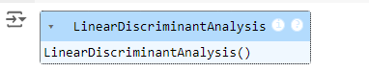

**Evaluate the Model**

**# Compute evaluation metrics with zero_division parameter**

**precision = precision_score(y_test, y_pred, average='weighted', zero_division=0)**

**recall = recall_score(y_test, y_pred, average='weighted', zero_division=0)**

**print(f'Accuracy: {accuracy:.2f}')**

**print(f'Precision: {precision:.2f}')**

**print(f'Recall: {recall:.2f}')**

**print('Confusion Matrix:\n', conf_matrix)**

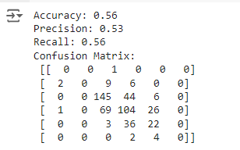

**Compare the Logistic Regression**

**# Import necessary libraries**

**from sklearn.model_selection import train_test_split**

**from sklearn.preprocessing import StandardScaler**

**from sklearn.linear_model import LogisticRegression**

**from sklearn.metrics import accuracy_score, precision_score, recall_score, confusion_matrix**

**# Assuming you have already loaded the dataset into X and y**

**# Example: X, y = load_wine(return_X_y=True)**

**# Split the dataset into training and testing sets (70% train, 30% test)**

**X_train, X_test, y_train, y_test = train_test_split(X, y, test_size=0.3, random_state=42)**

**# Standardize the data**

**scaler = StandardScaler()**

**X_train_scaled = scaler.fit_transform(X_train)**

**X_test_scaled = scaler.transform(X_test)**

**# Train Logistic Regression model with increased max_iter**

**logreg = LogisticRegression(max_iter=1000)**

**logreg.fit(X_train_scaled, y_train)**

**# Make predictions**

**y_pred_logreg = logreg.predict(X_test_scaled)**

**# Compute evaluation metrics**

**accuracy_logreg = accuracy_score(y_test, y_pred_logreg)**

**precision_logreg = precision_score(y_test, y_pred_logreg, average='weighted', zero_division=0)**

**recall_logreg = recall_score(y_test, y_pred_logreg, average='weighted', zero_division=0)**

**conf_matrix_logreg = confusion_matrix(y_test, y_pred_logreg)**

**# Print evaluation metrics**

**print(f'Logistic Regression Accuracy: {accuracy_logreg:.2f}')**

**print(f'Logistic Regression Precision: {precision_logreg:.2f}')**

**print(f'Logistic Regression Recall: {recall_logreg:.2f}')**

**print('Logistic Regression Confusion Matrix:\n', conf_matrix_logreg)**

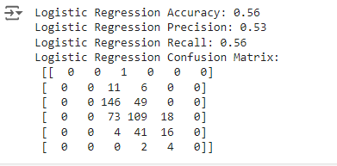

**Visuvalize the Boundaries**

**# Import required libraries**

**import numpy as np**

**import matplotlib.pyplot as plt**

**from sklearn.datasets import load_wine**

**from sklearn.model_selection import train_test_split**

**from sklearn.preprocessing import StandardScaler**

**from sklearn.discriminant_analysis import LinearDiscriminantAnalysis as LDA**

**from sklearn.decomposition import PCA**

**from sklearn.linear_model import LogisticRegression**

**from sklearn.metrics import accuracy_score, precision_score, recall_score, confusion_matrix**

**# 1. Load the Wine dataset**

**data = load_wine()**

**X = data.data**

**y = data.target**

**# 2. Split the dataset into training and testing sets (70% train, 30% test)**

**X_train, X_test, y_train, y_test = train_test_split(X, y, test_size=0.3, random_state=42)**

**# 3. Standardize the data (mean = 0, std = 1)**

**scaler = StandardScaler()**

**X_train_scaled = scaler.fit_transform(X_train)**

**X_test_scaled = scaler.transform(X_test)**

**# 4. Reduce dataset to 2D using LDA**

**lda_2d = LDA(n_components=2)**

**X_train_lda = lda_2d.fit_transform(X_train_scaled, y_train)**

**# Function to plot decision boundaries**

**def plot_decision_boundaries(X, y, model, title):**

**x_min, x_max = X[:, 0].min() - 1, X[:, 0].max() + 1**

**y_min, y_max = X[:, 1].min() - 1, X[:, 1].max() + 1**

**xx, yy = np.meshgrid(np.arange(x_min, x_max, 0.01), np.arange(y_min, y_max, 0.01))**

**# Predict over the grid**

**Z = model.predict(np.c_[xx.ravel(), yy.ravel()])**

**Z = Z.reshape(xx.shape)**

**# Plot the contour and data points**

**plt.contourf(xx, yy, Z, alpha=0.3)**

**plt.scatter(X[:, 0], X[:, 1], c=y, edgecolors='k', marker='o')**

**plt.title(title)**

**plt.show()**

**# 5. Train a new LDA model on the 2D-reduced data**

**lda_model = LDA()**

**lda_model.fit(X_train_lda, y_train)**

**# Plot decision boundaries for LDA**

**plot_decision_boundaries(X_train_lda, y_train, lda_model, "LDA Decision Boundaries")**

**# 6. Reduce dataset to 2D using PCA for Logistic Regression**

**pca = PCA(n_components=2)**

**X_train_pca = pca.fit_transform(X_train_scaled)**

**# 7. Train Logistic Regression on the 2D-reduced data**

**logreg = LogisticRegression(max_iter=2000) # Increased max_iter to 2000**

**logreg.fit(X_train_pca, y_train)**

**# Plot decision boundaries for Logistic Regression**

**plot_decision_boundaries(X_train_pca, y_train, logreg, "Logistic Regression Decision Boundaries")**

**# Evaluate the Logistic Regression model on test data (optional)**

**X_test_pca = pca.transform(X_test_scaled)**

**y_pred_logreg = logreg.predict(X_test_pca)**

**# Compute evaluation metrics**

**accuracy_logreg = accuracy_score(y_test, y_pred_logreg)**

**precision_logreg = precision_score(y_test, y_pred_logreg, average='weighted')**

**recall_logreg = recall_score(y_test, y_pred_logreg, average='weighted')**

**conf_matrix_logreg = confusion_matrix(y_test, y_pred_logreg)**

**print(f'Logistic Regression Accuracy: {accuracy_logreg:.2f}')**

**print(f'Logistic Regression Precision: {precision_logreg:.2f}')**

**print(f'Logistic Regression Recall: {recall_logreg:.2f}')**

**print('Logistic Regression Confusion Matrix:\n', conf_matrix_logreg)**

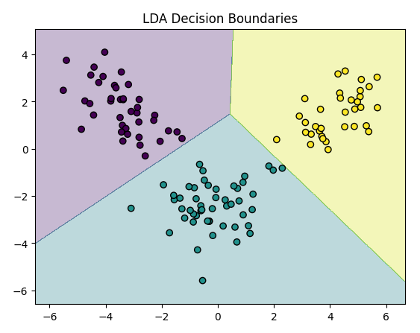

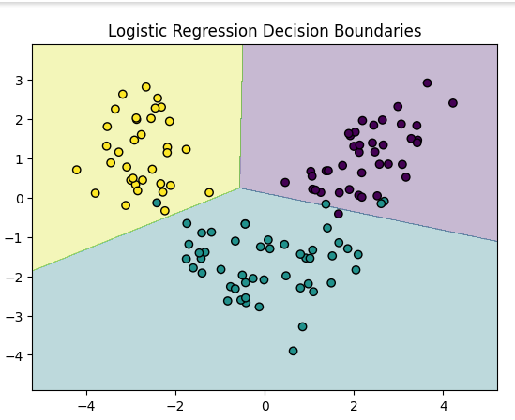

**CODE REPOSITORY:**

**GITHUB:** **https://github.com/Roda1458/LDA**