**Multiple Linear Regression**

**CSE 303: Machine Learning**

Submitted by

Name: Roda Chinthapalli

Roll No: AP22110011496

Section: CSE-M

Lab Date: 26/08/24

Submission Date:02/09/24

**Department Computer Science and Engineering**

**School of Engineering and Sciences**

**SRM University–AP**

**Amaravati, Andhra Pradesh – 522 240, India**

1. **Question**

(Provide problem statement with figures if available)

1. **Algorithm Description**

Corresponding concepts (theory -> handwritten, scanned)

(Provide detailed writeup with figures if possible)

1. **Solution**

Dataset used:  
data preprocessing if any

(Add all the code here: provide code and corresponding solution using markdown-cell style)

1. **Code Repository:**

Provide GitHub link for the assignment

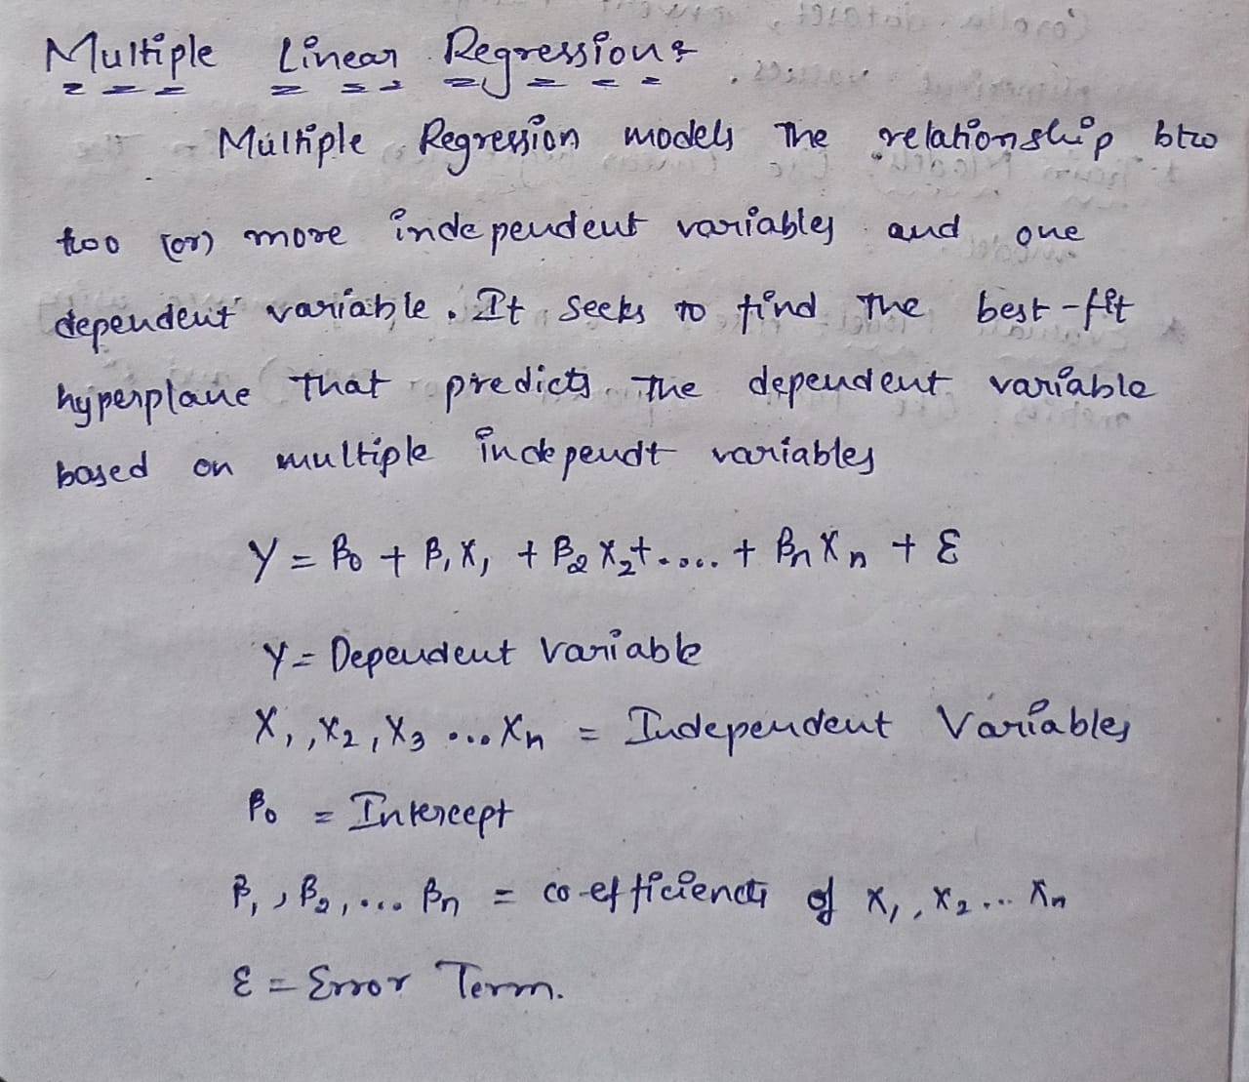

**Question:**

1. Use 50-startup dataset to predict the profit for a startup using single and multiple regression (['R&D Spend', 'Administration', 'Marketing Spend', 'State', 'Profit'])

Provide accuracy, and R2 value for the same.

Dataset Link: <https://www.kaggle.com/code/cundratjuninhokuth/multiple-linear-regression-predict-profit>

**Problem Statement and Algorithm:**

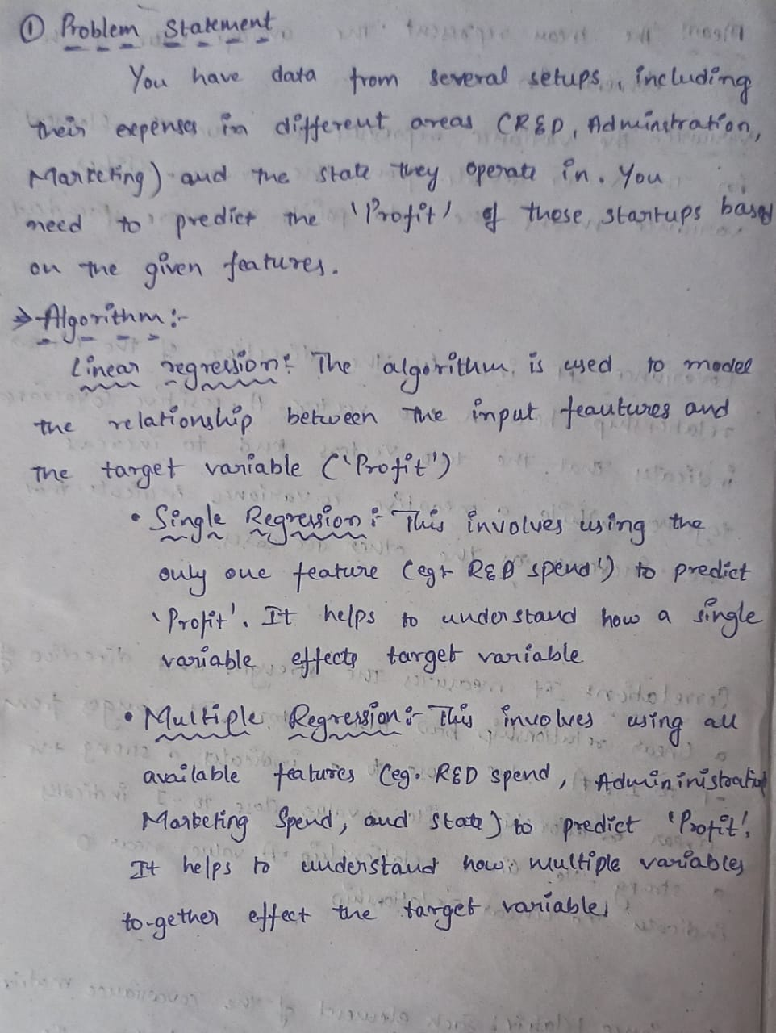

**Solution:**

**SINGLE REGRESSION:**

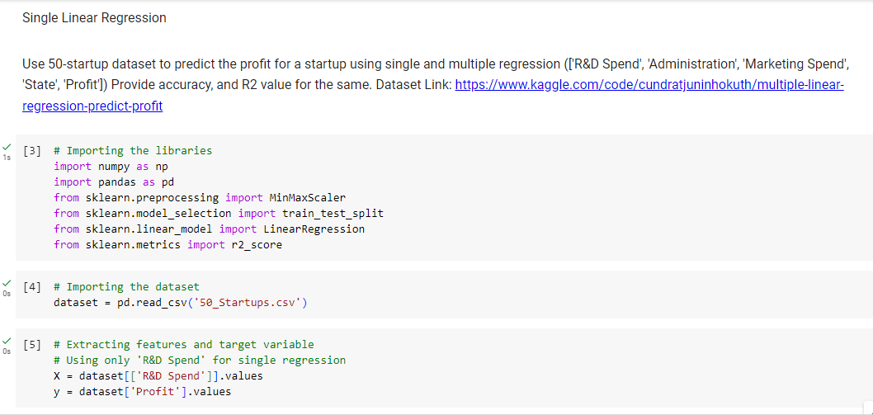

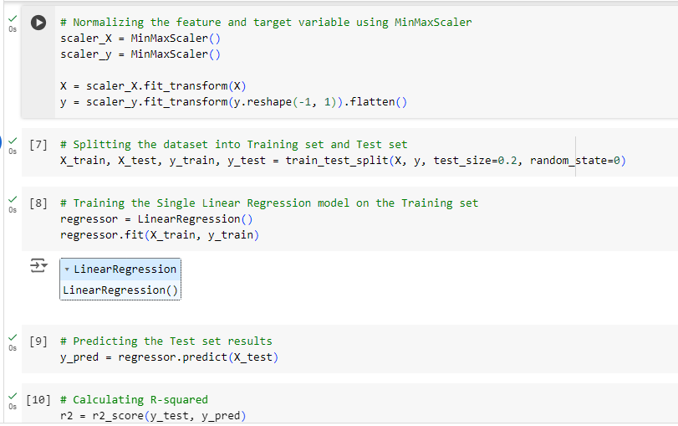

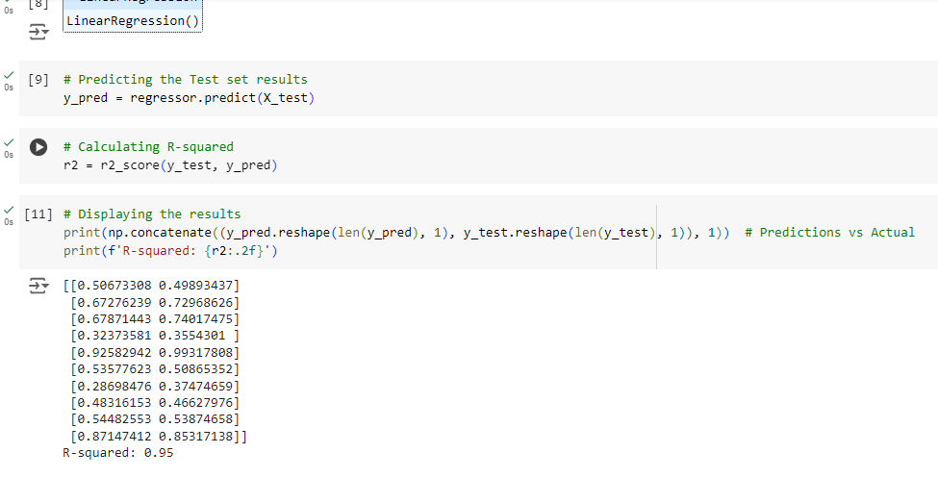

**MULTIPLE REGRESSION:**

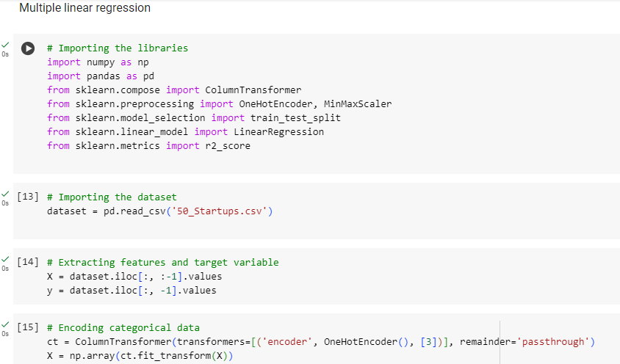

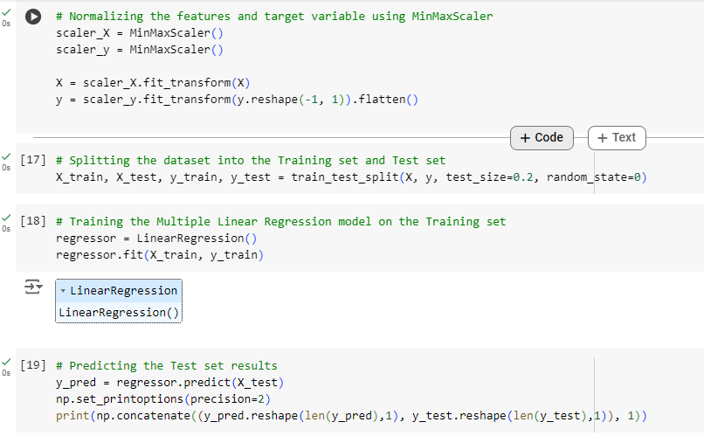

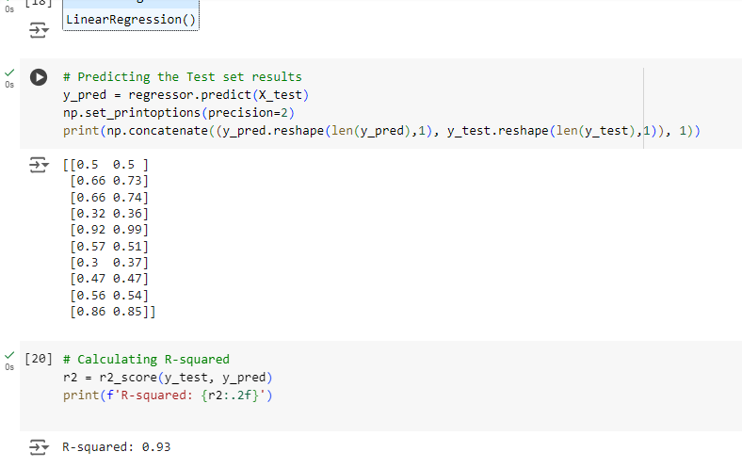

**Conclusion:** Using multiple regression provides a more accurate prediction of startup profits compared to single regression. This is because multiple regression accounts for the combined effect of various factors (e.g., R&D Spend, Administration, Marketing Spend, State) on profit, leading to better overall predictions.

**Question:**

**2.**Consider only the below columns and prepare a prediction model for predicting Price.

Corolla[c("Price","Age_08_04","KM","HP","cc","Doors","Gears","Quarterly_Tax","Weight")]

Provide accuracy, and R2 value for the same.

Dataset Link: <https://www.kaggle.com/datasets/klkwak/toyotacorollacsv?select=ToyotaCorolla.csv>

**Problem statement and Algorithm:**

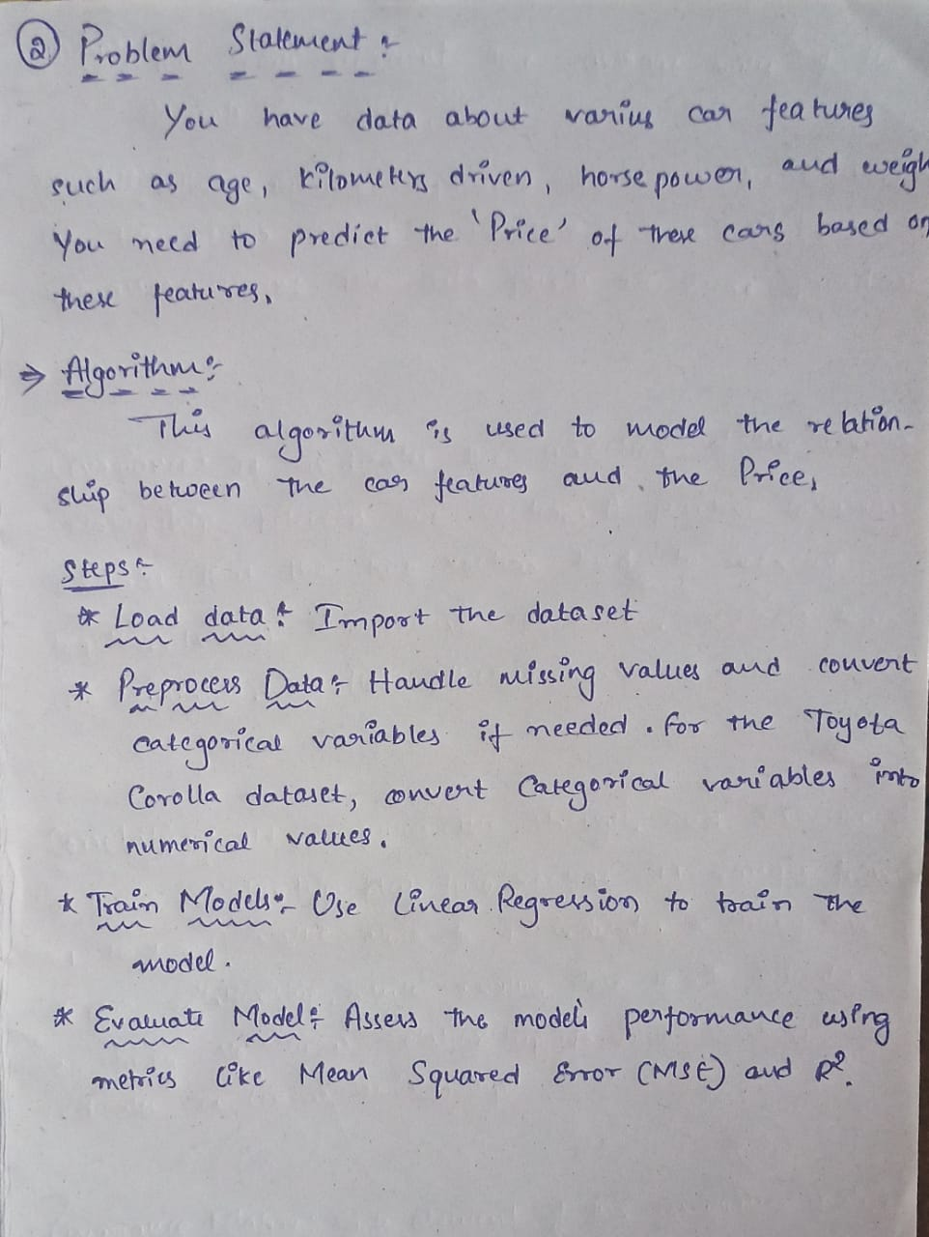

**Solution:**

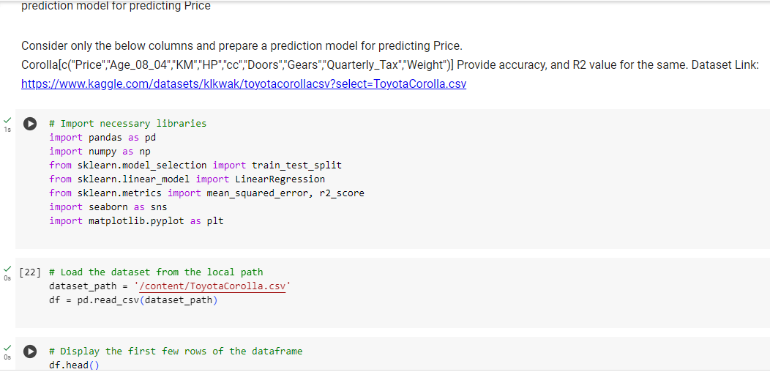

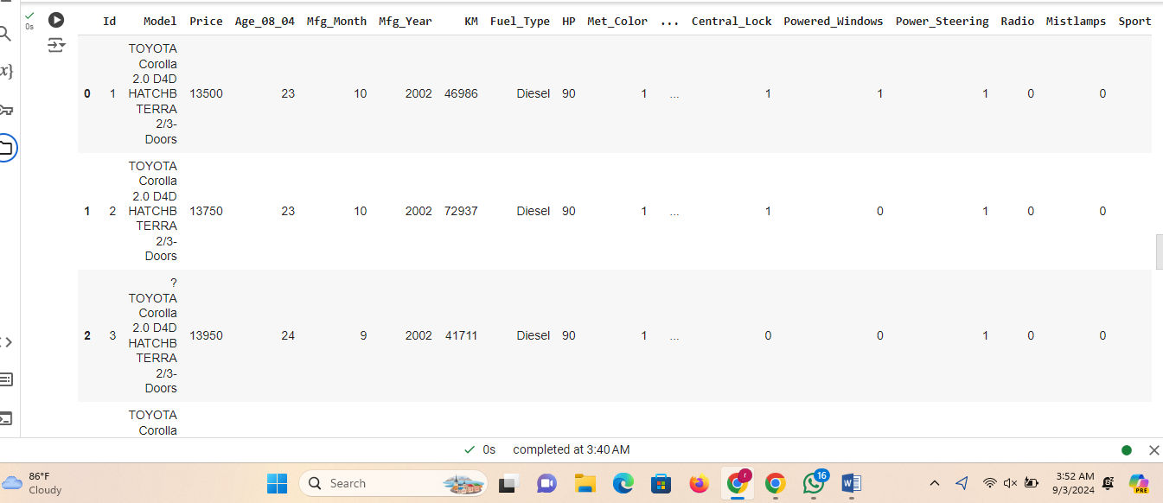

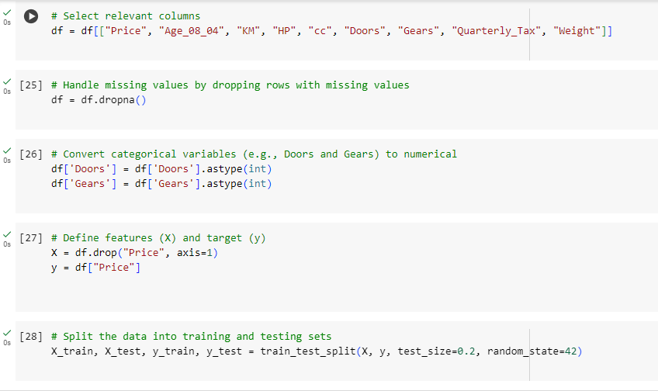

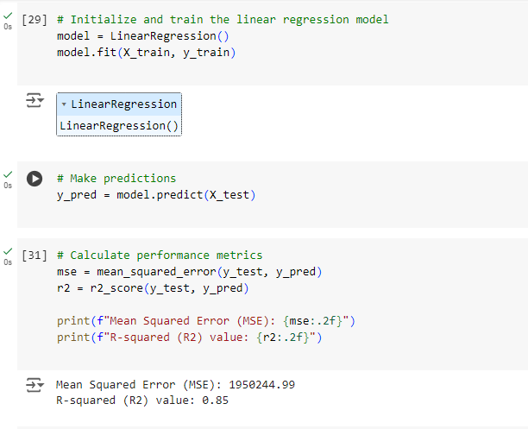

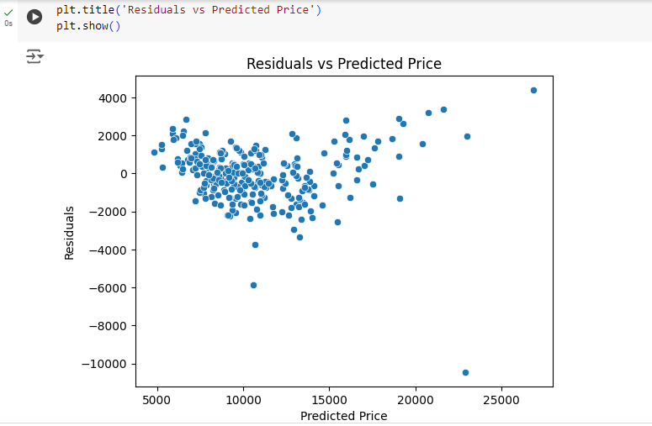

**Conclusion:** Multiple regression effectively predicts car prices by incorporating various features (e.g., Age, KM, HP, Weight). This approach captures the complex relationships between multiple predictors and car price, resulting in more accurate price predictions compared to using fewer features.

**Code Repository:**

**https://github.com/Roda1458/Multiple-Linear-Regression**