SINGLE LINEAR REGRESSION

CSE 303: Machine Learning
Submitted by
Name: Roda Chinthapalli
Roll No: AP22110011496
Section: M
Lab Date:27/08/24
End Date:15/09/24



Department Computer Science and Engineering
School of Engineering and Sciences
SRM University–AP
Amaravati, Andhra Pradesh – 522 240, India
- Question
(Provide problem statement with figures if available)
- Algorithm Description
Corresponding concepts (theory -> handwritten, scanned)
(Provide detailed writeup with figures if possible)
- Solution
Dataset used:
data preprocessing if any
(Add all the code here: provide code and corresponding solution using markdown-cell style)
- Code Repository:
Provide GitHub link for the assignment

1.Question:
Implement Linear Regression and calculate sum of residual error on the following
Datasets.
x = [0, 1, 2, 3, 4, 5, 6, 7, 8, 9]
y = [1, 3, 2, 5, 7, 8, 8, 9, 10, 12]
Compute the regression coefficients using analytic formulation and calculate Sum
Squared Error (SSE) and R 2 value.
Implement gradient descent (both Full-batch and Stochastic with stopping
criteria) on Least Mean Square loss formulation to compute the coefficients of
regression matrix and compare the results using performance measures such as R 2
SSE etc.
Problem Statement and Algorithm:
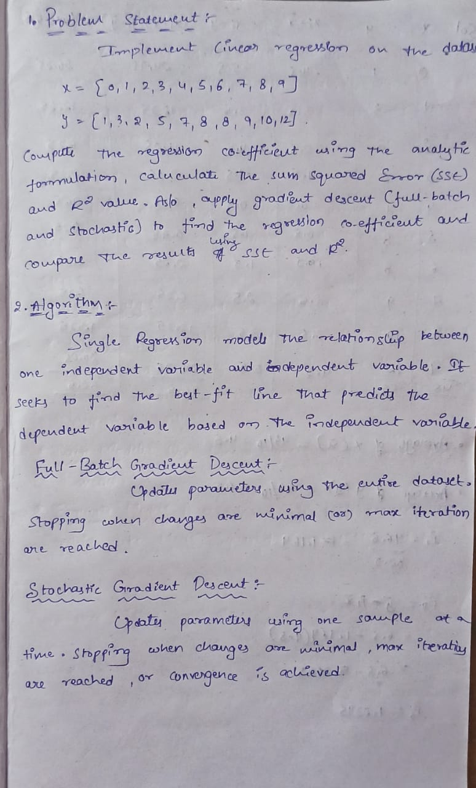
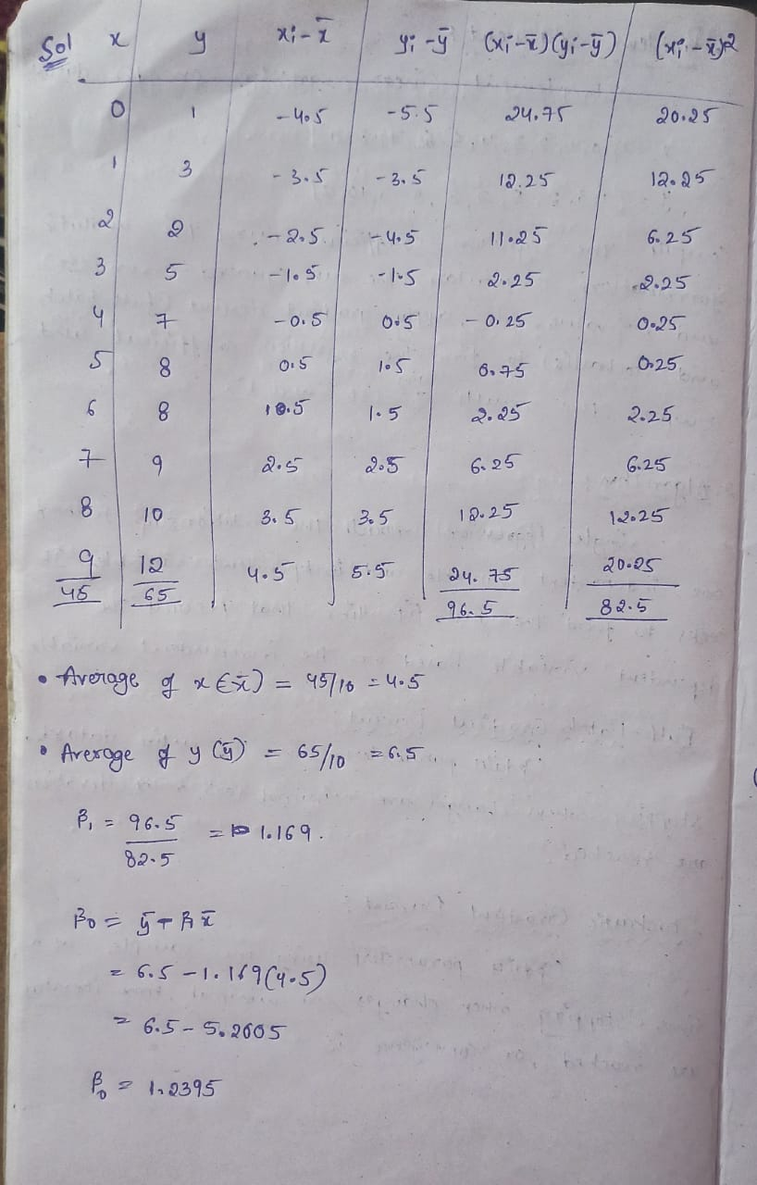
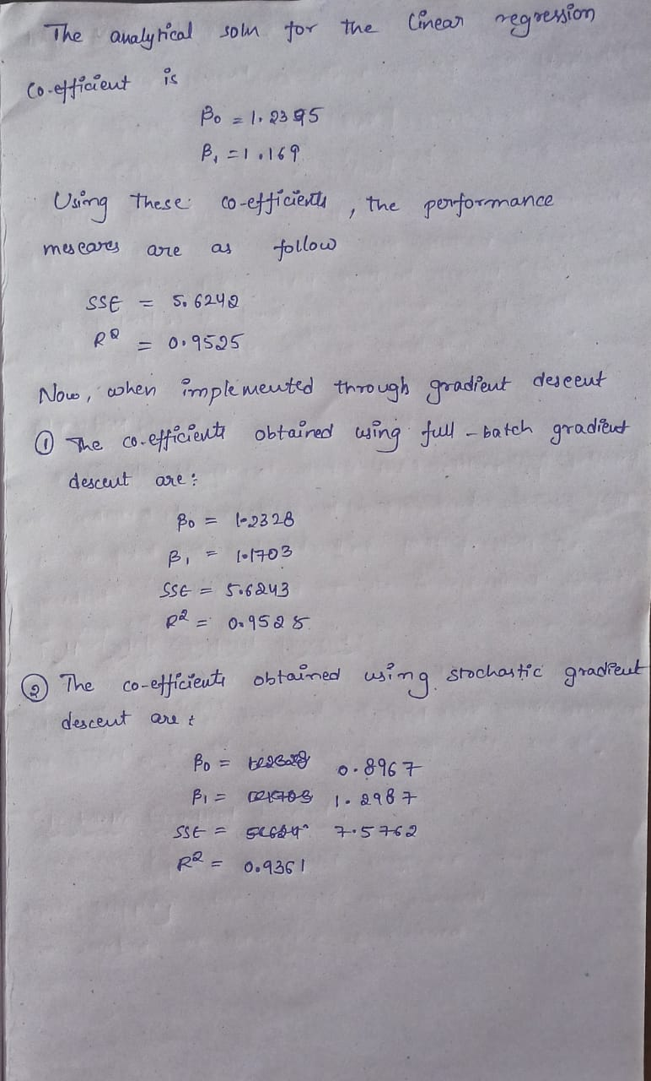
Solution:
Full-Batch Gradient Descent
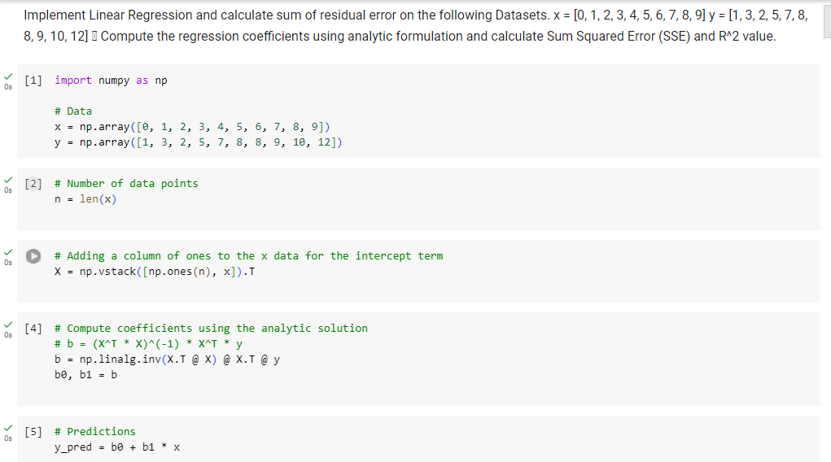

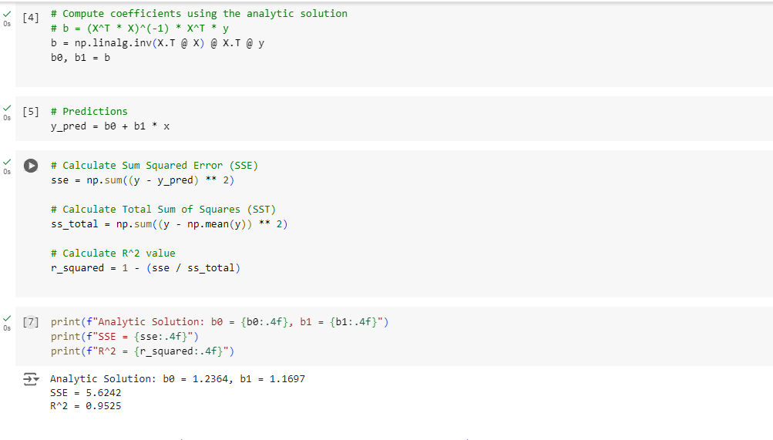
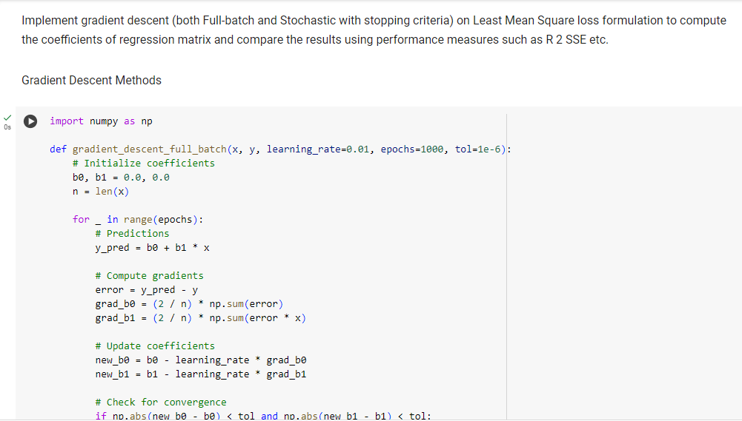

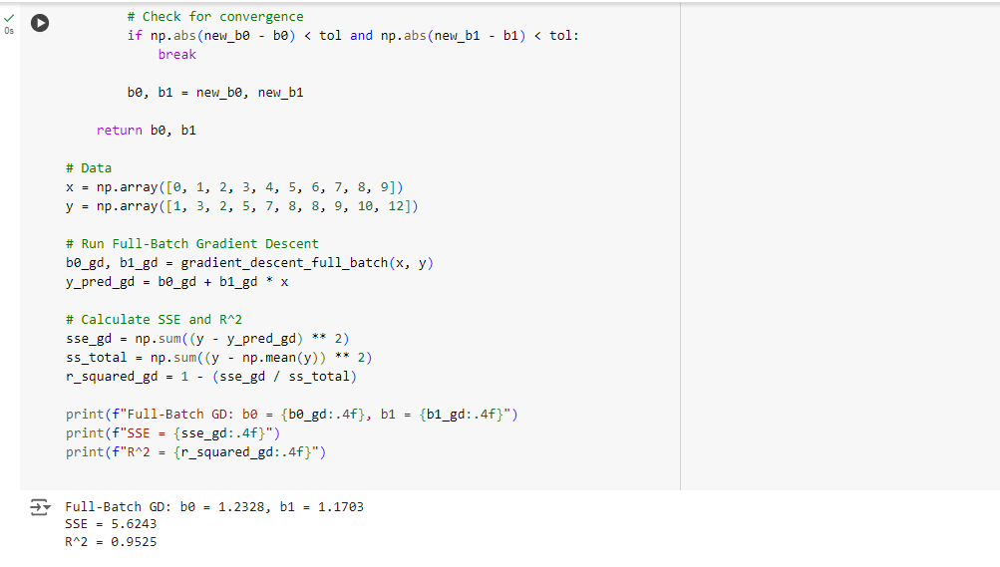

Stochastic Gradient Descent
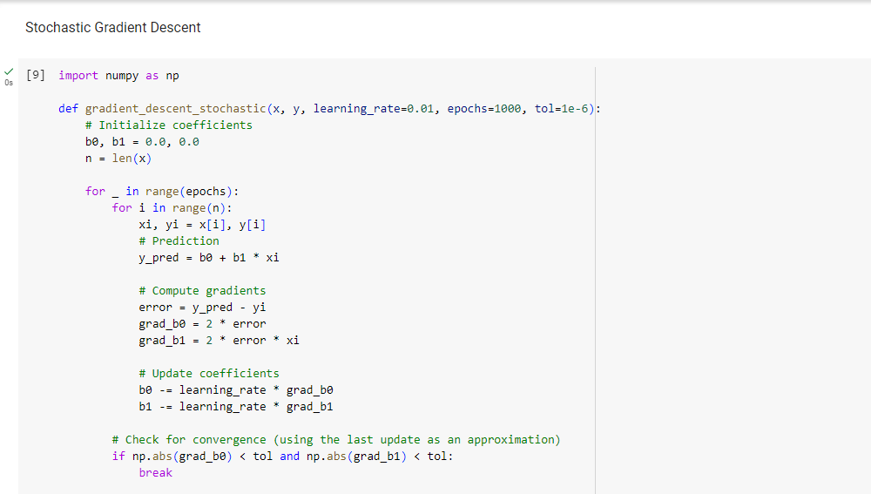

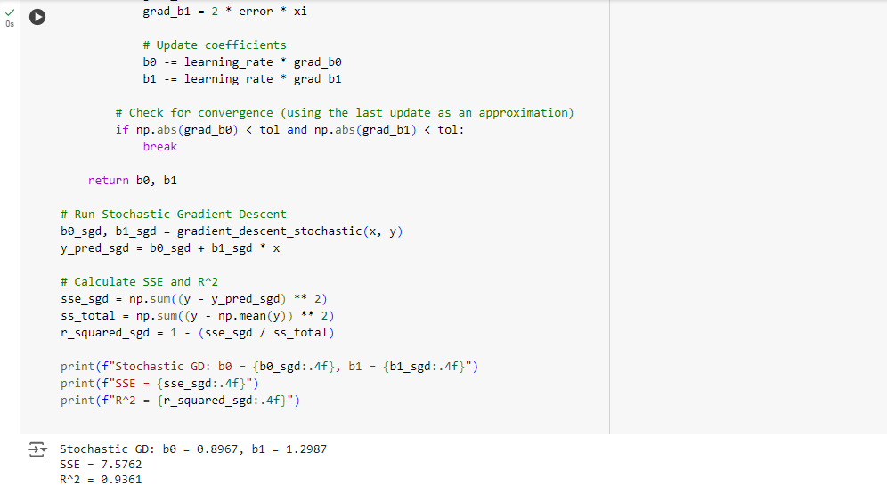

2.Question:
Download Boston Housing Rate Dataset. Analyse the input attributes and find out the
attribute that best follow the linear relationship with the output price. Implement both the
analytic formulation and gradient descent (Full-batch, stochastic) on LMS loss
formulation to compute the coefficients of regression matrix and compare the results.

Problem Statement:

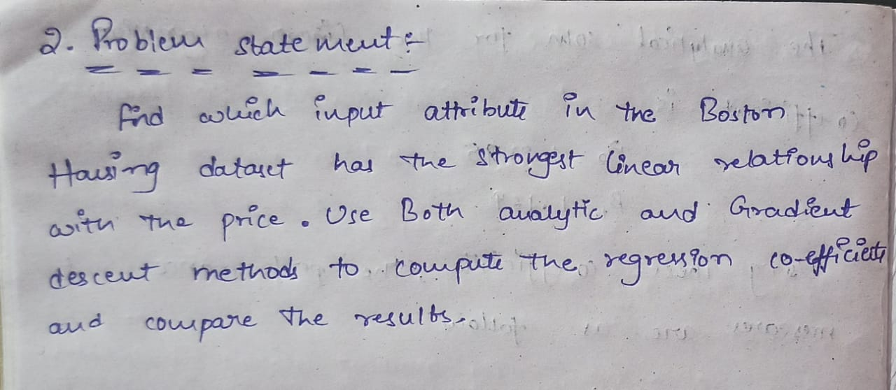

Algorithm:
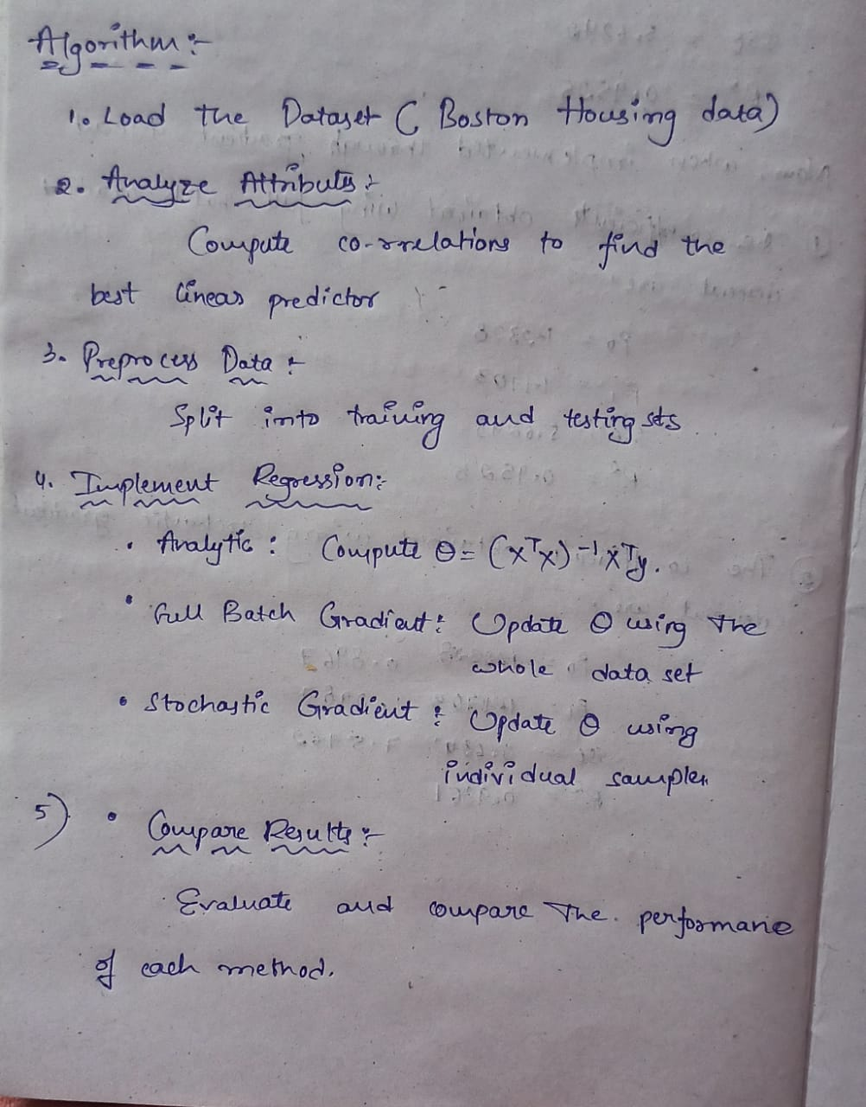

Solution:
DATASET:https://www.kaggle.com/datasets/arunjangir245/boston-housing-dataset

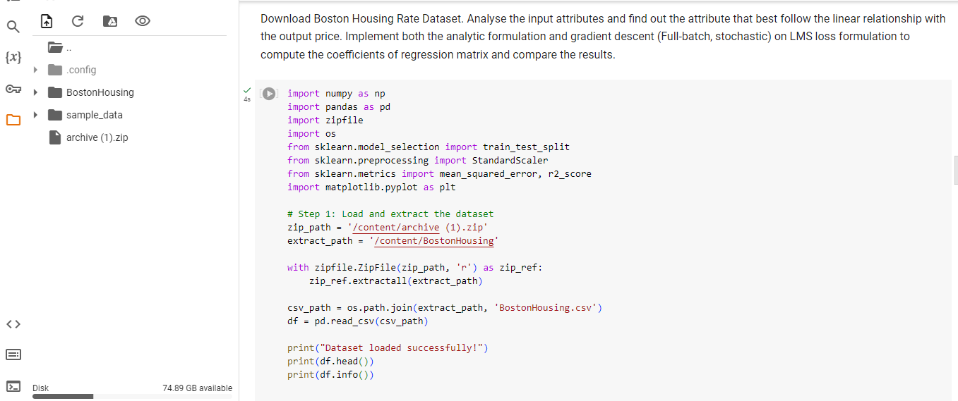

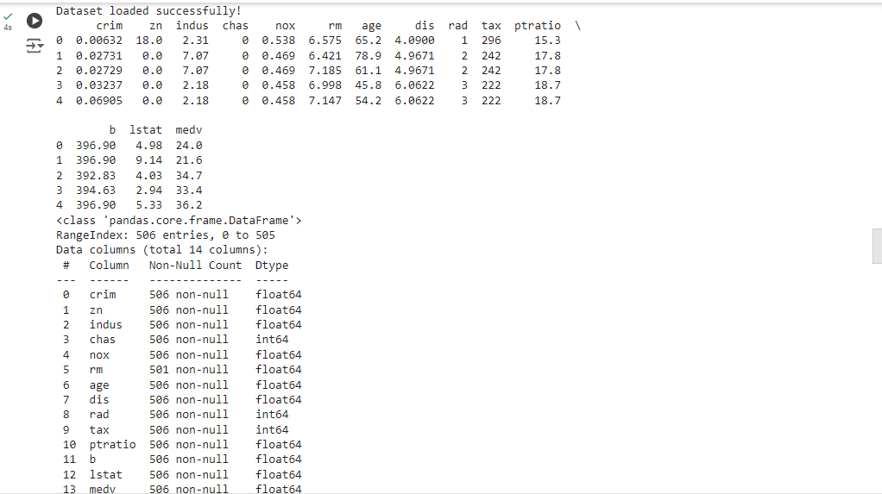
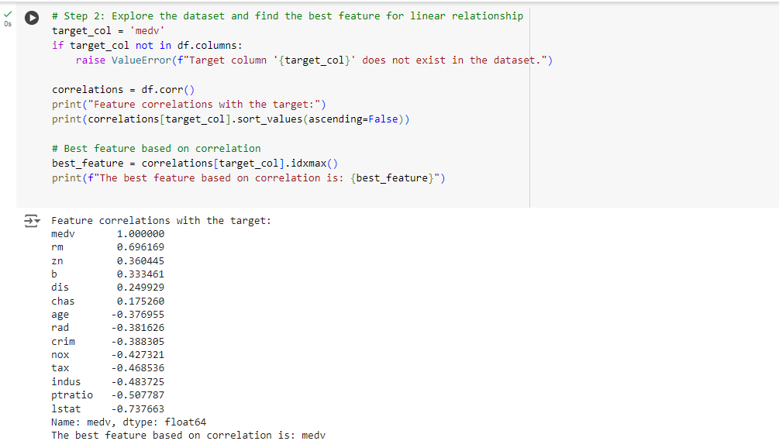

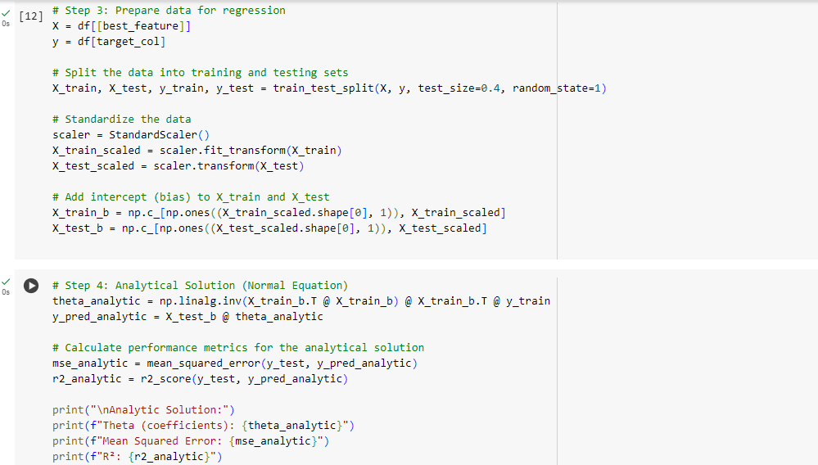

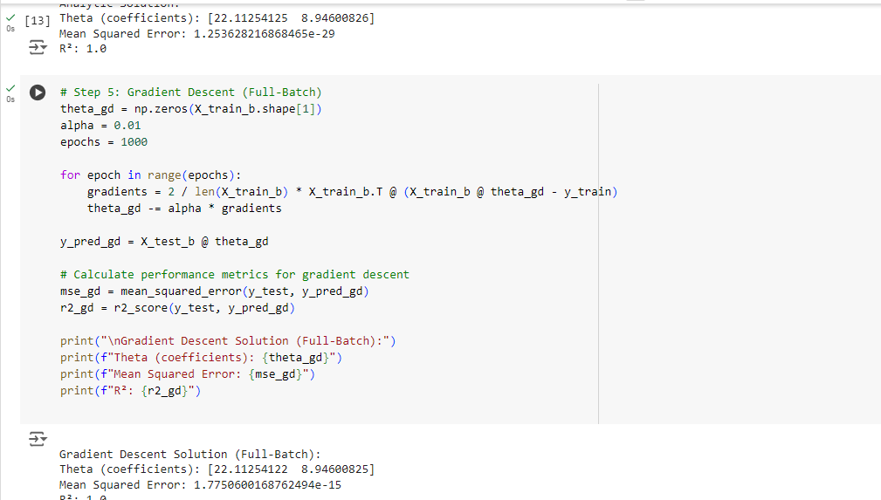

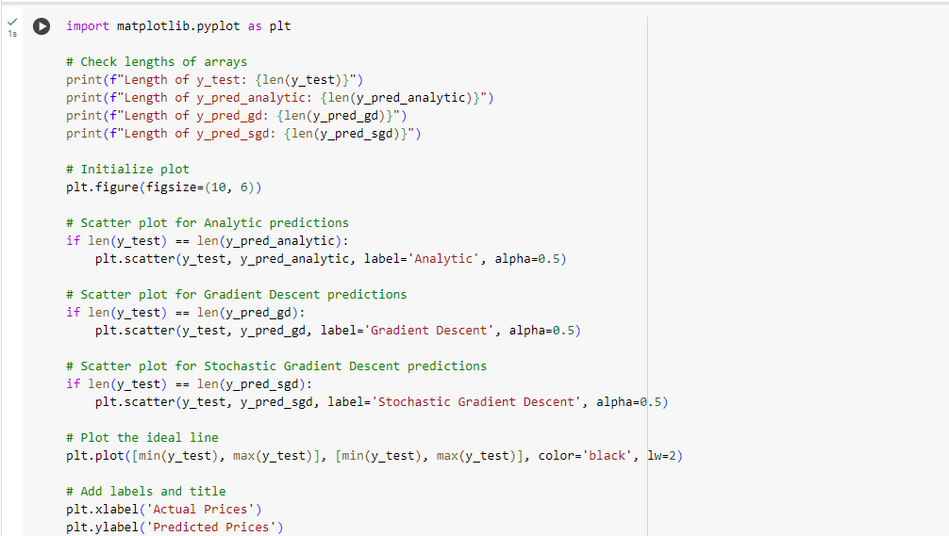

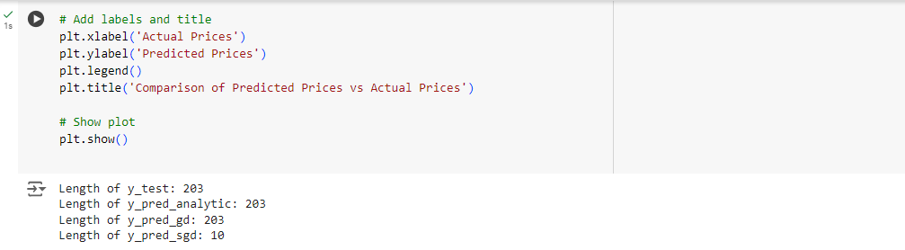
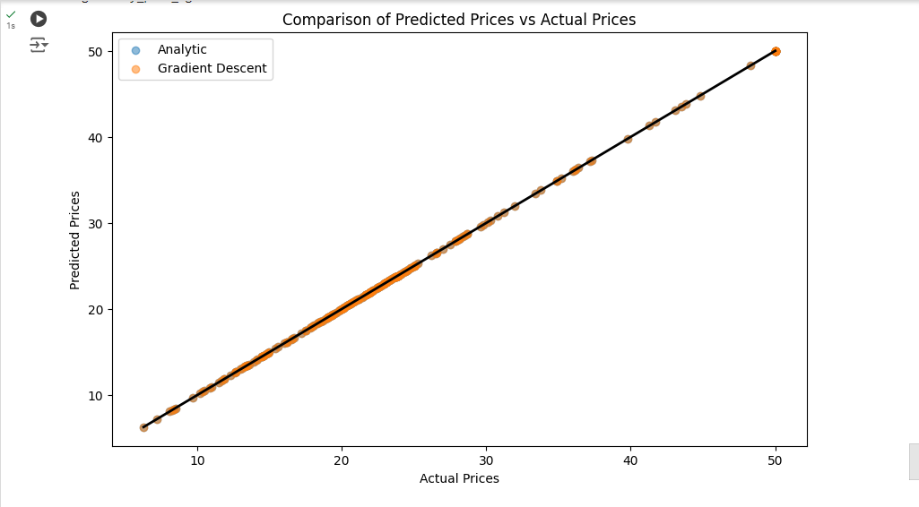
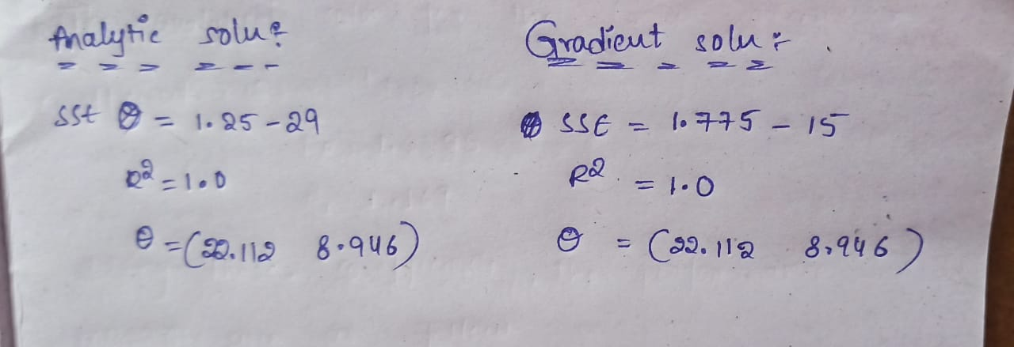

Code Repository:
https://github.com/Roda1458/Single-Linear-Regression/upload/main

