ADD RABONIA LOGO

AND

MAIN SCREEN GRAPHIC

Overview and Vision 2

Core Values 3

Technology 4

Ethereum Smart Chain 4

DxSale – Launch and Token Locking 4

SushiSwap - Exchange 5

How to Buy 5

Tokenomics 6

The Numbers 6

Transactions 6

Burns 6

sports Work and Media 7

Sports Work 7

Interacting with the Community 7

High Level Roadmap 8

April 2021 8

May 2021 8

Q3 and Q4 2021 and beyond! 8

Non-Fungible Tokens and the Rabonia App 8

Overview and Vision

The vision of the Rabonia Token project is to provide assistance for underdeveloped sports teams and sports communities. Across the world there are many communities in dire need of accommodations, schools, stadiums and other assistance just to survive. Rabonia Token can make a real impact for these communities, whilst at the same time benefiting the token holder community.

Rabonia Token provides a simple and affordable mechanism to not only help the world, but to invest and reward token holders through passive income generated from the trading of tokens within the community.

Our project ensures that all projects undertaken are fully documented, with the community able to see where every penny goes. Our experience has shown that many so-called “charities” pocket too much of the money donated to them, with the people in need only receiving a fraction of the donations.

Buying it is super easy, all you need to do is download the MetaMask or Trust Wallet app from the app store and use Sushi Swap to buy it using ETH.

Let’s change the sports together!

ADD RABONIA LOGO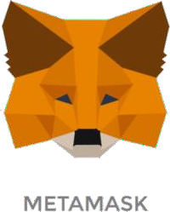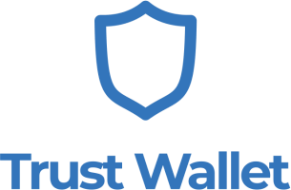



# Transparency

Rabonia Token’s team believes that to ensure the project’s success that full transparency of actions is available at all times.

We share transparent information with each other and the community, to ensure we are all moving towards our combined success with Rabonia Token.

All projects we undertake as a community are fully documented and available for scrutinization through our website, our YouTube and fully visible through the blockchain.

# Integrity

With the ever-increasing interest in cryptocurrency DeFi projects, we have the inevitable scams appearing with rug pulls and other scams occurring on a daily basis.

The Rabonia Token team is committed to integrity and honesty and without both we can not make the impact to the world that is so desperately needed.

# Charity

Rabonia Token can make a real impact for underdeveloped communities. Our united approach can ensure that we provide funding and assistance for accommodations, schools, stadiums and other community support.



Technology

## Ethereum Smart Chain

Rabonia Token is a deflationary token on the Ethereum Smart Chain.

Ethereum Smart Chain (BSC) is a blockchain protocol built by one of the larges centralized exchanges in crypto, Ethereum [(https://www.ethereum.org/en/smartChain)](https://ethereum.org/en/), that provides the stable and easily accessible platform to ensure that Rabonia Token thrives.

## DxSale – Launch and Token Locking

To facilitate the initial launch of Rabonia Token, DxSale’s DeFiLaunch was utilised to provide a presale launch pad.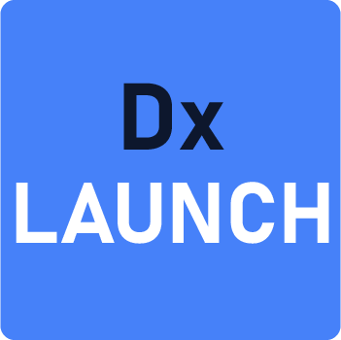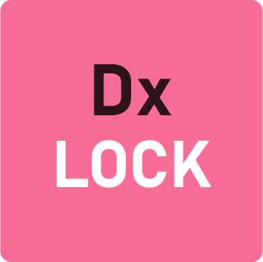

DxSale’s DxLock Certified Token Locker has been used to lock Rabonia Tokens until May 2026 to give certainty to all members of the community.

SushiSwap - Exchange

With the token now live, SushiSwap is now available as the default way to trade Rabonia Tokens.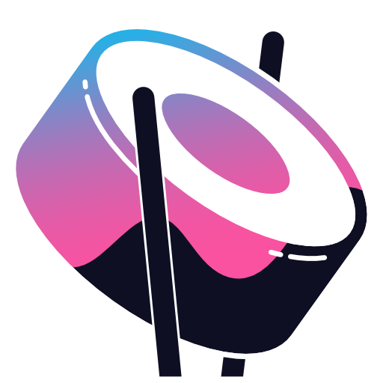

SushiSwap is the leading decentralized exchange on the Ethereum Smart Chain, with the highest training volumes in the market.

SushiSwap provides the ability for community members to exchange ETH for Rabonia Tokens. Most importantly, SushiSwap does not hold your funds when you trade: you have 100% ownership of your own cryptocurrency.

The Rabonia Token can be exchanged through the following link:

[https://exchange.SushiSwap.finance/#/swap?inputCurrency=](https://exchange.pancakeswap.finance/%23/swap?inputCurrency=0x3e18D938d3AbF7e18440dAc2D02C2dcD67a9f0bB)ADD RBN ADDRESS

The Rabonia Token team is working towards including Rabonia on major exchanges as the project moves forward.

Ensure you always use the Rabonia Token address:

## ADD RABONIA ADDRESS

Rabonia Token (Rabonia): ADD RBN ADDRESS



|  |  |
| --- | --- |
| The Numbers | Transactions |
| 1 Trillion Supply  2 Brillion Burnt  All LP Locked  2023 91% Token supply | 2% redistribution to holders  1% LP locked for 2 years  1% Community projects and marketing |

## Burns

A continuous burn on any one token can provide benefits in the initial launch of a token, however this means that the burn cannot be controlled in any way. The Rabonia Token team believes that controlled burns by the team based on achievements helps to keep the community rewarded and information as we reach for our goals.

These manual burns are advertised, promoted and tracked through our Telegram channel and total burns will be updated on our website. Both of these ensure that we are providing the transparency and integrity set out in our core values. The strategy implemented is designed to provide beneficial rewards to those who are long term holders of Rabonia Token.

As always, the total number of tokens burned is available through the EthScan Ethereum Smart Chain Explorer to enable identification of the current circulating supply at any point in time.

The longer you hold, the more tokens you accumulate.

You win, the community wins, and most importantly of all, our charities win!

## Sports Charity Work

Rabonia Token can make a real impact for underdeveloped sport communities. Our united approach can ensure that we provide funding and assistance for accommodations, schools, stadiums and other essential sports community support.

We take pride in our collective mission to provide support and assistance to those that need it. We support each other through this by rewarding token holders by continually holding tokens.

The community is imperative to the projects that we undertake, involved in not only funding, but in deciding what causes Rabonia Token will support.

Rabonia Token’s team believes that to ensure the project’s success that full transparency of actions is available at all times. We share transparent information with each other and the community, to ensure we are all moving towards our combined success with Rabonia Token.

All projects we undertake as a community will be fully documented and available for scrutiny through our website, our YouTube and fully visible through the blockchain.

We are currently finalising our first community project selections and look forward to sharing these with your through our social media so that together we can change the world.

As part of our roadmap commitments, we will be establishing a formal Community Project team, in addition to the creation of project governance and formal policies to ensure that our projects meet our compliance requirements and deliver the best outcomes to the community.

We aren’t just a charity token; we want to make a difference.

## Interacting with the Community

The community is key to the success of Rabonia Token and the projects that we will undertake together will change the world.

To ensure that your voice is heard and that you get the most out of Rabonia Token, make sure you join us in our social media channels.



*Note: Due to the highly competitive nature and copycat behaviour in this space, limited specific details on future projects are provided below. Please join our social media channels for more information.*

## April 2021

* Team formation
* Token design and testing
* Initial website design and launch
* Social Media Feeds

## May 2021

* Presale Launch on DxLaunch
* Lock Tokens through DxLock to May 2023
* Whitepaper publish
* Marketing and promotion
* Establish AMA cadence and hold first AMA
* Website update and Influencer Marketing
* CoinGeko listing
* CoinMarketCap listing
* First Rabonia Community Project Announced

## Q3 and Q4 2021 and beyond!

* Community Project team formation, project governance and policies established
* Rabonia App and NFT Project launchpad
* Rabonia Merchandise – show your support for the projects we undertake together
* Listing on centralized exchanges that share our goals to change the world
* Future Projects

## 

## Non-Fungible Tokens and the Rabonia App

Thanks to the advent of blockchain technology, collectors can become the immutable owners of items and other unique assets through non-fungible tokens. Non-fungible tokens (NFT) are digital assets that represent a wide range of digital assets such as multimedia art. These have been tokenised in the blockchain. They represent verifiable ownership of unique assets that are indestructible and indivisible.

Rabonia Token aims to create a platform for deliver of NFTs, including trading. Our Rabonia Projects will make available NFTs representing the Gifts we provide to our communities, enabled our community to obtain a memorial of the good work we have done together, as well as providing a collectable piece of art.

Through the Rabonia App, our NFT holders will be supported through NFT rare giveaways, ensuring that the community is reward by not only holding Rabonia Token but also by supporting the NFT project.

ADD RABONIA LOGO

Disclaimer

The whitepaper provides information and material of general nature. You are not authorized, and nor should you rely on the whitepaper for legal advice, business advice, or advice of any kind. You act at your own risk in reliance on the contents of the whitepaper. Should you decide to act or not act, you should contact a licensed attorney in the relevant jurisdiction in which you want or need help. In no way are the owners of, or contributors to, the whitepaper responsible for the actions, decisions, or other behavior taken or not taken by you in reliance upon the whitepaper.

The Rabonia Token team does not recommend that any cryptocurrency should be bought, sold, or held by you. Do conduct your due diligence and consult your financial advisor before making any investment decisions. By purchasing Rabonia tokens, you agree that you are not purchasing a security or investment, and you agree to hold the team harmless and not liable for any losses or taxes you may incur. You also agree that the team is presenting the token “as is” and is not required to provide any support or services.

The team does not guarantee compliance with any country across the world. Always make sure that you comply with your local laws and regulations before you make any purchase.

The whitepaper is provided on an “as is” basis without any warranties of any kind regarding the whitepaper and/or any content, data, materials, and/or services provided on the whitepaper.

Unless otherwise required by law, in no event shall the owners of, or contributors to, the whitepaper be liable for any damages of any kind, including, but not limited to, loss of use, loss of profits, or loss of data arising out of, or in any way connected with, the use of the whitepaper.

The reader of the whitepaper agrees to arbitrate any dispute arising from or in connection with the whitepaper or this disclaimer, except for disputes related to copyrights, logos, trademarks, trade names, trade secrets, or patents.

There may be matters in this whitepaper that are forward-looking statements. Such statements are subject to risks and uncertainty. Participants are cautioned not to place undue reliance on these forward-looking statements. The actual results or events that transpire afterwards may be different from what is implied here. The Rabonia Token team shall not guarantee the accuracy of the forward-looking statements outlined in this whitepaper.