THESIS 2

Smart Coffee Sniffer: E-Nose Classification of Brewed vs Instant Coffee Using MOS Sensors and Support Vector Machine

Member’s Name: Navarro, Rod Geryk C.

Course/Section: CPE200-2L-E04

Group: AbadillaNavarro

Advisor: Engr. Noel B. Linsangan

Progress Report Number: # 4
Date of Submission: May 8, 2026

C:\venv39nc\Scripts\python.exe generate_report.py

___________Cyrel O. Manlises, PH.D._______________
Instructor

Part I. Discuss your progress here in detail.

[INSERT GEMINI PART I HERE]

Part II. Provide screenshots as proof of your progress.
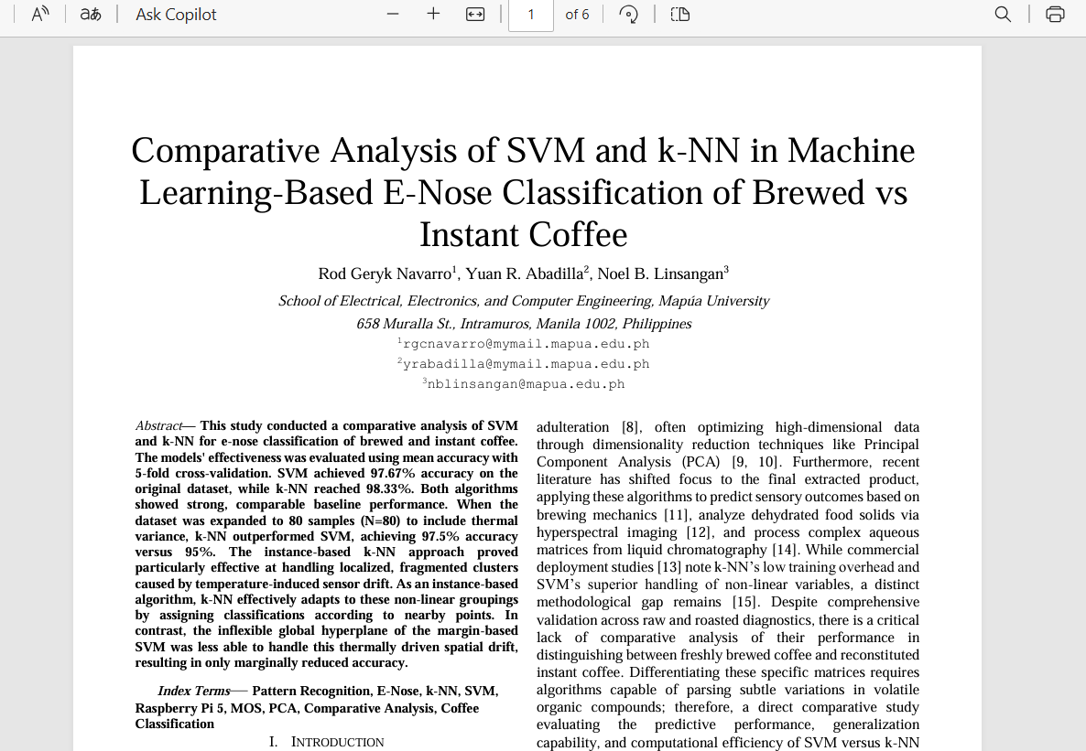
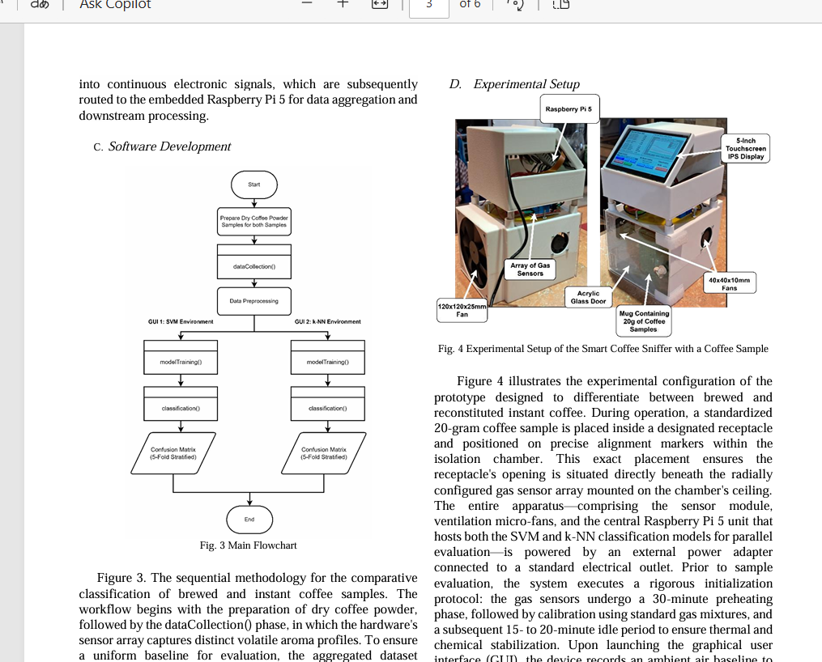

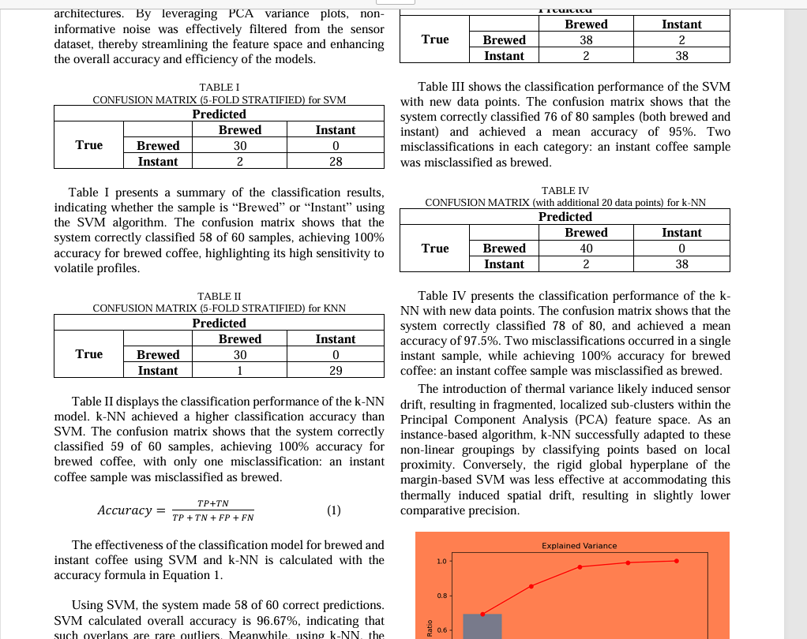
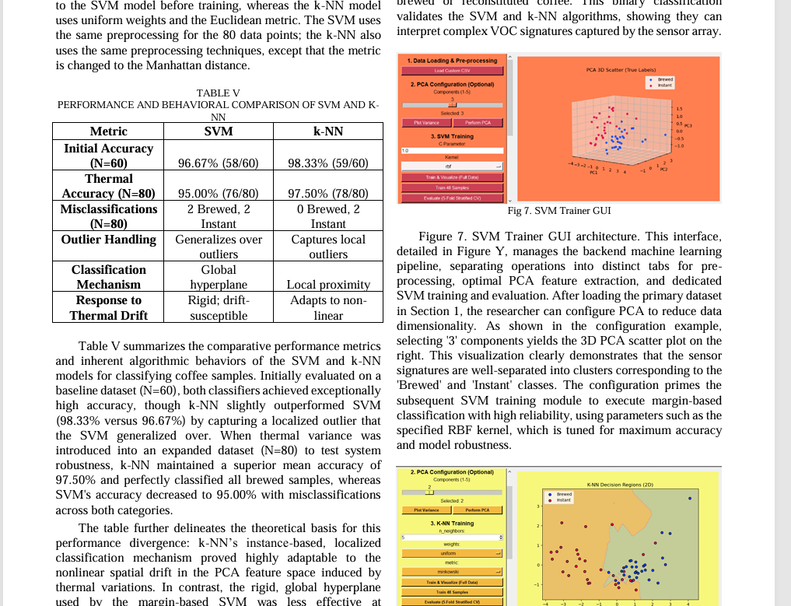

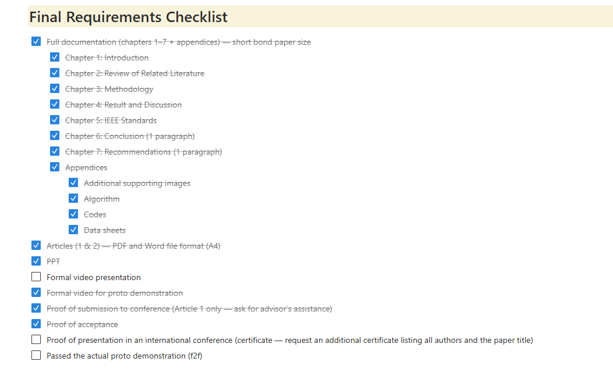

Part III. List down your workload or individual progress (per member)
- [INSERT GEMINI PART III HERE]
Part IV. Gantt chart (showcase the target output every week)

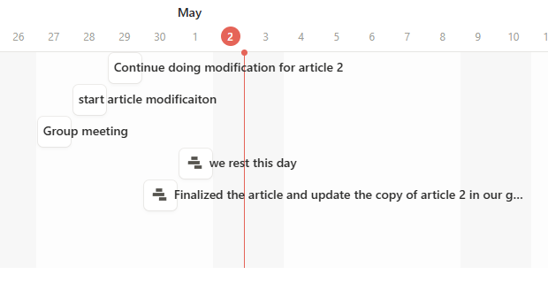

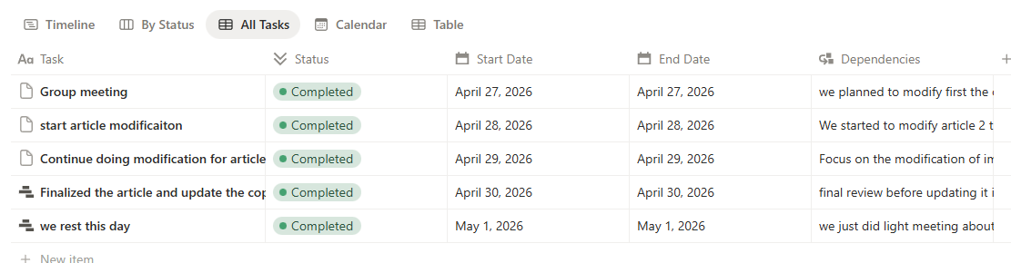

Part V. Progress in article 1 (provide proof of progress)

We have already completed Article 1. The article was submitted and accepted to our chosen conference, and we successfully presented the paper at ICCCS. We are now waiting for the paper's publication.

Part VI. Progress in Full documentation (provide proof of progress)

Our full documentation is complete and has already undergone final modification and review.

Part VII. Progress in prototype (provide proof of progress)

This is the final version of the study's prototype, showcasing the final visual look and design that we've carefully finalized for this research.

