
MINISTRY OF EDUCATION, CULTURE AND RESEARCH
OF THE REPUBLIC OF MOLDOVA
Technical University of Moldova
Faculty of Computers, Informatics and Microelectronics
Department of Software Engineering and Automation

Rodion Bulimar FAF-242

Report
Laboratory Work 1
Network Programming

Checked by:
Fiștic Cristofor, university assistant
FCIM, UTM

Chișinău – 2026
Table of Contents
1. Introduction 3
2. Hardware and Software 3
3. Project Structure 3
4. Test Data 4
5. Methodology 4
6. Implementation and Results 5
6.1 Task 1a – Counting with threads 5
6.2 Task 1b – Three ways to count 6
6.3 Task 1c – Producer / consumers 8
6.4 Task 2 – Many files on slow storage 9
7. Conclusion 10
8. Build and Run Instructions 11
8.1 Build 11
8.2 Run 11
8.3 Troubleshooting 11
Appendix A. Source Code Overview 11

1. Introduction
This report documents a Java implementation of Laboratory Work 1. The goal of the work is to measure how the number of threads and the strategy used to divide work affect the execution time and peak memory of a real workload, to distinguish CPU-bound from I/O-bound behaviour, to observe a race condition together with the cost of fixing it, and to find the point where parallel speed-up stops.
The workload is simple on purpose: given a text file of 5 000 000 integers in the range [−1 000 000, 1 000 000], one per line, count how many numbers are negative, positive and zero. Because the computation per number is trivial, the experiments mostly reveal the cost of I/O, parsing, synchronisation and thread management rather than of the arithmetic itself.
The work is split into four programs:
- Task 1a – N threads, each processing its own byte range of the file.
- Task 1b – three counting styles over a shared in-memory array (unsynchronised, lock-protected, per-thread counters).
- Task 1c – one reader thread feeding worker threads through a bounded blocking queue.
- Task 2 – eight files stored on a USB drive, processed by 1, 2 and 4 threads.

2. Hardware and Software
The measurements were obtained on the machine described below.
Item | Value
CPU model | Intel(R) Core(TM) i5-8250U
Physical cores | 4
Logical processors | 8
RAM | 8 GB
Internal disk | SSDPR-PX500-256-80 SSD
USB drive | VendorCo ProductCode USB Device 60GB
Operating system | Windows 10 (10.0), amd64
Java runtime | Java 1.8.0_503 (Oracle Corporation); max heap 1820 MB (-Xmx2g)
javac version | 17.0.17
Table 1. Test machine
javac and java must be of the same major version; otherwise the program fails with UnsupportedClassVersionError (see Section 8). Every program prints the hardware and runtime summary (OS, architecture, Java version, logical CPUs, maximum heap) at start-up through Utils.printHardwareInfo().

3. Project Structure
lab1-concurrency/
├── src/lab1/
│ ├── Utils.java shared helpers: Counts, timing, memory
│ ├── DataGenerator.java creates numbers.txt + parts/
│ ├── Task1a.java N threads, byte-range split
│ ├── Task1b.java 3 counting styles on a shared array
│ ├── Task1c.java producer / consumers with blocking queue
│ └── Task2.java 8 files on USB, 1/2/4 threads
├── numbers.txt generated (5 000 000 lines)
├── parts/ generated (8 × 625 000 lines)
├── out/ compiled .class files
└── README.md

Utils.java holds the constants (FILE = numbers.txt, TOTAL = 5 000 000, MIN/MAX = ±1 000 000), the Counts class (neg, pos, zero with add, equals and toString), the classify method, and the timing and memory helpers. Memory is measured as usedMemory = totalMemory − freeMemory; a baseline is taken after System.gc() and a short sleep, and the reported peak is the highest sample minus that baseline.

4. Test Data
DataGenerator creates numbers.txt with 5 000 000 pseudo-random integers using java.util.Random with the fixed seed 42, so the file is identical on every run. It then splits the file into eight line-aligned parts, parts/part0.txt … part7.txt, of 625 000 lines each, so no number is divided between two files.
For every task and every configuration the totals must satisfy neg + pos + zero = 5 000 000 and be identical across all tasks (the only exception being Task 1b version 1, see Section 6.2). The reference result is given below; it was also verified independently with a separate script over numbers.txt (36 942 224 bytes, 5 000 000 lines).
negative | positive | zero
2 499 314 | 2 500 685 | 1
Table 2. Reference counts for numbers.txt

5. Methodology
- Each configuration was started with a fixed heap (java -Xmx2g).
- Time is wall-clock time measured with System.nanoTime() around the parallel section only (file generation and preparation are excluded).
- Speed-up is computed as S(n) = T(1) / T(n).
- Peak memory is the highest value of used heap observed by the worker threads, minus the baseline memory measured before the run.
- For Task 2 the USB drive was ejected, unplugged and plugged back in before every run so the operating-system file cache could not serve the data; on macOS Spotlight indexing was also disabled for the volume (mdutil -i off).
- Task 2 was run in a separate JVM process for every thread count (java … lab1.Task2 "F:\parts" --only N), with the drive replugged between runs, so that no configuration benefits from data cached by the previous one.
- For each task three charts are produced: execution time, speed-up and peak memory versus the number of threads.

6. Implementation and Results

6.1 Task 1a – Counting with threads
Implementation. The program runs with 1, 2, 4, 8, 16, 32 and 64 threads in a fixed thread pool. The file size is divided into N equal byte ranges. A range boundary rarely falls exactly on a line break, so each thread adjusts its range: the start is moved back to just after the previous newline, and the end is moved forward to just after the next newline. Adjacent threads therefore compute the same boundary, and no line is split or counted twice. Each thread memory-maps only its own range with FileChannel.map and parses the digits directly from the bytes (handling the '-' sign), without creating String objects. A CountDownLatch releases all threads simultaneously and a second latch signals completion; every thread writes into its own Counts object, and the results are summed after all threads finish.
Results.
All configurations produced the same, correct counts (Table 3).
threads | time (ms) | speed-up | peak mem (MB) | counts
1 | 173 | 1.00× | 2 | n=2499314 p=2500685 z=1
2 | 96 | 1.80× | 1 | n=2499314 p=2500685 z=1
4 | 51 | 3.39× | 2 | n=2499314 p=2500685 z=1
8 | 54 | 3.20× | 3 | n=2499314 p=2500685 z=1
16 | 40 | 4.33× | 12 | n=2499314 p=2500685 z=1
32 | 43 | 4.02× | 11 | n=2499314 p=2500685 z=1
64 | 40 | 4.33× | 28 | n=2499314 p=2500685 z=1
Table 3. Task 1a measurements
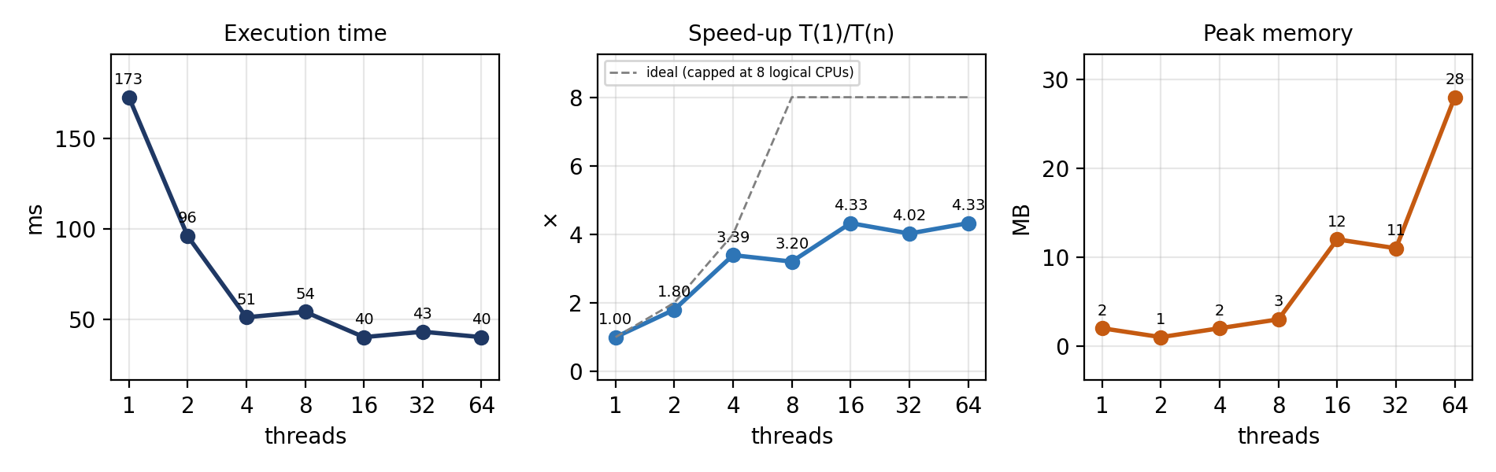
Figure 1. Task 1a – execution time, speed-up and peak memory versus number of threads
Discussion.
- Speed-up limit. The time falls from 173 ms with one thread to 96 ms with two (1.80×) and 51 ms with four (3.39×), i.e. almost linearly up to 4 threads. Doubling to 8 threads, the number of logical processors, gave no improvement (54 ms, 3.20×), and the best result, 40 ms (4.33×), was reached with 16 and 64 threads. The maximum speed-up is therefore about 4.3×, far below the 8 logical processors. This is consistent with a CPU that has 4 physical cores with hyper-threading: the second hardware thread of each core adds almost nothing here, because both threads execute the same tight parsing loop and compete for the same execution units and caches.
- Why 32 and 64 threads do not help. Beyond the number of logical processors, extra threads cannot run simultaneously. In this measurement the penalty is small: 32 threads took 43 ms against 40 ms for 16 threads, and 64 threads again 40 ms. Differences of 2–3 ms on a run that lasts only about 40 ms are within measurement noise, so the honest conclusion is that the curve flattens and then stays flat, with no further gain. What the extra threads do cost is visible in memory and in overheads that are not part of the useful work: thread creation and start-up, scheduling and context switching, and more memory mappings. With such a short run these fixed costs are comparable to the useful work, so adding threads cannot pay off. A larger input would make a slow-down at 32 and 64 threads easier to see.
- Memory versus threads. Peak memory stays at 1–3 MB for up to 8 threads and then rises to 11–12 MB (16 and 32 threads) and 28 MB (64 threads). The numbers are small because the file is memory-mapped and parsed directly from bytes, so the 35 MB of data is never copied onto the Java heap; the growth comes from per-thread objects (stacks, buffers, mapping objects). It is roughly proportional to the thread count.
- CPU-bound. The speed-up scales with the number of cores while the file is read through the operating-system cache, which shows that this task is limited by CPU (parsing), not by the disk. The runs after the first one read the file from the OS file cache, which has to be kept in mind when comparing with Task 2.

6.2 Task 1b – Three ways to count
Implementation. All 5 000 000 numbers are first loaded into an int[] (this loading is not measured). Then the array is split into equal chunks and processed by Runtime.getRuntime().availableProcessors() threads in three different ways:
- Version 1 – shared, no synchronisation. all threads increment the same shared.neg / pos / zero fields. The expression shared.neg++ is a read-modify-write sequence, so concurrent updates are lost. The test is run three times to show that the totals are wrong and differ from run to run.
- Version 2 – shared, lock-protected. each increment is wrapped in lock.lock() / unlock() of a single ReentrantLock. The result is correct, but the threads constantly compete for one lock.
- Version 3 – per-thread counters. each thread counts into a private Counts object; the objects are merged after all threads have been joined. No sharing, no locking.
Results.
version | run | time (ms) | neg | pos | zero
V1 – no sync | 1 | 44 | 787 164 | 780 713 | 1
V1 – no sync | 2 | 19 | 843 642 | 840 904 | 1
V1 – no sync | 3 | 26 | 1 058 053 | 1 050 965 | 1
V2 – ReentrantLock | 1 | 201 | 2 499 314 | 2 500 685 | 1
V3 – per-thread | 1 | 32 | 2 499 314 | 2 500 685 | 1
Table 4. Task 1b measurements (8 threads). Correct totals: neg = 2 499 314, pos = 2 500 685, zero = 1, sum = 5 000 000
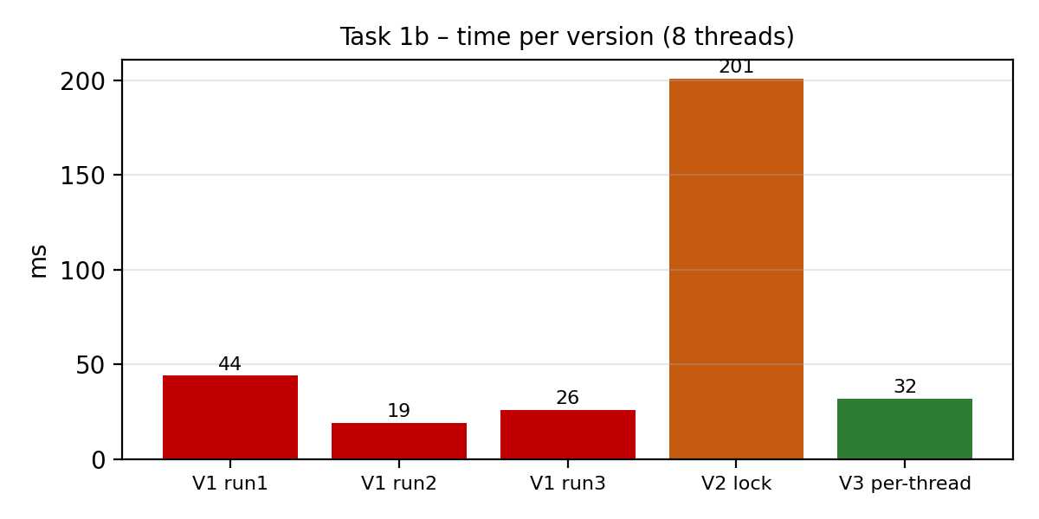
Figure 2. Task 1b – execution time of the three versions
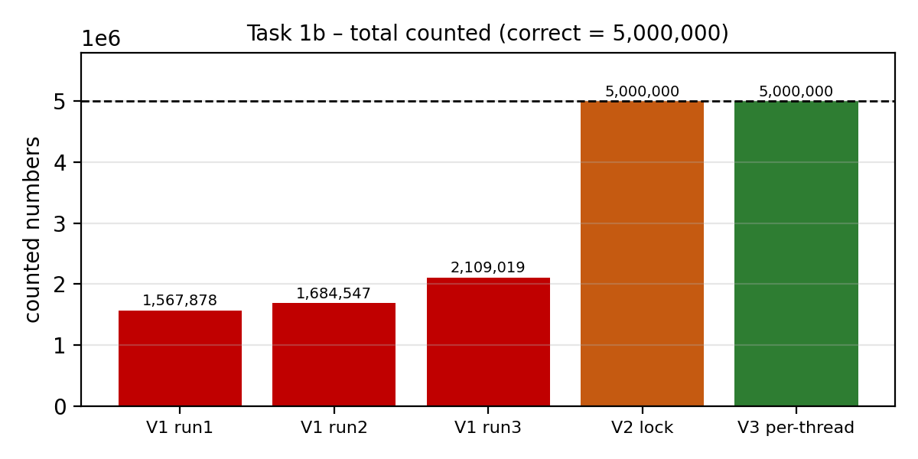
Figure 3. Task 1b – total number of counted values (the dashed line is the correct value)
Discussion.
- Correctness. Version 1 is incorrect. In the three runs it counted only 1 567 878, 1 684 547 and 2 109 019 numbers instead of 5 000 000 (31–42 %), and the result is different every time. This is a data race: shared.neg++ is a read-modify-write, so when two threads read the same old value, one of the increments is lost. The zero counter was right in all runs only because it is incremented once in total, so there was no concurrent update to lose. Versions 2 and 3 produced the exact reference counts.
- Ranking by speed. Version 2 is by far the slowest: 201 ms, about 6.3 times slower than version 3 (32 ms), because five million lock acquisitions are serialised through a single ReentrantLock and the threads constantly block and wake each other. Version 1 took 44, 19 and 26 ms; it looks fastest only because it does no coordination and its result is wrong. Its first run (44 ms) includes JIT warm-up and thread start-up, as does the single run of version 3 (32 ms), so versions 1 and 3 are of the same order of magnitude. Even the unsynchronised version suffers from several cores writing the same cache line, which the per-thread version avoids completely.
- Ranking overall. Taking correctness and speed together, the order is: V3 (correct and fast) > V2 (correct but slow) > V1 (fast but wrong, i.e. unusable). Correctness has a price when state is shared, and the cheapest way to avoid it is not to share: partition the data, count privately and combine at the end.
- Memory. Baseline memory after loading the array was 21 MB (the 5 000 000 ints are about 20 MB) and the peak was 22 MB, so the three counting methods add only about 1 MB.

6.3 Task 1c – Producer / consumers
Implementation. One reader thread reads numbers.txt line by line with a BufferedReader, parses each line with Integer.parseInt and groups the values into batches of 10 000 (BATCH). The batches are placed into an ArrayBlockingQueue with a capacity of 100 batches (QUEUE_CAP). Worker threads (1, 2, 4, 8, 16, 32, 64) take batches from the queue and count signs into private Counts objects, which are summed at the end. The queue is bounded, so the producer blocks when it is full and the consumers block when it is empty. At end of file the reader inserts one empty list (a poison pill) per worker, which tells each worker to stop.
Results.
workers | time (ms) | speed-up | peak mem (MB) | counts
1 | 529 | 1.00× | 64 | n=2499314 p=2500685 z=1
2 | 500 | 1.06× | 130 | n=2499314 p=2500685 z=1
4 | 419 | 1.26× | 121 | n=2499314 p=2500685 z=1
8 | 383 | 1.38× | 112 | n=2499314 p=2500685 z=1
16 | 368 | 1.44× | 104 | n=2499314 p=2500685 z=1
32 | 369 | 1.43× | 97 | n=2499314 p=2500685 z=1
64 | 316 | 1.67× | 87 | n=2499314 p=2500685 z=1
Table 5. Task 1c measurements
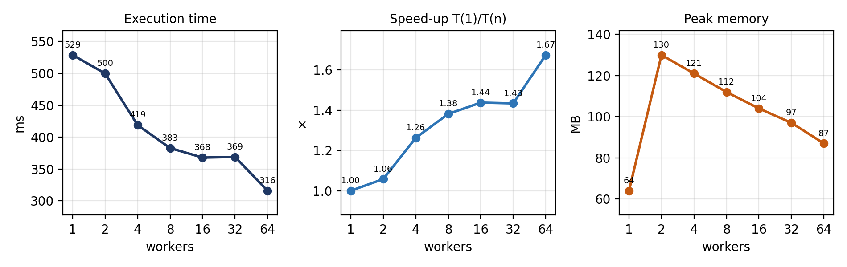
Figure 4. Task 1c – execution time, speed-up and peak memory versus number of workers
Discussion.
- Comparison with Task 1a. Task 1c is much slower. With one worker it needs 529 ms, about three times the 173 ms of Task 1a with one thread, and its best time, 316 ms (64 workers), is about eight times the best time of Task 1a (40 ms). In Task 1a every thread reads and parses its own part of a memory-mapped file by hand, directly from bytes. In Task 1c one thread reads line by line, creates a String per line, parses it with Integer.parseInt, boxes it into an Integer and puts it into a list, while the workers only perform a trivial comparison. It also needs far more memory: 64–130 MB against 1–28 MB, because of the Strings, boxed integers and up to 100 queued batches of 10 000 Integer objects.
- Where the speed-up stops. The speed-up is small from the start and quickly saturates: 1.06× with 2 workers, 1.26× with 4, 1.38× with 8 and 1.44× with 16, then it stays flat at 32 workers (1.43×). The single 64-worker value (1.67×) is a modest further improvement on one run and should not be over-interpreted. The reason is that the single reader thread is the bottleneck (Amdahl's law with a large sequential fraction): consumers cannot process data faster than the reader produces it. Adding workers only helps until they keep up with the reader, so that it never has to wait on a full queue; after that the pipeline runs at the reader's speed, around 0.3–0.4 s here.
- One line per queue element. If each queue element were a single line (batch size 1), there would be 5 000 000 queue operations, each with lock acquisition, signalling and possibly waking a blocked thread, while the useful work per element is one comparison. The synchronisation cost would exceed the work by orders of magnitude and the queue would become the bottleneck; extra workers would then even make it worse because they would compete for the same lock. Batching 10 000 lines per element reduces this to about 500 queue operations.
- Unbounded queue. With an unbounded queue the reader never blocks. Since the reader is the slower stage here, the queue would stay short; but with slower workers (or a faster reader) it would grow without limit and could hold the whole file as Integer objects on the heap, which can lead to OutOfMemoryError. The bounded queue (100 batches) gives back-pressure and keeps memory limited.

6.4 Task 2 – Many files on slow storage
Implementation. The eight files part0.txt … part7.txt, stored on a USB drive, are processed by 1, 2 and 4 threads. File indices are placed into a LinkedBlockingQueue and each thread repeatedly takes the next index until the queue is empty (dynamic distribution, so a faster thread processes more files). Each file is read in a single Files.readAllBytes call into one byte array, and the bytes are then parsed in one pass; no list of lines is created. Per-thread counts are summed at the end.
Results.
threads | time (ms) | speed-up | peak mem (MB) | counts
1 | 1768 | 1.00× | 9 | n=2499314 p=2500685 z=1
2 | 1594 | 1.11× | 22 | n=2499314 p=2500685 z=1
4 | 1576 | 1.12× | 49 | n=2499314 p=2500685 z=1
Table 6. Task 2 measurements (USB drive F:\parts, cold cache, separate process per run)
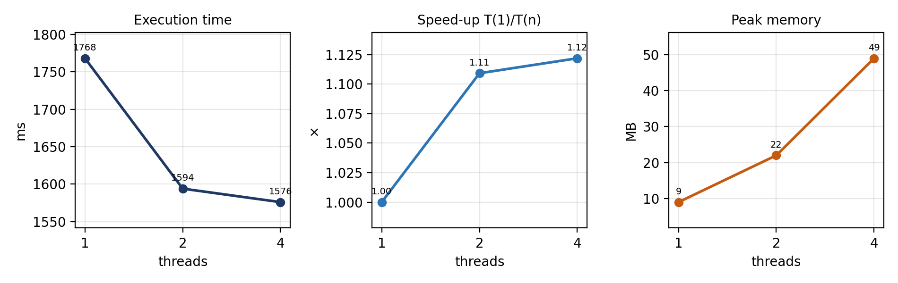
Figure 5. Task 2 – execution time, speed-up and peak memory versus number of threads
Discussion.
- CPU-bound or I/O-bound. The task is I/O-bound. The same amount of data (about 35 MB) is processed by Task 1a with one thread in 173 ms, but here it takes 1768 ms, about ten times longer, although the parsing code is equivalent. The extra time is spent waiting for the USB drive: 36.9 MB in 1.77 s is a throughput of roughly 21 MB/s (and about 23 MB/s with 4 threads), typical for a USB flash drive and far below the speed of the memory or the CPU.
- Why more threads do not help. The speed-up is only 1.11× with 2 threads (1594 ms) and 1.12× with 4 threads (1576 ms). The limit is the single USB device and its bus: parallel read requests do not make the device deliver more bytes per second, they just wait in its queue. The small gain probably comes from overlapping the parsing of one file with the reading of another (while one thread parses, another can already be waiting for data), which can hide only the small CPU portion of the total time. Beyond that the drive is saturated, so 4 threads are practically the same as 2.
- Memory. Peak memory grows with the number of threads (9, 22 and 49 MB), because each thread keeps a whole file (about 4.6 MB) in a byte array while it is being parsed, plus per-thread overhead. The difference between the files is therefore small, but it shows the cost of reading each file in a single operation.

7. Conclusion
The experiments show that the effect of concurrency depends on where the real bottleneck is:
- CPU-bound work (Task 1a, Task 1b version 3): when the data is already available and the threads work independently, the execution time decreases with the number of threads until the number of physical cores is reached (4.3× with up to 8 logical processors in Task 1a), then flattens.
- Synchronisation-bound work (Task 1b versions 1 and 2): sharing mutable state either gives wrong results (no synchronisation) or removes the parallelism (a global lock). Per-thread counters merged at the end are both correct and fast.
- Producer-bound work (Task 1c): a pipeline is only as fast as its slowest stage. A single sequential reader limits the speed-up regardless of the number of workers; batching and a bounded queue are required to keep overhead and memory under control.
- I/O-bound work (Task 2): when the device is the limit, extra threads do not help, because the CPU is not the resource that is exhausted.
This was determined by comparing the time and speed-up curves of the tasks, by the dependence on the number of cores, and by the fact that Task 2 does not improve with more threads even though its computation is identical to that of Task 1a.

8. Build and Run Instructions

8.1 Build
From the project root, in PowerShell:
Remove-Item -Recurse -Force out -ErrorAction SilentlyContinue
New-Item -ItemType Directory -Force -Path out | Out-Null
javac -d out src\lab1\*.java

If java is older than javac, compile for the runtime that is installed:
javac --release 8 -d out src/lab1/*.java
javac --release 11 -d out src/lab1/*.java
javac --release 17 -d out src/lab1/*.java

8.2 Run
java -cp out lab1.DataGenerator # once: numbers.txt + parts/
java -Xmx2g -cp out lab1.Task1a
java -Xmx2g -cp out lab1.Task1b
java -Xmx2g -cp out lab1.Task1c
java -Xmx2g -cp out lab1.Task2 E:\parts # Windows
java -Xmx2g -cp out lab1.Task2 /Volumes/YOURUSB/parts # macOS/Linux

Before Task 2 copy parts/ to the USB drive, and before every run eject the drive, unplug it and plug it back in.

8.3 Troubleshooting
- UnsupportedClassVersionError (class file version 61.0 … up to 52.0): javac is newer than java. Compile with --release matching the runtime, or (preferably) make both the same version and put the JDK bin folder before the JRE in Path.
- Remove-Item … '/q': this is PowerShell, not CMD; use Remove-Item -Recurse -Force.
- Could not find or load main class lab1.DataGenerator: add -cp out and run from the project root.
- OutOfMemoryError in Task 1b: run with -Xmx2g; 5 000 000 ints need about 20 MB plus JVM overhead.
- Task 2 reads from cache: eject, unplug and replug the USB drive before every run.

Appendix A. Source Code Overview
File | Purpose
Utils.java | Constants, Counts class, classify/parse, timing and memory helpers, hardware info.
DataGenerator.java | Generates numbers.txt (seed 42) and splits it into 8 line-aligned parts.
Task1a.java | Fixed thread pool; per-thread byte range snapped to newlines; FileChannel.map; byte-level parsing.
Task1b.java | int[] loaded once; V1 unsynchronised, V2 ReentrantLock, V3 per-thread counters.
Task1c.java | Reader thread, batches of 10 000, ArrayBlockingQueue (100), poison-pill termination.
Task2.java | 8 files, queue of file indices, Files.readAllBytes, 1/2/4 threads.
Table 7. Source files
The complete source code is submitted together with this report.

