
MINISTRY OF EDUCATION, CULTURE AND RESEARCH
OF THE REPUBLIC OF MOLDOVA
Technical University of Moldova
Faculty of Computers, Informatics and Microelectronics
Department of Software Engineering and Automation

Rodion Bulimar FAF-242

Report
Laboratory Work 5&6
Operating Systems

Checked by:
Reițman Patricia, university assistant
FCIM, UTM

Chișinău – 2026
Table of Contents
Fifth Laboratory Work 3
Goal 3
Setup 3
Part 1. The tree and the file types 3
Observations 3
Part 2. Inodes and links 5
Observations 7
Part 3. Permissions 8
Observations 9
Part 4. Disks and the kernel as files 10
Observations 12
Conclusion 12
Sixth Laboratory Work 14
Goal 14
Setup 14
Part 1. Read what xv6 shows you 14
Observations 16
Part 2. Write mystat 16
Observations 17
Part 3. Measure the limits 18
Observations 19
Part 4. Write find 20
Observations 23
Conclusion 23

Fifth Laboratory Work

Goal
The goal of this lab is to check on my own Linux machine everything covered in the lecture on file systems: the directory tree and the file types, the inodes that stand behind file names, hard and symbolic links, permissions, and the disks and kernel interfaces underneath. No programming is involved: only commands, careful observation and short explanations.

Setup
All work was done in the terminal of the Ubuntu virtual machine, as a normal user, not as root: root ignores most permission checks and the experiments in Part 3 would give false results. The working directory was created as follows:
whoami # must not print root
mkdir -p ~/os-lab5 && cd ~/os-lab5

Output:
rodion

Fig 1.1 – whoami command

Part 1. The tree and the file types
Commands run: a listing of the root directory, the long listing of several special paths, the beginning of /dev, the type detection with file, and the size of /var/log and /usr.
ls /
ls -ld /etc /etc/passwd /bin /dev/null /tmp
ls -l /dev | head
file /usr/bin/ls /etc/passwd /bin
du -sh /var/log 2>/dev/null ; du -sh /usr 2>/dev/null

Output (key lines):
drwxr-xr-x 147 root root 12288 Oct 6 22:46 /etc
-rw-r--r-- 1 root root 2772 Sep 28 22:38 /etc/passwd
lrwxrwxrwx 1 root root 7 Apr 20 11:46 /bin -> usr/bin
crw-rw-rw- 1 root root 1, 3 Oct 16 22:15 /dev/null
drwxrwxrwt 17 root root 440 Oct 16 22:26 /tmp

Observations
1. The type of each path (first letter of ls -l).
Path | Letter | Type
/etc | d | directory
/etc/passwd | - | regular file
/bin | l | symbolic link (on a modern distribution)
/dev/null | c | character device
/tmp | d | directory (the last permission letter is t, the sticky bit)

2. What is /bin on my system?
ls -ld /bin starts with l, so /bin is a symbolic link, not a directory. It points to usr/bin (shown as /bin -> usr/bin): since the “merged /usr” layout, /bin, /sbin and /lib are only links into /usr, so old scripts with #!/bin/sh still work. file /bin confirms it with “symbolic link to usr/bin”. On my system: ls -ld /bin outputs lrwxrwxrwx ... /bin -> usr/bin.
3. One character device and one block device in /dev.
Character device: /dev/null (letter c, major/minor 1, 3; also /dev/tty or /dev/zero). It is read and written as a stream of bytes. Block device: /dev/loop0 (and /dev/loop1, etc.) – in my own ls -l /dev output, these start with b, e.g., brw-rw---- 1 root disk 7, 0 Oct 16 22:14 loop0. A block device is read and written in fixed-size blocks and can be randomly accessed, which is what file systems need.
4. Which is bigger, /var/log or /usr?
/usr is the bigger one: /usr is 5.6G, while /var/log is only 294M. This is expected, because /usr holds all installed programs, libraries and documentation, while /var/log holds only text logs that grow slowly and are rotated.
Output / screenshots:
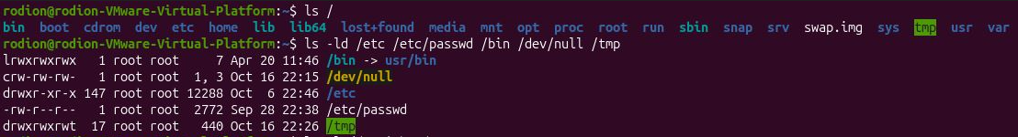Fig 2.1 – Root directory and the long listing of special paths
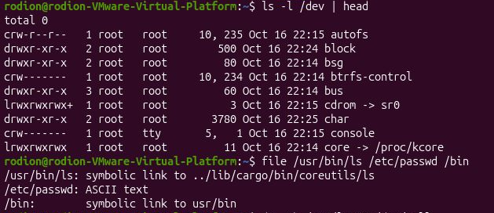Fig 2.2 – /dev and the output of file
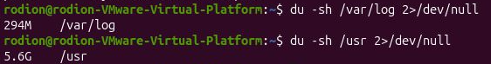
Fig 2.3 – Sizes of /var/log and /usr

Part 2. Inodes and links
Commands run: a file was created and inspected with stat; a hard link was made and the “original” removed; a symbolic link was made and its target removed; link counts of directories were checked; and apparent size was compared with disk usage.
An inode, and a name that is not part of it:
echo hello > notes.txt
stat notes.txt
ls -li notes.txt
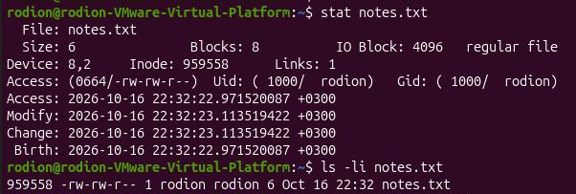
Fig 3.1 – stat and ls -li of notes.txt
Hard link, then remove the “original”:
ln notes.txt hard.txt
ls -li notes.txt hard.txt
rm notes.txt
cat hard.txt ; ls -li hard.txt
Expected and observed: both names show the same inode number and a link count of 2; after rm notes.txt the command cat hard.txt still prints hello and the link count drops to 1. My observed inode number was 959558.
Fig 3.2.1 – Hard link: same inode, link count 2 then 1
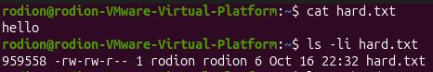
Fig 3.2.2 – Hard link: same inode, link count 2 then 1
Symbolic link, then remove its target:
ln -s hard.txt soft.txt
ls -li hard.txt soft.txt
cat soft.txt
rm hard.txt
cat soft.txt ; ls -l soft.txt
Expected and observed: soft.txt has its own inode and type l; cat soft.txt works while hard.txt exists. After rm hard.txt the link is dangling: cat: soft.txt: No such file or directory, while ls -l still shows soft.txt -> hard.txt with size 8.
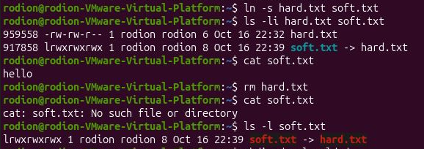
Fig 3.3 – Symbolic link and the dangling link
Directories have links too (predict first):
mkdir d ; ls -ld d
mkdir d/x d/y ; ls -ld d
My prediction: 2 for the new directory and 4 after two subdirectories. Observed: drwxr-xr-x 2 ... d and then drwxr-xr-x 4 ... d.
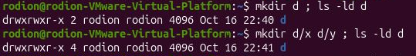
Fig 3.4 – Link count of a directory
Size is not space:
echo x > one.txt ; ls -l one.txt ; du -h one.txt
truncate -s 1G big.img ; ls -lh big.img ; du -h big.img
rm big.img
Observed: one.txt has size 2 bytes (the letter and the newline) but du -h reports 4.0K; big.img has an apparent size of 1.0G but du -h reports 0.
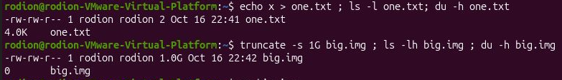Fig 3.5 – Apparent size versus disk usage

Observations
1. Which number in stat is the inode, and which tells how many names the file has?
The field Inode: is the inode number (the same number is printed in the first column of ls -li). The field Links: is the link count: the number of names (directory entries) that point to this inode. A freshly created file has Links: 1.
2. After rm notes.txt, why could I still read hard.txt? What does rm really remove?
A file name is not part of the file. A directory entry is only a pair “name → inode number”, and the data, the size, the owner and the permissions live in the inode. ln added a second entry pointing to the same inode (link count 2). rm does not delete a file: it calls unlink(), which removes one name and decreases the link count. The inode and its data blocks are freed only when the link count reaches 0 and no process has the file open. After rm notes.txt the count was 1, so hard.txt kept working.
3. Why did cat soft.txt fail at the end? How big is soft.txt and why exactly that size?
A symbolic link is a separate small file (own inode) whose content is just the path of the target, here the text hard.txt. When the target was removed, the path in the link no longer led anywhere, so opening it gave “No such file or directory”, although the link itself still exists (a dangling link). The size of soft.txt is 8 bytes, because it stores the 8 characters of the string hard.txt (without a terminating newline).
4. Why does a new directory have 2 links, and 4 after two subdirectories?
A new empty directory has two names pointing to it: (1) its entry in the parent directory (d inside ~/os-lab5), and (2) the entry . inside the directory itself. Every subdirectory contains an entry .. that points back to its parent, so each mkdir inside d adds one more link to d. With x and y the count is 2 + 2 = 4. Regular files do not add links to the directory.
5. Why does a 2-byte file use 4.0K, and a 1 GB file use 0?
The file system allocates space in blocks (here 4 KiB), not in bytes, so even a 2-byte file occupies one whole block, and du shows the allocated space. truncate -s 1G only sets the size field in the inode; it does not write any data. The result is a sparse file: the “holes” have no blocks allocated, and reading them returns zeros. So ls -l shows the apparent size (1 GB) and du shows the real usage (0). This is why rm big.img was instant.

Part 3. Permissions
Commands run: permission changes on a file, the effect of umask, a directory experiment with read-only and execute-only access, and a look at special bits and protected system files.
Files:
echo secret > s.txt
chmod 600 s.txt ; ls -l s.txt
chmod 000 s.txt ; cat s.txt
chmod u+r s.txt ; cat s.txt
umask ; touch new.txt ; mkdir newdir ; ls -ld new.txt newdir
Observed: after chmod 600 the mode is -rw-------; with mode 000 cat s.txt prints cat: s.txt: Permission denied; after chmod u+r it prints secret. umask: 0002; new.txt: -rw-rw-r--; newdir: drwxrwxr-x.
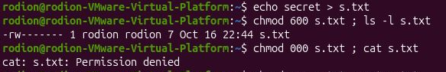
Fig 4.1 – chmod 600 / 000 and cat
Fig 4.2 – umask and the permissions of new.txt and newdir
Directories (predict first):
mkdir box ; echo hi > box/f
chmod u=r,go= box ; ls box ; cat box/f # read only
chmod u=x,go= box ; ls box ; cat box/f # execute only
chmod 755 box
Mode of box | My prediction | Real result
r-- (read only) | ls box works and shows f; cat box/f fails | f  cat:box/f:Permission denied
--x (execute only) | ls box fails; cat box/f works | ls:cannot open directory ‘box’:Permission denied  hi

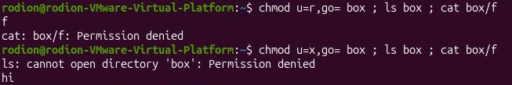Fig 4.3 – The box experiment
Special bits and other people's files:
ls -l /usr/bin/passwd ; ls -ld /tmp
cat /etc/shadow
ls -l /etc/shadow
Observed: /usr/bin/passwd is -rwsr-xr-x owned by root; /tmp is drwxrwxrwt; cat /etc/shadow prints Permission denied; /etc/shadow is -rw-r----- root shadow.
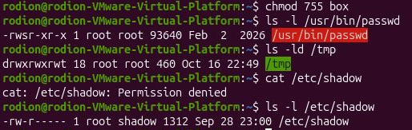
Fig 4.4 – passwd, /tmp and /etc/shadow

Observations
1. 600, 644, 755 and 700 as rwx strings, with one real use for each.
Mode | String | Typical use
600 | rw------- | private files only the owner may read and write, e.g. an SSH private key ~/.ssh/id_ed25519
644 | rw-r--r-- | ordinary data and configuration files readable by everyone, e.g. /etc/passwd, web pages
755 | rwxr-xr-x | programs and public directories, e.g. /usr/bin/ls, /home subdirectories that must be traversed
700 | rwx------ | private directories, e.g. ~/.ssh

2. With chmod 000 I own the file but cannot read it. Why does ownership not help?
The kernel decides access by choosing exactly one class of permission bits: if the user is the owner, only the owner bits are used; otherwise the group bits, otherwise “others”. For my file the owner bits are ---, so I am denied, and the more permissive group/other bits are not consulted (they are 0 anyway). Ownership gives a different right: the right to change the mode. That is why chmod u+r s.txt worked and the file could be read again.
3. What is my umask, and how does it explain the permissions of new.txt and newdir?
The umask is a mask of permission bits that are removed from the default mode of every new file. The defaults requested by programs are 666 for files (no execute bit by default) and 777 for directories. For the Ubuntu default umask 0002: files 664 (rw-rw-r--) and directories 775 (rwxrwxr-x).
4. Explain the box experiment: what does r allow on a directory, and what does x allow?
A directory is a table of “name → inode” entries. r allows reading that table, i.e. listing the names (ls box). x allows passing through the directory, i.e. using it in a path to reach an entry whose name is already known (box/f); it is needed for cd and for opening anything inside. With r--, ls can show the name f, but cat box/f fails because I cannot traverse the directory (and ls -l also fails, as it needs to read the inode of each entry). With --x, ls box fails because I cannot read the list of names, but cat box/f works because I know the name and may traverse the directory. Note that to read or write a file I need x on every directory of its path.
5. What do the s in /usr/bin/passwd and the t in /tmp mean, and why does passwd need the s?
The s in the owner’s execute position is the setuid bit: when the file is executed, the process runs with the privileges of the file’s owner (root), not of the user who started it. The t in the last position of /tmp is the sticky bit on a directory: everyone can create files there, but a file can be deleted or renamed only by its owner, the owner of the directory or root. passwd needs the setuid bit because it must change my entry in /etc/shadow, a file that only root can write (as seen from the Permission denied of cat /etc/shadow). A normal user can therefore change his own password, but only through this small, trusted program, and not by editing the file directly.

Part 4. Disks and the kernel as files
Commands run: the block devices and mounted file systems, the root mount, and several files from /proc, the virtual file system through which the kernel shows its state.
lsblk
df -h
mount | grep " / "
grep -c processor /proc/cpuinfo
head -3 /proc/meminfo
head -5 /proc/self/status
ls -l /proc/self/fd

Output (key lines):
NAME MAJ:MIN RM SIZE RO TYPE MOUNTPOINTS
sda 8:0 0 50G 0 disk
sda1 8:1 0 1M 0 part
sda2 8:2 0 50G 0 part /
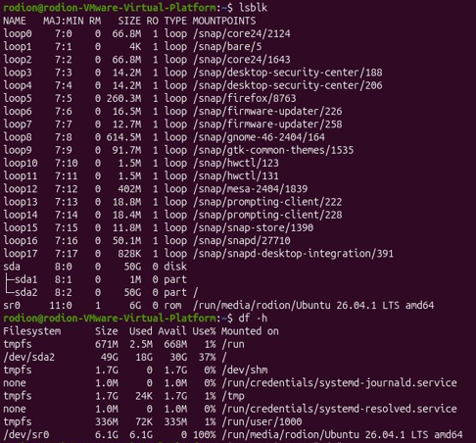
Fig 5.1 – lsblk and df -h
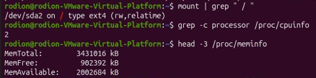
Fig 5.2 – Root mount, CPU count and memory
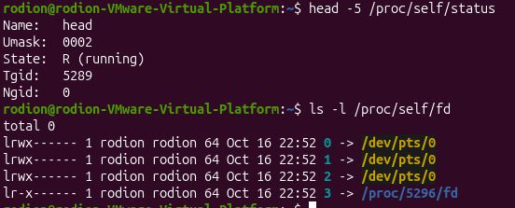
Fig 5.3 – /proc/self/status and /proc/self/fd

Observations
1. My disk: disk name, partitions, the one mounted at / and its file system type.
The disk is sda of size 50GB. It has the partitions sda1, sda2. The partition mounted at / is sda2, with the file system type ext4 (taken from mount | grep " / ").
2. How full is my root file system?
df -h / shows used 18GB of 50GB, 37%] used, with 30GB available.
3. How many CPU cores and how much RAM, according to /proc?
grep -c processor /proc/cpuinfo printed 2, so the machine has 2 logical CPU cores. The first line of /proc/meminfo, MemTotal, is 3431016 kB, about 3.4 GB of RAM.
4. /proc/self/status showed the name of a program. Which one, and why that one?
The first line is Name: head. /proc/self is a special link that always points to the directory of the process that is reading it. The process reading the file was head itself, so the kernel described head, not the shell. For the same reason ls -l /proc/self/fd describes the process ls: its descriptors 0, 1 and 2 point to the terminal, and one more descriptor points to the directory /proc/<pid>/fd that ls is reading. None of these “files” is stored on disk; the kernel generates their content at the moment of reading.

Conclusion
In this lab I checked on a real Linux system how the file system is organised. I saw that the tree is built from different kinds of objects (directories, regular files, links, character and block devices), and that the first letter of ls -l tells which kind each one is. I learned that a file name is only an entry in a directory, while the file itself is an inode with a link count: rm removes a name (unlink), a hard link is another name for the same inode, and a symbolic link is a small separate file that stores a path and breaks when the target disappears. The experiments with directory link counts and with sparse files showed the difference between names, apparent size and allocated blocks. In the permissions part I saw that the kernel picks only one class of bits (owner, group or other), that umask removes bits from the defaults, that r and x on a directory mean “list the names” and “pass through”, and that setuid and sticky bits solve specific problems (passwd and /tmp). Finally, lsblk, df and /proc showed the disks underneath the tree and how the kernel exposes its own state through files.
Summary of the main concepts:
Concept | What it means | Where I saw it
File types | First letter of ls -l: -, d, l, c, b | Part 1: /etc, /bin, /dev/null
Inode | Stores metadata and data location; the name is separate | Part 2: stat, ls -li
Hard link | Another name for the same inode (link count +1) | Part 2: ln, rm notes.txt
Symbolic link | A file that holds a path; may dangle | Part 2: soft.txt, 8 bytes
Sparse file | Size without allocated blocks | Part 2: big.img 1G / 0
Permissions, umask | rwx for owner, group, others; umask removes bits | Part 3: chmod, new.txt
setuid / sticky | Run as owner; restrict deletion in a directory | Part 3: passwd, /tmp
/proc | Kernel state shown as files | Part 4: cpuinfo, self/status

Sixth Laboratory Work

Goal
The goal of this lab is to look inside the xv6 file system and see that it uses the same ideas as ext4 (inodes, directories as tables of names, hard links, a log) in a few hundred readable lines of C. I read what xv6 shows about files, wrote my own stat program (mystat), measured the limits defined in kernel/fs.h, and finally wrote find, which walks the directory tree recursively.

Setup
All work was done in my xv6-riscv tree (~/xv6-riscv). Every new program consists of a file user/NAME.c and one line in the UPROGS list of the Makefile (a TAB at the start, nothing after the backslash). The two programs of this lab, mystat and find, were added to the list (the other lines of the list are unchanged):
UPROGS=\
$U/_cat\
...
$U/_sync\
$U/_mystat\
$U/_find\

The system is built and started with make qemu and left with Ctrl-A, then X. For the tests that need a clean disk I used make clean ; make qemu, because the file system image fs.img is rebuilt by make.

Part 1. Read what xv6 shows you
Commands run at the xv6 prompt (started with make qemu); the type constants were read in kernel/stat.h:
ls
mkdir a
ls a

Output:
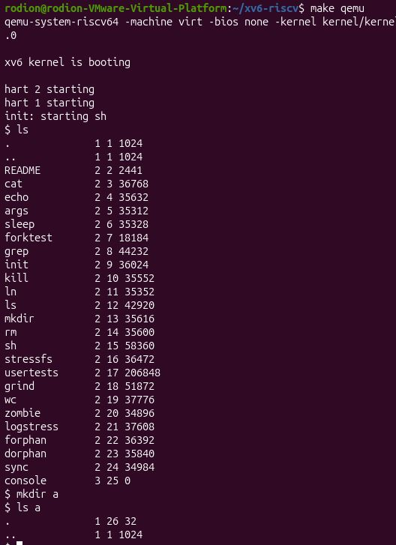
Fig 1.1 – make qemu, ls, mkdir a and ls a in xv6
The type constants from kernel/stat.h:
#define T_DIR 1 // Directory
#define T_FILE 2 // File
#define T_DEVICE 3 // Device

Observations
1. What do types 1, 2 and 3 mean (kernel/stat.h)?
Type 1 is T_DIR, a directory. Type 2 is T_FILE, an ordinary file. Type 3 is T_DEVICE, a device; in the listing it is the console (console 3 25 0), which has size 0 because it holds no data on disk. The second column of ls is exactly this type.
2. Which inode number does the root directory have, and why are . and .. the same there?
The root directory has inode number 1 (ROOTINO in kernel/fs.h); the listing shows . 1 1 1024 and .. 1 1 1024. A directory entry ".." points to the parent directory, but the root has no parent, so ".." points back to the root itself and both entries carry the same inode number.
3. An empty directory a has size 32. How big is one entry, and which two entries does a contain?
A directory entry is struct dirent: a 2-byte inode number (ushort inum) and a name of DIRSIZ = 14 bytes, so one entry is 16 bytes. The size 32 therefore means two entries. They are "." (inode 26, the directory a itself) and ".." (inode 1, the root directory, its parent), as ls a shows: . 1 26 32 and .. 1 1 1024.

Part 2. Write mystat
The stat() call fills a struct stat (dev, ino, type, nlink, size). The TODO parts of user/mystat.c were completed: typename() turns the type constant into a word, and main() calls stat() for every argument, prints an error to file descriptor 2 and continues if it fails, otherwise prints the line NAME: TYPE, inode N, links N, size N bytes.
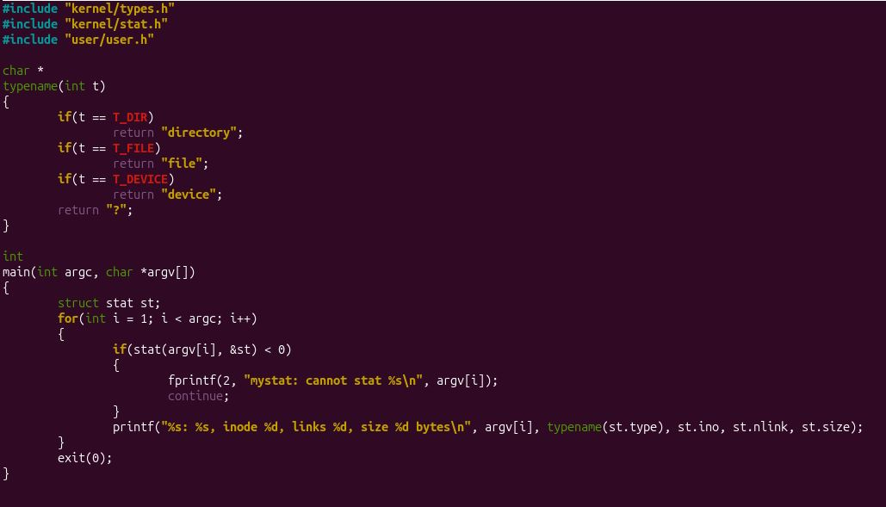
Fig 2.1 – user/mystat.c
Output:
Then hard links were observed:
ln README r2
mystat README r2
rm README
mystat r2
cat r2 | wc

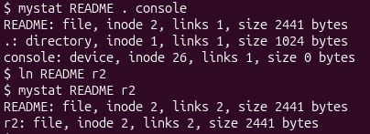
Fig 2.2 – mystat on README, . and console, then after ln README r2
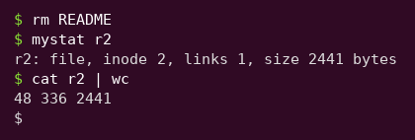
Fig 2.3 – After rm README: the file is still there

Observations
1. Paste the outputs after ln and after rm. What changed and what did not?
After ln, README and r2 report the same inode (2), the same size (2441 bytes) and links 2: they are two names for one file. After rm README, mystat r2 still shows inode 2 and size 2441, but links dropped to 1, and cat r2 | wc prints 48 336 2441, the same 2441 bytes as before. So only the name README and the link count changed; the inode number, the size and the data did not. rm removed a name, not the file.
2. Find the line in kernel/sysfile.c (sys_unlink) that decrements the link count. When are the data blocks freed?
In sys_unlink the directory entry is first overwritten with zeros (writei of an empty struct dirent), and then the line ip->nlink--; (line 244 in my tree) decrements the link count, followed by iupdate(ip) to write the inode to disk. sys_unlink itself never frees data blocks. They are freed in iput() (kernel/fs.c): when the last in-memory reference to the inode is released and ip->nlink == 0, it calls itrunc(ip), which frees all data blocks. So the data disappears only when the link count is 0 and no process has the file open any more. In my experiment nlink went from 2 to 1, therefore nothing was freed.
3. Look at struct dinode in kernel/fs.h: which fields does an xv6 inode have?
struct dinode has: type (file, directory or device), major and minor (device numbers, used only for devices), nlink (number of directory entries pointing to it), size in bytes and addrs[NDIRECT+1], the block addresses (12 direct blocks and one indirect block). There is no owner, no permission bits, no timestamps and no type for a symbolic link, which is why xv6 has neither permissions nor symlinks.

Part 3. Measure the limits
grep -n "define BSIZE\|define NDIRECT\|define NINDIRECT\|define DIRSIZ" kernel/fs.h
make clean ; make fs.img 2>&1 | grep nmeta

$ mkdir averyveryverylongname
$ ls

Output:
Fig 3.1 – The constants of kernel/fs.h
Fig 3.2 – The nmeta line printed by mkfs
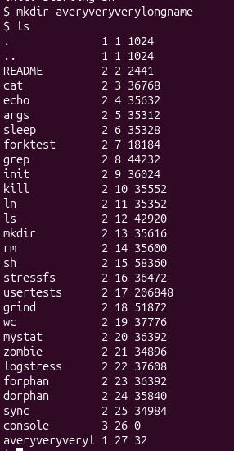
Fig 3.3 – A directory with a name longer than 14 characters

Observations
1. What does ls show for averyveryverylongname, and which constant explains it?
ls shows averyveryveryl, only the first 14 characters: the name has 21 characters, and a directory entry holds at most DIRSIZ = 14 bytes of name, so the rest is cut off when the entry is created. The directory is really called averyveryveryl in the file system.
2. Compute the largest file xv6 can hold.
BSIZE = 1024 and a block number is 4 bytes, so one indirect block holds NINDIRECT = 1024 / 4 = 256 block numbers. MAXFILE = NDIRECT + NINDIRECT = 12 + 256 = 268 blocks. The largest file is 268 × 1024 = 274 432 bytes, that is 268 KiB (about 268 KB).
3. From the nmeta line: how many blocks does the whole disk have, and how many are for the log, the inodes, and the data?
The line is: nmeta 47 (boot, super, log blocks 31, inode blocks 13, bitmap blocks 1) blocks 1953 total 2000. The whole disk has 2000 blocks (FSSIZE), i.e. 2000 KiB. The log takes 31 blocks (30 data blocks plus 1 header block), the inodes take 13 blocks (200 inodes, 16 inodes of 64 bytes per block, 200 / 16 + 1 = 13), and 1953 blocks are left for data. The remaining blocks are 1 boot block, 1 superblock and 1 bitmap block. Check: 1 + 1 + 31 + 13 + 1 = 47 metadata blocks, and 2000 − 47 = 1953.

Part 4. Write find
find <dir> <name> prints every path under <dir> whose last component is <name>. I started from user/ls.c and kept its function fmtname(), which returns the last component of a path. The function find() opens the path and calls fstat; if the path is a directory, it reads struct dirent entries one by one, builds the full path of every entry in a buffer and calls itself recursively. The details required by the task: entries with inum == 0 (free slots) are skipped; "." and ".." are never entered, otherwise the recursion would never end; names are compared with strcmp; and the descriptor of every opened directory is closed before returning (a process may have only 16 open files). The path itself is compared with the name before the directory is read, so that find a b also prints the directory a/b. The path "." is excluded from the comparison.
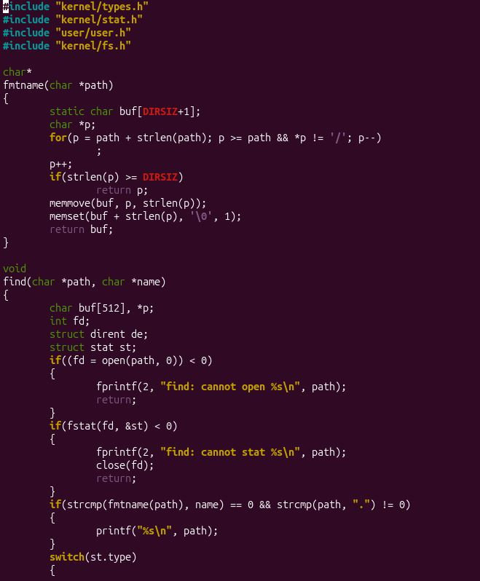
Fig 4.1 – user/find.c (part 1)
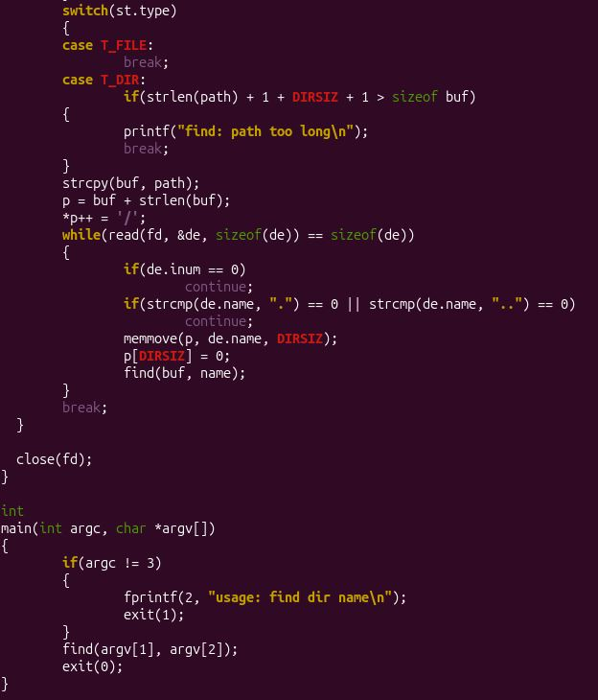
Fig 4.2 – user/find.c (part 2)
Test on a fresh disk (make clean ; make qemu):
mkdir a
mkdir a/b
echo x > a/b/r2
echo y > a/r2
ln cat r2
find . r2
find a b

Output:
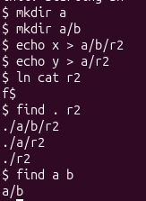
Fig 4.3 – find on the test tree

Observations
find . r2 found all three files named r2: ./a/b/r2, ./a/r2 and ./r2 (the last one is a hard link to cat, created with ln cat r2, so it is the same file as cat under another name). find a b found only the directory a/b, which shows that the name is compared with the last component of the path and that directories are matched as well as files. The order of the lines follows the order of the entries in the directories.

Conclusion
In this lab I looked at how xv6 stores files. A file is an inode (type, nlink, size and block addresses); a directory is an ordinary file made of 16-byte entries, each holding an inode number and a name of at most 14 characters, and the root directory is inode 1 and is its own parent. With mystat I saw that a hard link is just a second directory entry for the same inode: ln raised the link count to 2, and rm README lowered it to 1 without touching the data, because the blocks are freed in iput() only when nlink reaches 0 and the file is no longer open. The constants of kernel/fs.h explain the limits: DIRSIZ = 14 truncated the long directory name, and 12 direct blocks plus 256 indirect ones give a maximum file size of 268 blocks = 274 432 bytes. From the nmeta line I read the layout of the 2000-block disk: 1 boot, 1 super, 31 log, 13 inode, 1 bitmap and 1953 data blocks. Finally, find showed how a program walks the tree recursively using only open, fstat and read on directories, and why "." and ".." must be skipped.
Summary:
Concept | Key fact | Where I saw it
Directory entry | 16 bytes: 2-byte inode number + 14-byte name | Part 1: empty directory has size 32; Part 3: long name cut
Hard link | Second name for the same inode, nlink counts the names | Part 2: ln README r2, rm README
Freeing data | In iput() when nlink == 0 and no references remain | Part 2: sys_unlink and iput
Maximum file | (12 + 256) blocks × 1024 B = 274 432 bytes | Part 3: calculation

