
MINISTRY OF EDUCATION, CULTURE AND RESEARCH
OF THE REPUBLIC OF MOLDOVA
Technical University of Moldova
Faculty of Computers, Informatics and Microelectronics
Department of Software Engineering and Automation

Rodion Bulimar FAF-242

Report
Laboratory Work 1&2
Operating Systems

Checked by:
Reițman Patricia, university assistant
FCIM, UTM

Chișinău – 2026

Table of Contents
Goal 3
Setup 3
Part 1. Files and directories 3
Observations 3
Part 2. Processes 5
Observations 6
Interesting output 7
Part 3. Memory 8
Observations 8
Interesting output 9
Part 4. Devices and storage 9
Observations 9
Interesting output 10
Conclusion 11
Goal 12
Setup 12
Part 1. Build it and boot it 12
Observations 12
Part 2. Use xv6 as the Unix it is 12
Observations 13
Part 3. Read the source 14
Observations 14
Interesting output 16
17
Part 4. Write your first xv6 program 17
user/sleep.c 17
Makefile 17
Observations 18
Interesting output 18
Interesting commands 19
Conclusion 19

First Laboratory Work

Goal
The goal of this lab is to observe, directly in the terminal of the provided Linux VM, the four core jobs of an operating system: managing files, processes, memory and devices.

Setup
mkdir -p ~/os-lab1 && cd ~/os-lab1
whoami
uname -a
uptime

Output / screenshot:
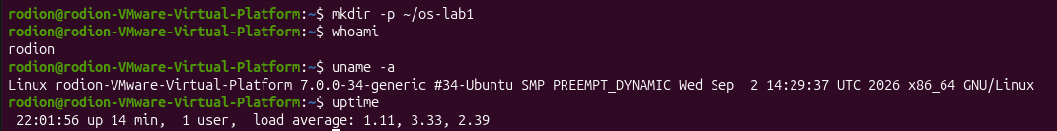
Fig 1.1 – Output of the setup commands

Part 1. Files and directories
Commands run: navigation (pwd, ls -la /, ls -la ~, cd /etc && ls | head), then create / copy / rename / remove files in ~/os-lab1/demo, then inspect and change permissions.
cd ~/os-lab1 && mkdir demo && cd demo
echo "hello operating systems" > note.txt
cp note.txt copy.txt && mv copy.txt renamed.txt
ls -l && rm renamed.txt
ls -l note.txt && chmod 600 note.txt && ls -l note.txt && chmod 644 note.txt

Observations
1. Who owns the files you created, and which group?
Owner: Rodion, group: FAF-242. On Linux the OS stamps every new file with the user who created it and that user's primary group.
2. What do the ten characters at the start of ls -l mean for note.txt after chmod 600?
The string is -rw-------. The first character - means it is a regular file (a directory would show d). The next three, rw-, are the owner's permissions: read and write, no execute. The following three --- are the group's and the last three --- are everyone else's: no access. So only the owner can read or modify the file.
3. Two directories directly under / and what they hold.
- /etc — system-wide configuration files (for example user accounts, network and service settings).
- /home — the personal directories of the normal users, where their files live.
(Other valid choices: /bin essential programs, /dev device files, /proc kernel and process information, /tmp temporary files.)
Output / screenshot:
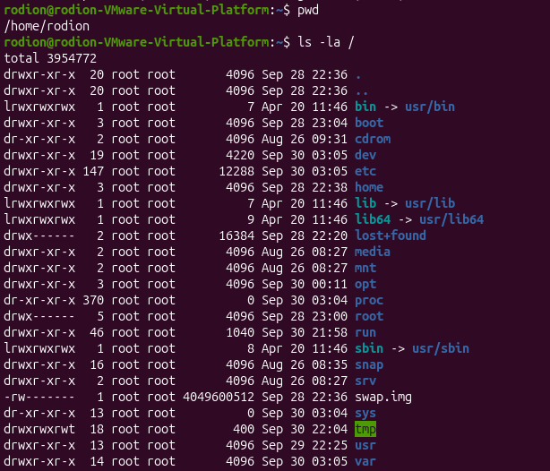
Fig 2.1 – Output of pwd and ls –la / commands
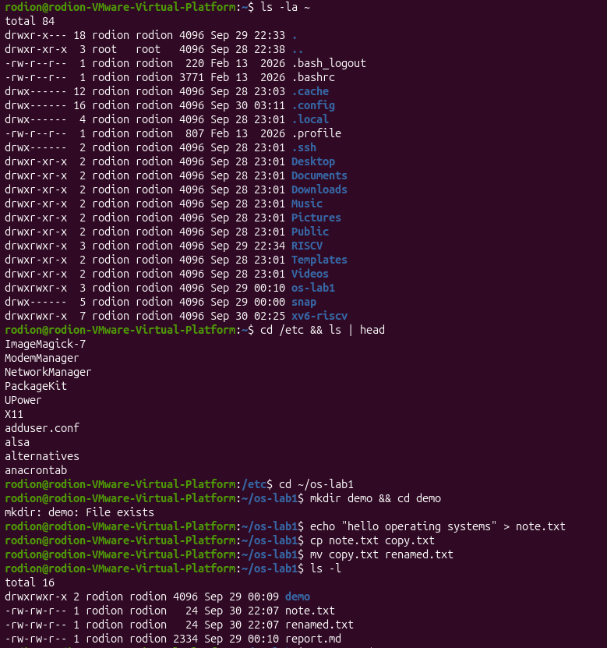
Fig 2.2 – Output of the next commands
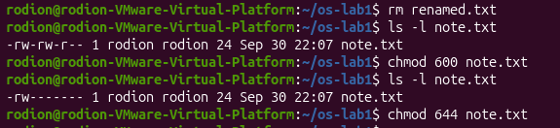
Fig 2.3 – Output of the last commands
Interesting output
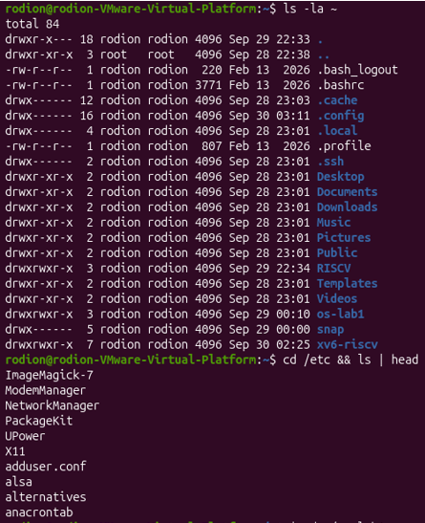
Fig 2.4 – Interesting commands in the first part

Part 2. Processes
Commands run: ps aux | head, ps aux | wc -l, top, then a background sleep 300 & found with jobs and ps -ef | grep sleep and stopped with kill; finally the /proc/<pid>/ directory of a sleeping process.
ps aux | head
ps aux | wc -l
sleep 300 &
jobs
ps -ef | grep sleep
kill <PID>

sleep 300 &
PID=$!
ls /proc/$PID/
cat /proc/$PID/status | head -20
kill $PID

Observations
1. What is the PID of process number 1, and what is it?
PID 1 is 1. It is the first process started by the kernel at boot; every other process descends from it, and it starts and supervises the system services.
2. Roughly how many processes were running on the idle VM?
About 307 processes, most of them kernel threads and background services.
3. What does the State: line say for the sleeping process?
State: shows 5330. The process is not using the CPU; it is waiting for its timer to expire, and the scheduler simply skips it until then.
Output / screenshot:
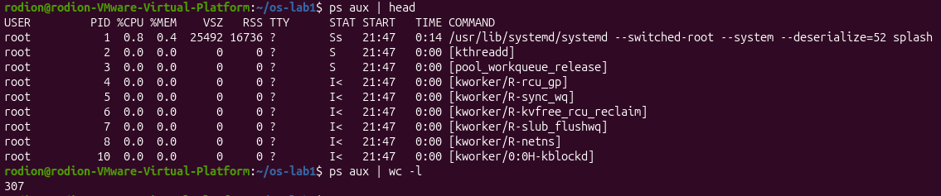
Fig 2.1 – Output of ps aux | head and ps aux | wc -l commands
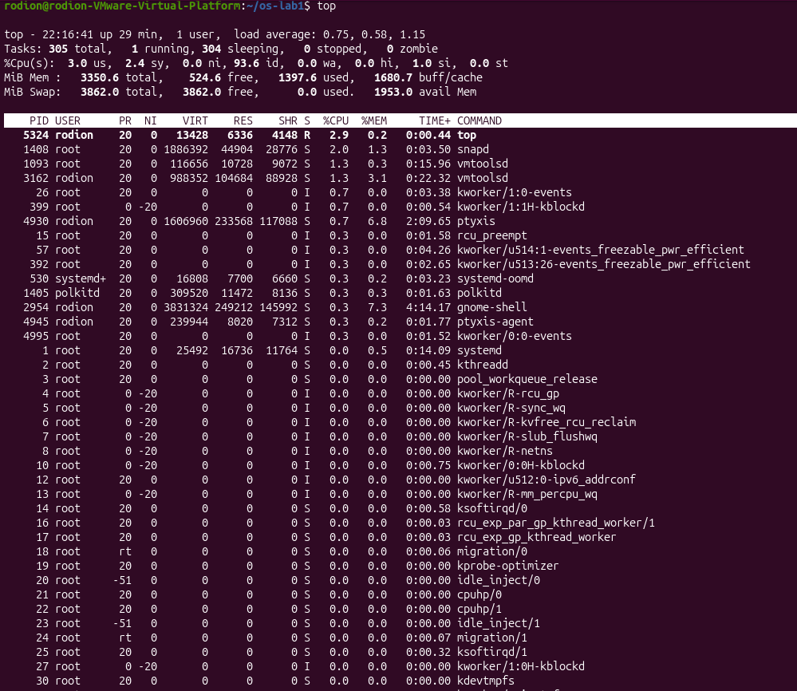
Fig 3.2 – Output of top command
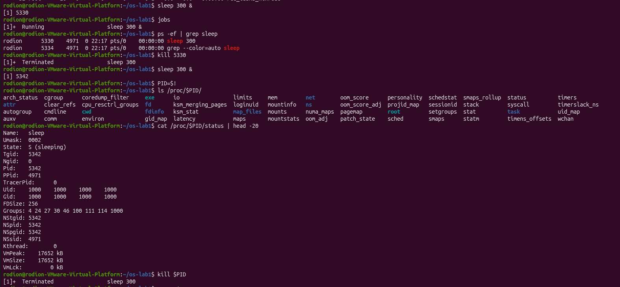
Fig 3.3 – Output of the rest of commands

Interesting output
Fig 3.4 – Interesting command in the second part

Part 3. Memory
Commands run: free -h, cat /proc/meminfo | head -6, and grep VmRSS on the status file of a background sleep process.
free -h
cat /proc/meminfo | head -6
sleep 300 & PID=$!
grep VmRSS /proc/$PID/status
kill $PID

Observations
1. Total RAM of the VM and how much is free?
Total: 3.3 GiB, free: 381 MiB(from free -h). Note that the “available” column is more meaningful than “free”, because Linux uses spare RAM for disk cache and gives it back when programs need it.
2. What is swap and how much is configured?
Swap is disk space the OS uses as an overflow for RAM: when memory is short, the kernel moves rarely used pages from RAM to disk, at the cost of speed. Configured on this VM: 3.8 GiB and 0 B used.
3. How much resident memory (VmRSS) does a bare sleep use, and is it surprising?
VmRSS = 8000 kB. It is small because sleep does almost nothing, and a large part of that is shared library code (such as libc) that the OS maps into many processes at once and stores in RAM only one time. This shows how the OS shares physical RAM between processes.
Output / screenshot:
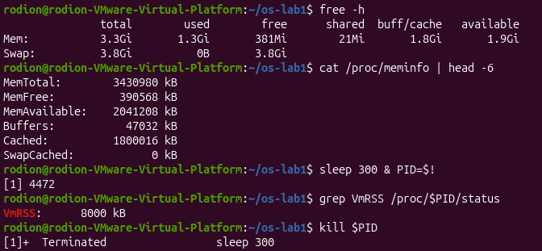
Fig 4.1 – Output of the commands

Interesting output
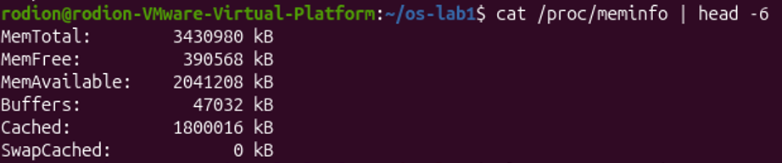
Fig 4.2 – Interesting command of the third part

Part 4. Devices and storage
Commands run: df -h, lsblk, du -sh ~/os-lab1, ls -l /dev | head, mount | head.
df -h
lsblk
du -sh ~/os-lab1
ls -l /dev | head
mount | head

Observations
1. Which device is the root filesystem / mounted on?
/dev/sda2, a partition of the VM's virtual disk.
2. One entry from /dev and the real thing it stands for.
/dev/sda2 stands for the first physical (here virtual) disk. Other examples: /dev/tty is the terminal, /dev/null discards everything written to it (no hardware), /dev/random is the kernel's random number source.
3. What does “everything is a file” mean?
Disks, terminals and other devices are presented as entries in the same file tree, so programs use the same operations (open, read, write, close) on them as on ordinary files; the OS hides the hardware differences behind this uniform interface.
Output / screenshot:
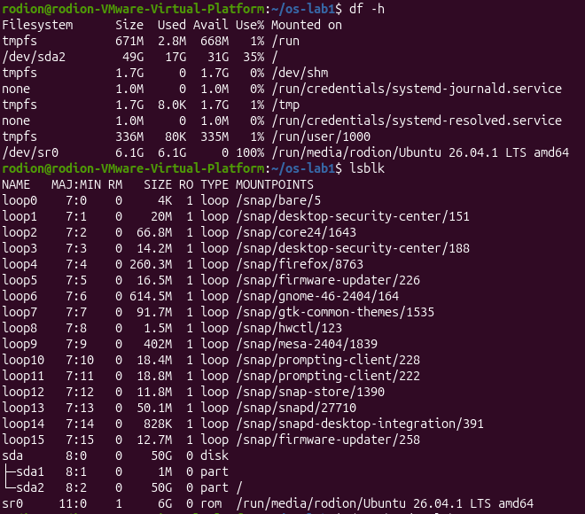
Fig 4.3 – Output of df –h and lsblk commands
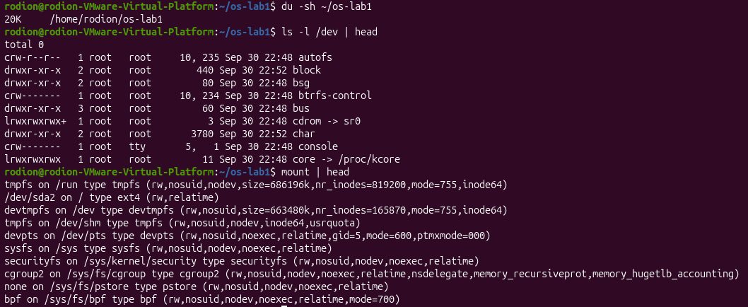
Fig 4.4 – Output of the rest of commands

Interesting output
Fig 4.5 – Interesting commands of the fourth part

Conclusion
An operating system is the manager between programs and hardware, and it manages four resources. It manages files, which I observed with ls -l and chmod showing owners and permissions; processes, which I observed with ps aux and /proc/<pid>/status; memory, which I observed with free -h and grep VmRSS; and devices, which I observed with df -h, lsblk and ls -l /dev. Together these commands showed the OS working live as the layer that shares the machine safely between all running programs.

Resource | OS job | Command that showed it
Files | Turns the disk into a tree of named files with owners and permissions | ls -l, chmod, mkdir
Processes | Creates, isolates and schedules running programs | ps aux, top, kill
Memory | Shares physical RAM and gives each process its own view | free -h, /proc/<pid>/status
Devices | Hides disks and hardware behind file-like interfaces | df -h, lsblk, ls -l /dev

Second Laboratory Work

Goal
The goal of this lab is to build xv6, a small teaching Unix written in about 9,000 lines of C for RISC-V, boot it under QEMU, use it as a Unix, read its source to see the split between kernel and user code, and write a first program that runs inside it.

Setup
cd ~/xv6-riscv 2>/dev/null || git clone https://github.com/mit-pdos/xv6-riscv ~/xv6-riscv
cd ~/xv6-riscv
ls

Output / screenshot:
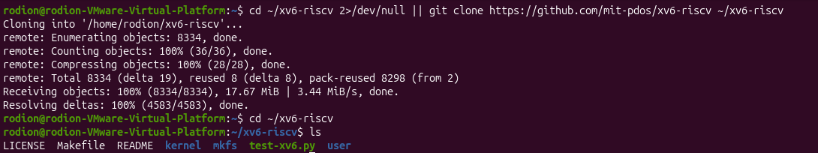
Fig 5.1 – Output of the setup commands

Part 1. Build it and boot it
Command run: make qemu compiles the kernel and the user programs, then starts xv6 in the QEMU emulator. To quit the emulator I pressed Ctrl-A, released, then X.
make qemu
# expected: xv6 kernel is booting
# init: starting sh
# $

Observations
1. What did the boot print?
The kernel printed xv6 kernel is booting, then init: starting sh, and finally the shell prompt $.
2. How do you leave xv6?
xv6 runs inside QEMU, so the exit key is the emulator's: Ctrl-A, release, then X. It is not a command inside xv6.
Output / screenshot:
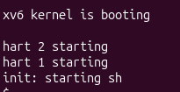
Fig 6.1 – Output of the make qemu command

Part 2. Use xv6 as the Unix it is
Commands run at the xv6 prompt: the built-in programs, including a pipe.
$ ls
$ cat README
$ echo hello xv6
$ ls | grep c
$ wc README
$ usertests -q # optional

Observations
1. Three programs xv6 ships with.
Examples from the ls output: cat (prints a file), echo (prints its arguments), wc (counts lines, words and bytes). Others include grep, mkdir, rm and sh.
2. Which two OS features must exist for a pipe to work?
First, processes: the shell has to create two separate processes (with fork and exec), one for each side of the |. Second, inter-process communication: the kernel provides a pipe, a buffer with a write end and a read end exposed as file descriptors, so the output of the first process becomes the input of the second.
3. How does the xv6 shell compare to the Linux shell from Lab 1?
It is the same idea in a much smaller form: it runs programs, redirects input and output and supports pipes, but it has none of the comfort of bash such as history, tab completion or scripting.
Output / screenshot:
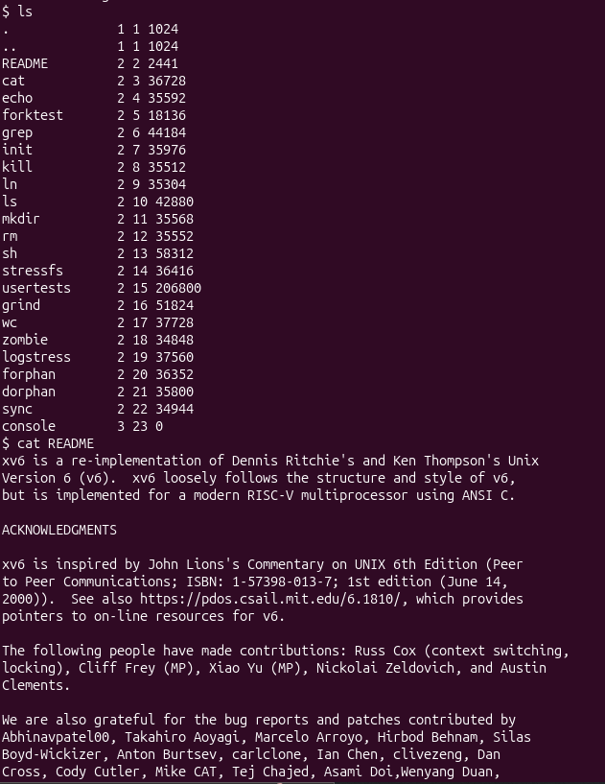
Fig 7.1 – Output of the first lines of code
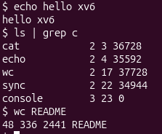
Fig 7.2 – Output of the last lines of code

Part 3. Read the source
After quitting QEMU I read two small user programs and looked for where their system calls are declared and implemented.
sed -n "1,40p" user/ls.c
sed -n "1,30p" user/cat.c
cat user/user.h
grep -n "sys_read\|sys_write" kernel/sysfile.c | head

Observations
1. Which system calls does user/cat.c use, and what does each one ask the kernel to do?

- open — open the named file and give back a file descriptor.
- read — copy bytes from that file descriptor into a buffer in the program.
- write — copy the buffer to file descriptor 1 (the screen).
- close — release the file descriptor when finished.
- exit — end the process and tell the kernel its exit status.

2. In which kernel file, and on which line, is sys_read implemented?
In kernel/sysfile.c, on line 3. The function is a thin wrapper: it fetches the arguments from the user's registers and calls fileread in the file layer.
3. What is the difference between the code in kernel/ and the code in user/?
The code in kernel/ is the operating system itself and runs in privileged mode with full access to hardware and memory, while the code in user/ consists of ordinary programs that run unprivileged and can only reach the kernel through system calls.
Output / screenshot:
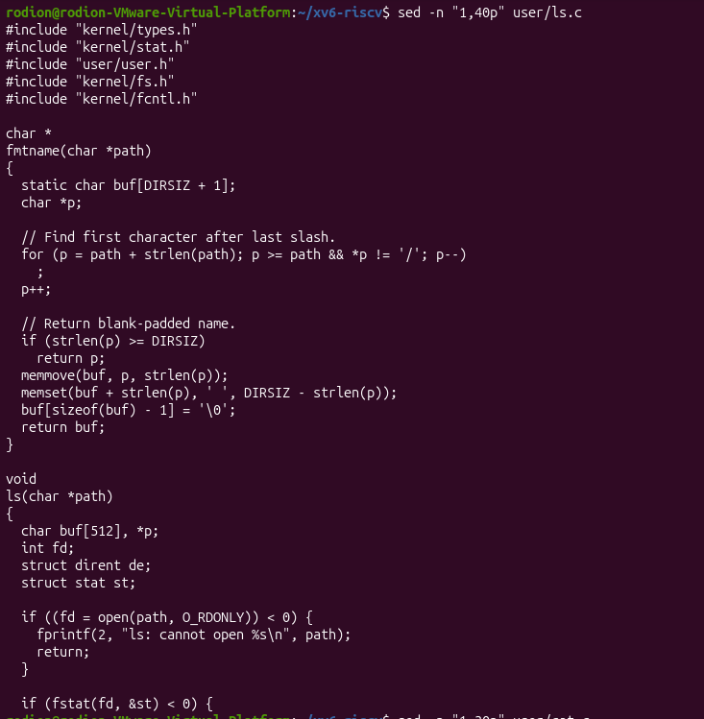
Fig 8.1 – Output of the sed -n "1,40p" user/ls.c command
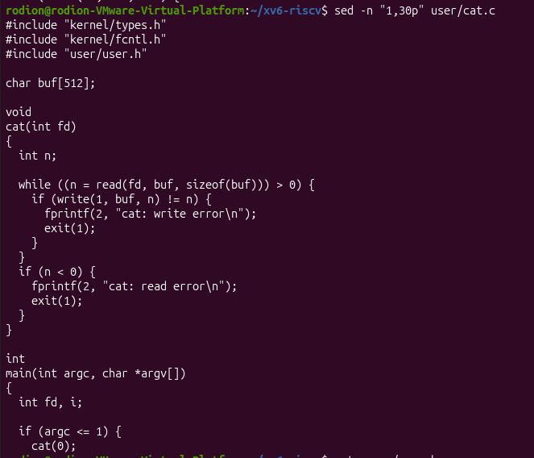
Fig 8.2 – Output of the sed -n "1,30p" user/cat.c command
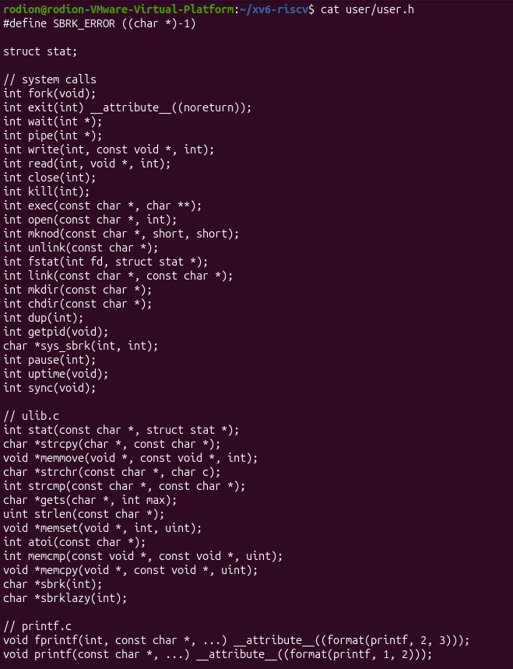
Fig 8.3 – Output of the cat user/user.h command
Fig 8.4 – Output of the last command

Interesting output
Fig 8.5 – Interesting command of the third part

Part 4. Write your first xv6 program
I added a new user program, sleep, which pauses for a number of clock ticks by calling the sleep system call that already exists in the kernel.

user/sleep.c
#include "kernel/types.h"
#include "user/user.h"

int
main(int argc, char *argv[])
{
if(argc != 2){
fprintf(2, "usage: sleep <ticks>\n");
exit(1);
}
sleep(atoi(argv[1])); // system call into the kernel
exit(0);
}

Makefile
In the UPROGS list I added one line for the new program, copying the tab indentation and the trailing backslash of the line above it:
UPROGS=\
$U/_cat\
$U/_echo\
$U/_sleep\ # <-- added
...

make qemu
$ sleep 10 # pauses, then returns to the prompt
$ sleep # prints the usage message

Observations
1. What happened with sleep 10?
The prompt did not come back immediately: the program paused for 10 ticks and then returned.
2. What happened with sleep and no argument?
Because argc is 1 and not 2, the program printed usage: sleep <ticks> to file descriptor 2 (standard error) and exited with status 1.
3. Where does the actual waiting happen?
Not in my program. sleep(atoi(argv[1])) is a system call, so the kernel puts the process to sleep and the scheduler runs other processes until the ticks have passed.

Interesting output
Output / screenshot:
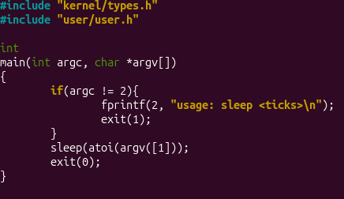
Fig 9.1 – The program in user/sleep.c
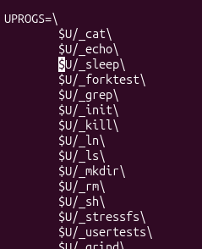
Fig 9.2 – Makefile
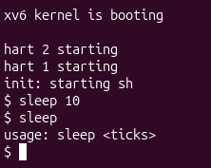
Fig 9.3 – make qemu

Interesting commands
- sleep 10 — my own program making a real system call into a kernel I compiled
- sleep — the usage check: exactly one argument is accepted
- $U/_sleep\ — the one Makefile line that makes the build include a new program

Conclusion
In this lab I built xv6 from source, booted it in QEMU and used it as a small Unix, including a pipe. Reading the source showed the key structure of an OS: kernel/ holds the privileged system and user/ holds ordinary programs that reach it through system calls such as read and write. Finally I wrote sleep.c, registered it in UPROGS and ran it, which gave me a first program making a real system call into a kernel I built myself.

Step | What I did | Key command
Build and boot | Compiled the kernel and user programs and booted xv6 in QEMU | make qemu
Use it | Ran the built-in Unix tools, including a pipe | ls | grep c
Read the source | Compared user/ programs with the kernel/ code that serves them | grep -n sys_read kernel/sysfile.c
Write a program | Added sleep.c and registered it in UPROGS | sleep 10

