
MINISTRY OF EDUCATION, CULTURE AND RESEARCH
OF THE REPUBLIC OF MOLDOVA
Technical University of Moldova
Faculty of Computers, Informatics and Microelectronics
Department of Software Engineering and Automation

Rodion Bulimar FAF-242

Report
Laboratory Work 3&4
Operating Systems

Checked by:
Reițman Patricia, university assistant
FCIM, UTM

Chișinău – 2026
Table of Contents
Third Laboratory Work 3
Goal 3
Setup 3
Part 1. Move fast, find help 3
Observations 4
Part 2. What the shell does to your line 5
Observations 7
Part 3. Redirection, chaining and jobs 7
Observations 8
Part 4. Answer questions with one-liners 9
Q1. How many requests failed? 9
Q2. How many different pages were requested, and which? 9
Q3. How many requests did each page get? 10
Q4. Which user or users have the most failed requests, and how many? 10
Q5. How many requests did user3 make, and how many of them failed? 10
Q6. Print the last 3 failed requests, showing only time and user. 11
Q7. Which login shells appear in /etc/passwd, and how many accounts use each? 11
Q8. Why do ls /etc | wc -l and ls -l /etc | wc -l differ by exactly one? 11
Bonus. Minute ends in 0 and the request failed 12
Part 5. Your first script 13
Observations 14
Conclusion 14
Fourth Laboratory Work 16
Goal 16
Setup 16
Part 1. Fix sleep for the current xv6 16
Part 2. bash versus the xv6 shell 18
Observations 20
Part 3. Who expands *? A program that prints its argv 20
Observations 23
Part 4. Read the shell 23
Observations 25
Conclusion 26

Third Laboratory Work

Goal
The goal of this lab is to learn to work fast in the bash shell, to predict what the shell does to a command line before the command runs (globbing, quoting, expansion), to redirect input and output, and to answer questions about data with one line of small text filters joined by pipes. The lab ends with a first shell script.

Setup
All work was done in the terminal of the Ubuntu virtual machine. The test data set (an artificial web access log of 500 lines) was generated with the block from the lab description:
mkdir -p ~/os-lab3 && cd ~/os-lab3
for i in $(seq 1 500); do
echo "2026-10-05 10:$(printf %02d $((i % 60))) user$((i % 7)) $([ $((i % 5)) -eq 0 ] && echo FAIL || echo OK) /page$((i % 4))"
done > access.log
head -3 access.log ; wc -l access.log

Output:
2026-10-05 10:01 user1 OK /page1
2026-10-05 10:02 user2 OK /page2
2026-10-05 10:03 user3 OK /page3
500 access.log

The last command prints 500, so the file is correct. Each line has five fields: date, time, user, result (OK or FAIL) and page.
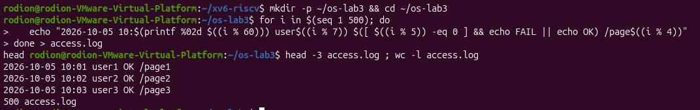Fig 1.1 – Generating access.log

Part 1. Move fast, find help
Commands run: Tab completion (ls /usr/sh, cd /et), history search with Ctrl+R, then type, which, echo $PATH, a command that does not exist, and the help tools man, --help, man -k and help.
ls /usr/sh<Tab><Tab>
cd /et<Tab>
type cd ; type ls ; type echo ; which ls
echo $PATH
echo $PATH | tr ':' '\n'
nosuchprog ; echo "exit code: $?"
man ls
ls --help | head
man -k "list directory"
help cd

Observations
Tab and Ctrl+R. Tab asks the shell to finish the word I am typing: cd /et was completed to /etc/, and ls /usr/sh was completed to /usr/share/. When several names match, pressing Tab twice prints the list of candidates instead of guessing. Ctrl+R opens "reverse-i-search": after typing a few letters of an earlier command, the shell showed the most recent command containing them, and Enter ran it again.
1. Which of cd, ls, echo are built-ins, and why MUST cd be one?
type cd and type echo report "shell builtin"; type ls reports an external program (on Ubuntu it is first shown as an alias for ls --color=auto, and which ls shows the file /usr/bin/ls). So cd and echo are built-ins, ls is external. (echo also exists as /usr/bin/echo, but the shell uses its own built-in copy first.)
cd must be a built-in because the current working directory belongs to the process. An external program runs in a child process; if it changed its own directory, only the child would move and the shell, the parent, would stay where it was. Only a command executed inside the shell process itself can change the shell's directory.
2. How many directories are in your PATH, and in which one is ls?
PATH holds 9 directories (shown one per line by tr): /usr/local/sbin, /usr/local/bin, /usr/sbin, /usr/bin, /sbin, /bin, /usr/games, /usr/local/games and /snap/bin. ls is in /usr/bin (which ls prints /usr/bin/ls).
3. What exit code does a command that is not found return?
127 ("command not found"). The shell prints nosuchprog: command not found and $? holds 127. Exit code 0 means success, any non-zero value means some kind of failure.
4. Which option of ls sorts by modification time?
-t (found in man ls with the search /sort: "sort by time, newest first"). Combined with -l it gives ls -lt, and -r reverses the order.
Output / screenshots:
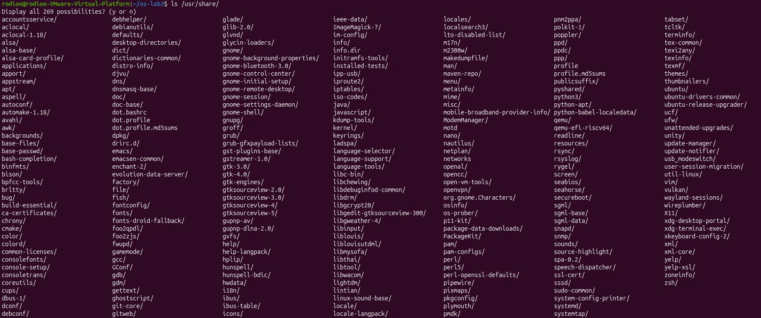Fig 2.1.1 – Tab completion (ls /usr/sh<Tab><Tab>)
Fig 2.1.2 – Tab completion (cd /et<Tab>)
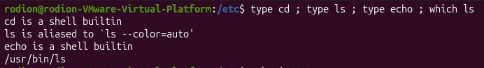Fig 2.2 – Output of type and which
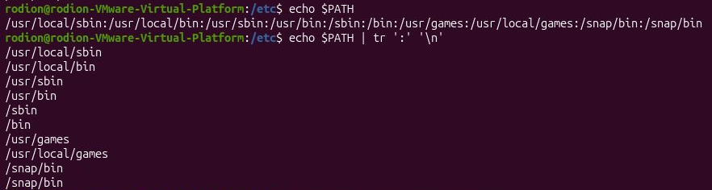Fig 2.3 – The directories in PATH
Fig 2.4 – Exit code of a missing command

Part 2. What the shell does to your line
Commands run: a test directory with six files was created, then ten command lines were first predicted and then executed.
mkdir -p ~/os-lab3/play && cd ~/os-lab3/play
touch a.c b.c file1.txt file2.txt notes.txt "alfa beta.txt"
ls

Output:
a.c ‘alfa beta.txt’ b.c file1.txt file2.txt notes.txt

Fig 3.1 – Files created in the play directory
Predictions and real results:
Command | My prediction | Real output | Explanation (if different)
echo *.c | a.c b.c | a.c b.c | The shell expands the glob *.c to the matching file names before echo starts.
echo file?.txt | file1.txt file2.txt | file1.txt file2.txt | ? matches exactly one character.
echo [a-b]* | a.c b.c | a.c alfa beta.txt b.c | Names starting with a or b: I forgot "alfa beta.txt". It is printed as one file name, but in echo output the space makes it look like two words.
echo *.xyz | (empty line) | *.xyz | No file matches, so bash leaves the pattern unchanged and echo prints it literally.
ls alfa beta.txt | alfa beta.txt | ls: cannot access 'alfa': No such file or directory  ls: cannot access 'beta.txt': No such file or directory | The shell splits the line at spaces: ls received two arguments, "alfa" and "beta.txt".
ls "alfa beta.txt" | alfa beta.txt | alfa beta.txt | The quotes make it a single argument.
echo '$HOME' "$HOME" \$HOME | $HOME /home/rodion $HOME | $HOME /home/rodion $HOME | Single quotes and the backslash stop expansion; only double quotes expand the variable.
echo {1..5} ; echo $((7 * 6)) | 1 2 3 4 5 and 42 | 1 2 3 4 5  42 | Brace expansion generates the numbers; $(( )) does arithmetic. Both are done by the shell.
echo "today is $(date +%A), I am $(whoami)" | today is <weekday>, I am <user> | today is Monday, I am rodion | $( ) runs the inner commands first and pastes their output into the line.
touch log{1..3}.txt && ls log* | log1.txt log2.txt log3.txt | log1.txt log2.txt log3.txt | Braces create three names for touch; && runs ls only because touch succeeded.

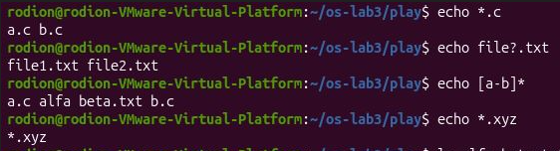
Fig 3.2 – Globbing results
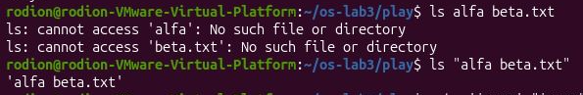
Fig 3.3 – The ls error on a name with a space, and the fix
Fig 3.4 – Single quotes, double quotes and backslash

Observations
1. For each line: prediction, real output, explanation.
See the table above. The only mismatch was echo [a-b]*, where I forgot the file "alfa beta.txt".
2. echo knows nothing about files, yet echo *.c printed file names. Who produced them?
The shell. Before it starts a command, bash performs expansions on the line. It replaced the word *.c with the list of matching names (globbing, or pathname expansion), so echo simply received a.c and b.c as ordinary arguments and printed them. echo never saw the star.
3. Why did ls alfa beta.txt fail? Give two different ways to fix it.
The shell splits the line into words at spaces, so ls was started with two arguments, "alfa" and "beta.txt", and neither file exists. Fixes: (1) quote the name: ls "alfa beta.txt" (or with single quotes); (2) escape the space with a backslash: ls alfa\ beta.txt. (Pressing Tab after ls alf also works, because completion inserts the backslash itself.)
4. What is the difference between single and double quotes?
Single quotes keep everything literally: $, * and backslash have no special meaning, so '$HOME' prints $HOME. Double quotes only protect spaces and the glob characters from the shell, but still allow $variable, $(command) and \ escapes, so "$HOME" prints the home directory.
Why ls shows 'alfa beta.txt' in quotes: when ls writes to a terminal it quotes names that contain special characters such as a space, so that the name can be copied and pasted back into the shell as one single argument. When the output goes into a pipe or a file, ls prints the plain name without quotes.

Part 3. Redirection, chaining and jobs
Commands run:
cd ~/os-lab3
ls /etc /nope > out.txt 2> err.txt
wc -l out.txt ; cat err.txt
ls /etc /nope > all.txt 2>&1 ; tail -2 all.txt
echo first > notes.md ; echo second >> notes.md ; cat notes.md
wc -l < access.log
ls /nope 2> /dev/null || echo "failed with code $?"
mkdir -p tmp && cd tmp && echo "I am in $(pwd)" ; cd ~/os-lab3
sleep 100 &
jobs ; kill %1 ; jobs

# the order experiment
ls /etc /nope > all.txt 2>&1
ls /etc /nope 2>&1 > all.txt

Output (the line count of out.txt depends on the size of /etc on each machine):
138 out.txt
ls: cannot access '/nope': No such file or directory
(tail -2 all.txt: the last two lines of the listing, e.g. two file names from /etc)
first
second
500
failed with code 2
I am in /home/rodion/os-lab3/tmp
[1] <PID>
[1]+ Running sleep 100 &
[1]+ Terminated sleep 100

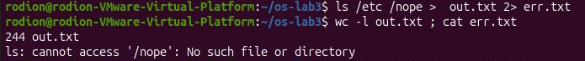Fig 4.1 – stdout and stderr in separate files
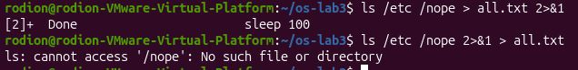
Fig 4.2 – Comparing the order of redirections
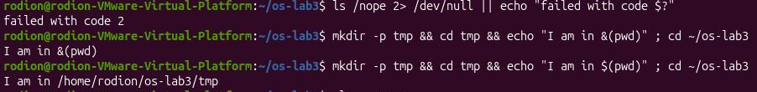Fig 4.3 – The ; && || operators
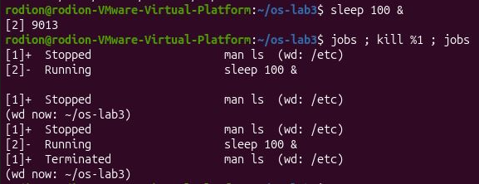
Fig 4.4 – Running a background job and stopping it

Observations
1. Which file got the error message, and which got the listing?
out.txt got the listing (standard output, file descriptor 1) and err.txt got the message ls: cannot access '/nope': No such file or directory (standard error, file descriptor 2). wc -l out.txt counted the listing lines and cat err.txt showed the single error line.
2. What is the difference between > all.txt 2>&1 and 2>&1 > all.txt?
The shell processes redirections from left to right, and 2>&1 means "make stderr point to wherever stdout points right now".
In > all.txt 2>&1 stdout is first sent to the file, then stderr is copied from stdout, so both go into all.txt: the error line is inside the file and nothing appears on the screen.
In 2>&1 > all.txt stderr is copied from stdout while stdout still points to the terminal, and only afterwards stdout is moved to the file. So stderr stays on the terminal: the error message appears on the screen and all.txt contains only the listing (one line fewer than in the first version).
3. Why does wc -l < access.log print only a number, while wc -l access.log also prints the file name?
With < the shell opens the file and connects it to wc's standard input; wc just reads a stream of bytes and does not know the name of the file, so it prints only the count. With wc -l access.log the file name is passed as an argument, wc opens the file itself and prints its name next to the count.
4. Explain each operator in one sentence: ; && ||
; runs the next command always, no matter how the previous one ended. && runs the next command only if the previous one succeeded (exit code 0). || runs the next command only if the previous one failed (non-zero exit code); this is why ls /nope 2> /dev/null || echo "failed with code $?" printed the message with code 2.

Part 4. Answer questions with one-liners
Every question was answered with one command line, and all the lines are saved in oneliners.sh (question as a comment above each line). The file runs with bash oneliners.sh inside ~/os-lab3. The fields of access.log are: 1 date, 2 time, 3 user, 4 result, 5 page.

Q1. How many requests failed?
grep -c FAIL access.log

Output:
100

grep -c counts the lines that contain FAIL. 500 lines, every fifth request fails, so 100.
Fig 5.1 – How many requests failed

Q2. How many different pages were requested, and which?
cut -d' ' -f5 access.log | sort -u

Output:
/page0
/page1
/page2
/page3
4 different pages

cut takes field 5, sort -u removes duplicates, awk prints the pages and counts them at the end.
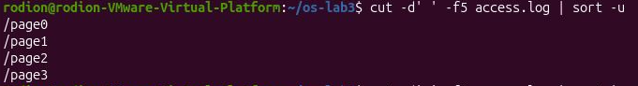Fig 5.2 – How many different pages were requested, and which

Q3. How many requests did each page get?
cut -d' ' -f5 access.log | sort | uniq –c | sort -rn

Output:
125 /page3
125 /page2
125 /page1
125 /page0

uniq -c needs sorted input. Check: 4 x 125 = 500 lines, as expected.
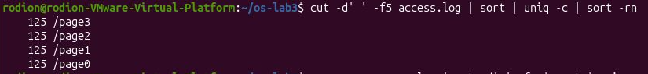Fig 5.3 – How many requests did each page get

Q4. Which user or users have the most failed requests, and how many?
grep FAIL access.log | cut -d' ' -f3 | sort | uniq -c | sort -rn | head -1

Output:
15 user5

Two users share the maximum: user3 and user5, with 15 failures each (the awk part keeps all lines that have the same count as the first one). Check: the full per-user counts are 15 + 15 + 5 x 14 = 100, equal to Q1.
Fig 5.4 – Which user or users have the most failed requests, and how many

Q5. How many requests did user3 make, and how many of them failed?
grep -c ' user3 ' access.log; grep ' user3 ' access.log | grep -c FAIL

Output:
72
15

user3 made 72 requests and 15 of them failed. The spaces around user3 make sure only that exact user is matched.
Fig 5.5 – How many requests did user3 make, and how many of them failed

Q6. Print the last 3 failed requests, showing only time and user.
grep FAIL access.log | tail -3 | cut -d' ' -f2,3

Output:
10:10 user0
10:15 user5
10:20 user3

grep keeps the failures, tail -3 keeps the last three, cut keeps fields 2 and 3.
Fig 5.6 – Print the last 3 failed requests, showing only time and user

Q7. Which login shells appear in /etc/passwd, and how many accounts use each?
cut -d: -f7 /etc/passwd | sort | uniq -c | sort -rn

Output:
40 /usr/sbin/nologin
5 /bin/false
2 /bin/bash
1 /bin/sync

The shell is field 7 of /etc/passwd (separator :). Most accounts are system accounts with nologin, so they cannot log in. The numbers depend on the machine.
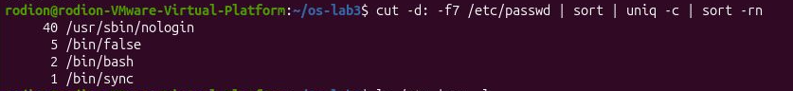 Fig 5.7 – Which login shells appear in /etc/passwd, and how many accounts use each

Q8. Why do ls /etc | wc -l and ls -l /etc | wc -l differ by exactly one?
ls /etc | wc -l
ls -l /etc | wc -l

Output:
243
244

The numbers depend on the machine, but the second is always exactly one more. Prediction: the long format adds something that is not a file. Explanation: ls -l prints a first summary line total N (the disk blocks used by the listed files) before the entries. wc -l counts that extra line, so the second command is one line longer, while the number of real entries is the same.

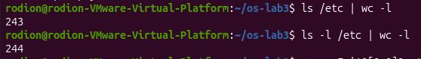
Fig 5.8 – Why the two counts differ by one
Full contents of oneliners.sh:
# Q1. How many requests failed?
grep -c FAIL access.log
# Q2. How many different pages were requested, and which?
cut -d' ' -f5 access.log | sort -u
# Q3. How many requests did each page get?
cut -d' ' -f5 access.log | sort | uniq –c | sort -rn
# Q4. Which user or users have the most failed requests, and how many?
grep FAIL access.log | cut -d' ' -f3 | sort | uniq -c | sort -rn | head -1
# Q5. How many requests did user3 make, and how many of them failed?
grep -c ' user3 ' access.log; grep ' user3 ' access.log | grep -c FAIL
# Q6. Print the last 3 failed requests, showing only time and user.
grep FAIL access.log | tail -3 | cut -d' ' -f2,3
# Q7. Which login shells appear in /etc/passwd, and how many accounts use each?
cut -d: -f7 /etc/passwd | sort | uniq -c | sort -rn
# Q8. Why do the two counts differ by exactly one?
ls /etc | wc -l; ls -l /etc | wc -l
# Bonus. Minute ends in 0 and the request failed.
grep -E ' 10:[0-9]0 .* FAIL ' access.log | wc -l

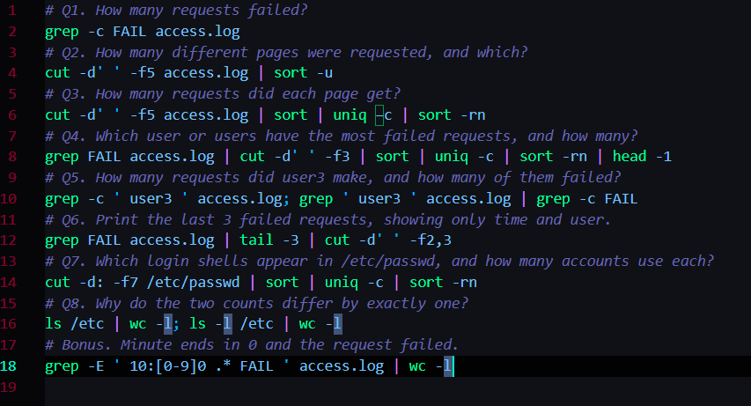Fig 5.9 – Full run of oneliners.sh

Bonus. Minute ends in 0 and the request failed
grep -E ' 10:[0-9]0 .* FAIL ' access.log | wc -l

Output:
50

There are 50 such lines. The minute is the request number modulo 60, so a minute ending in 0 means the request number is a multiple of 10, and every multiple of 10 is also a multiple of 5, which is always a FAIL. 500 / 10 = 50.

Part 5. Your first script
The script report.sh was created in ~/os-lab3 and the TODO was completed with a loop over user0 … user6. For each user it counts the lines that contain that user and FAIL.
#!/bin/bash
# usage: ./report.sh access.log
log=$1
if [ ! -f "$log" ]; then
echo "no such file: $log" >&2
exit 1
fi
total=$(wc -l < "$log")
fails=$(grep -c FAIL "$log")
echo "$total requests, $fails failed"
for n in 0 1 2 3 4 5 6; do
x=$(grep " user$n " "$log" | grep -c FAIL)
echo "user$n: $x failures"
done

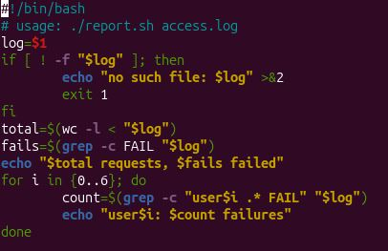
Fig 6.1 – Contents of report.sh
chmod +x report.sh
./report.sh access.log
./report.sh nope.log ; echo "exit code: $?"

Output:
500 requests, 100 failed
user0: 14 failures
user1: 14 failures
user2: 14 failures
user3: 15 failures
user4: 14 failures
user5: 15 failures
user6: 14 failures

no such file: nope.log
exit code: 1

The per-user numbers add up to 100, the same as the total of failures, which confirms the loop is correct.
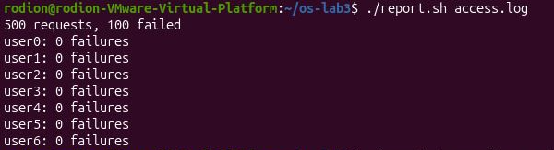
Fig 6.2 – Running the script on access.log
Fig 6.3 – Error handling for a missing file

Observations
1. What does the first line #!/bin/bash do, and what happens if you run ./report.sh before chmod +x?
It is the "shebang": when a file is executed, the kernel reads its first line and starts the named interpreter (/bin/bash) with the script as its argument, so the script runs under bash. Before chmod +x the file has no execute permission, and ./report.sh fails with bash: ./report.sh: Permission denied.
2. Why must you type ./report.sh and not just report.sh?
Typing a bare name makes the shell search only the directories listed in PATH, and the current directory is not in PATH (for safety, so that a malicious file with the name of a common command cannot be run by accident). ./report.sh is a path, not a bare name, so the shell runs exactly that file in the current directory without searching.
3. Why does the script write the error with >&2 and end with exit 1?
>&2 sends the message to standard error, the channel meant for errors, so it is not mixed with the normal output and still shows on the screen when stdout is redirected to a file or a pipe. exit 1 ends the script with a non-zero exit code, which tells whoever called it (the shell, &&/||, cron, another script) that it failed; without it the script would end with code 0, which means success.

Conclusion
In this lab I worked with the bash shell as the layer between me and the operating system. I learned that the shell, not the program, prepares the command line: it splits words at spaces, expands globs (*.c), braces ({1..5}), variables and $( ), and removes quotes, and only then starts the program with the finished list of arguments. I saw that every program has three standard streams (input, output, error), that redirections are processed from left to right, and that ;, && and || chain commands depending on the exit code, where 0 is success and 127 means "command not found". Small filters such as grep, cut, sort, uniq, wc, head and tail joined by pipes answered all eight questions about the log without writing a program, and the numbers could be cross-checked (500 requests, 100 failures). Finally, report.sh showed how the same commands become a program with a shebang, execute permission, arguments, a loop, and a meaningful exit code.
Concept | What it does | Where I saw it
Globbing, quoting, expansion | The shell rewrites the line before the program starts | Part 2: echo *.c, quotes, $( )
Redirection | Connects stdin, stdout and stderr to files | Part 3: >, 2>, 2>&1, <
; && || | Chain commands using the exit code | Part 3: failed with code 2
Pipes and filters | Combine small tools to answer a question | Part 4: Q1-Q8
Scripts | Save commands as a program with shebang and exit code | Part 5: report.sh

Fourth Laboratory Work

Goal
The goal of this lab is to compare the bash shell on Linux with the xv6 shell, which is a single program of about 500 lines (user/sh.c), and to discover by experiment what a shell must do and what bash adds on top. A small program that prints its arguments shows exactly who expands * and who removes quotes. The lab also makes sure the sleep program from Lab 2 builds on the current xv6.

Setup
The laptop preparation was checked with the course script (it only tests, it installs nothing). The VM runs Ubuntu; xv6 is in ~/xv6-riscv, branch lab, revision 06aad25.
bash os2026-setup.sh --check

Output (last lines):
[ OK ] RISC-V compiler: riscv64-linux-gnu-gcc
[ OK ] QEMU 8.2
[ OK ] already present, left as it is (your work is safe)
[ OK ] build
[ OK ] xv6 booted and ran ls

All set. Start xv6 with: cd ~/xv6-riscv && make qemu
Leave xv6 with: Ctrl-A, then X.

Part 1. Fix sleep for the current xv6
In August 2025 the xv6 authors renamed the system call sleep() to pause(), so the sleep program from Lab 2 may no longer build. First I checked which name my tree declares:
cd ~/xv6-riscv
grep -n "pause\|sleep" user/user.h

Output:
13:int sleep(int);
26:int pause(int);

user.h declares pause and no sleep, so the call in user/sleep.c must be changed to pause. The final user/sleep.c:
#include "kernel/types.h"
#include "user/user.h"

int
main(int argc, char *argv[])
{
if(argc != 2){
fprintf(2, "usage: sleep <ticks>\n");
exit(1);
}
pause(atoi(argv[1])); // was sleep() before Aug 2025
exit(0);
}

In the Makefile the line $U/_sleep\ (a TAB at the start, nothing after the backslash) is in UPROGS. Then I built, booted and tested:
make qemu
$ sleep 20
$ sleep
usage: sleep <ticks>

sleep 20 waits 20 ticks (about two seconds) and returns to the prompt without printing anything, which means it works. Without an argument the program prints the usage message on standard error (file descriptor 2) and exits with code 1.
Output / screenshots:
Fig 7.1 – The grep result in user.h
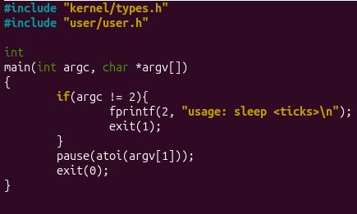
Fig 7.2 – The updated sleep.c
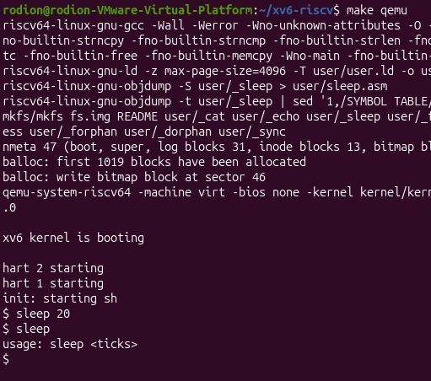
Fig 7.3 – sleep running in xv6, with and without an argument

Part 2. bash versus the xv6 shell
Every command from the table was run twice: in bash on Linux, in an empty folder ~/shtest that contains only a file README (mkdir ~/shtest && cd ~/shtest && touch README), and at the $ prompt of xv6 (make qemu). The commands were run one after another, so the files f and d created by earlier lines are visible in later ones.
Command | Tests | bash | xv6 | Why
echo hello > f ; cat < f | redirection | hello | hello | Both shells open the file and connect it to stdout / stdin before starting the program. > and < exist in both.
ls | grep READ | pipe | README | README 2 2 2441 | Both shells connect two programs with a pipe. xv6 ls prints name, type, inode and size, bash prints only the name when output is not a terminal.
(echo a; echo b) | wc | grouping, list | 2 2 4 | 2 2 4 | Both support ( ) and ;. The group runs in one process whose output goes into the pipe; wc counts 2 lines, 2 words, 4 bytes.
echo one ; echo two | sequence | one  two | one  two | The ; operator is supported by both.
echo bg & | background | bg | bg | Both start the command in the background and give the prompt back. (bash also prints the job number in an interactive session.)
ls * | globbing | README  f | ls: cannot open * | bash expands * into the file names before ls starts. xv6 does not: ls received the literal word * and looked for a file with that name.
echo $HOME | variables | /home/rodion | $HOME | bash replaces $HOME with the variable value. xv6 has no variables, so echo prints the text as it is.
echo "a b" | quotes | a b | "a b" | bash removes the quotes. The xv6 shell does not know quotes: they stay in the text as normal characters.
mkdir d ; cd d ; ls .. | PATH | README  d  f | exec cd failed  (then the listing of / ) | In bash cd is a built-in, so the shell moved into d and ls .. listed the parent. In xv6 cd is recognised only when it is the whole line, so inside a list it was run as a program and failed ("exec cd failed"); ls .. was then run from the same directory.
arrow up, Tab, Ctrl+R | history, completion | work (previous command, completion, reverse search) | do not work | These belong to bash's line editor (readline). xv6 reads the line from the console as it is typed, with no history and no completion.

Separate test: ls after cd d in xv6 (typed as two separate lines):
$ mkdir d
$ cd d
$ ls
exec ls failed
$ /ls
(the listing of the files in the current directory is printed)

Fig 8.1 – The commands run in bash
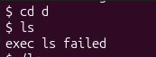
Fig 8.2 – The same commands run in xv6
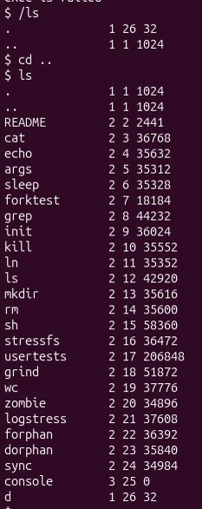
Fig 8.3 – ls failing after cd d, and the working alternative

Observations
1. List the features both shells have, and the ones only bash has.
Both have: running a program with arguments, redirection of input and output (<, >), pipes (|), sequences (;), grouping with parentheses and background jobs (&).
Only bash has: globbing (*, ?), variables ($HOME) and expansions ($( ), {1..5}), quotes and the backslash, && and ||, the cd built-in inside lists, a search path (PATH), command history, Tab completion and Ctrl+R, jobs control and scripting (if, for).
2. In xv6, ls stops working after cd d. Why? Find a way to run ls from inside d anyway.
The xv6 shell has no PATH. To run ls it simply asks the kernel to execute a file called ls in the current directory. The program files of xv6 (ls, cat, echo, ...) all live in the root directory /, so after cd d the file d/ls does not exist and the shell prints exec ls failed. A bash user is not affected because bash searches the directories of PATH, not only the current one.
The way around it is to give the full path: /ls runs the program from the root directory while the shell stays inside d.
3. Which missing feature would you miss most in daily work, and which would be easiest to add?
I would miss globbing and history/Tab completion most: without * every file must be typed by name, and without history every command must be typed again. The easiest to add would be a simple search path (try /ls when ls is not found in the current directory) or variables like $HOME, since the shell already handles the command line as text; globbing needs more work because the shell would have to read directories and sort the names.

Part 3. Who expands *? A program that prints its argv
Two small programs print the number of arguments they receive and every argument in square brackets. user/args.c for xv6 (line $U/_args\ was added to UPROGS):
#include "kernel/types.h"
#include "user/user.h"

int
main(int argc, char *argv[])
{
printf("argc = %d\n", argc);
for(int i = 0; i < argc; i++)
printf("argv[%d] = [%s]\n", i, argv[i]);
exit(0);
}

args_linux.c is the same program with <stdio.h> instead of the two xv6 headers and return 0 instead of exit(0); it was compiled with gcc -o args args_linux.c. The same four lines were run in both shells (bash in a folder with the files a.c, b.c and args_linux.c, run as ./args).
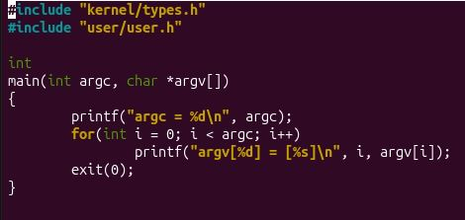
Fig 9.1.1 – args.c
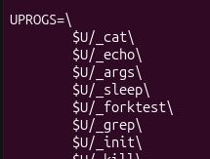
Fig 9.1.2 – the UPROGS line
Output in xv6:
$ args one two three
argc = 4
argv[0] = [args]
argv[1] = [one]
argv[2] = [two]
argv[3] = [three]
$ args *.c "x y"
argc = 4
argv[0] = [args]
argv[1] = [*.c]
argv[2] = ["x]
argv[3] = [y"]
$ args $HOME
argc = 2
argv[0] = [args]
argv[1] = [$HOME]
$ args 'single quoted'
argc = 3
argv[0] = [args]
argv[1] = ['single]
argv[2] = [quoted']

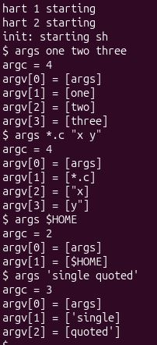
Fig 9.2 – args output in xv6
Output in bash:
$ ./args one two three
argc = 4
argv[0] = [./args]
argv[1] = [one]
argv[2] = [two]
argv[3] = [three]
$ ./args *.c "x y"
argc = 5
argv[0] = [./args]
argv[1] = [a.c]
argv[2] = [args_linux.c]
argv[3] = [b.c]
argv[4] = [x y]
$ ./args $HOME
argc = 2
argv[0] = [./args]
argv[1] = [/home/rodion]
$ ./args 'single quoted'
argc = 2
argv[0] = [./args]
argv[1] = [single quoted]

The file names printed for *.c depend on the .c files in your folder. With my files (a.c, b.c, args_linux.c) bash passed 5 arguments including the program name.
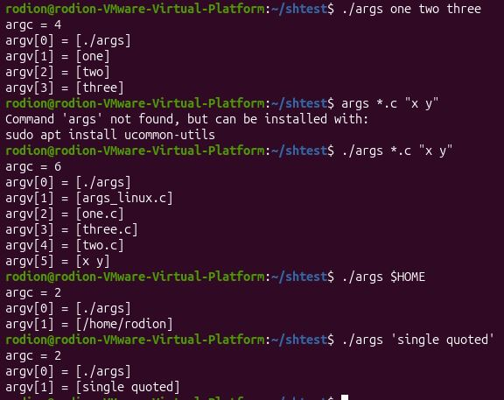
Fig 9.3 – args_linux output in bash

Observations
1. Paste both outputs for args *.c "x y". How many arguments did each program receive?
See the outputs above. In xv6 the program received argc = 4: the program name, the literal *.c, "x and y". In bash it received argc = 5 (with my three .c files): the program name, the three file names that matched *.c, and one argument x y without the quotes. Counting without the program name, that is 3 arguments in xv6 and 4 in bash.
2. So who turns *.c into file names and removes the quotes: the program, the kernel, or the shell?
The shell. The program only reads the array argv it was given, and the kernel only copies that array into the new process. In bash the shell expanded *.c and removed the quotes before starting the program. The xv6 shell does neither, so the program got the raw words, with the star and the quote characters inside them.
3. What happened to the extra spaces in one two three?
They disappeared in both shells: args one two three gave exactly four arguments (args, one, two, three) and none of them contains spaces. The shell uses whitespace only as a separator between words and throws away how many spaces there were. To keep spaces inside one argument you need quotes, which only bash understands.

Part 4. Read the shell
Inside ~/xv6-riscv I ran the commands below and read the parts of user/sh.c they point to.
wc -l user/sh.c
grep -n "#define" user/sh.c
grep -n "case " user/sh.c
grep -n "cd" user/sh.c | head

Output (the shell is 499 lines long):
499 user/sh.c
8:#define EXEC 1
9:#define REDIR 2
10:#define PIPE 3
11:#define LIST 4
12:#define BACK 5
14:#define MAXARGS 10
75: case EXEC:
83: case REDIR:
93: case LIST:
101: case PIPE:
125: case BACK:
284: case 0:
286: case '|':
... (more lines in the tokenizer and in nulterminate)
170: fprintf(2, "cannot cd %s\n", cmd + 3);

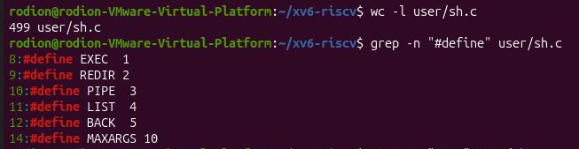Fig 10.1 – The command kinds defined in sh.c
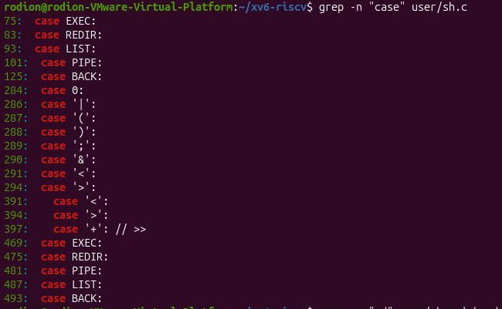Fig 10.2 – Where each kind is run
Fig 10.3 – The code that handles cd
The code that handles cd is in main() (lines 160 to 176). Note that grep -n "cd" finds only the message on line 170, because the test itself compares single characters (cmd[0] == 'c' && cmd[1] == 'd') and the call is chdir (line 169).
if (cmd[0] == 'c' && cmd[1] == 'd' && cmd[2] == ' ') {
// Chdir must be called by the parent, not the child.
cmd[strlen(cmd) - 1] = 0; // chop \n
if (chdir(cmd + 3) < 0)
fprintf(2, "cannot cd %s\n", cmd + 3);
} else {
if (fork1() == 0)
runcmd(parsecmd(cmd));
wait(0);
}

Observations
1. Name the five kinds of command the xv6 shell knows and the character that produces each.
Kind (#define) | Produced by | Meaning
EXEC | a plain word list | run a program with its arguments, e.g. echo hello
REDIR | < > >> | run a command with its input or output connected to a file
PIPE | | | connect the output of the left command to the input of the right one
LIST | ; | run the left command, wait for it, then run the right one
BACK | & | run the command in the background without waiting

Parentheses ( ) do not create a sixth kind: they only group a command so that it can be used as one unit, for example in a pipe.
2. Where is cd handled, and why is it not run as a separate program?
In main(), before the shell forks (lines 166 to 170): if the line starts with "cd " the shell itself calls chdir. The source comment says why: chdir must be called by the parent, not the child. The current directory belongs to a process; a separate program would run in a child process and would change only the child's directory, which disappears when it exits, so the shell would stay where it was.
This also explains the failure in Part 2: only a line that starts with "cd " is handled this way, so mkdir d ; cd d ; ls .. ran cd in a child process, where it was not found (exec cd failed).
3. Search sh.c for any code that handles * or $. What does that explain about Part 2?
There is none: searching for the characters * and $ in the tokenizer and in the command parser finds no code that expands them. The only special characters the tokenizer knows are whitespace, |, (, ), ;, &, < and >. That explains Part 2 and Part 3: ls * failed with "cannot open *" and echo $HOME printed $HOME, because in xv6 the words are passed to the program unchanged. Everything bash does to a line before it starts the program (globbing, variables, quotes) is simply not implemented in the 500 lines of the xv6 shell.

Conclusion
In this lab I used the bash shell and the xv6 shell side by side. The experiments showed that the core job of a shell is small: read a line, split it into words, set up redirections and pipes with file descriptors, start programs with fork and exec, and wait for them (or not, with &). The xv6 shell does exactly this in about 500 lines and has five kinds of command: EXEC, REDIR, PIPE, LIST and BACK. bash adds a lot on top: globbing, variables, quotes, && and ||, PATH, history and completion. The program that prints its argv proved that it is the shell, not the program and not the kernel, that expands *.c and removes the quotes. cd must be a built-in because only the shell process can change its own directory, and xv6 has no PATH, so after cd d the program has to be started with a full path such as /ls. I also fixed the sleep program for the current xv6, where the system call was renamed from sleep to pause.
Feature | bash | xv6 shell
Redirection, pipes, ;, & | yes | yes
Globbing (*), variables, quotes | yes, done by the shell | no, the program gets the raw text
cd | built-in | handled by the shell only if the line starts with "cd "
Finding programs | PATH | current directory only (use /ls)
History, Tab completion | yes | no

