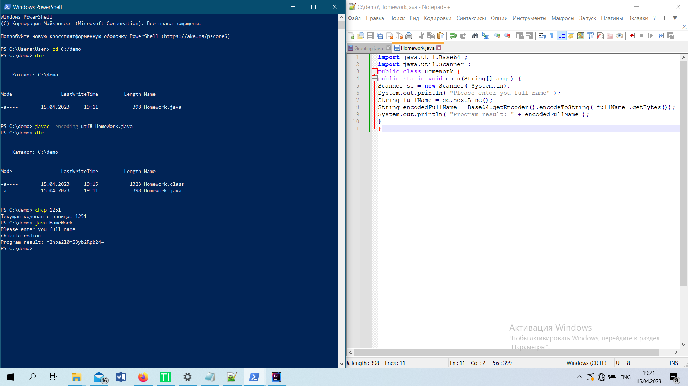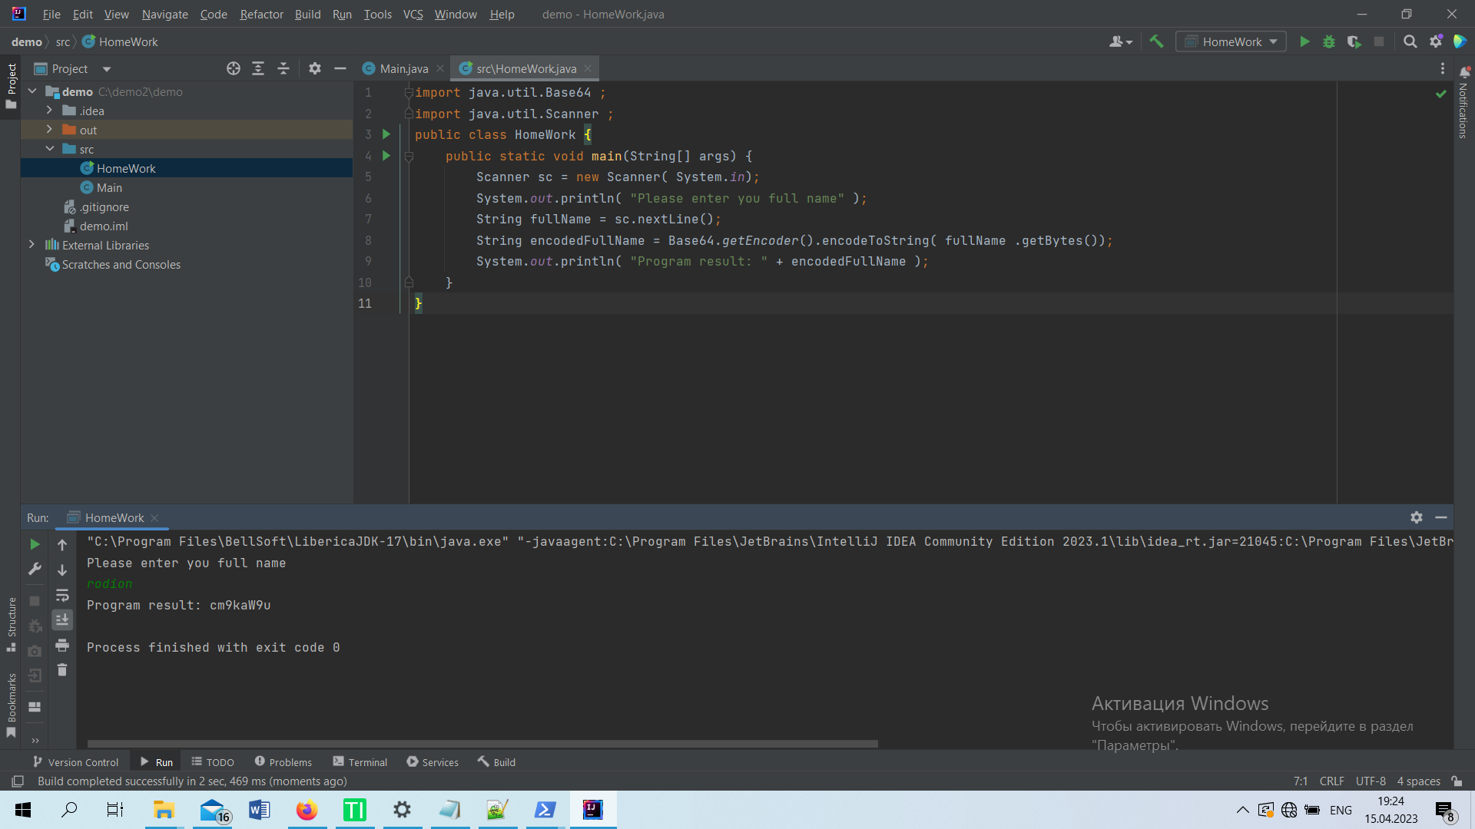

import java.util.Base64 ;  
import java.util.Scanner ;  
public class HomeWork {  
 public static void main(String[] args) {  
 Scanner sc = new Scanner( System.*in*);  
 System.*out*.println( "Please enter you full name" );  
 String fullName = sc.nextLine();  
 String encodedFullName = Base64.*getEncoder*().encodeToString( fullName .getBytes());  
 System.*out*.println( "Program result: " + encodedFullName );  
 }  
}