**Ministerul Educaţiei și Cercetării al Republicii Moldova Universitatea Tehnică a Moldovei**

**Facultatea Calculatoare, Informatică și Microelectronică**

Laboratory work 3: Empirical analysis of algorithms: Depth First Search (DFS), Breadth First Search(BFS)

Elaborated:

st. gr. FAF-221 Clepa Rodion

Verified:

asist. univ. Fiștic Cristofor

Chişinău – 2024

Contents

**ALGORITHM ANALYSIS** 3

**Objective** 3

**Tasks:** 3

**Theoretical Notes** 3

**Input Format** 3

**Comparison Metric:** 3

**IMPLEMENTATION** 3

**Breadth First Search** 4

**Depth First Search** 5

**Conclusion** 7

# **ALGORITHM ANALYSIS**

## **Objective**

Study and empirical analysis of graph traversal algorithm.

## **Tasks:**

Implement the algorithms listed above in a programming language

Establish the properties of the input data against which the analysis is performed

Choose metrics for comparing algorithms

Perform empirical analysis of the proposed algorithms

Make a graphical presentation of the data obtained

Make a conclusion on the work done.

## **Theoretical Notes**

In the empirical analysis of an algorithm, the following steps are usually followed:

The purpose of the analysis is established.

Choose the efficiency metric to be used (number of executions of an operation (s) or time execution of all or part of the algorithm.

The properties of the input data in relation to which the analysis is performed are established (data size or specific properties).

The algorithm is implemented in a programming language.

Run the program for each input data set.

The obtained data are analyzed.

## **Input Format**

The algorithms will receive a random generated graph. The number of nodes will start from 100 and go up to 2000 by 100. To generate graph will be used “**networkx”** library which uses Erdős-Rényi model.

## **Comparison Metric:**

The comparison metric for this laboratory work will be considered the time of execution of each algorithm (T(n)).

# **IMPLEMENTATION**

All 2 algorithms will be implemented in their naive form in Python an analyzed empirically based on the time required for their completion. To represent connection between nodes will be used dictionary. Example: {0: [1, 2], 1: [3, 4], 2: [4]}

## **Breadth First Search**

Breadth First Search (BFS) is a graph traversal algorithm that explores all the vertices in a graph at the current depth before moving on to the vertices at the next depth level.

*def* bfs(*self*, *startNode*, *toPrint* = 0):

        if startNode not in *self*.edges:

            return "No such Node"

        visited = [startNode]

        queue = [startNode]

        while queue:

            if queue[0] in *self*.edges:

                for neighbor in *self*.edges[queue[0]]:

                    if neighbor not in visited:

                        visited.append(neighbor)

                        queue.append(neighbor)

            queue.pop(0)

*Figure 1 Code for BFS*

**Input Validation:** Checks if the **startNode** exists in the graph. If not, it returns "No such Node".

**Initialization:** Initializes a list called visited with the **startNode**, which keeps track of visited nodes. Also initializes a queue with the **startNode**.

**BFS Traversal:** While the queue is not empty: Checks if the first node in the queue has neighbors. If it has neighbors iterates through each neighbor of the current node (if a neighbor has not been visited yet) marks it as visited. Appends it to both the visited list and the queue. Removes the current node from the queue.

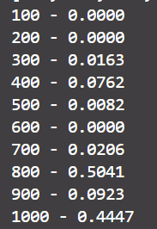

*Figure 2 Results for first 10 inputs BFS*

In Figure 2 is represented the table of results for the 10 set of inputs. The left column denotes the number of elements in array. On right column we get the number of seconds that elapsed from when the function was run till when the function was executed.

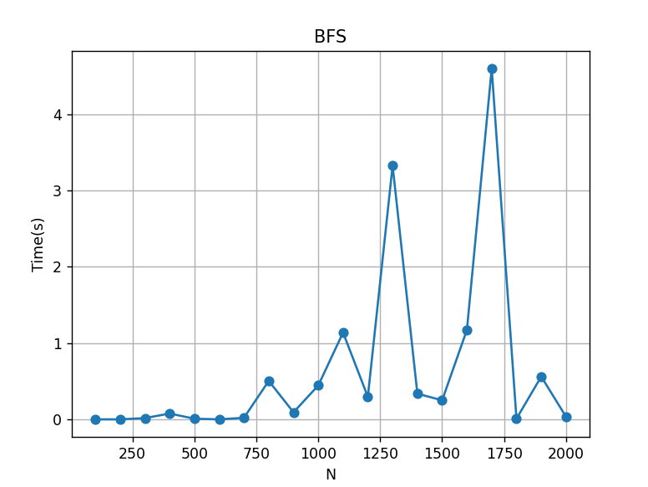

*Figure 3 Graph of BFS*

We can notice how, as the number of elements increases, the algorithm begins to require more time to execute.

## **Depth First Search**

*def* dfs(*self*, *startNode*, *toPrint* = 0):

        visited = [startNode]

        stack = [startNode]

        while stack:

            node = stack.pop(0)

            if node not in *self*.edges:

                continue

            for neighbor in *self*.edges[node]:

                if neighbor not in visited:

                    stack.insert(0, neighbor)

                    visited.append(neighbor)

*Figure 4 Code for DFS*

**Initialization**: Initializes a list called visited with the **startNode**, which keeps track of visited nodes. Initializes a stack with the **startNode**.

**DFS Traversal:** While the stack is not empty: Pops the top node from the stack. If the node does not have any edges (neighbors), it skips to the next iteration. Iterates through each neighbor of the current node. If a neighbor has not been visited yet: Pushes it onto the stack. Marks it as visited by appending it to the visited list.

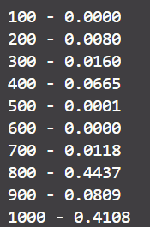

*Figure 5 Results for first 10 inputs DFS*

As we can see DFS have the similar results as BFS.

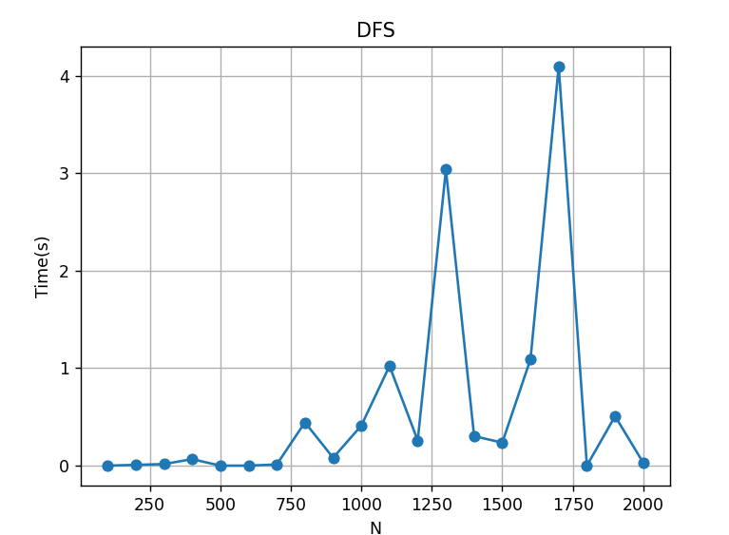

*Figure 6 Graph of DFS*

# **Conclusion**

Both algorithms have same time complexity of O(V+E), where V is the number of vertices (nodes) and E is the number of edges in the graph. For BFS this is because it visits each vertex and edge once. DFS explores a graph by traversing as deeply as possible along each branch before backtracking. Space Complexity, BFS generally requires more memory compared to DFS because it uses a queue to store nodes, which can potentially grow to hold all the nodes at a given level of the graph. DFS, on the other hand, uses a stack to store nodes, which can lead to a smaller memory footprint compared to BFS, especially for graphs with many levels or branching factors.

Git Link

https://github.com/RodionClepa/APA/tree/Lab3