TA Home Task #1 (Xpath locators)

AMAZON.COM

1. **Sell Button**//a[contains(@data-csa-c-content-id, 'nav_cs_sell')]  
   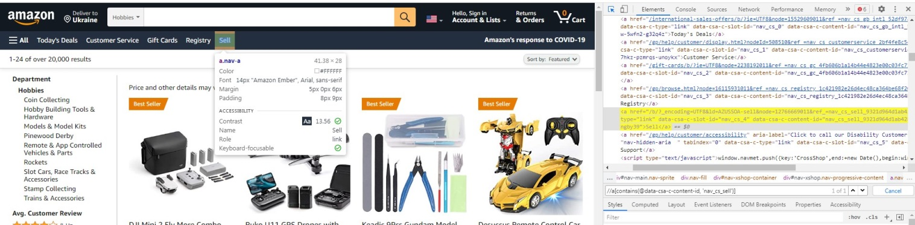
2. **Add to list button**//span[@id="wishListMainButton"]/span/a  
   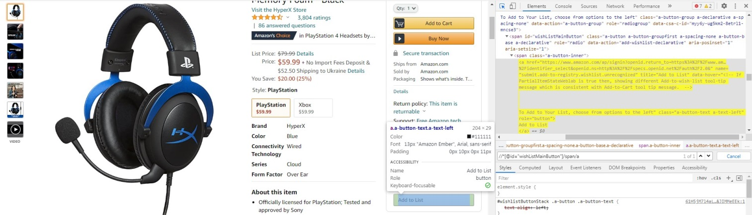
3. **Drone image**  
   Xpath: //div/img[contains(@alt,"Ruko U11 GPS")]  
   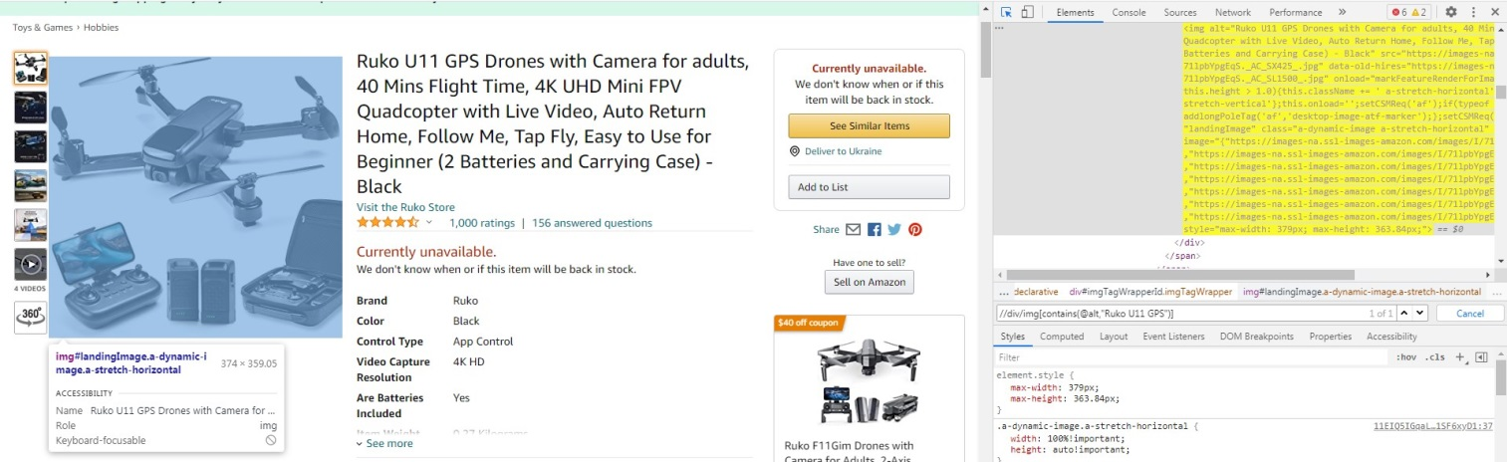
4. **Add to cart**  
   //div/descendant::input[@name ='submit.addToCart']  
   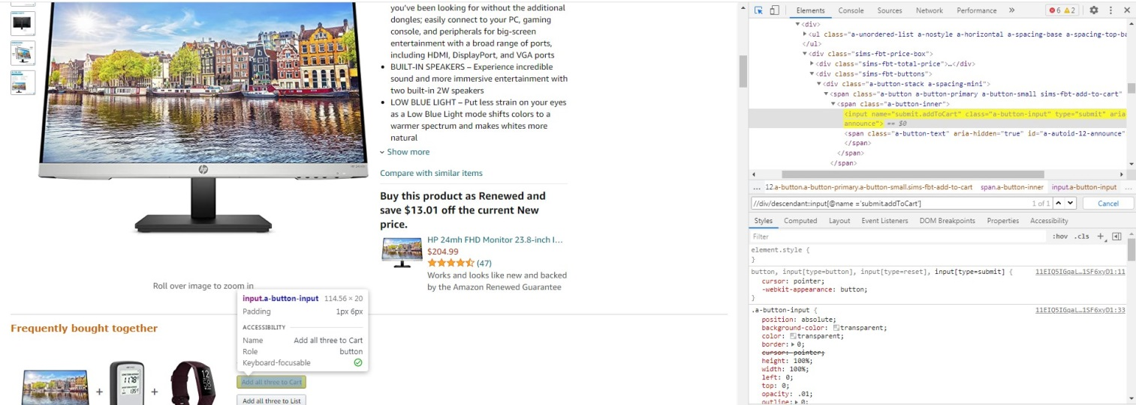
5. **Sign In button**

//a[@class='action-button']/span[text()='Sign in']  
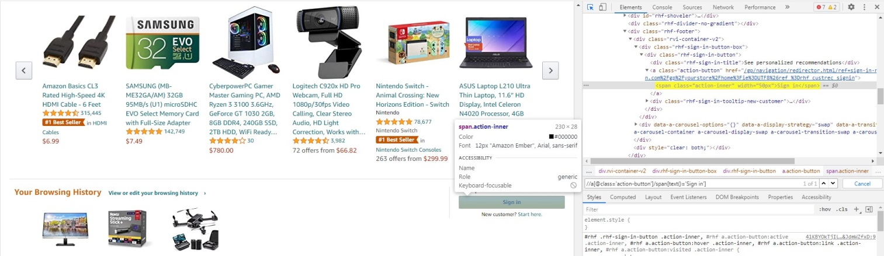

1. **#1 Best Seller**//span[contains(text(), '#1 Best Seller')]  
   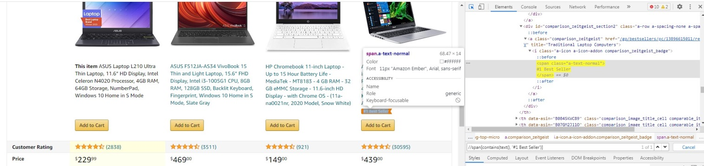
2. **Gift Card**//a[contains(@href, 'Graduation-Cap')]/div[contains(text(), 'Gift Card')]  
   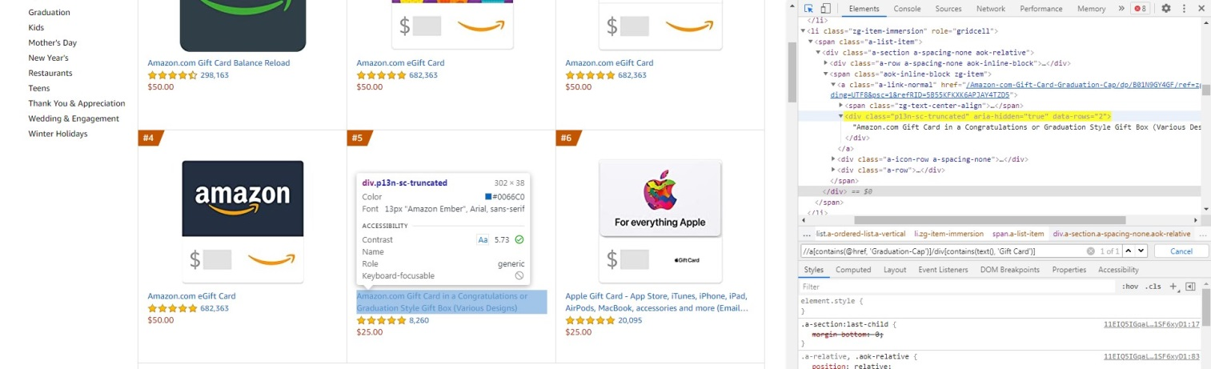
3. **AirPurifier**//*[@id='dealTitle']/span[contains(text(), 'LEVOIT Air Purifier')]  
   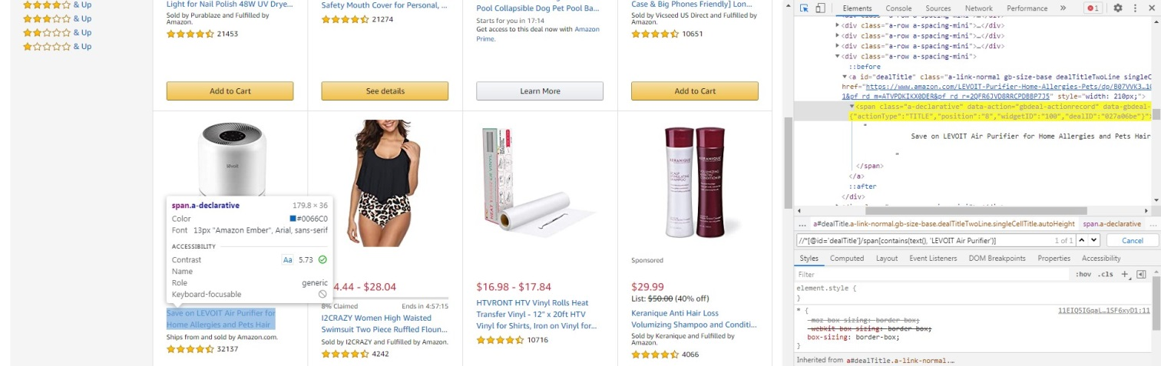
4. **Write Customer review**//a[@id="a-autoid-37-announce"]  
   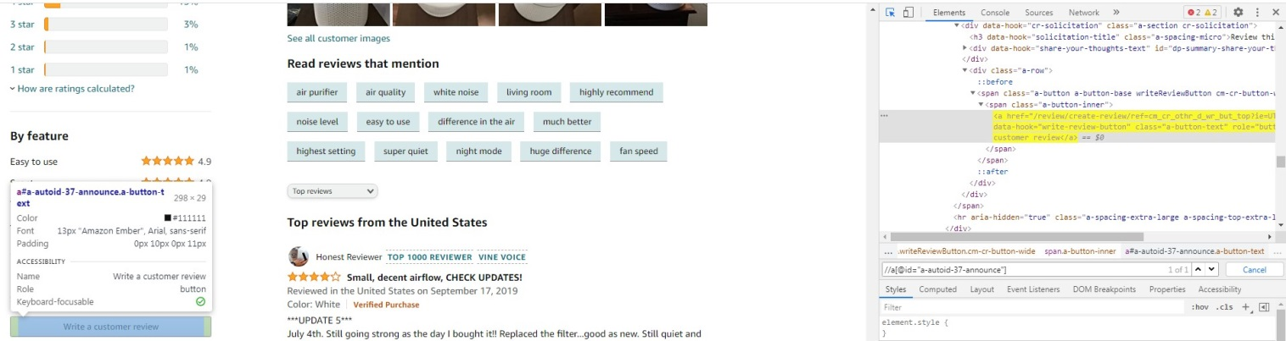
5. **Search Bar**//div/input[@id="twotabsearchtextbox"]  
   