LLM Chatbots and Vector Databases

1.Where would you rate yourself on (LLM, Deep Learning, AI, ML). A, B, C [A = can code independently; B = can code under supervision; C = have little or no understanding]

B : can code under supervision.

2. What are the key architectural components to create a chatbot based on an LLM? Explain the approach at a high level.

Introduction
An LLM-based chatbot is an application that uses a Large Language Model (LLM) to understand user questions and generate meaningful responses. Unlike traditional chatbots that depend mainly on predefined rules, LLM-based chatbots can understand natural language, answer different types of questions, summarize information, and maintain the context of a conversation.
For example, a company could develop a chatbot to answer customer questions about its products, explain company policies, or help users solve common problems. To build such a chatbot, we need several components that work together rather than relying on the LLM alone.

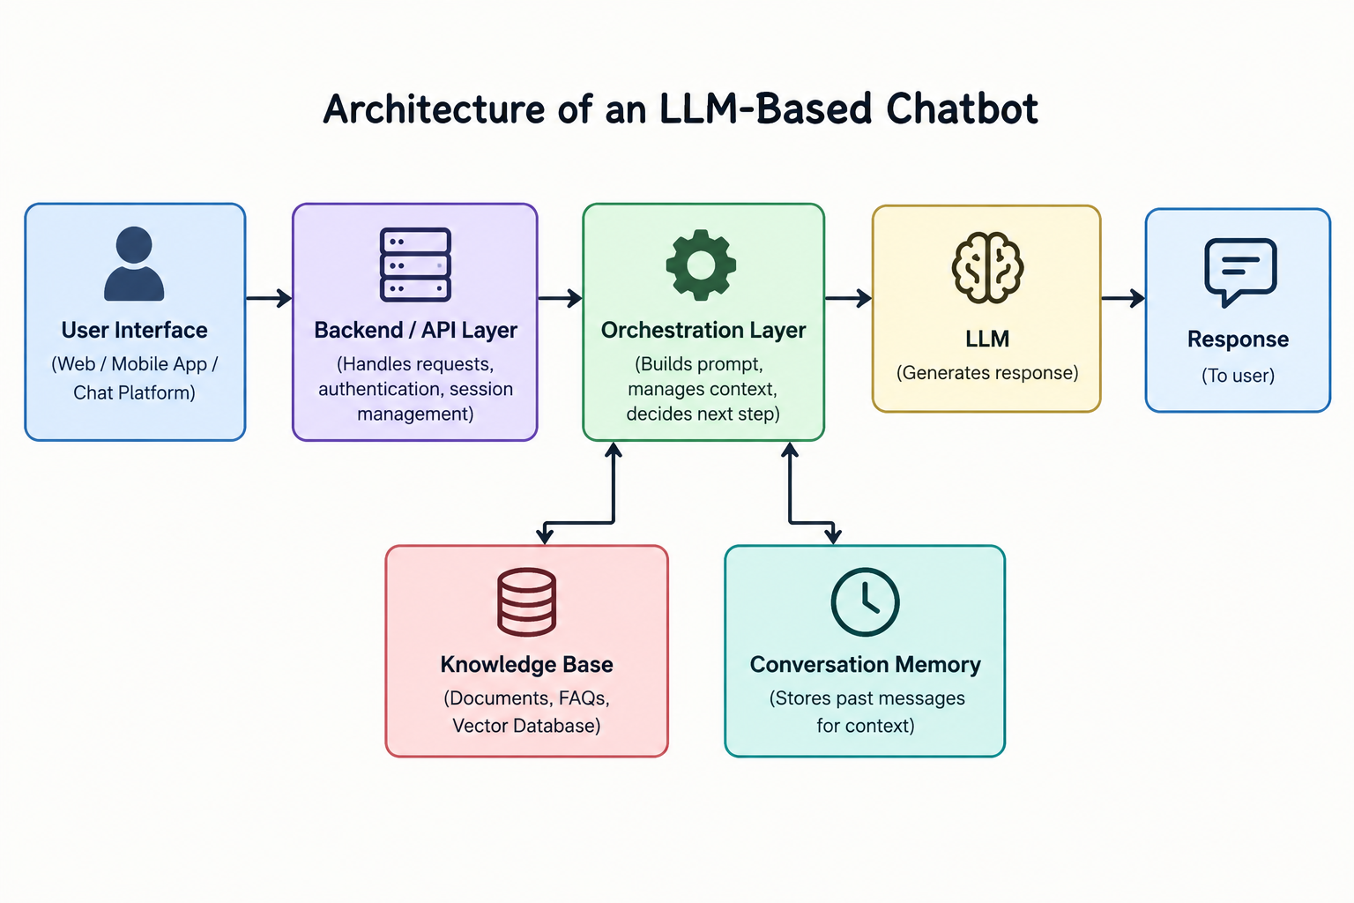

Key architectural components

1. User Interface
The user interface is the part of the application through which users interact with the chatbot. It could be a website, mobile application, or messaging platform.
It allows users to enter questions and view the responses generated by the chatbot. A good interface should be simple, responsive, and easy to use.

2. Backend and API Layer
The backend connects the user interface to the AI components. When a user submits a question, the backend receives it, processes the request, and sends it to the appropriate service.
A backend can be developed using Python frameworks such as FastAPI or JavaScript technologies such as Node.js and Express.
It is also responsible for authentication, managing conversations, handling errors, and protecting sensitive information such as API keys.

3. Large Language Model (LLM)
The LLM is the main component responsible for understanding the user's query and generating a response. Examples include GPT, Claude, and Gemini.
These models can perform tasks such as answering questions, summarizing documents, generating content, and explaining complex topics.
However, an LLM may sometimes generate incorrect information or provide answers that are not supported by reliable sources. Therefore, its responses should be evaluated, especially when the chatbot is used in areas where accuracy is important.

4. Prompt Engineering and Orchestration
Prompt engineering involves providing clear instructions to the LLM so that it responds appropriately. For example, a chatbot can be instructed to answer questions politely, use simple language, or rely on company documents when providing information.
The orchestration layer manages the overall workflow. It combines the user's question with instructions, conversation history, and any relevant information retrieved from external sources.
It can also decide whether a question should be answered directly by the LLM or whether the application needs to retrieve information or call an external tool first.
Frameworks such as LangChain and LangGraph can help build these workflows, although they are not essential for every chatbot.

5. Knowledge Base and Retrieval-Augmented Generation (RAG)
In many real-world applications, the chatbot needs information that is not available in the LLM's training data. For example, a company may want its chatbot to answer questions using internal documents, product manuals, or updated policies.
This can be achieved using Retrieval-Augmented Generation (RAG).
The basic process is:
- Collect documents such as PDFs, manuals, and FAQs.
- Split large documents into smaller sections called chunks.
- Convert these chunks into numerical representations called embeddings.
- Store the embeddings in a vector database.
- When a user asks a question, convert the question into an embedding and retrieve relevant chunks.
- Send the retrieved information along with the question to the LLM.
- Generate a response based on the available context.
This approach helps the chatbot provide answers based on relevant information instead of depending entirely on the model's existing knowledge.

6. Conversation Memory
Conversation memory helps the chatbot understand follow-up questions by keeping track of previous messages.
For example, if a user asks, “What is machine learning?” and then asks, “What are its applications?”, the chatbot can understand that the second question refers to machine learning.
The application can store recent messages or summarize older conversations to preserve useful context. However, sending the entire conversation to the model every time can increase costs and use more tokens, so the system should retain only the information that is relevant.

7. External Tools and API Integrations
Sometimes, a chatbot needs to perform an action rather than simply generate a response. In such cases, it can use external tools or APIs.
For example, a chatbot could check an order's status, retrieve information from a database, create a support ticket, or schedule an appointment.
The backend should validate requests and check permissions before performing these actions. This is important because the LLM should not have unrestricted access to sensitive data or important operations.

8. Security, Testing, and Monitoring
Security and monitoring are important when moving a chatbot from a prototype to a production application.
The system should protect user data, prevent unauthorized access, and handle errors properly. It should also be tested to check whether its answers are accurate, relevant, and safe.
After deployment, performance can be monitored using metrics such as response time, API errors, token usage, retrieval quality, and operating costs.

High-level implementation approach
- Identify the use case: Understand what the chatbot should do and who will use it.
- Choose an LLM: Select a model based on accuracy, cost, speed, and privacy requirements.
- Develop the backend: Create APIs to handle user requests and manage conversations.
- Prepare the knowledge base: If the chatbot needs private or domain-specific information, process the documents and set up a retrieval system.
- Implement the workflow: Connect the LLM with prompts, conversation history, retrieval, and external tools where necessary.
- Build the interface: Create a simple interface through which users can interact with the chatbot.
- Test the application: Check answer quality, response time, and how well the chatbot handles different questions.
- Deploy and monitor: Make the application available to users and improve it based on its performance.

Conclusion
Building an LLM-based chatbot involves more than connecting an application to a language model. The user interface, backend, LLM, orchestration, knowledge base, and security mechanisms all play important roles.
For a chatbot that needs to answer questions using private or frequently updated information, I would consider using RAG with a vector database. I would begin with a simple implementation, test it using realistic questions, and gradually improve its accuracy, performance, and reliability.

3. Explain vector databases. If you were to select one for a hypothetical problem, which would you choose and why?

1. Introduction
A vector database is a type of database that stores and searches data using numerical representations called embeddings. These embeddings capture the meaning of text, images, and other types of data, allowing a system to find information based on similarity rather than relying only on exact keyword matches.
Vector databases are widely used in AI chatbots, recommendation systems, semantic search, and Retrieval-Augmented Generation (RAG). They help AI applications retrieve relevant information from large collections of data.

2. How Does a Vector Database Work?
The working process of a vector database involves three main steps:
1. Embedding generation: Documents or other data are converted into numerical vectors using an embedding model.
2. Storage: The vectors are stored along with the original content and relevant metadata, such as document type, category, or date.
3. Similarity search: When a user submits a query, it is converted into a vector. The database searches for vectors that are most similar to the query and returns the relevant results.
The retrieved information can then be passed to a Large Language Model (LLM), which uses the information to generate a relevant answer. This process is commonly used in RAG-based applications.

3. Problem Scenario and Choice of Vector Database
Suppose a university wants to develop an AI chatbot for its student portal. The university has approximately 10,000 PDF documents containing admission guidelines, fee structures, examination rules, course syllabi, and academic calendars.
Students may ask questions using different wording, and the chatbot must retrieve relevant information from the correct department and academic year. It should also handle updated documents without requiring the entire application to be rebuilt.
For this scenario, I would choose Qdrant because it supports vector similarity search and metadata filtering. Each document can be divided into smaller chunks and stored with metadata such as department, document type, academic year, and last-updated date.
For example, if a student asks, "What is the examination fee for the current academic year?", the chatbot can filter documents using the relevant academic year and document category before retrieving the most similar passages. The retrieved information can then be provided to the LLM to generate an answer.
This approach helps the chatbot find relevant information and reduces the chances of retrieving outdated or unrelated documents. Qdrant also supports local and cloud deployment, giving the university flexibility in how it manages the system.

4. Comparison of Vector Databases
Different vector databases offer different features, deployment options, and trade-offs. The following table compares five popular options for the university chatbot scenario.
Database | Strengths | Possible drawbacks
Qdrant | Efficient vector search, metadata filtering, local and cloud deployment | Self-hosting requires setup and maintenance
Pinecone | Managed cloud service that reduces infrastructure maintenance | Less control over the underlying infrastructure
Weaviate | Hybrid search combining keyword matching and semantic search | Additional features may increase configuration complexity
Chroma | Simple setup and convenient for prototypes | Production requirements need careful evaluation
PostgreSQL + pgvector | Combines relational data and vector search within PostgreSQL | Performance depends on indexing, filtering, and workload
These databases have different strengths, and none is automatically the best for every application. Weaviate's hybrid search can be useful when questions contain exact course codes or policy terms. PostgreSQL with pgvector is attractive when an organization wants to manage relational data and vector embeddings in the same database.
For the university chatbot, Qdrant is a strong candidate because filtering documents by department, academic year, and document category is an important requirement.

5. Why Choose Qdrant Over PostgreSQL + pgvector?
PostgreSQL with pgvector is also a capable solution for vector search. However, I would prefer Qdrant for this scenario because document retrieval is a central requirement of the university chatbot.
1. Search-focused design: Qdrant is designed specifically for vector search, making it a natural choice for retrieving relevant passages from university documents.
2. Metadata filtering: Both solutions support metadata-based filtering. Qdrant provides filtering features designed for vector-search workflows, which are useful when restricting results by department, academic year, or document category.
3. Separation of responsibilities: The university can use PostgreSQL to manage structured information such as student accounts and course registrations, while Qdrant handles semantic searches across document embeddings. This separates transactional data management from document retrieval.
4. Deployment flexibility: Qdrant can be deployed locally or in the cloud. This allows the university to choose an environment that suits its infrastructure and future requirements.
5. Practical trade-off: PostgreSQL with pgvector may be more convenient and economical if the university already uses PostgreSQL and wants to manage structured data and vector embeddings together. Qdrant is attractive when vector retrieval deserves a dedicated system.
Therefore, I would select Qdrant because it is well suited to the chatbot's document-retrieval requirements. However, the final decision should be based on actual performance, cost, and workload testing rather than assuming that one database is always faster or better.

6. Evaluation and Testing
Before deploying the chatbot, I would evaluate the selected database using real student questions and university documents.
The main evaluation criteria would include:
- Retrieval accuracy: Whether the system finds the correct and relevant document passages.
- Response time: How quickly the database retrieves results.
- Metadata filtering: Whether searches return documents from the correct department and academic year.
- Update handling: Whether revised policies and newly added documents become searchable correctly.
- Scalability and cost: Whether the system can handle increasing numbers of documents and user requests within the available budget.
I would test Qdrant against PostgreSQL with pgvector using the same dataset and comparable configurations. The results would help determine whether Qdrant provides sufficient practical benefits for the university.

7. Conclusion
Vector databases enable AI applications to retrieve information based on semantic similarity rather than relying only on exact keyword matches. For the university chatbot, I would choose Qdrant because of its vector-search capabilities, metadata filtering, and deployment flexibility.
Combined with an LLM and Retrieval-Augmented Generation (RAG), Qdrant can help the chatbot answer student questions using relevant university documents. Comparing it with alternatives such as PostgreSQL with pgvector and testing it with real queries would help confirm whether it is the most suitable choice.

References

Question 2: Architecture of an LLM-Based Chatbot
- OpenAI. (n.d.). How to use the OpenAI API for Q&A or to build a chatbot? OpenAI Help Center. https://help.openai.com/en/articles/6643167-how-to-use-the-openai-api-for-qa-or-to-build-a-chatbot
- OpenAI. (n.d.). Retrieval. OpenAI API Documentation. https://developers.openai.com/api/docs/guides/retrieval
- OpenAI. (n.d.). Function Calling. OpenAI API Documentation. https://developers.openai.com/api/docs/guides/function-calling
- LangChain. (n.d.). Retrieval. LangChain Documentation. https://docs.langchain.com/oss/python/langchain/retrieval

Question 3: Vector Databases and Their Applications
- Qdrant. (n.d.). Qdrant Documentation. https://qdrant.tech/documentation/
- Qdrant. (n.d.). Filtering. Qdrant Documentation. https://qdrant.tech/documentation/search/filtering/
- PostgreSQL Global Development Group. (n.d.). pgvector: Open-source vector similarity search for Postgres. GitHub. https://github.com/pgvector/pgvector
- Pinecone. (n.d.). Pinecone Documentation. https://docs.pinecone.io/
- Weaviate. (n.d.). Hybrid Search. Weaviate Documentation. https://docs.weaviate.io/weaviate/search/hybrid
- Chroma. (n.d.). Chroma Documentation. https://docs.trychroma.com/

