The Online Shoppers Purchasing Intention Dataset (2020) provided by Henry Sue on Kaggle is a popular benchmarking tool used to predict whether a website visitor will complete a purchase. It contains data from 12,330 sessions collected over a one-year period.
Dataset Overview
- Source: Originally sourced from the UCI Machine Learning Repository.
- Composition: 10 numerical and 8 categorical attributes.
- Class Label: The Revenue attribute (True/False) indicates if a purchase was made.
- Imbalance: The dataset is highly imbalanced, with roughly 84.5% of sessions resulting in no purchase and only 15.5% ending in a sale.
Key Attributes & Features
The features are divided into behavioral metrics and session metadata:
Category | Features | Description
Page Visits | Administrative, Informational  , ProductRelated | Number of pages visited in each category.
Time Spent | ...Duration | Total time spent in each of the page categories mentioned above.
Google Analytics | BounceRate, ExitRate, PageValue | Metrics derived from Google Analytics for each page. PageValue is often the strongest predictor of revenue.
Temporal | Month, OperatingSystems, Browser, Region, TrafficType | General metadata about the user's connection and the time of the visit.
Visitor Info | VisitorType, Weekend | Whether the user is returning or new, and if the visit occurred on a weekend.

FINDINGS ON THE DATA:
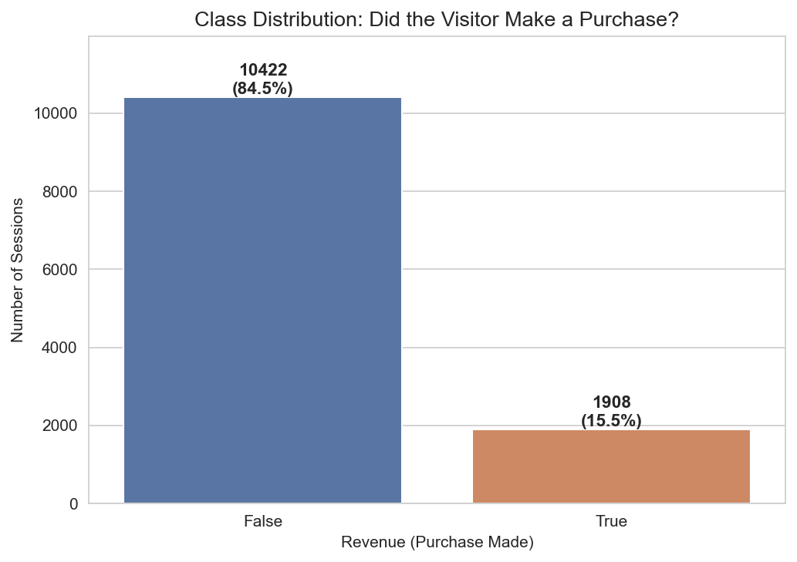
- For every 1 person who bought something, about 5.5 people just browsed and left. This is normal for e-commerce — most online visitors don't buy. The dataset exhibits significant class imbalance, with only 15.47% of sessions resulting in a purchase.
- The model would be 84.53% accurate without doing any actual learning, because it would be right every time the visitor didn't buy (which is most of the time).
- So accuracy alone is a trap here. A model can look great on paper while being completely useless. This is why our capstone will report multiple metrics — accuracy, precision, recall, F1-score, and the confusion matrix — so the real performance shows through.
- This imbalance necessitates the use of multiple evaluation metrics beyond accuracy to ensure meaningful assessment of model performance.
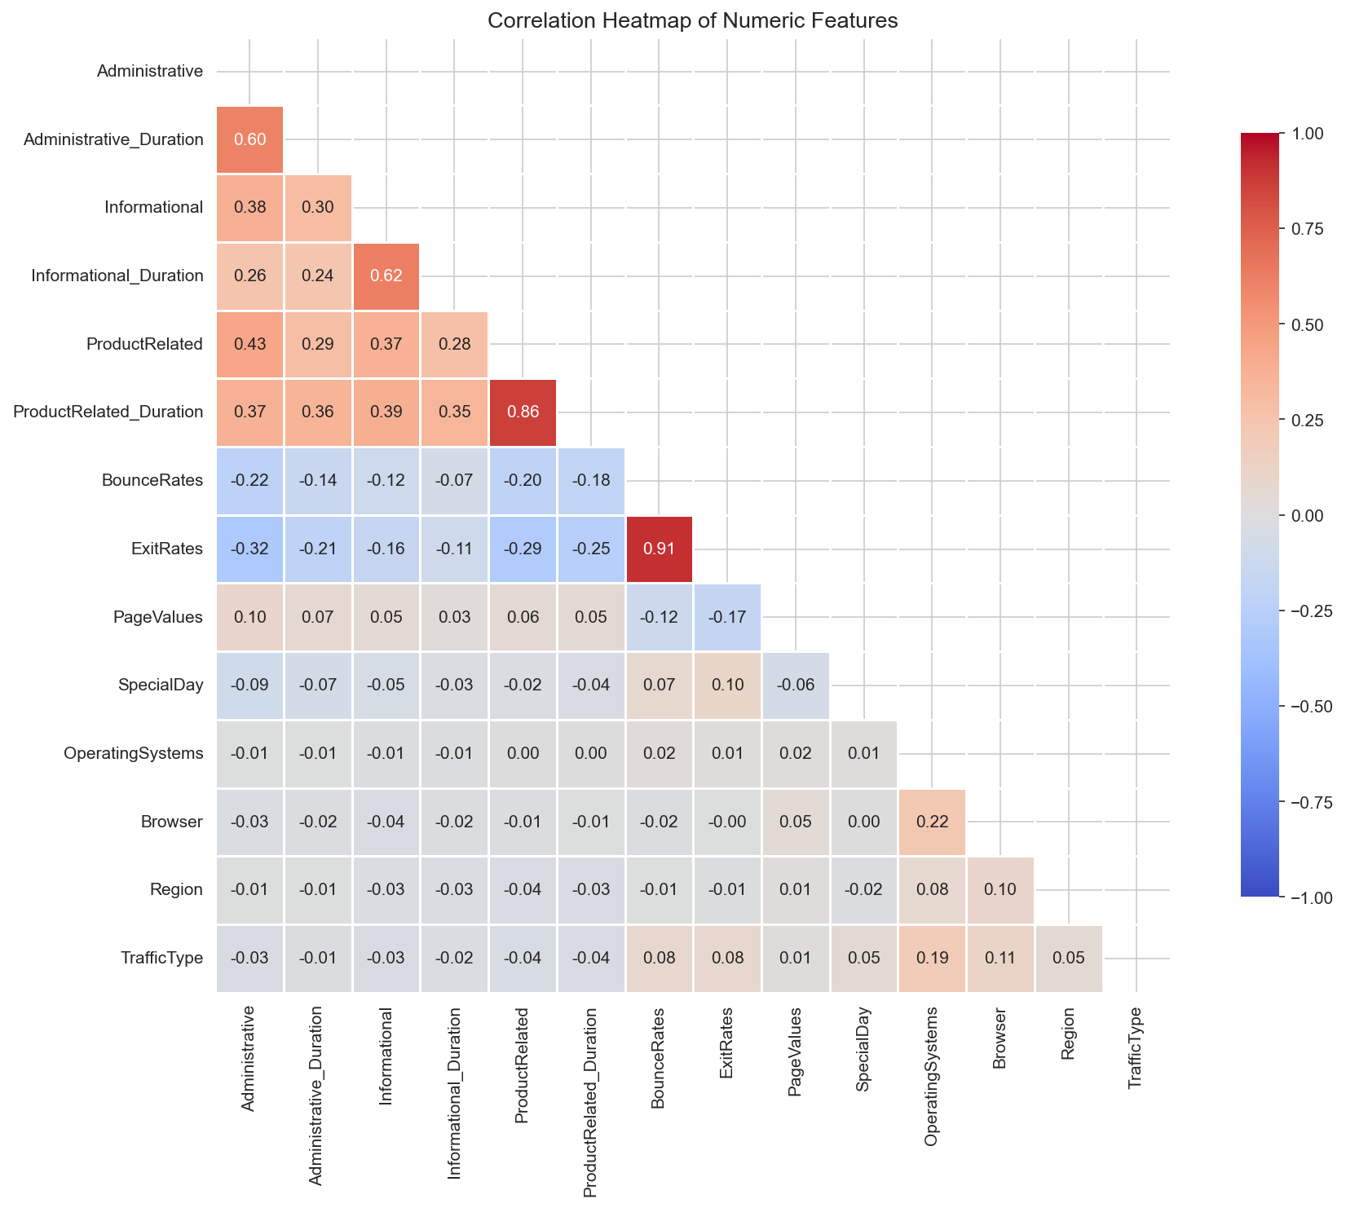
- Some of the features are basically saying the same thing. BounceRates and ExitRates at 0.913 are duplicates. ProductRelated and its duration at 0.861 are nearly duplicates too.
- kNN measures "distance" between visitors using all features at once. When two features are duplicates, they essentially get counted twice in the distance calculation, giving them double influence. For example, if Visitor A bounced a lot AND exited a lot, kNN counts that behavior twice — once via BounceRates, once via ExitRates. Not a fatal one, but something honest to mention in our Limitations section.
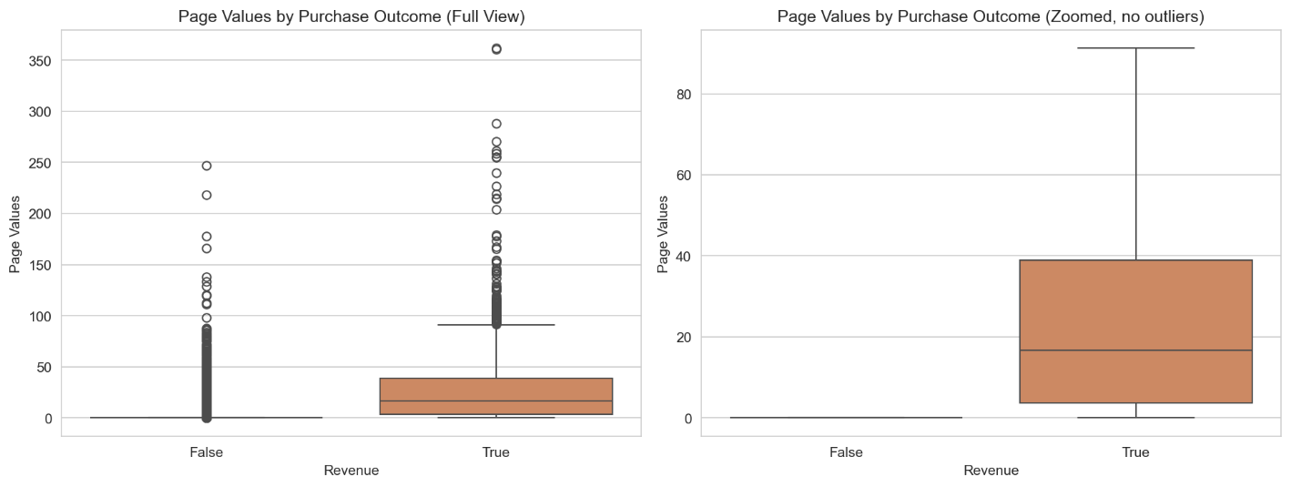
- This is Google Analytics' measure of how "valuable" the pages someone visited are. A high Page Value means they were on pages that typically lead to sales. A Page Value of zero means they only saw pages that don't drive sales.
- People who didn't buy: median Page Value = 0. People who bought: median Page Value = 16.76. The mean for buyers (27.26) is almost 14 times higher than for non-buyers (1.98). This is what data scientists call strong class separability — and it's exactly what kNN needs to work well.
- Page Values emerged as the most discriminative feature: visitors who completed purchases had a mean Page Value of 27.26, compared to only 1.98 for non-purchasers — a 13.8-fold difference.
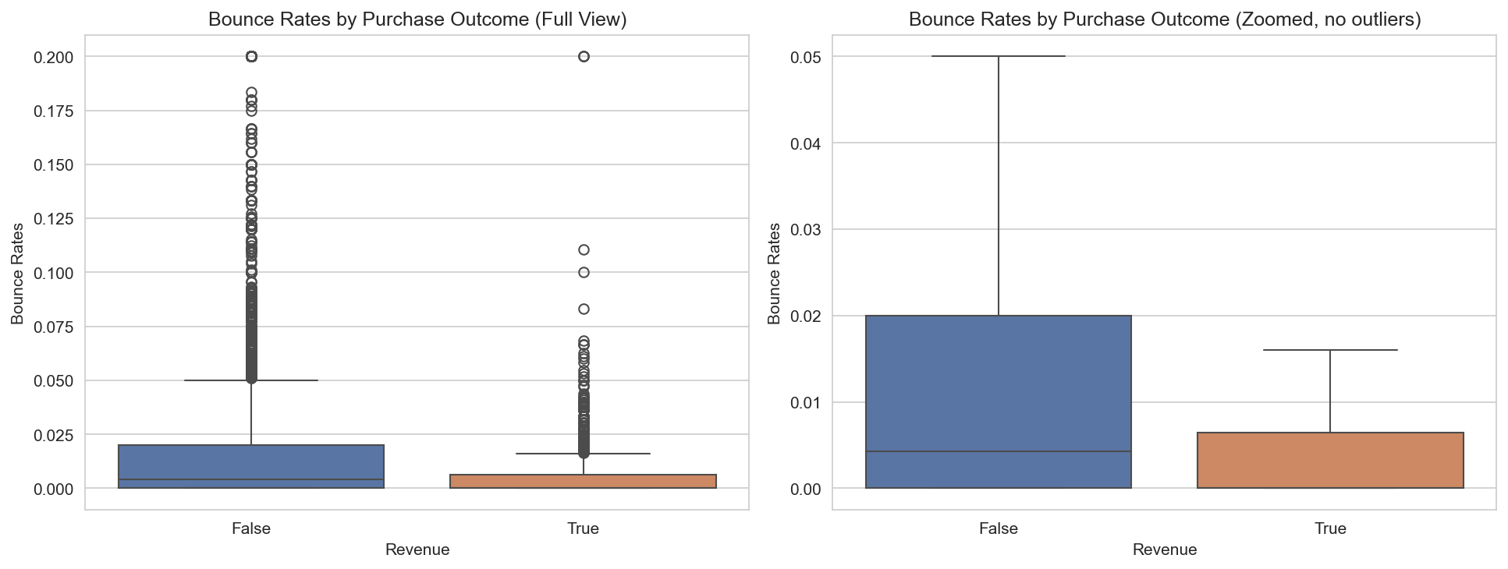
- The percentage of times a visitor lands on a page and immediately leaves. Higher bounce rate = more "drive-by" behavior. Non-buyers had bounce rates roughly 5 times higher than buyers (0.0253 vs 0.0051). The median bounce rate for buyers is literally zero.
- Buyers stay and engage; non-buyers drift in and out.
- Buyers showed substantially lower bounce rates (mean = 0.0051) compared to non-buyers (mean = 0.0253), confirming that engagement depth is strongly associated with purchase completion.
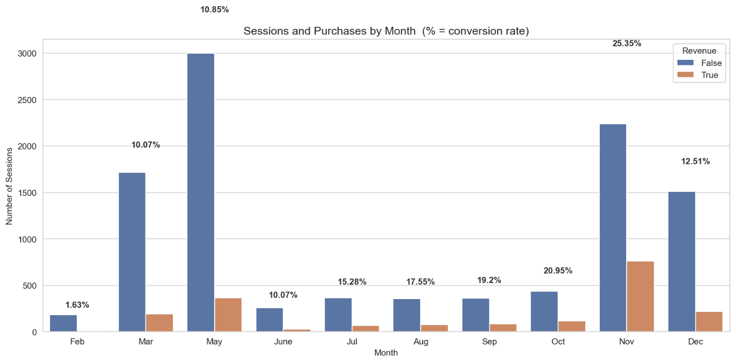
- Where the traffic is: May (3,364) and November (2,998) had the most visitors. Where the buyers are: November isn't just busy — it's the highest converting month at 25.35%.
- There's a clear upward trend from July (15.28%) to November (25.35%). The model will learn that if a session happens in November, there's a higher prior probability of purchase.
- Conversion rates varied significantly by month, ranging from 1.63% in February to 25.35% in November.
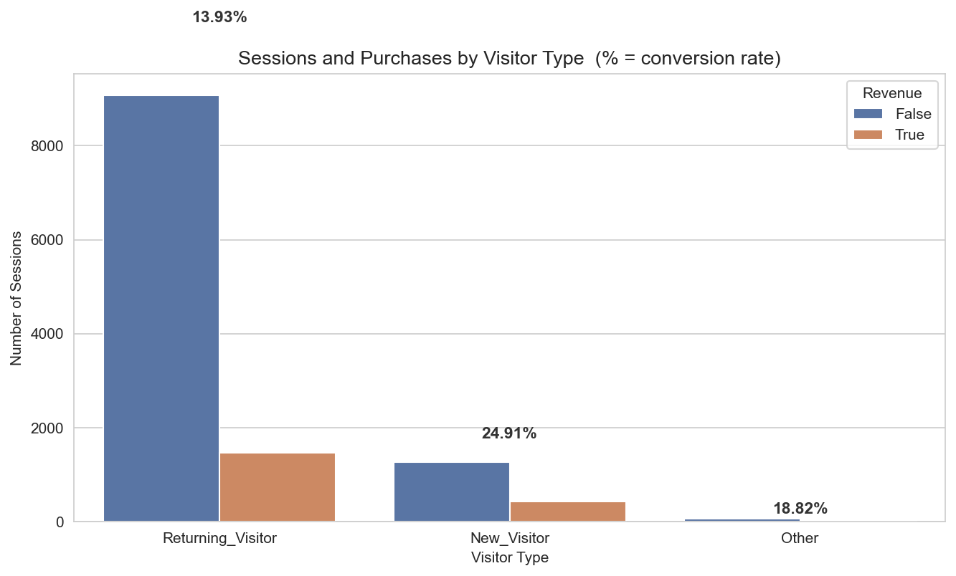
- New visitors convert at 24.91%, while returning visitors convert at only 13.93%. New visitors buy at almost 2 times the rate of returning visitors! New visitors often arrive with high purchase intent, while returning visitors include lots of "browsers."
- This is a perfect discussion point. When someone asked "what insights did we find?", we can lead with this counterintuitive result. It shows we didn't just plug numbers into a model — we actually understood what the data was saying.

