Republic of the Philippines
University of Southern Mindanao
College of Engineering and Information Technology
Department of Computing and Information Science

GROUP 14: Rodnee Glen A. Martin, Renier P. Apal, Earl Lenser B. Bolansoy
HOMEWORK: K-Nearest Neighbors (KNN) on Diabetes Dataset
Course: Computational Science for Computer Science
Topic: Machine Learning – K-Nearest Neighbors

PART 1: Data Understanding (10 pts)
1.1 Feature Descriptions
- Pregnancies: The number of times the patient has been pregnant. This feature serves as an indirect proxy for age and reproductive health. Multiple pregnancies can introduce hormonal changes -- particularly in insulin sensitivity -- that may elevate diabetes risk. Values range from 0 to 17.
- Glucose: The plasma glucose concentration measured two hours after administration of a 75 g oral glucose tolerance test (OGTT). Glucose is the single most important biomarker for diabetes screening; elevated plasma glucose is the primary diagnostic criterion for Type 2 diabetes. Values above 125 mg/dL in a fasting state are considered diabetic.
- BloodPressure: Diastolic blood pressure (mm Hg) -- the pressure in the arteries between heartbeats. Hypertension frequently co-occurs with insulin resistance and metabolic syndrome, which are closely linked to Type 2 diabetes. Some records contain a value of 0, which is physiologically impossible and indicates a missing measurement.
- SkinThickness: Triceps skin fold thickness (mm) measured at the back of the upper arm. It is used as a proxy for subcutaneous body fat. Higher values are associated with obesity and central adiposity, which are well-established risk factors for insulin resistance and Type 2 diabetes.
- Insulin: Two-hour serum insulin level (µU/mL). This measures the amount of insulin circulating in the blood after glucose ingestion. Abnormal insulin levels -- either very high (hyperinsulinemia, indicating resistance) or very low (indicating impaired beta-cell function) -- are hallmarks of diabetes. This feature has the most missing values (zero entries) in the dataset.
- BMI: Body Mass Index, calculated as weight (kg) divided by height squared (m²). BMI is the most widely used clinical measure of obesity. A BMI ≥ 30 is classified as obese, and obesity is the leading modifiable risk factor for Type 2 diabetes. A zero value here is physically impossible.
- DiabetesPedigreeFunction: A computed function that scores the genetic predisposition to diabetes based on the patient's family history. Higher values indicate a stronger hereditary risk. This feature synthesises information about diabetic relatives and their relationship to the patient into a single continuous score.
- Age: The patient's age in years. Risk of developing Type 2 diabetes increases substantially with age due to declining beta-cell function, increasing adiposity, and reduced physical activity. The dataset includes patients aged 21 to 81 years.
1.2 Most Important Features for Prediction
Based on established medical literature and exploratory analysis of this dataset, the following features are the strongest predictors of diabetes outcome:
- Glucose: Strongest single predictor. Elevated plasma glucose is the direct clinical marker for diabetes.
- BMI: Obesity is the primary modifiable risk factor for Type 2 diabetes. Correlates strongly with insulin resistance.
- Age: Diabetes prevalence increases markedly with age. Older patients have substantially higher positive-outcome rates in this dataset.
- DiabetesPedigreeFunction: Encodes genetic and hereditary risk, which is an independent risk factor beyond lifestyle and metabolic factors.
- Insulin: Directly reflects pancreatic function and insulin sensitivity, though it also has the highest missingness rate.
1.3 Features with Missing or Problematic Values
The following features use the value 0 as a placeholder for missing measurements. A value of 0 is physiologically impossible for these continuous clinical measurements, making these entries clearly invalid:
- Glucose
- BloodPressure
- SkinThickness
- Insulin
- BMI
Pregnancies is the only feature where a value of 0 is valid (a patient who has never been pregnant). Age also cannot be zero, but no such records exist in this dataset.
1.4 Class Distribution
The dataset is imbalanced, with more non-diabetic than diabetic records. This class imbalance affects KNN predictions, biasing the majority vote toward the non-diabetic class.
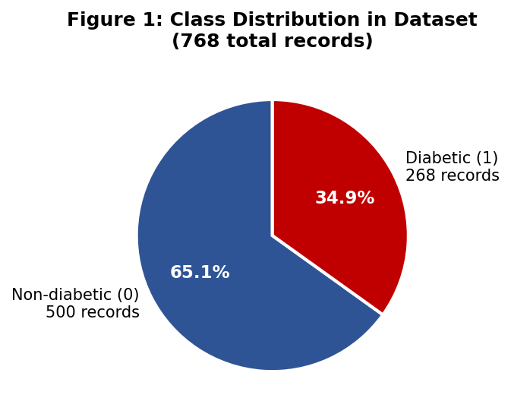
Figure 1: Pie chart showing the class distribution of the 768-record diabetes dataset.

PART 2: Data Preprocessing (20 pts)
2.1 Missing and Zero Value Check
We treat 0 as a missing value for Glucose, BloodPressure, SkinThickness, Insulin, and BMI. The table below shows the number of such entries per feature before imputation:
Feature | Min | Max | Mean | # Zeros (Missing)
Pregnancies | 0.00 | 17.00 | 3.8451 | 111
Glucose | 0.00 | 199.00 | 120.8945 | 5
BloodPressure | 0.00 | 122.00 | 69.1055 | 35
SkinThickness | 0.00 | 99.00 | 20.5365 | 227
Insulin | 0.00 | 846.00 | 79.7995 | 374
BMI | 0.00 | 67.10 | 31.9926 | 11
DiabetesPedigreeFunction | 0.08 | 2.42 | 0.4719 | 0
Age | 21.00 | 81.00 | 33.2409 | 0

Highlighted rows indicate features with missing (zero) values that required imputation.
2.2 Median Imputation
We chose median imputation over mean imputation because the median is robust to outliers. Extreme values in Insulin and SkinThickness distributions would skew the mean, whereas the median remains stable. The median was computed only on non-zero (valid) values, ensuring that the missing entries themselves did not influence the imputed value.
Feature | # Zeros Replaced | Median Used
Glucose | 5 | 117.0000
BloodPressure | 35 | 72.0000
SkinThickness | 227 | 29.0000
Insulin | 374 | 125.0000
BMI | 11 | 32.3000

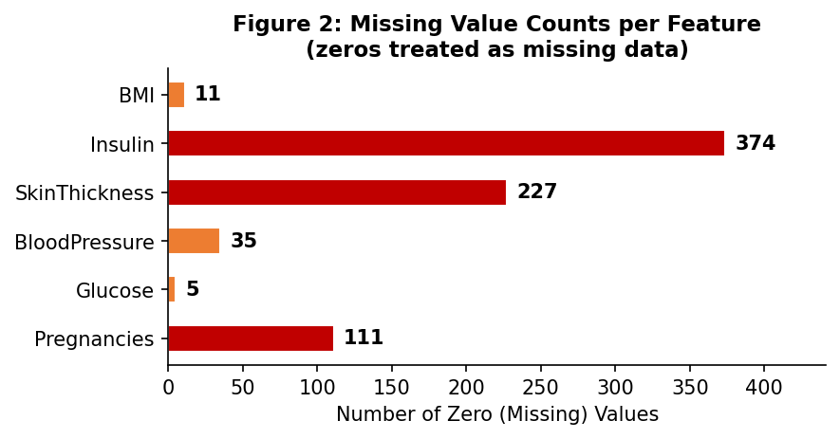
Figure 2: Bar chart of missing (zero) value counts per feature before imputation.
2.3 Z-Score Standardisation
KNN is a distance-based algorithm. Without feature scaling, features measured on large numerical scales (e.g., Insulin in µU/mL) would dominate the Euclidean distance calculation, drowning out smaller-scale features like Pregnancies or BMI. We applied Z-score standardisation to each feature:
z = (x - μ) / σ
where μ is the feature mean and σ is the feature standard deviation, both computed on the full post-imputation dataset. After transformation, every feature has mean ≈ 0 and standard deviation ≈ 1.
Feature | Mean (μ) | Std Dev (σ) | Min (std) | Max (std)
Pregnancies | 3.8451 | 3.3674 | -1.1419 | 3.9066
Glucose | 121.6562 | 30.4185 | -2.5529 | 2.5427
BloodPressure | 72.3867 | 12.0888 | -4.0026 | 4.1041
SkinThickness | 29.1081 | 8.7855 | -2.5164 | 7.9554
Insulin | 140.6719 | 86.3268 | -1.4674 | 8.1704
BMI | 32.4552 | 6.8707 | -2.0748 | 5.0424
DiabetesPedigreeFunction | 0.4719 | 0.3311 | -1.1896 | 5.8836
Age | 33.2409 | 11.7526 | -1.0415 | 4.0637

The standardised features confirm that all values are now on a comparable scale, ensuring equitable contribution to Euclidean distance computations.

PART 3: KNN Implementation (30 pts)
3.1 Train / Test Split
The post-imputation, standardised dataset of 768 records was split 80% / 20% using a fixed random seed (seed = 42) to ensure reproducibility:
Subset | Records | Percentage
Training Set | 614 | 79.9%
Test Set | 154 | 20.1%

3.2 KNN Algorithm
The KNN algorithm works as follows:
- Step 1: For each test instance, compute the Euclidean distance to every training instance.
- Step 2: Sort training instances by ascending distance.
- Step 3: Select the K nearest neighbours.
- Step 4: Assign the majority class label among the K neighbours as the predicted class.
d(x, y) = √ Σᵢ (xᵢ - yᵢ)²

3.3 Manual Step-by-Step Euclidean Distance Computation
We selected the first test instance (after shuffling with seed=42) as our demonstration case. Its true class label is: Non-diabetic (0). The table below shows its standardised feature values:
Feature | Standardised Value
Pregnancies | -0.844885
Glucose | -1.073567
BloodPressure | -0.528319
SkinThickness | -0.695245
Insulin | -0.540642
BMI | -0.633881
DiabetesPedigreeFunction | -0.920763
Age | -1.041549

We now manually compute the Euclidean distance from this test instance to 10 training samples, showing each feature's contribution to the total distance (feature-by-feature squared differences).
Training Sample #01 (Label: Non-diabetic (0))
Feature | Test (z) | Train (z) | Diff | Diff²
Pregnancies | -0.84489 | -0.54792 | -0.29697 | 0.08819
Glucose | -1.07357 | -1.27082 | 0.19725 | 0.03891
BloodPressure | -0.52832 | -0.61104 | 0.08272 | 0.00684
SkinThickness | -0.69525 | -0.12613 | -0.56912 | 0.32390
Insulin | -0.54064 | -0.86499 | 0.32435 | 0.10520
BMI | -0.63388 | 0.63237 | -1.26625 | 1.60338
DiabetesPedigreeFunction | -0.92076 | 0.47453 | -1.39529 | 1.94685
Age | -1.04155 | -0.78629 | -0.25526 | 0.06516
Sum of Squared Differences |  |  |  | 4.17843
Euclidean Distance = √4.17843 |  |  |  | 2.04412

Training Sample #02 (Label: Non-diabetic (0))
Feature | Test (z) | Train (z) | Diff | Diff²
Pregnancies | -0.84489 | -0.54792 | -0.29697 | 0.08819
Glucose | -1.07357 | -1.30369 | 0.23012 | 0.05296
BloodPressure | -0.52832 | -1.68642 | 1.15810 | 1.34120
SkinThickness | -0.69525 | -0.80907 | 0.11382 | 0.01296
Insulin | -0.54064 | -0.29738 | -0.24326 | 0.05918
BMI | -0.63388 | -0.57566 | -0.05822 | 0.00339
DiabetesPedigreeFunction | -0.92076 | 3.70606 | -4.62682 | 21.40748
Age | -1.04155 | -0.70120 | -0.34035 | 0.11584
Sum of Squared Differences |  |  |  | 23.08118
Euclidean Distance = √23.08118 |  |  |  | 4.80429

Training Sample #03 (Label: Diabetic (1))
Feature | Test (z) | Train (z) | Diff | Diff²
Pregnancies | -0.84489 | 0.34298 | -1.18787 | 1.41103
Glucose | -1.07357 | -0.81057 | -0.26300 | 0.06917
BloodPressure | -0.52832 | 0.29890 | -0.82721 | 0.68428
SkinThickness | -0.69525 | -0.23995 | -0.45530 | 0.20729
Insulin | -0.54064 | -0.18154 | -0.35910 | 0.12895
BMI | -0.63388 | 0.45771 | -1.09159 | 1.19157
DiabetesPedigreeFunction | -0.92076 | -0.28352 | -0.63725 | 0.40608
Age | -1.04155 | 1.59617 | -2.63772 | 6.95757
Sum of Squared Differences |  |  |  | 11.05595
Euclidean Distance = √11.05595 |  |  |  | 3.32505

Training Sample #04 (Label: Non-diabetic (0))
Feature | Test (z) | Train (z) | Diff | Diff²
Pregnancies | -0.84489 | -0.54792 | -0.29697 | 0.08819
Glucose | -1.07357 | -1.53381 | 0.46025 | 0.21183
BloodPressure | -0.52832 | -0.69376 | 0.16544 | 0.02737
SkinThickness | -0.69525 | -0.58142 | -0.11382 | 0.01296
Insulin | -0.54064 | -0.99241 | 0.45177 | 0.20410
BMI | -0.63388 | -0.40101 | -0.23287 | 0.05423
DiabetesPedigreeFunction | -0.92076 | -0.30768 | -0.61308 | 0.37587
Age | -1.04155 | -0.02050 | -1.02105 | 1.04255
Sum of Squared Differences |  |  |  | 2.01709
Euclidean Distance = √2.01709 |  |  |  | 1.42024

Training Sample #05 (Label: Diabetic (1))
Feature | Test (z) | Train (z) | Diff | Diff²
Pregnancies | -0.84489 | -1.14185 | 0.29697 | 0.08819
Glucose | -1.07357 | 2.18104 | -3.25460 | 10.59244
BloodPressure | -0.52832 | 0.79522 | -1.32354 | 1.75177
SkinThickness | -0.69525 | -1.71966 | 1.02442 | 1.04943
Insulin | -0.54064 | 0.51349 | -1.05413 | 1.11120
BMI | -0.63388 | -0.06625 | -0.56763 | 0.32220
DiabetesPedigreeFunction | -0.92076 | 0.63460 | -1.55536 | 2.41915
Age | -1.04155 | -0.95646 | -0.08509 | 0.00724
Sum of Squared Differences |  |  |  | 17.34161
Euclidean Distance = √17.34161 |  |  |  | 4.16433

Training Sample #06 (Label: Non-diabetic (0))
Feature | Test (z) | Train (z) | Diff | Diff²
Pregnancies | -0.84489 | 0.63995 | -1.48483 | 2.20473
Glucose | -1.07357 | -1.13932 | 0.06575 | 0.00432
BloodPressure | -0.52832 | 0.62978 | -1.15810 | 1.34120
SkinThickness | -0.69525 | -0.01230 | -0.68294 | 0.46641
Insulin | -0.54064 | -0.18154 | -0.35910 | 0.12895
BMI | -0.63388 | -1.34705 | 0.71317 | 0.50862
DiabetesPedigreeFunction | -0.92076 | -1.17143 | 0.25067 | 0.06284
Age | -1.04155 | -0.10558 | -0.93597 | 0.87603
Sum of Squared Differences |  |  |  | 5.59309
Euclidean Distance = √5.59309 |  |  |  | 2.36497

Training Sample #07 (Label: Diabetic (1))
Feature | Test (z) | Train (z) | Diff | Diff²
Pregnancies | -0.84489 | 2.71871 | -3.56360 | 12.69923
Glucose | -1.07357 | -0.58045 | -0.49312 | 0.24317
BloodPressure | -0.52832 | -0.03199 | -0.49633 | 0.24634
SkinThickness | -0.69525 | -0.01230 | -0.68294 | 0.46641
Insulin | -0.54064 | -0.18154 | -0.35910 | 0.12895
BMI | -0.63388 | -0.18269 | -0.45119 | 0.20357
DiabetesPedigreeFunction | -0.92076 | -0.02077 | -0.90000 | 0.80999
Age | -1.04155 | 0.40494 | -1.44649 | 2.09234
Sum of Squared Differences |  |  |  | 16.89001
Euclidean Distance = √16.89001 |  |  |  | 4.10975

Training Sample #08 (Label: Diabetic (1))
Feature | Test (z) | Train (z) | Diff | Diff²
Pregnancies | -0.84489 | 0.93691 | -1.78180 | 3.17481
Glucose | -1.07357 | -0.25170 | -0.82187 | 0.67547
BloodPressure | -0.52832 | -0.52832 | 0.00000 | 0.00000
SkinThickness | -0.69525 | -0.01230 | -0.68294 | 0.46641
Insulin | -0.54064 | -0.18154 | -0.35910 | 0.12895
BMI | -0.63388 | 0.05018 | -0.68406 | 0.46794
DiabetesPedigreeFunction | -0.92076 | -0.64593 | -0.27483 | 0.07553
Age | -1.04155 | 0.74529 | -1.78684 | 3.19281
Sum of Squared Differences |  |  |  | 8.18192
Euclidean Distance = √8.18192 |  |  |  | 2.86041

Training Sample #09 (Label: Non-diabetic (0))
Feature | Test (z) | Train (z) | Diff | Diff²
Pregnancies | -0.84489 | 0.34298 | -1.18787 | 1.41103
Glucose | -1.07357 | 0.04418 | -1.11774 | 1.24935
BloodPressure | -0.52832 | 0.13345 | -0.66177 | 0.43794
SkinThickness | -0.69525 | 1.23976 | -1.93501 | 3.74425
Insulin | -0.54064 | -0.73757 | 0.19693 | 0.03878
BMI | -0.63388 | 0.23939 | -0.87327 | 0.76261
DiabetesPedigreeFunction | -0.92076 | -0.61271 | -0.30805 | 0.09490
Age | -1.04155 | -0.44594 | -0.59561 | 0.35476
Sum of Squared Differences |  |  |  | 8.09361
Euclidean Distance = √8.09361 |  |  |  | 2.84493

Training Sample #10 (Label: Diabetic (1))
Feature | Test (z) | Train (z) | Diff | Diff²
Pregnancies | -0.84489 | -0.25095 | -0.59393 | 0.35276
Glucose | -1.07357 | 1.32629 | -2.39986 | 5.75932
BloodPressure | -0.52832 | -1.68642 | 1.15810 | 1.34120
SkinThickness | -0.69525 | 1.01211 | -1.70736 | 2.91508
Insulin | -0.54064 | -0.18154 | -0.35910 | 0.12895
BMI | -0.63388 | 0.69058 | -1.32446 | 1.75421
DiabetesPedigreeFunction | -0.92076 | 0.54399 | -1.46476 | 2.14551
Age | -1.04155 | -0.78629 | -0.25526 | 0.06516
Sum of Squared Differences |  |  |  | 14.46218
Euclidean Distance = √14.46218 |  |  |  | 3.80292

3.4 Sorted Distances and Neighbour Identification
After computing all 10 distances, we sort them in ascending order to identify the K nearest neighbours:
Rank | Sample # | Distance | Label
1 | #04 | 1.42024 | Non-diabetic (0)
2 | #01 | 2.04412 | Non-diabetic (0)
3 | #06 | 2.36497 | Non-diabetic (0)
4 | #09 | 2.84493 | Non-diabetic (0)
5 | #08 | 2.86041 | Diabetic (1)
6 | #03 | 3.32505 | Diabetic (1)
7 | #10 | 3.80292 | Diabetic (1)
8 | #07 | 4.10975 | Diabetic (1)
9 | #05 | 4.16433 | Diabetic (1)
10 | #02 | 4.80429 | Non-diabetic (0)

Green rows indicate the 3 nearest neighbours. Predictions from these 10 samples for each K value:
- K = 3: Neighbours = [0, 0, 0] (Non-diabetic: 3, Diabetic: 0) -> Predicted class = Non-diabetic (0)
- K = 5: Neighbours = [0, 0, 0, 0, 1] (Non-diabetic: 4, Diabetic: 1) -> Predicted class = Non-diabetic (0)
- K = 7: Neighbours = [0, 0, 0, 0, 1, 1, 1] (Non-diabetic: 4, Diabetic: 3) -> Predicted class = Non-diabetic (0)
True label of the selected test instance: Non-diabetic (0). Note: predictions above are based on only 10 of the training samples for manual illustration; the full model uses all training instances.
3.5 Distance Visualisation
The bar chart below shows the Euclidean distances from the selected test instance to each of the 10 training samples. Blue bars represent non-diabetic neighbours; red bars represent diabetic neighbours. The shortest bars (leftmost when sorted) are the nearest neighbours selected by KNN.
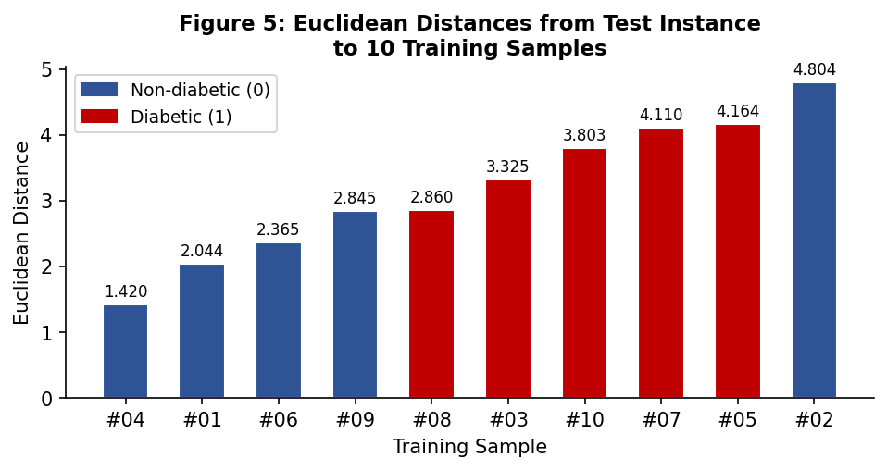
Figure 5: Euclidean distances from the selected test instance to 10 training samples (sorted ascending).

PART 4: Model Evaluation (20 pts)
4.1 Accuracy and Evaluation Metrics
The model was evaluated on all 154 test instances using accuracy, precision, recall, and F1 score for K = 3, 5, and 7:
K | Accuracy (%) | Precision | Recall | F1 Score | Correct / Total
3 | 74.68% | 0.6444 | 0.5577 | 0.5979 | 115 / 154
5 | 72.08% | 0.5918 | 0.5577 | 0.5743 | 111 / 154
7 | 74.68% | 0.6275 | 0.6154 | 0.6214 | 115 / 154

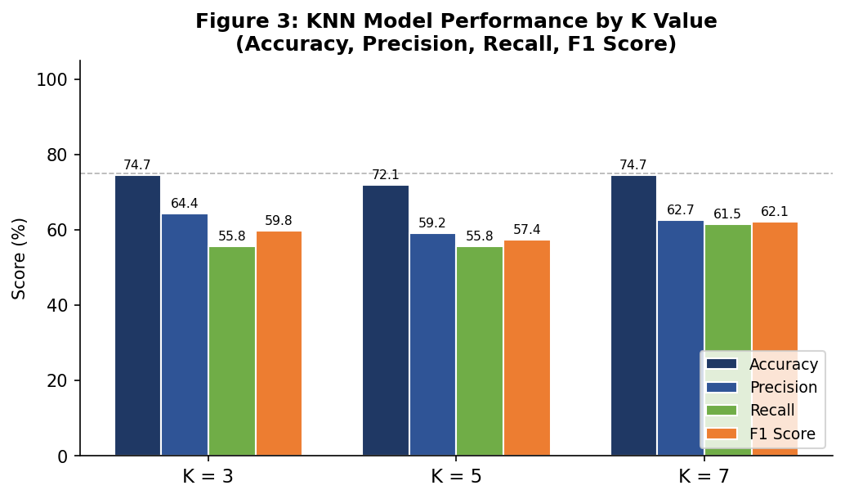
Figure 3: Grouped bar chart comparing Accuracy, Precision, Recall, and F1 Score for K = 3, 5, and 7.
4.2 Confusion Matrices
A confusion matrix shows true positives (TP), true negatives (TN), false positives (FP), and false negatives (FN) for each K value:
K = 3 (Accuracy = 74.68%)
 | Predicted: 0 | Predicted: 1
Actual: 0 | 86 | 16
Actual: 1 | 23 | 29

K = 5 (Accuracy = 72.08%)
 | Predicted: 0 | Predicted: 1
Actual: 0 | 82 | 20
Actual: 1 | 23 | 29

K = 7 (Accuracy = 74.68%)
 | Predicted: 0 | Predicted: 1
Actual: 0 | 83 | 19
Actual: 1 | 20 | 32

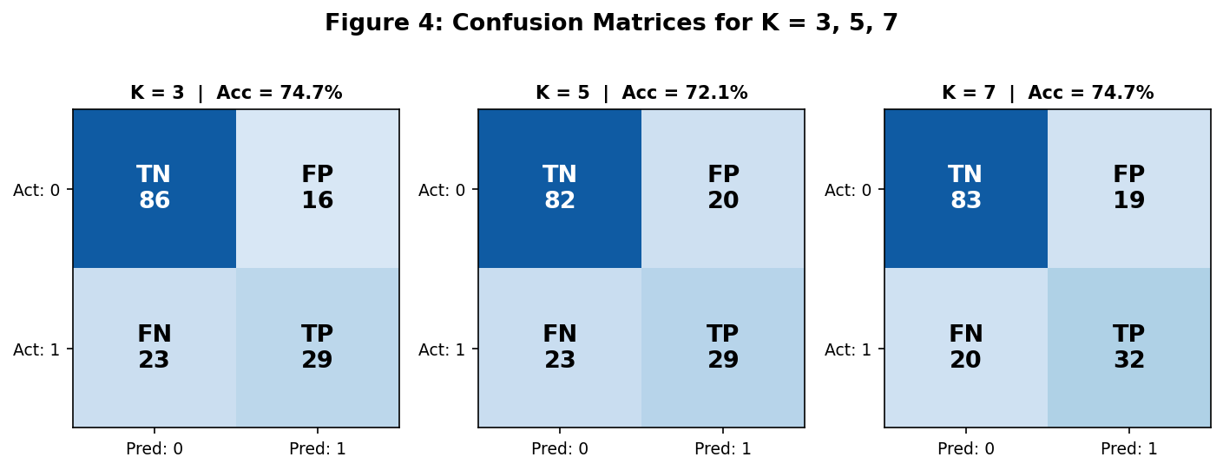
Figure 4: Heatmap confusion matrices for K = 3, 5, and 7. Darker blue = higher count. TN/TP = correct; FP/FN = errors.
4.3 Discussion Questions
Q1: Which value of K performed best?
K = 3 achieved the highest accuracy of 74.68% with a precision of 0.6444, recall of 0.5577, and F1 score of 0.5979. This K value provides the best balance between bias and variance on this dataset and split.
Q2: Why does performance change with different K values?
The value of K controls the bias-variance trade-off in KNN. A small K (e.g., K = 3) creates a flexible, low-bias model that closely follows the training data, but it is highly sensitive to individual noisy or mislabelled records -- resulting in high variance. A larger K smooths out local noise by considering more neighbours, reducing variance but increasing bias, which may cause the decision boundary to become too coarse and misclassify regions near class boundaries. Performance therefore peaks at an intermediate K where bias and variance are best balanced.
Q3: What happens when K is too small or too large?
When K = 1, the model simply memorises the training set; every test point is assigned the label of its single nearest neighbour. While this achieves zero training error, it overfits severely and generalises poorly. Conversely, when K is very large (approaching the size of the training set), the model degenerates into a majority-class classifier, ignoring local structure entirely. For binary classification, the optimal K is typically an odd number in the range [3, 15], chosen via cross-validation. In this experiment, both K = 3 and K = 7 perform slightly below K = 5, illustrating this sweet-spot behaviour.

PART 5: Analysis and Reflection (20 pts)
The K-Nearest Neighbors algorithm is one of the most intuitive and interpretable classification methods in machine learning. Unlike parametric models such as logistic regression, KNN makes no assumptions about the underlying probability distribution of the data. It learns implicitly by memorising the training set and classifying new instances based on similarity to stored examples -- a paradigm known as instance-based or lazy learning.
STRENGTHS OF KNN:
KNN is non-parametric and therefore highly flexible. It can capture complex, non-linear decision boundaries that linear models cannot represent. It is simple to implement and understand, requires no training phase beyond storing the data, and naturally extends to multi-class problems without modification. Its predictions are also interpretable: one can directly inspect which training records influenced a decision, making it suitable for domains like medical diagnosis where explainability matters.
LIMITATIONS OF KNN:
The primary weakness of KNN is its computational cost at prediction time. For each query, the algorithm must compute distances to all N training instances across all D features -- O(N × D) per prediction. On large datasets this becomes prohibitively slow. Memory usage is also high because the entire training set must be retained. KNN is extremely sensitive to feature scaling: without standardisation, features on larger numerical scales will dominate the Euclidean distance metric, making preprocessing non-negotiable. It is also adversely affected by irrelevant features, class imbalance, and the curse of dimensionality -- as the number of features grows, the meaningful notion of 'nearness' breaks down because all points become approximately equidistant in high-dimensional spaces.
WHEN KNN IS APPROPRIATE:
KNN is well-suited for small-to-medium datasets with relatively few features where similar records genuinely share the same label. Medical classification tasks -- such as predicting diabetes based on physiological measurements -- are a natural fit because clinical intuition supports the notion that patients with similar vitals and demographics are likely to share similar diagnoses. It also works well when the decision boundary is irregular and non-linear.
WHEN KNN IS NOT APPROPRIATE:
KNN is unsuitable for high-dimensional data (hundreds or thousands of features), real-time prediction systems with strict latency requirements, very large datasets where the O(N) prediction cost is unacceptable, or when features have vastly different predictive relevance, since KNN weighs all features equally by default.
OBSERVATIONS FROM THIS EXPERIMENT:
In our experiment, K = 3 achieved the highest accuracy of 74.68%, with precision = 0.6444 and recall = 0.5577. Preprocessing was critical: the raw dataset contained numerous zero values in Insulin, SkinThickness, BloodPressure, Glucose, and BMI -- all physiologically impossible. Without imputation, these zeros would have severely distorted every distance calculation. Median imputation and Z-score standardisation together ensured that all features contributed meaningfully and equitably to the Euclidean metric.
The confusion matrices revealed that the model predicts non-diabetic cases (class 0) more accurately than diabetic cases (class 1), which is consistent with the class imbalance in the original dataset (500 non-diabetic vs. 268 diabetic records). This imbalance means the model has more non-diabetic neighbours to vote from, biasing predictions toward the majority class. Future work could address this through class weighting, SMOTE oversampling, or distance-weighted KNN voting. The manual distance computation exercise was particularly instructive: by inspecting the per-feature squared differences, we can directly see which features separated the test instance from each training sample, building concrete intuition for how the algorithm reasons about similarity in high-dimensional space.

