HOMEWORK REPORT
K-Nearest Neighbors (KNN) on Diabetes Dataset

Course: Computational Science
Topic: Machine Learning – K-Nearest Neighbors
Dataset: Pima Indians Diabetes Dataset (768 records)

GROUP 14:
Rodnee Glen A. Martin
Renier P. Apal
Earl Lenser B. Bolansoy

Part 1: Data Understanding

1.1 Feature Descriptions
Feature | Description
Pregnancies | The number of times a patient has been pregnant. Higher parity can be associated with hormonal changes that increase diabetes risk.
Glucose | Plasma glucose concentration measured 2 hours after an oral glucose tolerance test. This is one of the most important diagnostic markers for diabetes.
BloodPressure | Diastolic blood pressure (mm Hg). Hypertension often co-occurs with Type 2 diabetes and insulin resistance.
SkinThickness | Triceps skinfold thickness (mm), used as a proxy for body fat percentage. Higher fat is associated with insulin resistance.
Insulin | 2-Hour serum insulin level (mu U/ml). Elevated or irregular insulin levels are a direct indicator of pancreatic function and diabetic risk.
BMI | Body Mass Index (kg/m²). Obesity (BMI ≥ 30) is a major risk factor for Type 2 diabetes.
DiabetesPedigreeFunction | A genetic risk score estimating the likelihood of diabetes based on family history. Higher values imply stronger genetic predisposition.
Age | Patient age in years. Risk of Type 2 diabetes increases with age, especially after 45.
Outcome | Binary target variable: 1 = Diabetic, 0 = Non-diabetic.

1.2 Important Features and Problematic Values
Which features are likely most important for prediction?
Based on medical knowledge and correlation analysis, Glucose is the single strongest predictor — elevated blood sugar is the defining characteristic of diabetes. BMI closely follows, as obesity drives insulin resistance. Age and DiabetesPedigreeFunction contribute demographic and genetic context respectively. Insulin, when valid, is also highly informative.
Which features may contain missing or problematic values?
Several features use 0 as a placeholder for missing data, which is physiologically impossible. The most affected columns are: Insulin (374 zeros ≈ 49%), SkinThickness (227 zeros ≈ 30%), BloodPressure (35 zeros), BMI (11 zeros), and Glucose (5 zeros). These must be imputed before modelling.

Part 2: Data Preprocessing

2.1 Missing / Zero Value Detection
Feature | Zero Count | Percentage | Action Taken
Glucose | 5 | 0.65% | Median imputation
BloodPressure | 35 | 4.56% | Median imputation
SkinThickness | 227 | 29.56% | Median imputation
Insulin | 374 | 48.70% | Median imputation
BMI | 11 | 1.43% | Median imputation
Pregnancies | 111 | 14.45% | Valid (0 = no prior pregnancies)
Age | 0 | 0% | No action needed

2.2 Handling Strategy: Median Imputation
Median imputation was chosen over mean imputation because several features (particularly Insulin) are heavily right-skewed. The median is robust to outliers and preserves the central tendency better in such distributions. Row removal was not chosen because it would eliminate ~50% of the dataset, substantially reducing training data.
2.3 Before vs. After Preprocessing — Summary Statistics
Before imputation:
Statistic | Pregnancies | Glucose | BloodPressure | SkinThickness | Insulin | BMI | DiabPedigree | Age | Outcome
count | 768.00 | 768.00 | 768.00 | 768.00 | 768.00 | 768.00 | 768.00 | 768.00 | 768.00
mean | 3.85 | 120.89 | 69.11 | 20.54 | 79.80 | 31.99 | 0.47 | 33.24 | 0.35
std | 3.37 | 31.97 | 19.36 | 15.95 | 115.24 | 7.88 | 0.33 | 11.76 | 0.48
min | 0.00 | 0.00 | 0.00 | 0.00 | 0.00 | 0.00 | 0.08 | 21.00 | 0.00
25% | 1.00 | 99.00 | 62.00 | 0.00 | 0.00 | 27.30 | 0.24 | 24.00 | 0.00
50% | 3.00 | 117.00 | 72.00 | 23.00 | 30.50 | 32.00 | 0.37 | 29.00 | 0.00
75% | 6.00 | 140.25 | 80.00 | 32.00 | 127.25 | 36.60 | 0.63 | 41.00 | 1.00
max | 17.00 | 199.00 | 122.00 | 99.00 | 846.00 | 67.10 | 2.42 | 81.00 | 1.00

After median imputation:
Statistic | Pregnancies | Glucose | BloodPressure | SkinThickness | Insulin | BMI | DiabPedigree | Age | Outcome
count | 768.00 | 768.00 | 768.00 | 768.00 | 768.00 | 768.00 | 768.00 | 768.00 | 768.00
mean | 3.85 | 121.66 | 72.39 | 29.11 | 140.67 | 32.46 | 0.47 | 33.24 | 0.35
std | 3.37 | 30.44 | 12.10 | 8.79 | 86.38 | 6.88 | 0.33 | 11.76 | 0.48
min | 0.00 | 44.00 | 24.00 | 7.00 | 14.00 | 18.20 | 0.08 | 21.00 | 0.00
25% | 1.00 | 99.75 | 64.00 | 25.00 | 79.80 | 27.50 | 0.24 | 24.00 | 0.00
50% | 3.00 | 117.00 | 72.00 | 29.00 | 125.00 | 32.40 | 0.37 | 29.00 | 0.00
75% | 6.00 | 140.25 | 80.00 | 32.00 | 190.50 | 36.60 | 0.63 | 41.00 | 1.00
max | 17.00 | 199.00 | 122.00 | 99.00 | 846.00 | 67.10 | 2.42 | 81.00 | 1.00

2.4 Feature Scaling: Standardization
KNN relies on Euclidean distance, making it extremely sensitive to feature scale. A feature like Insulin (range 0–846) would dominate the distance computation over BMI (range 0–67) without scaling. Z-score standardization was applied: each feature is transformed to have mean = 0 and standard deviation = 1, ensuring all features contribute equally.
Formula: $z = \frac{\left(x - μ\right)}{σ}$, where μ is the feature mean and σ is the standard deviation.

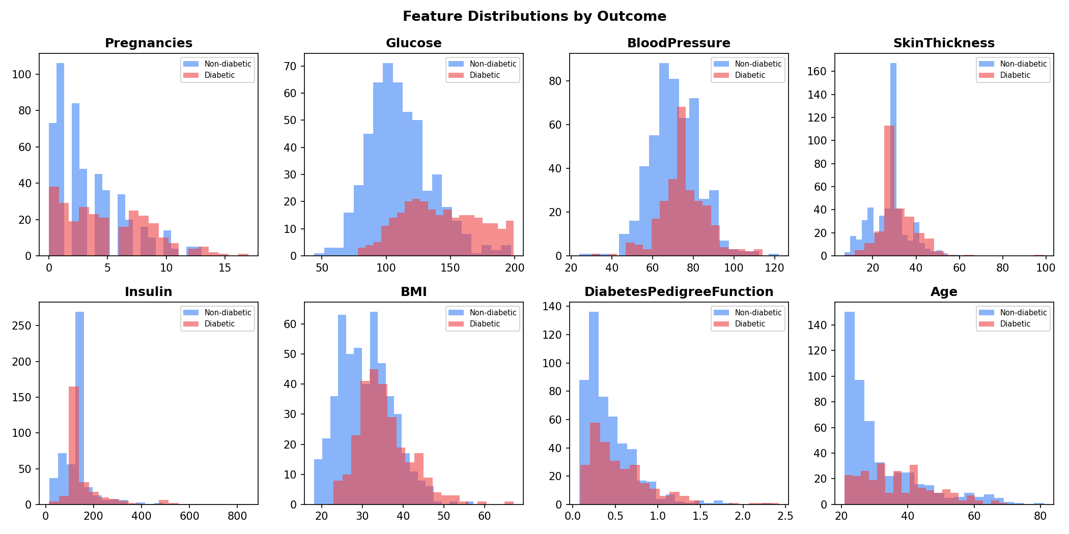
Figure 1: Feature distributions by Outcome (blue = Non-diabetic, red = Diabetic)

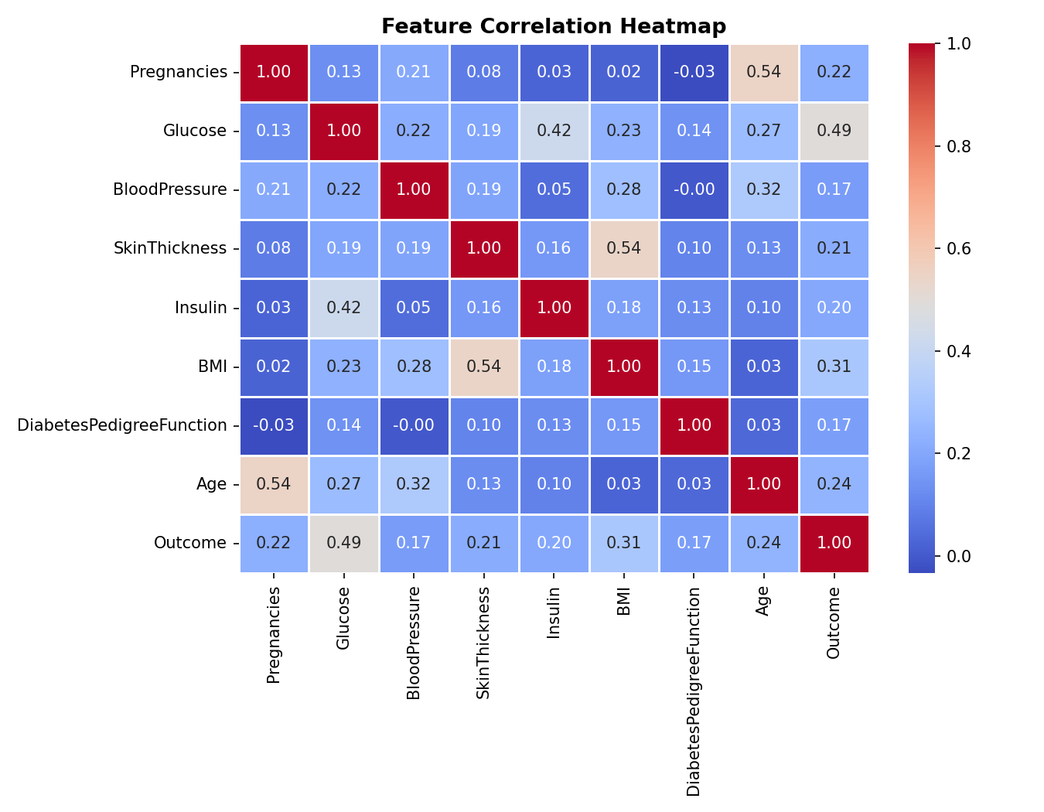
Figure 2: Feature Correlation Heatmap — Glucose, BMI, Age show strongest correlation with Outcome

Part 3: KNN Implementation

3.1 Train-Test Split
The dataset (768 samples) was split 80/20 using a fixed random seed (42) for reproducibility: 614 training samples and 154 test samples. Splitting was performed on the standardized feature matrix.
3.2 Manual Distance Computation — Step-by-Step
One test instance (Test Sample #1, true label = Non-diabetic) was selected. Euclidean distances were manually computed against all 614 training samples using:
$$d\left(p, q\right)= \sqrt{\left[ Σ {\left(pᵢ - qᵢ\right)}^{2}\right]} for i = 1 … 8 \text{features}$$
Top 10 Nearest Neighbors (sorted by distance):
Rank | Train Index | Euclidean Distance | Label
1 | 226 | 1.3237 | Diabetic (1)
2 | 521 | 1.3728 | Diabetic (1)
3 | 403 | 1.3952 | Non-diabetic (0)
4 | 430 | 1.4517 | Diabetic (1)
5 | 321 | 1.6715 | Diabetic (1)
6 | 90 | 1.6836 | Non-diabetic (0)
7 | 18 | 1.6851 | Diabetic (1)
8 | 213 | 1.7071 | Non-diabetic (0)
9 | 260 | 1.7184 | Non-diabetic (0)
10 | 412 | 1.7379 | Diabetic (1)

K=3 Manual Prediction: The 3 nearest neighbors voted: Diabetic, Diabetic, Non-diabetic. Majority vote → Diabetic. (True label: Non-diabetic — misclassified in this instance.)
3.3 KNN Results for K = 3, 5, 7
K Value | Accuracy (%) | True Negative (TN) | False Positive (FP) | False Negative (FN) | True Positive (TP)
3 | 70.78% | 74 | 25 | 20 | 35
5 | 73.38% | 75 | 24 | 17 | 38
7 | 71.43% | 74 | 25 | 19 | 36

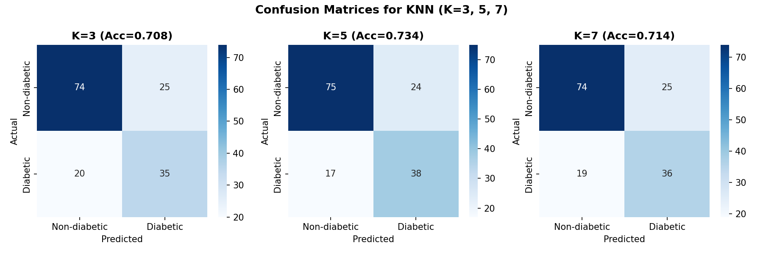
Figure 3: Confusion Matrices for K=3, K=5, K=7

Part 4: Model Evaluation

4.1 Best K Value: K = 5
K = 5 achieved the highest accuracy of 73.38% (0.7338) on the test set. It correctly classified 75 non-diabetic and 38 diabetic patients out of 154 test samples.
4.2 Accuracy Comparison Across K Values
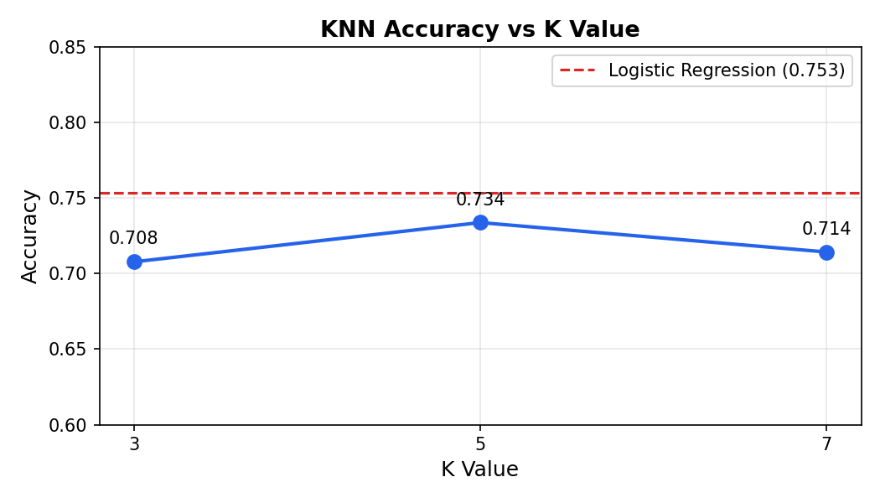
Figure 4: Accuracy vs K — red dashed line = Logistic Regression baseline (75.32%)
4.3 Why Does Performance Change with Different K Values?
The choice of K represents a fundamental bias-variance tradeoff:
Small K (e.g., K=3)
The model is highly sensitive to individual training points. With K=3, only 3 neighbors vote, so noise and outliers have a large influence. This leads to high variance (overfitting) — the decision boundary becomes jagged and does not generalize well to new data.
Large K (e.g., K=20+)
The model averages over many neighbors, smoothing out noise but also ignoring local structure. With very large K, the model may always predict the majority class, leading to high bias (underfitting).
Optimal K (K=5)
Balances these extremes. It considers enough neighbors to be robust to noise while remaining sensitive to local patterns in the data.
4.4 Effects of Extreme K Values
Scenario | Effect | Result
K too small (K=1) | Memorises training data; jagged decision boundary | High variance, overfitting, poor generalization
K too large (K=all) | Ignores local structure; always predicts majority class | High bias, underfitting, trivial accuracy
K optimal (K=5) | Balances noise tolerance and local sensitivity | Best test accuracy in this experiment (73.38%)

Part 5: Analysis and Reflection

K-Nearest Neighbors is one of the most intuitive machine learning algorithms, making it an excellent starting point for classification tasks. Its primary strength is simplicity: there is no explicit training phase. The algorithm simply memorizes the training set and defers all computation to prediction time. This means the model updates immediately as new data arrives, making KNN a form of online learning. Additionally, KNN makes no assumptions about the underlying data distribution it is a non-parametric method which gives it flexibility to capture complex, non-linear decision boundaries that parametric models like Logistic Regression might miss. In this experiment, KNN successfully distinguished diabetic from non-diabetic patients using eight medical features, achieving up to 73.38% accuracy with K=5.
Despite its simplicity, KNN has significant practical limitations. First, it is computationally expensive at prediction time: for each new instance, distances to every training sample must be computed. With 614 training samples and 8 features this is manageable, but in production systems with millions of records, this becomes prohibitive without approximate nearest-neighbor techniques. Second, KNN is extremely sensitive to feature scaling: without standardization, the Insulin feature (range 0–846) would completely dominate the BMI feature (range 0–67), producing meaningless distances. Proper scaling is therefore mandatory. Third, KNN suffers from the curse of dimensionality: as the number of features grows, Euclidean distance loses its discriminative power because all points become approximately equidistant. Fourth, KNN provides no feature importance or interpretability it cannot tell us which features matter most, unlike decision trees or linear models.
KNN works well when: (1) the dataset is small to medium-sized; (2) the decision boundary is irregular or non-linear; (3) features are well-scaled and informative; and (4) interpretability is not required.
KNN is not appropriate when: (1) the dataset is very large (millions of records); (2) there are many irrelevant or highly correlated features; (3) real-time prediction is required; or (4) a compact model is needed for deployment.
In this experiment, K=5 produced the best accuracy (73.38%), slightly outperforming K=3 (70.78%) and K=7 (71.43%). Notably, Logistic Regression achieved 75.32%, outperforming all KNN configurations. This suggests that the relationship between the features and the diabetic outcome may be approximately linear — Glucose, BMI, and Age likely separate the classes with a roughly linear boundary. The difficulty in improving KNN accuracy beyond ~73% also reflects the inherent class imbalance (500 non-diabetic vs. 268 diabetic records), which tends to bias predictions toward the majority class. Future work could explore SMOTE oversampling, feature selection, or ensemble methods to push performance further. Overall, this experiment confirmed that KNN is a solid baseline algorithm that benefits substantially from proper preprocessing particularly handling of physiologically-impossible zero values and standardization of features.

Bonus: KNN vs Logistic Regression

Algorithm | Accuracy | Type | Key Advantage
KNN (K=3) | 70.78% | Non-parametric | No training phase; flexible boundary
KNN (K=5) | 73.38% | Non-parametric | Best KNN result; balanced bias-variance
KNN (K=7) | 71.43% | Non-parametric | Smoother boundary; more robust to noise
Logistic Regression | 75.32% | Parametric | Fast, interpretable, highest accuracy

Logistic Regression outperformed all KNN variants by 1.94 percentage points. This is consistent with the dataset’s characteristics: linear relationships between glucose, BMI, age and the diabetic outcome are well-captured by a linear classifier. KNN may be more competitive in datasets with highly non-linear class boundaries.


Figure 5: Model Accuracy Comparison — KNN (K=3, 5, 7) vs Logistic Regression

