Developer Guide for Command-line Kanban System
Version 1.2

Prepared by Caleb TONG (1155176563),
Ho Lun Roland TSANG (1155194057),
Ming Hon Rodney HUI (1155213464),
Tung Chun LAM (1155211513)

Group 21, Software Engineering (CSCI3100), The Chinese University of Hong Kong

22/12/2025

Table of Contents
Introduction 2
Purpose 2
Developing Conventions 2
Overview of the Design 3
Plan Overview 3
Source Control and Installations 3
UML Usecase diagram 4
UML Component Diagram 4
UML Class Diagram 5
Database Layer Design 5
Developing Detail 7
1. Visual Task Management (SF1) 7
Add Task: 7
Delete Task: 7
Edit Task: 7
TASK table: 8
List Task: 8
Show Task: 9
Move Task: 9
Command Manual: 9
2. Advanced User Role Management (SF2) 10
USER table: 10
Registration: 10
Login: 11
Activation Status: 12
3. Notifications (SF3) 12
4. Advice (SF4) 14
5. License Key 15

Introduction

Purpose

This developer guide shows an overview of designing a Command-line Kanban system, which is a convenient system for users to manage their tasks. Key functions of the system include Visual Task Management, User Role Management and Notifications. In the following, important guides for developers will be mentioned, including developing timeline, structure and detail of the system.

Developing Conventions

Programming Language | Python 3
Python Libraries | CLI: pathlib.Path  DataStructures: datetime.datetime as dt  Database: sqlite3, pathlib.Path, bcrypt  KanbanInfoDatabase: sqlite3, pathlib.Path
Coding | UTF-8
Developing Environment | Linux terminal
Naming Convensions | CamelCase should be used, without using underscores
ID Convensions | Starting from 1
SQL Convensions | Table name should be capitalized, such as table USER  Field name should be in proper case, such as First name
Date-time Conventions | For due dates without a specified time, it will be assumed that the due time is the end of the due day, i.e. 23:59:59

Overview of the Design

Plan Overview

The Kanban system will be developed by using Agile methodologies.
Phase 1 | Phase 2 | Phase 3 | Phase 4
Requirement Analysis | Design | Implementation | Testing

The Kanban system will also be incrementally developed.
Phase 1 | Phase 2 | Phase 3 | Phase 4
- Command-line interface  - Database  - Data structure | - Add, delete, move, edit tasks  - Improved CLI with spacing and dotted line | - Data manipulation  - Validation check for tasks manipulation  - User login  - Advise | - Notification  - Licensing  - Testing

Source Control and Installations
All source codes and documentations will be shared on GitHub.
Project structure: Command-line Kanban System/
|-- Kanban.py
|-- README.md
|-- MyKanban
|--CLI.py
|--Database.py
|--DataStructure.py
|--KanbanInfoDatabase.py
|--License.py
|--Login.py
|--Notification.py
|--license_keys.txt
|-- Test
|--integrationtest.txt
|--systemtest.txt
|--unittest.txt
|-- Documents
|--Group21_Requirements_Specification.docx
|--Group21_Design_Implementation.docx
|--Group21_Group21_Testing.docx
|--Group21_Release_Notes_User_Manual.docx
Access Link: https://github.com/RodneyHui/CSCI3100_Gp21

UML Usecase diagram

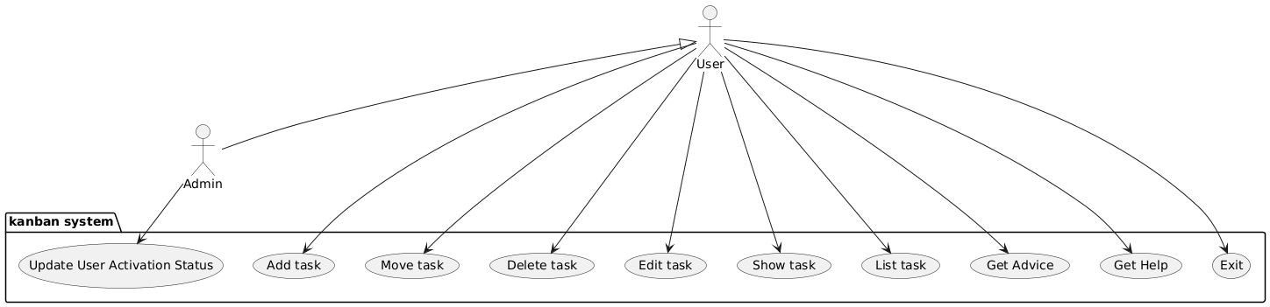

UML Component Diagram

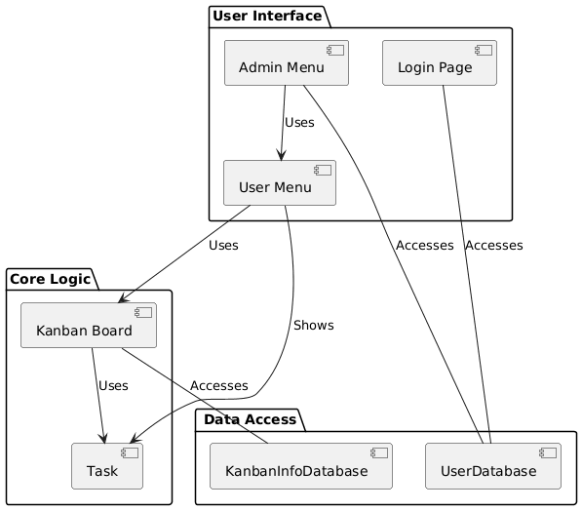

UML Class Diagram

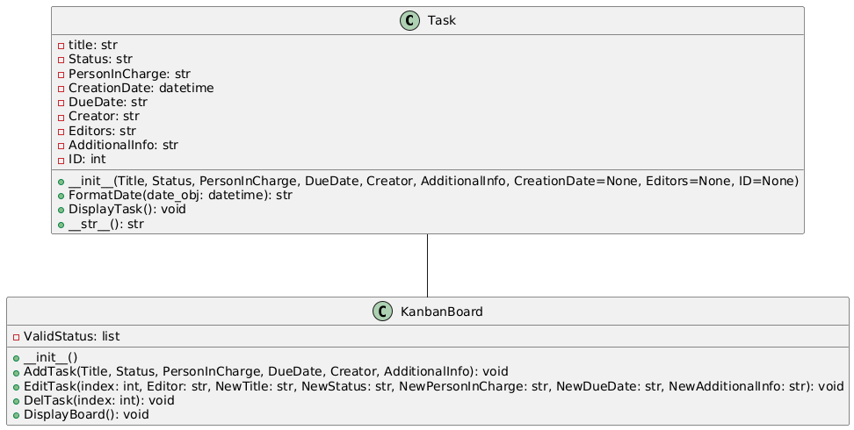

Database Layer Design
- Each user has a unique user ID to identify them. They should also input a unique phone number to identify them more easily since user ID is meaningless.
- The user is either activated or inactivated, inactivated users cannot access the system.
- The user should input their name as a string.
- The user should either be admin or user.
- The user should input a password, but the database will store the hash of the password instead of saving the password directly.
- Each Kanban task will have a unique ID to identify the task.
- Each task has a title that describes the task and an additional information field that stores the task details.
- Each task must have a creator, which is a phone number referenced to the user table.
- There could be an optional person in charge and editor, both are references to the user table.
- The task creation date and due date will be stored.

ER-Diagram
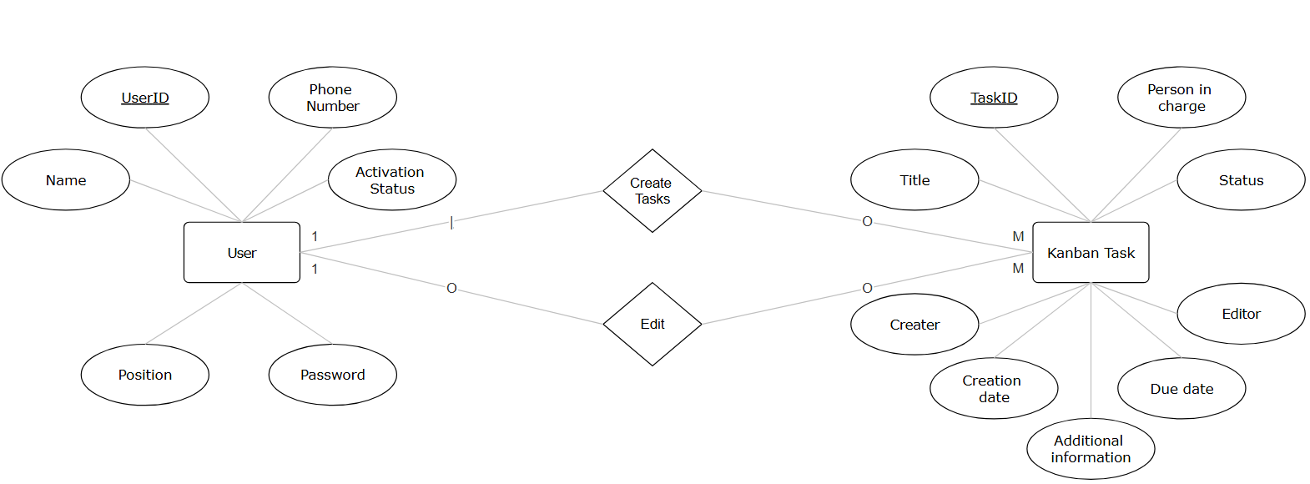
Database Schema
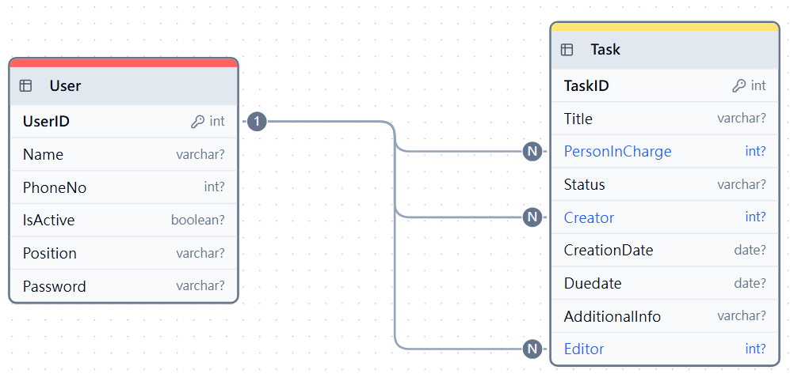
The above schema is refined to 3rd normal form.

Developing Detail

Visual Task Management (SF1)
This feature is mainly implemented in DataStructure.py. We first initiate the KanbanInfoDatabase and define 4 valid statuses whenever a KanbanBoard is created. AddTask, EditTask and DelTask are the 3 foundation methods to operate our kanban system. For each method, we make changes by directly accessing the KanbanInfoDatabase, so that we can achieve real-time updates.

Add Task:
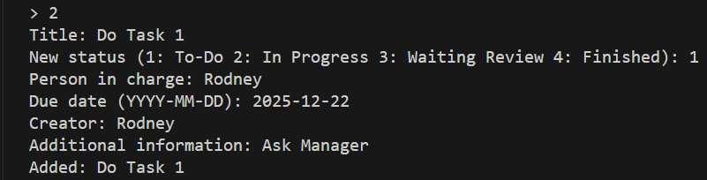
Each time a user adds a task, the system will create a Task object with the variables input, check whether the status is valid, then the related information will be added to a task table in a database.

Delete Task:
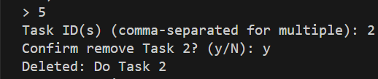
When the user wants to delete one or more tasks, the system first identifies which file(s) to delete and stores the task ID in a list. Then, if the task exists, the system prompts confirmation on deletion. Then, the system checks whether there are such tasks from the database. If the tasks are found, then the related information will be deleted from the table.

Edit Task:
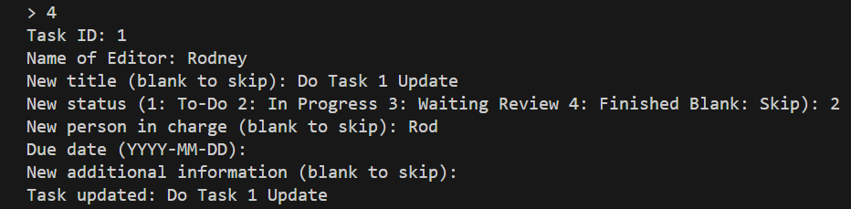
The system accepts a task ID as an input. Then, the editor should be identified. Then, the user can input again what they would like to change. The system will call different functions according to the input. For input related to the user, HandlePersonInCharge() and HandleEditorInput() mainly checks whether the user exists in the database user table. Only those who can be identified can be accepted as the target. Then, the phone number of the new personnel will be saved on the task table. HandleStatusInput() is implemented in a similar fashion. HandleDueDateInput() checks whether the new input date has passed the current time and whether it is a valid date.

TASK table:
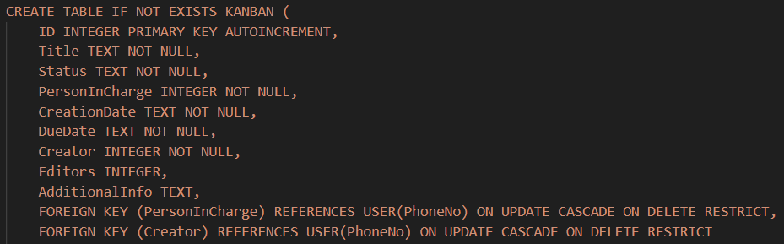

We have 2 commands, ListTask and ShowTasks, for visualization of kanban. The first one is implemented in class KanbanBoard, we first get all tasks from the database and save it into a list, sort it according to its deadline, and then group it by its status. It will print important information on tasks like TaskID, Title, DueDate and PersonInCharge only. The second one is for printing the details of a task. We implemented it in class Task but not KanbanBoard, so that we can directly find a task without creating a Kanbanboard and avoid “downloading” everything from the database to get faster experience and lower memory usage.

List Task:
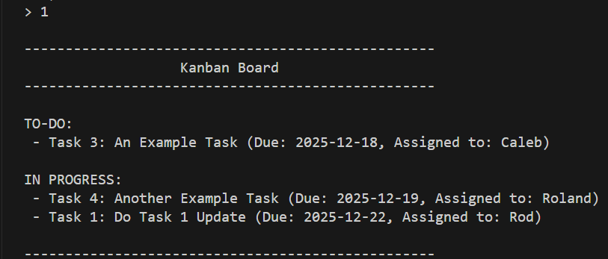

Show Task:
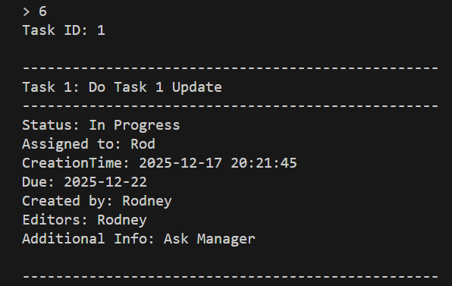
Considering the nature of the kanban system, we add an extra command MoveTask based on EditTask. Moving task is a simple version of editing a task since in most cases, the user will move a task to another status without editing other key information of that task.

Move Task:
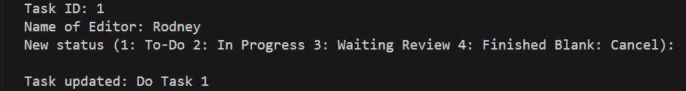

We implement the Command manual in CLI.py, to show all important commands for our system. By some if-else statement, the user can use the number key to choose command/ status, it fulfills the shortcut requirement.

Command Manual:
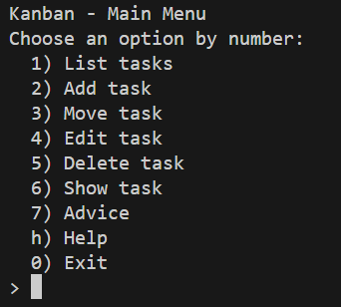

Advanced User Role Management (SF2)

USER table:
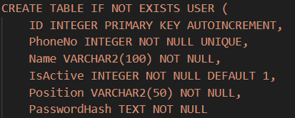
Primary key: ID
Candidate key: PhoneNo

The user first goes into a login page, where they can choose to register or to login.
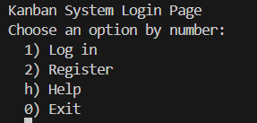

Registration:
For registration, the user has to input their phone number, name, and either admin or user. It will check whether the phone number exists in the USER table or not by a SQL query. If so, deny their registration. If they choose to be an admin, they have to input a validation key (3100 by default) to authenticate. For users, their activation status will be defaultly set to false. They have to also input a password twice. The passwords will be compared to ensure the input passwords are identical. The information will be passed to CreateUser() function, and the password will be hashed in another function. The hash of the password will be stored along with all other information into the table USER.
By default, the activation status of the user is true. But when the position field is not admin, the IsActive field will be inputted as false.

Successfully registered user (Activation status = false):
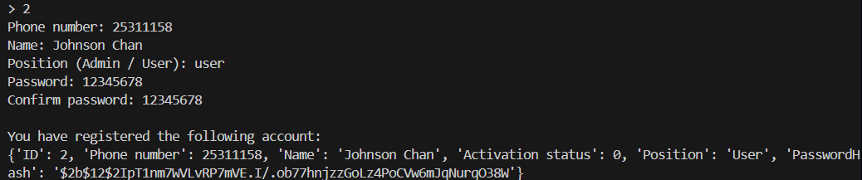

Invalid phone number: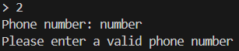
Duplicated phone number: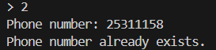

Admin validation check: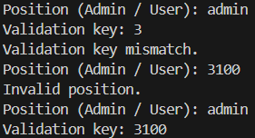

Password mismatch: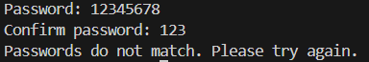

Successfully registered admin (Activation status = true):

Login:
For login, users are required to input their phone number and password. The ValidateLogin() checks the phone number and whether the password matches. It also determines whether the activation status is true. If the login is successful, then two different interactive menus will be displayed according to the user’s position.

Successfully login page (admin):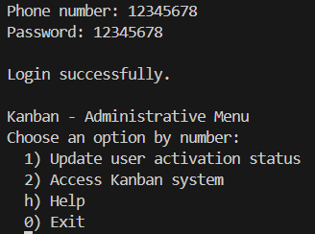

Invalid phone number or password mismatch: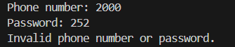

Activation Status:
Users’ accounts are by default inactivated. Only the admin who can provide a valid validation key is by default active.
The admin can view the user information and change the activation status of the users in their interactive menu by calling the function ChangeActivationStatus(PhoneNo, IsActive):
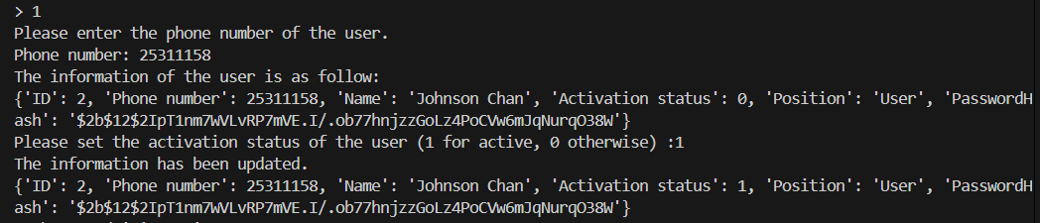

Notifications (SF3)
The notification feature is implemented in Notification.py which includes a load tasks function (UpcomingTask()) and print notification function (PrintNotification()).
We first establish a connection to the database system, and fetch all the tasks information from the database using a single SELECT SQL statement. We compare the due date and the current time stamp, then check whether they exceed the threshold time limit hardcoded by the admin (14 days by default). Save all the tasks that are within the threshold time limit into a list, with all the related information, such as creator and person in charge’s name fetched by the KanbanInfoDatabase.py GetUserByPhone() function.

The PrintNotification() function is called once when the user successfully logged in, displayed above the Kanban menu board.

Example usage:
There are two tasks that are due within two weeks, namely Testing01 and Testing02. After logging in the system, there will be two separate notifications that pop out before the Kanban menu board, listing all the information related to the task.

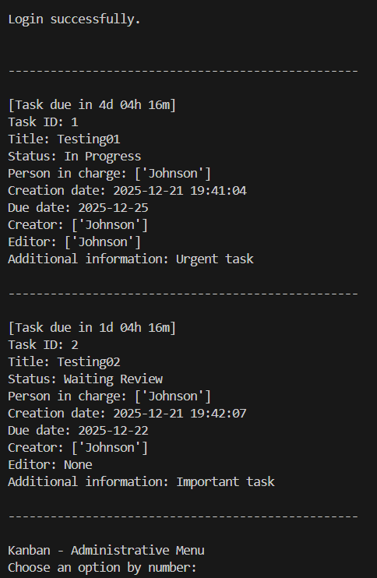
Tasks that are not urgent will not be displayed.
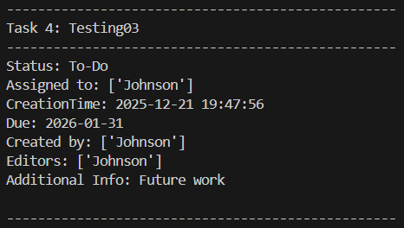

Advice (SF4)
Advice feature is directly implemented in CLI.py since it will be more convenient without importing another python file containing advice. We add CountTask in the database to get the number of tasks in each status in list form. We also add CountTaskByPerson to get the number of tasks assigned to each person in dictionary form. In CLI.py, we call these 2 methods to analyse the current work. If the number of tasks in To-Do, In progress and Waiting Review status are larger than 10, we give status-related suggestions to the user. If the number of tasks assigned to a person is larger than 3, we define it as OverLoadedPeople and prompt attention to the user. If the number of tasks assigned to a person is less than 3, we define it as ChillPeople and prompt attention to the user. The following pictures are an example of advice:

For Tasks below (Too many tasks in To-Do, Too many tasks for Rodney, too few tasks for Hon):
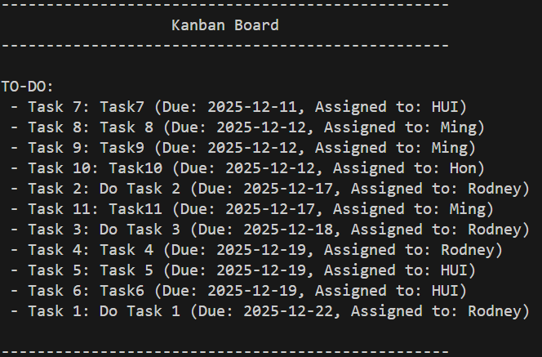

Prompt Advice:
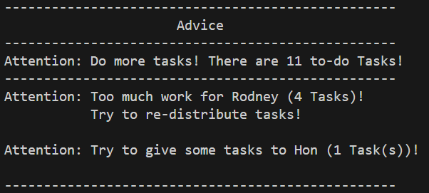

License Key
The system first loads the keys from a text file named license_keys.txt, which contains a list of keys in the format AAAA-BBBB-CCCC-DDDD. Each key is expected to occupy a single line, and there can be multiple keys. The LoadLicenseKeys() function opens the file and parses each line into a string list of license keys. The system only accepts three input trials for the license key. For each trial, the user needs to input a license key. Then the ValidateLicense() function will compare the input key to the list and check for a matching.

Example usage:
