Testing for Command-line Kanban System
Version 1.0

Prepared by Caleb TONG (1155176563),
Ho Lun Roland TSANG (1155194057),
Ming Hon Rodney HUI (1155213464),
Tung Chun James LAM (1155211513)

Group 21, Software Engineering (CSCI3100), The Chinese University of Hong Kong

22/12/2025

1. Objectives
The goal is to thoroughly test the Kanban Board System to make sure it works as intended, is dependable, and manages problems well. Testing will include every part: user login (Login.py, Database.py), handling tasks (CLI.py, DataStructures.py), system alerts (Notification.py), and checking the software license (License.py, Kanban.py).
2. Strategy
We will test the system on three levels:
- Unit Testing:​ Check each function and class method by itself, using simulated parts to isolate it.
- Integration Testing:​ Check how the different parts work together, like the login process talking to the database, or the menu using the task objects.
- System Testing:​ Check the entire program from start to finish, from opening it to using all the features as a normal user would.
3. Resources & Environment
- Testing Tool:​ We will use Pytest to run the tests.
- Environment:​ Tests need Python 3.3. They will run separately using new, temporary SQLite database files. This keeps test data away from the main program's data.
- Test Data:​ We will put a standard set of example users and tasks into the temporary database, so every test starts from the same point.
4. Test Deliverables
By the end, we will have:
- A full set of automated test scripts saved in unittest.txt, integrationtest.txt and systemtest.txt files.
- A final test report showing what passed, what failed, and any bugs that were found.

5. Development Process Integration

For Current Developers
- Write Tests First: Follow Test-Driven Development (TDD) when adding new features
- Run Tests Frequently: Execute relevant tests during development
- Maintain Test Quality: Ensure tests remain clean, focused, and maintainable
- Update Tests: When changing functionality, update corresponding tests
- Use Test Fixtures: Leverage pytest fixtures for test setup and teardown

For Future Developers
- Understand Test Structure: Review existing tests to understand patterns
- Follow Naming Conventions: Use descriptive test names
- Maintain Test Independence: Ensure tests don't depend on each other
- Mock External Dependencies: Use unittest.mock for external services
- Document Test Cases: Add comments explaining test scenarios

6. Test Quality Metrics

Coverage Goals
- Line Coverage: Aim for 80%+ coverage
- Branch Coverage: Ensure all code paths are tested
- Integration Coverage: Validate all module interactions
- System Coverage: Test all user workflows

1. Unit Testing
Unit tests focus on testing individual functions, methods, or classes in complete isolation from their dependencies. All external dependencies are mocked to ensure tests are fast and failures are easily traceable.

Module | Components for Unit Testing | Testing Focus
DataStructures.py | Task Class: Constructor, FormatDate(), str() | - Attribute initialization  - Date formatting with various inputs  - String representation format
Database.py​ (Logic Only) | HashPassword(), VerifyPassword(), DisplayData() | - Password hashing/verification  - Data dictionary formatting  - Edge cases for password checking
License.py | LoadLicenseKeys(), ValidateLicense(), LicenseInput() | - File reading with comments/empty lines  - Key matching logic  - Input attempt counting
Notification.py​ (Logic Only) | Time formatting, message building | - Time delta formatting  - Message string construction
CLI.py​ (Input Handlers) | HandleStatusInput(), HandleDueDateInput(), HandlePersonInChargeInput() | - Input validation and conversion  - Mandatory/optional field handling  - Error message generation

Key Implementation Patterns
- Isolation: Each test mocks external dependencies using unittest.mock
- Fast Execution: Unit tests run quickly without database or file system dependencies
- Clear Assertions: Tests use specific assertions to validate expected behavior
- Parameterized Testing: Multiple test cases for different input scenarios

DataStructures.py:
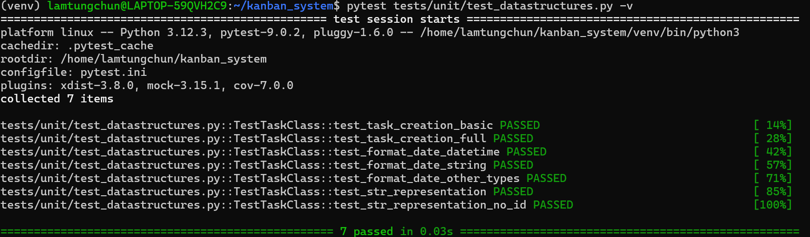
Database.py:
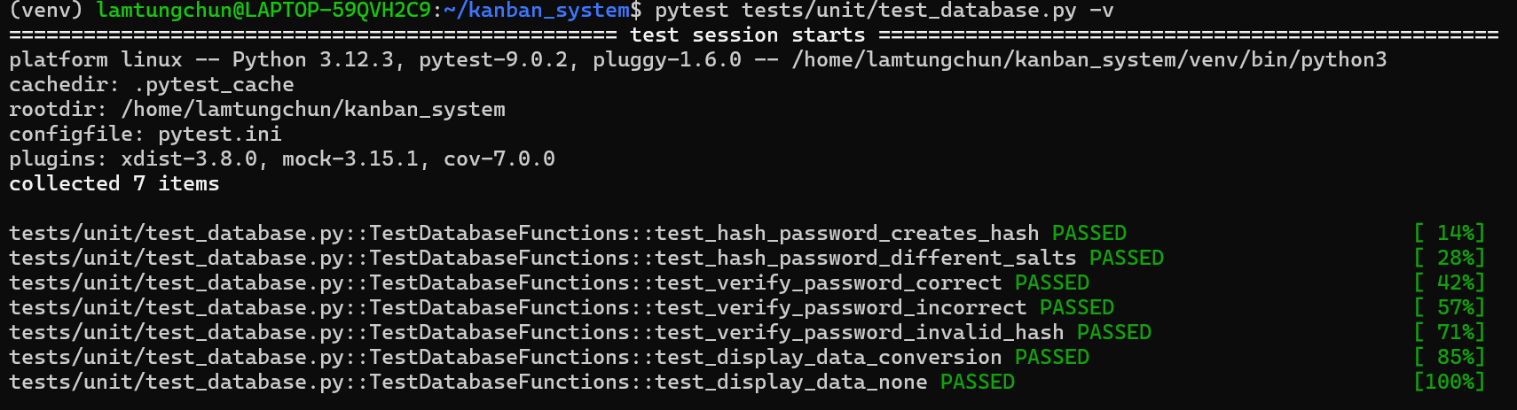

License.py:
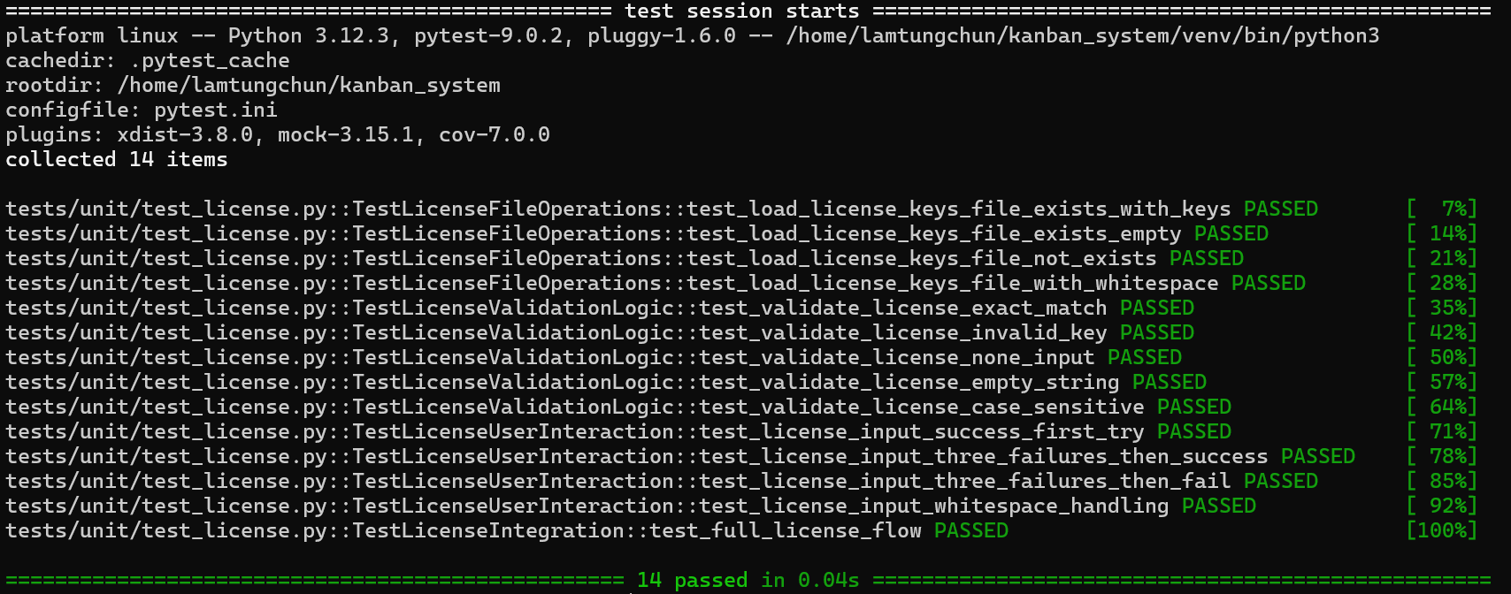

Notification.py:
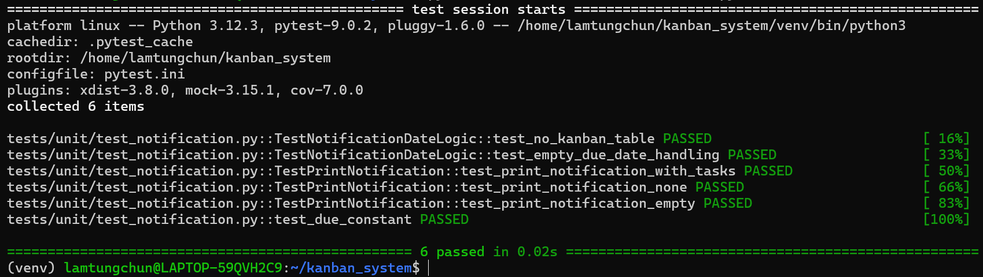

CLI.py:
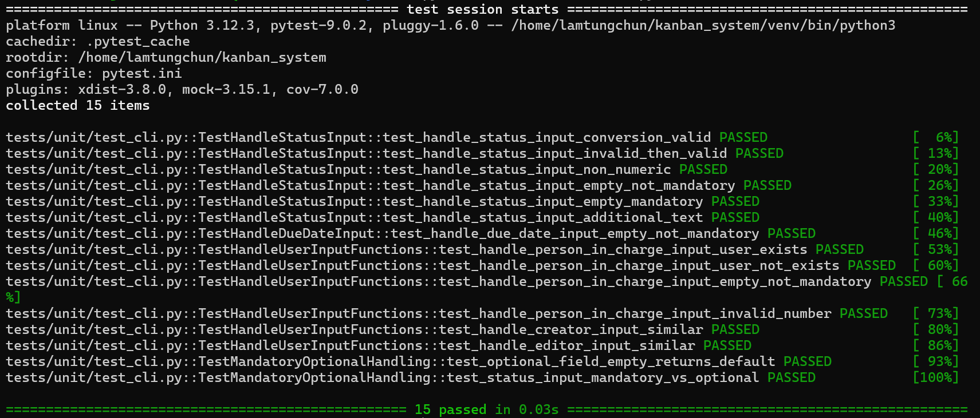

Representative Test Cases:

DataStructures.py Unit Tests

Test File: tests/unit/test_datastructures.py

1.1 TestTaskClass::test_task_creation_basic
Purpose: Validate basic Task object initialization
Design Rationale:
- Ensure the Task constructor correctly handles minimal required parameters
- Verify default values are properly set when optional parameters are omitted
- Establish foundational testing for more complex scenarios
Testing Approach:
- Create a Task object with only mandatory parameters
- Assert that all provided parameters are correctly assigned
- Verify that optional parameters (ID, CreationDate) have appropriate defaults
- Confirm the object is instantiated without errors
Expected Outcomes:
- Task title matches input
- Status matches input
- PersonInCharge matches input
- DueDate matches input
- Creator matches input
- AdditionalInfo matches input
- ID defaults to None
- CreationDate is automatically set to current time

1.2 TestTaskClass:test_format_date_datetime
Purpose: Test date formatting functionality
Design Rationale:
- Ensure datetime objects are correctly formatted for display
- Verify consistent date/time representation across the application
- Support proper task timeline management and display
Testing Approach:
- Create a datetime object with known values
- Pass it to the FormatDate method
- Verify the output string matches expected format (YYYY-MM-DD HH:MM:SS)
- Confirm the formatting is consistent and reversible
Expected Outcomes:
- datetime(2024, 1, 15, 14, 30, 45) formats to "2024-01-15 14:30:45"
- The method handles various datetime inputs without errors
- Edge cases (midnight, year boundaries) are handled correctly.

2. Integration Testing
Integration tests verify that different modules work together correctly, particularly focusing on database interactions and module-to-module communication.

Integration Area | Modules Involved | Testing Focus
Database Operations | ​Database.py + SQLite | - User table creation and schema  - User creation with phone uniqueness  - Password hashing and verification flow  - Activation status updates
Task Management | KanbanInfoDatabase.py + SQLite | - KANBAN table creation with foreign keys  - Complete task CRUD operations  - Task counting and grouping queries  - User existence validation
Business Logic + Data Layer | DataStructures.py + KanbanInfoDatabase.py | - KanbanBoard methods calling kdb functions  - Task object creation from database rows  - Status validation during task operations
CLI + Database | CLI.py + kdb.py + Database.py | - Input validation with real user checks

Database Operations:

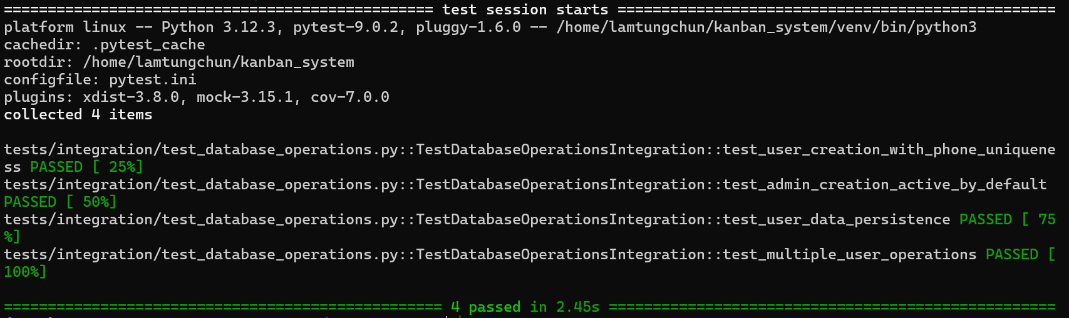

Task Management:

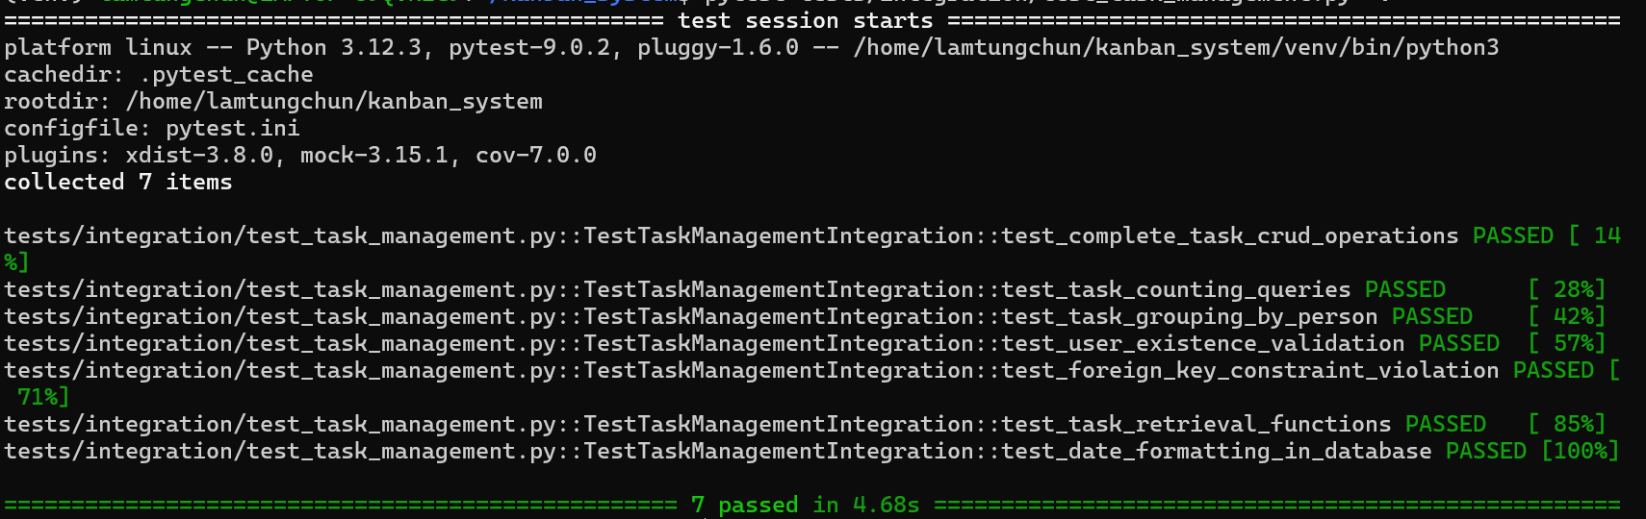

Business Logic + Data Layer:
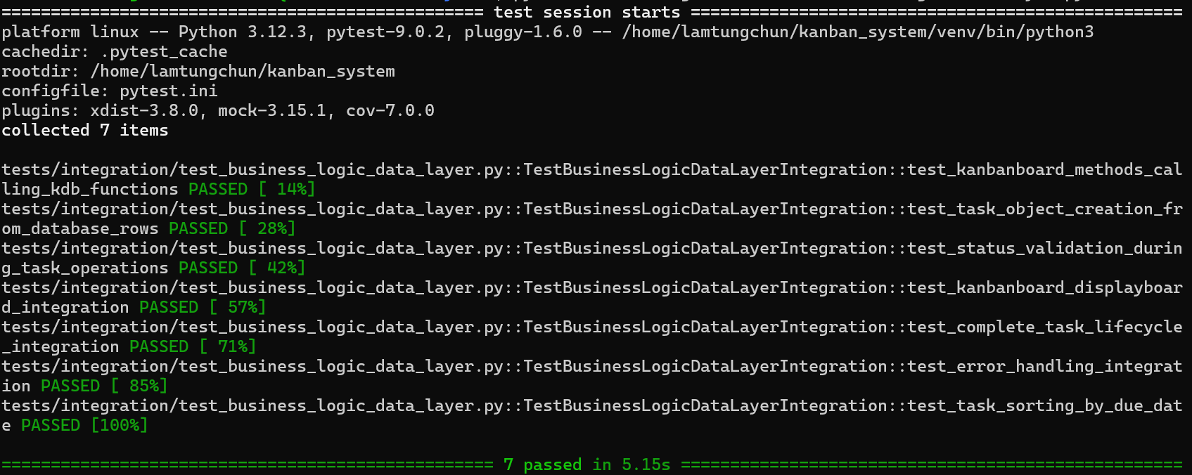
CLI + Database:
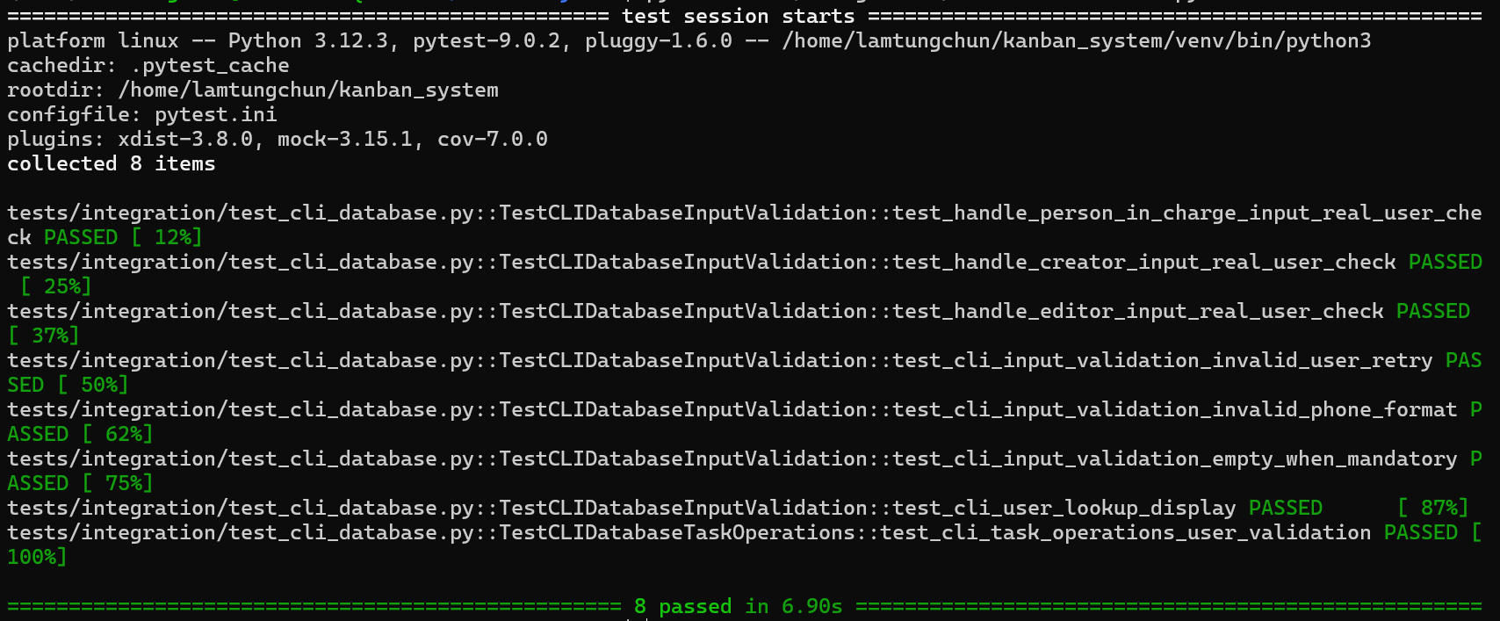
Representative Test Case:

Test Case: test_user_creation_with_phone_uniqueness
Purpose: Validate that user creation enforces phone number uniqueness constraints
Design Rationale:
- Ensure database-level constraints prevent duplicate phone number registrations
- Verify the application correctly handles SQLite integrity errors
- Prevent data corruption from duplicate user records
- Support system security and data integrity requirements
Testing Approach:
- Test Setup:
  - Create a temporary SQLite database
  - Initialize database schema with USER table
  - Set up foreign key constraints
- Test Execution:
  - Create first user with specific phone number (e.g., 1234567890)
  - Attempt to create second user with same phone number
  - Verify the second creation attempt fails
  - Validate error handling and exception propagation
- Validation Points:
  - First user creation succeeds
  - Second user creation raises ValueError
  - Error message indicates "Phone number already exists"
  - Database contains only one user with the phone number
  - Transaction isolation maintains data consistency

3. System Testing
System tests (end-to-end tests) verify complete user workflows from start to finish, simulating real user interactions with the application.
User Workflow | Modules Involved | Test Steps
Complete Application Startup | main.py → License.py → Login.py → CLI.py | 1. License validation (valid key)  2. User login (valid credentials)  3. Menu display based on role  4. Initial notifications
Regular User Task Lifecycle | Login.py → CLI.py → DataStructures.py → kdb.py | 1. User login  2. Add new task  3. Edit task details  4. Move task status  5. Delete task
Administrator Workflow | Login.py → CLI.py → Database.py → kdb.py | 1. Admin login  2. Access admin menu  3. Update user activation  4. Use regular features

Complete Application Startup:

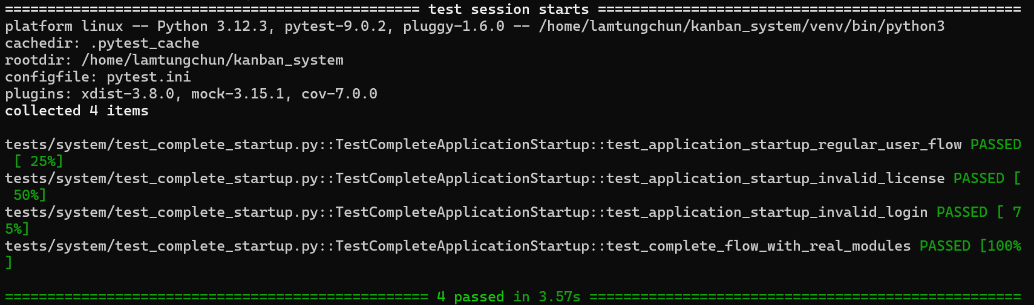

Regular User Task Lifecycle:
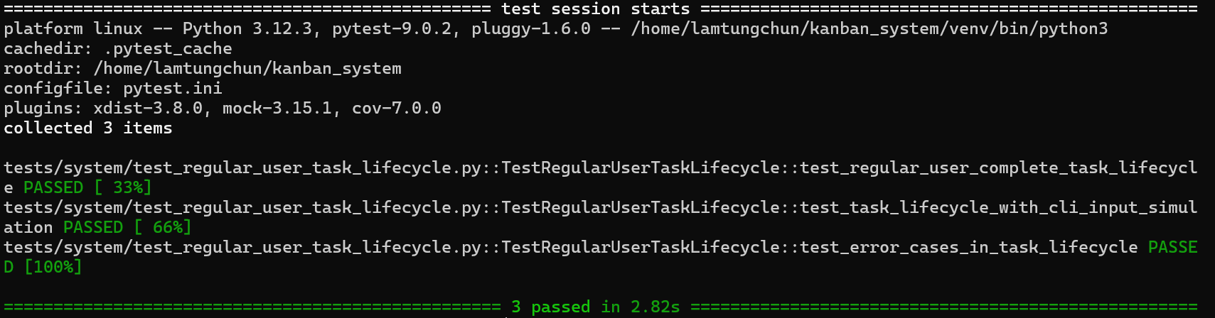

Administrator Workflow:
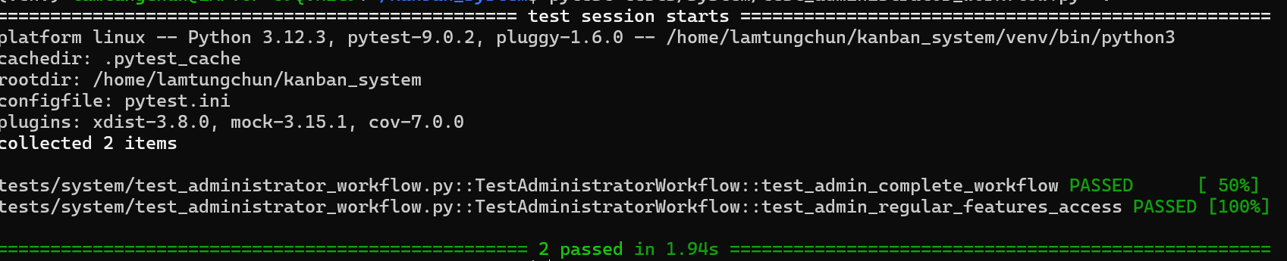

Representative test cases:

Test Case: test_application_startup_regular_user_flow
Purpose: Validate the complete application startup sequence for a regular (non-admin) user
Design Rationale:
- Verify the standard user journey from license validation to system access
- Ensure regular users can successfully navigate the authentication flow
- Validate that user permissions and menu access are correctly enforced
- Confirm the integration between License → Login → CLI modules works seamlessly
Testing Approach:
- Test Setup Phase:
  - Create a temporary test environment with mock databases
  - Configure a valid license key in the test license file
  - Create a regular user account in the test database
  - Set up appropriate activation status for the test user
- Test Execution Sequence:
  - Simulate user input sequence: valid license → login selection → user credentials
  - Mock the License validation to return success
  - Mock the Database authentication to validate user credentials
  - Mock the CLI interactive_menu function to capture invocation
  - Trigger the main application flow
- Validation Points:
  - License validation occurs with correct key
  - User authentication process executes
  - Correct CLI menu (non-admin) is presented
  - System displays appropriate welcome/notification messages
  - No errors or exceptions during the flow

