1. Find customers whose first name starts with 'J’, contains at least one character in between, and ends with 'n'. The output query should only contain all details from the Customers table.

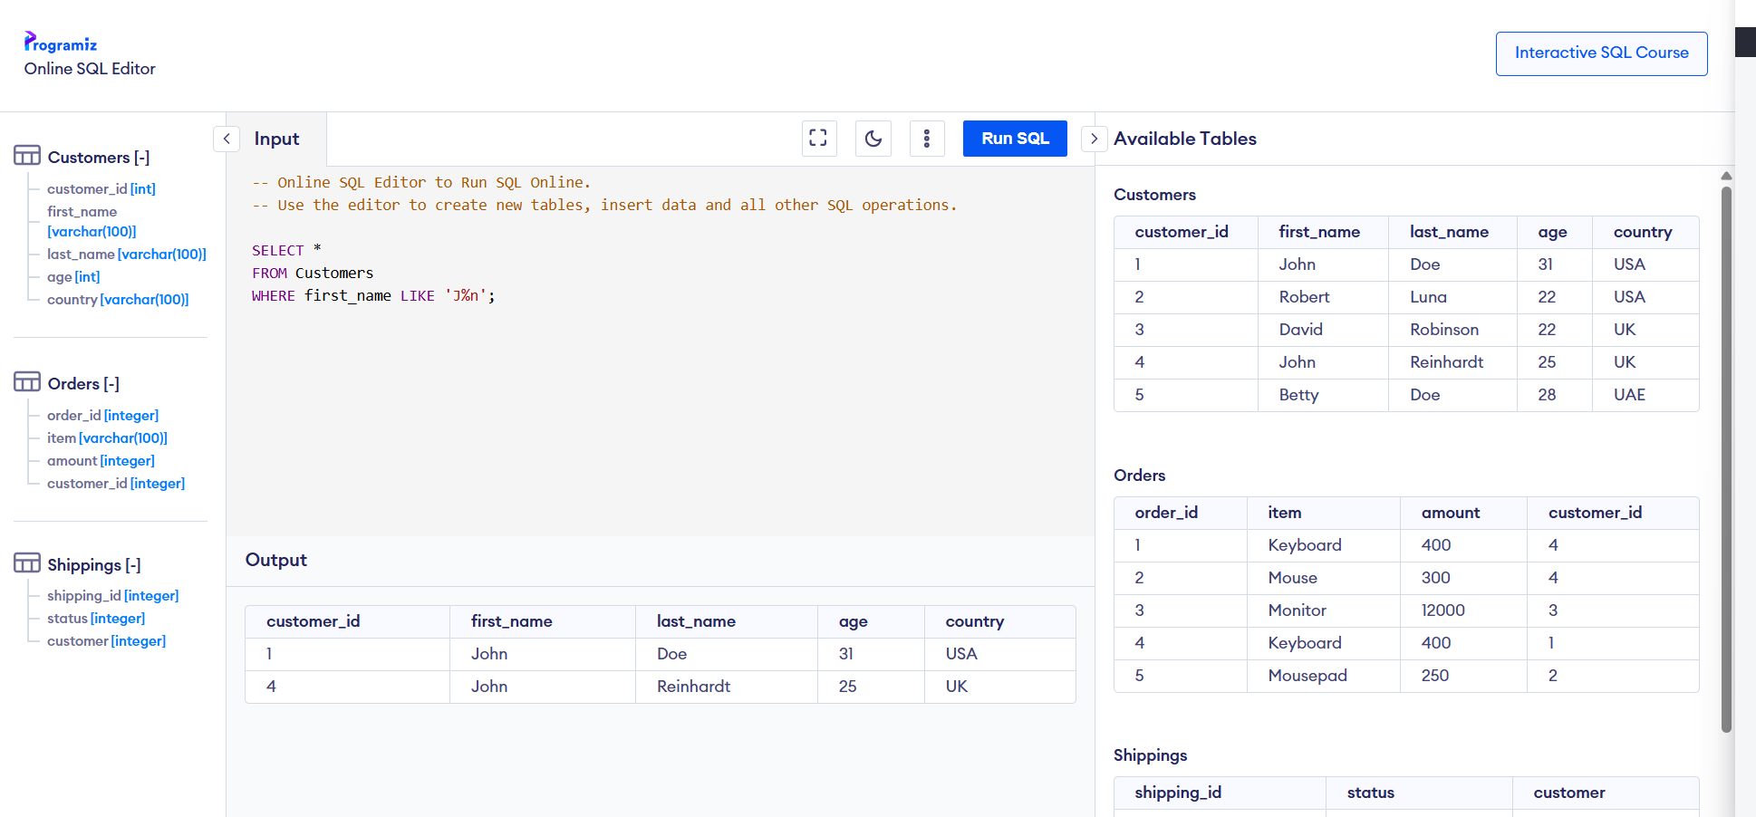

1. Find all orders placed by a customer with customer_id = 2. The Output query should only contain all details from the Orders table.

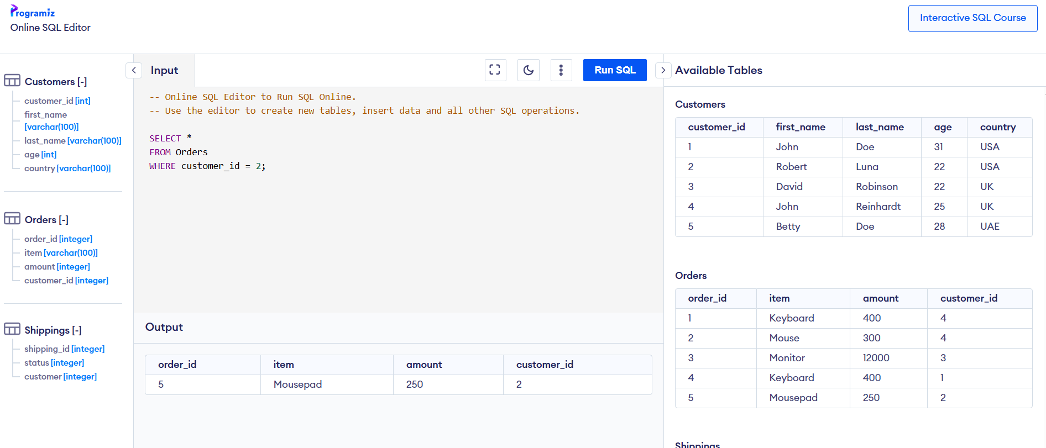

1. Retrieve the first and last names of all customers who have placed an order with an amount greater than 500. The output query should only contain the first name(s) and last name(s).

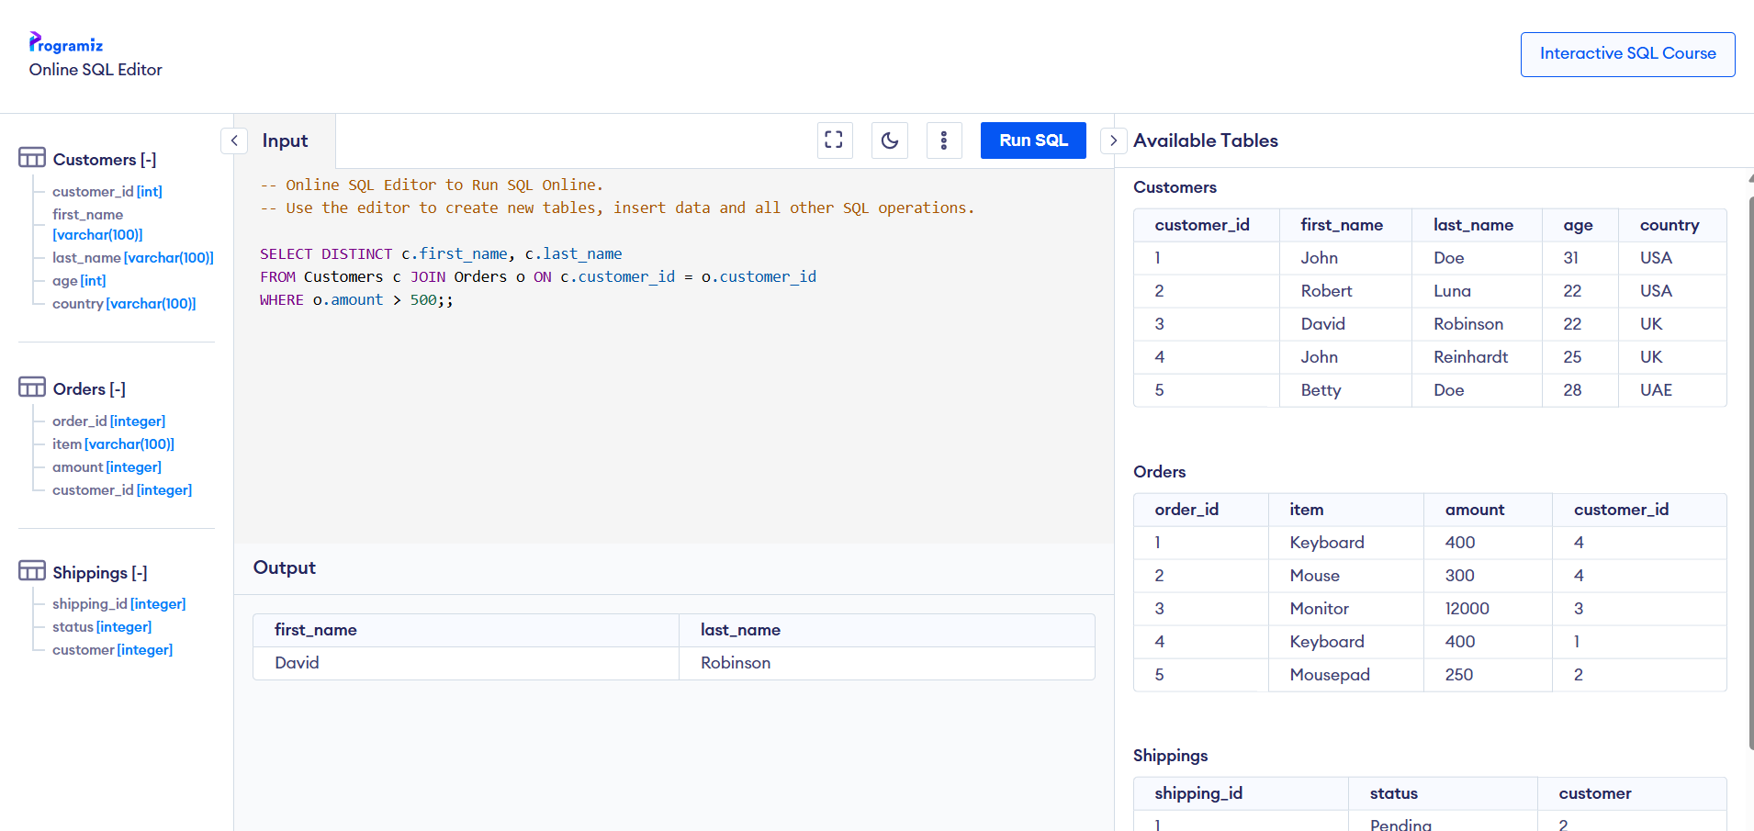

1. Show the total amount spent by each customer along with their first and last names. The output query should only contain the first name(s), last name(s) and total money spent.

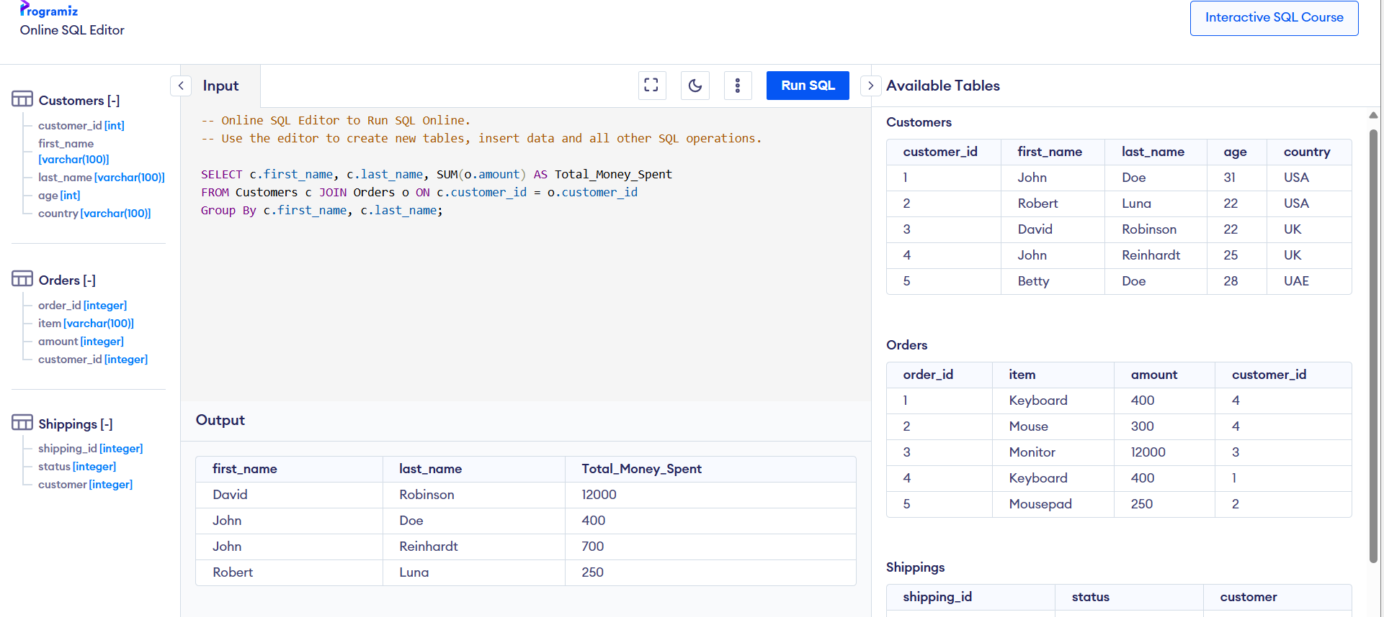

1. Display all orders with their shipping status where the shipping status is 'Pending’. The output should contain all order details and the shipping status. [3 points]

