Raghavendrababu.r@bounteous.com is a live user,
Screenshot of Finance Product page before creating a new application as live user
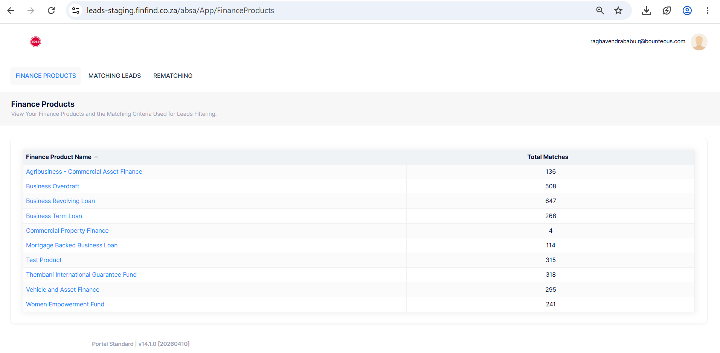

Now login into SME Portal as Live user (Raghavendrababu.r@bounteous.com) and create a Funding Request
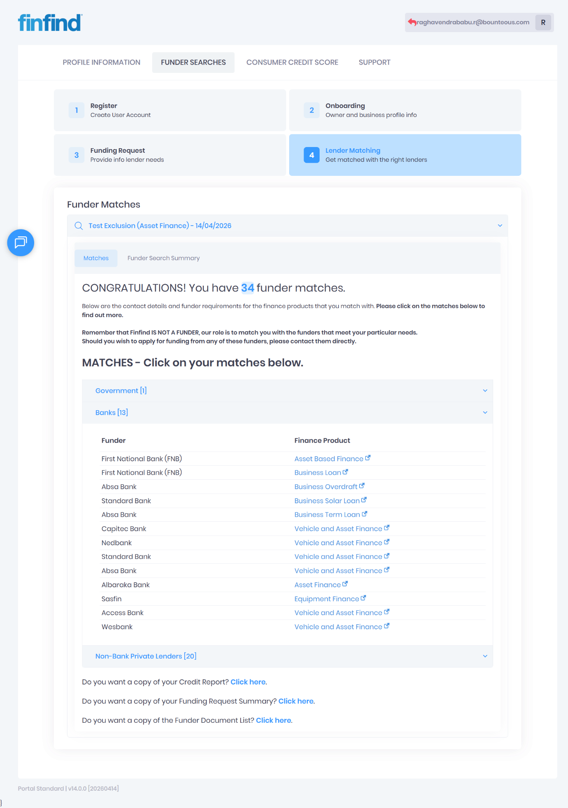

Now login into Leads Portal and check the difference in the match count in finance product page
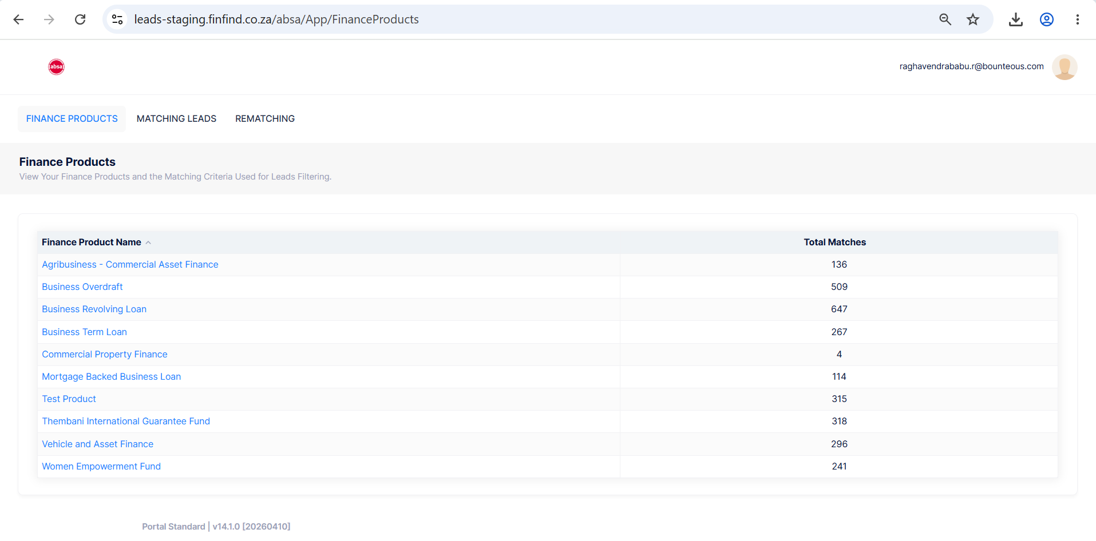
Now login as test user raghav@finfind.co.za in the leads portal and check the match count in the finance product page
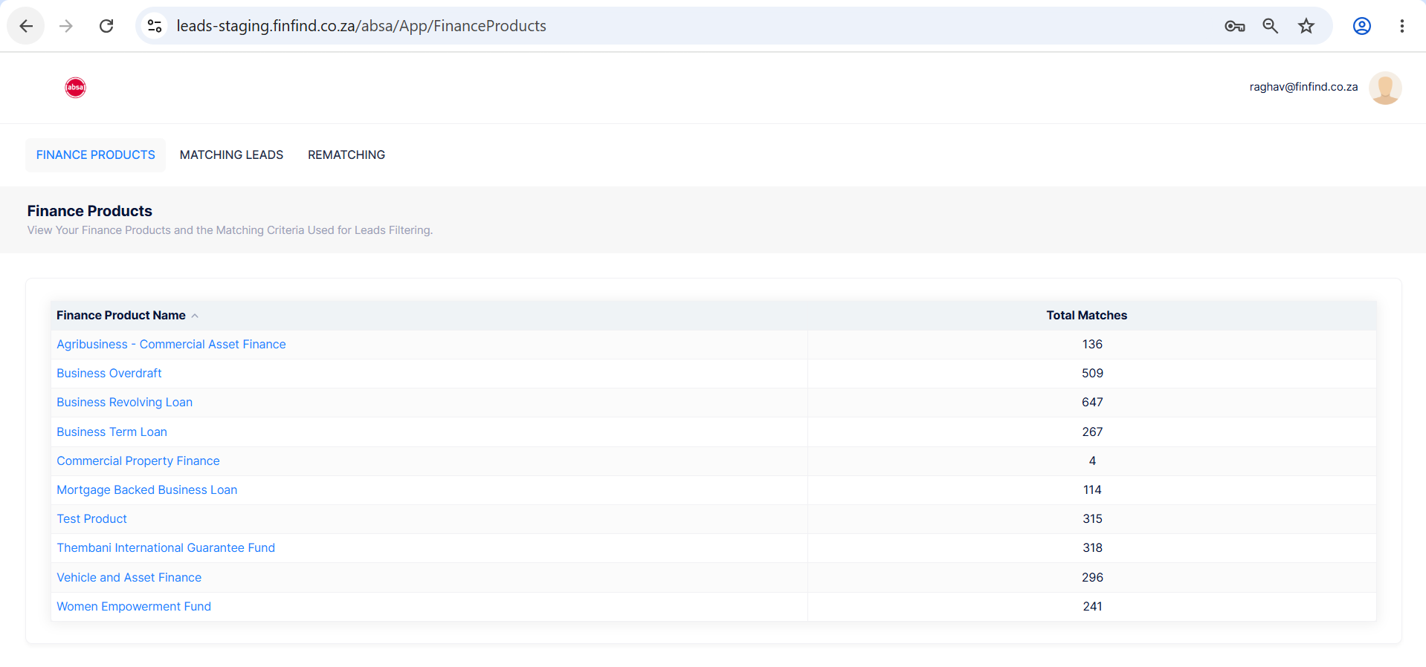
Now create a new application in SME Portal as test user
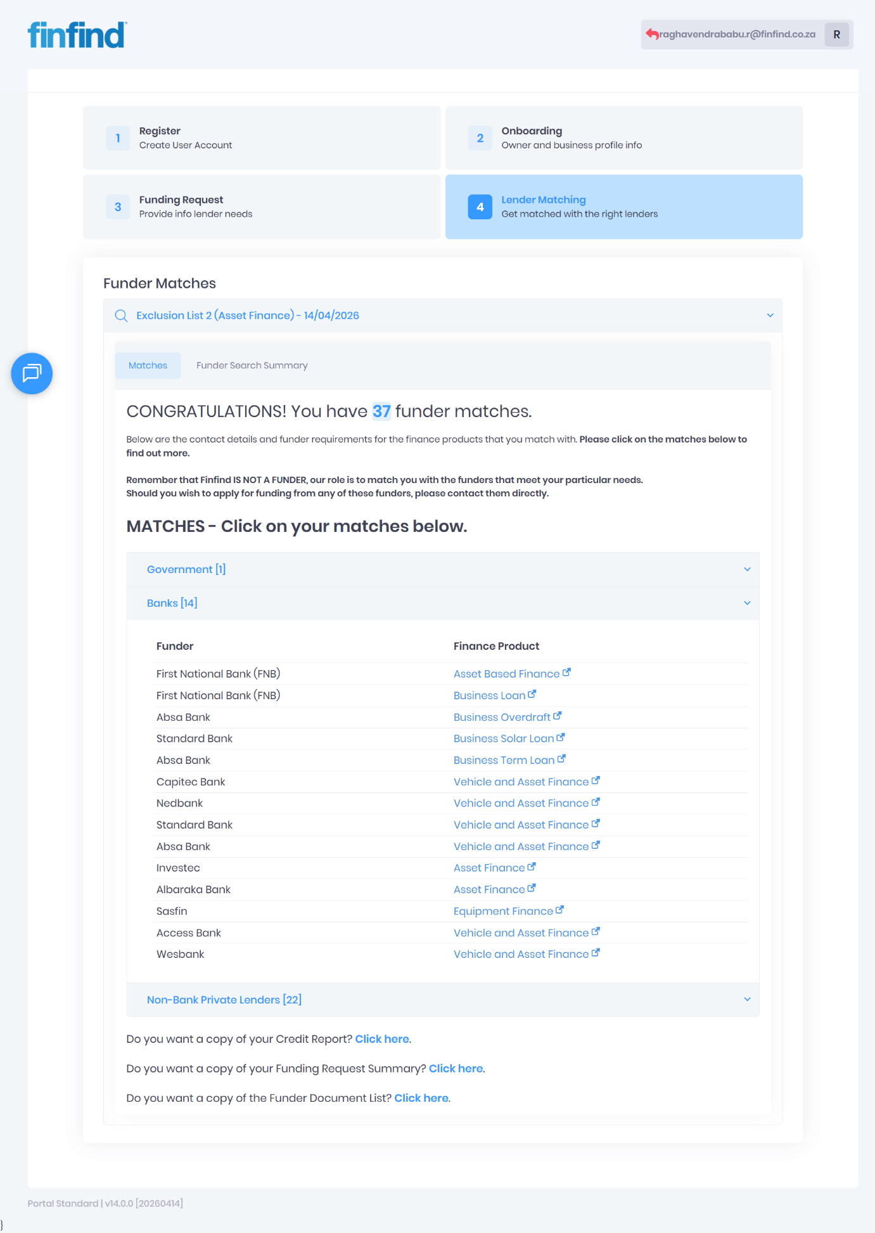
Now check the count in the Lead Portal

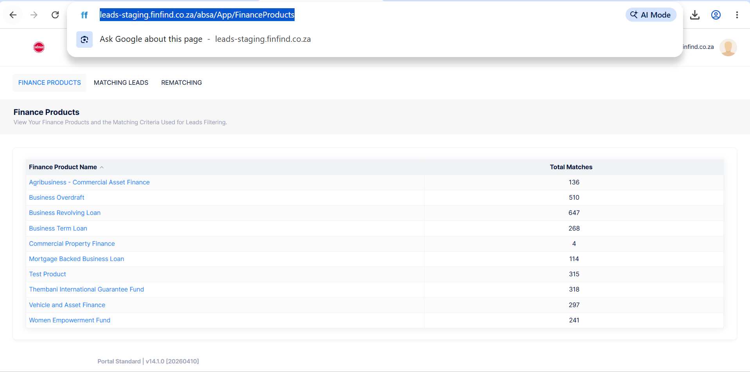

Login as Live user (Raghavendrababu.r@bounteous.com) and check the count
