Authentication basics
Adding Cookie Authentication
- We configure authentication in Program.cs by calling
builder.Services.AddAuthentication("Cookies").AddCookie();. This enables cookie-based authentication (the same mechanism used by ASP.NET Identity).
- The string "Cookies" specifies the authentication scheme. This tells ASP.NET Core which authentication method it should use when authenticating users. Explicitly specifying the authentication scheme ensures ASP.NET Core knows which handler to use by default.
- Instead of writing the scheme name as the string "Cookies", we can use CookieAuthenticationDefaults.AuthenticationScheme in Program.cs when configuring authentication.
For example, replace this line:
builder.Services.AddAuthentication("Cookies").AddCookie();
with this:
builder.Services.AddAuthentication(CookieAuthenticationDefaults.AuthenticationScheme).AddCookie();
- We then need to add the middleware that does the actually authentication, the app.UseAuthentication
- After configuring the authentication services in Program.cs, we need to add the middleware that performs the actual authentication. We do this by calling app.UseAuthentication() in the HTTP request pipeline, usually before app.UseAuthorization(). This middleware reads the authentication cookie on each request and identifies the user, allowing [Authorize] attributes and other authentication-dependent features to work.
Restricting Access with the Authorize Attribute
- We use the keyword [Authorize] outside the controller class to restrict access to the pages the controller provides. The proposal controller
- We can also use [Authorize] on individual methods to restrict access to only those actions.
- We can apply [Authorize] to all controllers in Program.cs by modifying builder.Services.AddControllersWithViews and adding a filter like this: o.Filters.Add(new AuthorizeFilter()).
- We can use [AllowAnonymous] on controllers or actions that we want to be public and accessible without requiring a logged-in user.
Signing in
- The object that represents the user is called a claims principle.
- We set up claims in our login post method by creating a list of claims
- 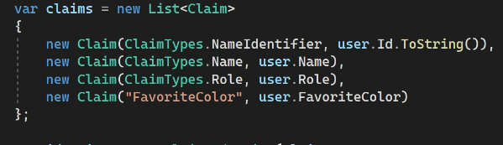
- Claims are great for fine grained authorization control, you can control what people do on your app on a much deeper level.
- After creating your claims list we need to create an identity object of type ClaimsIdentity where we specify the claims and the authentication scheme we are using
- The last thing is to create the claims principle object with the identity we just created
- Now all we need to do is sign in the user by using
- https://4sh.nl/googleclient for google sign
- we then need to add AddGoogle() extension method with the client id and client secret like this
