Course Four

Regression Analysis: Simplifying Complex Data Relationships
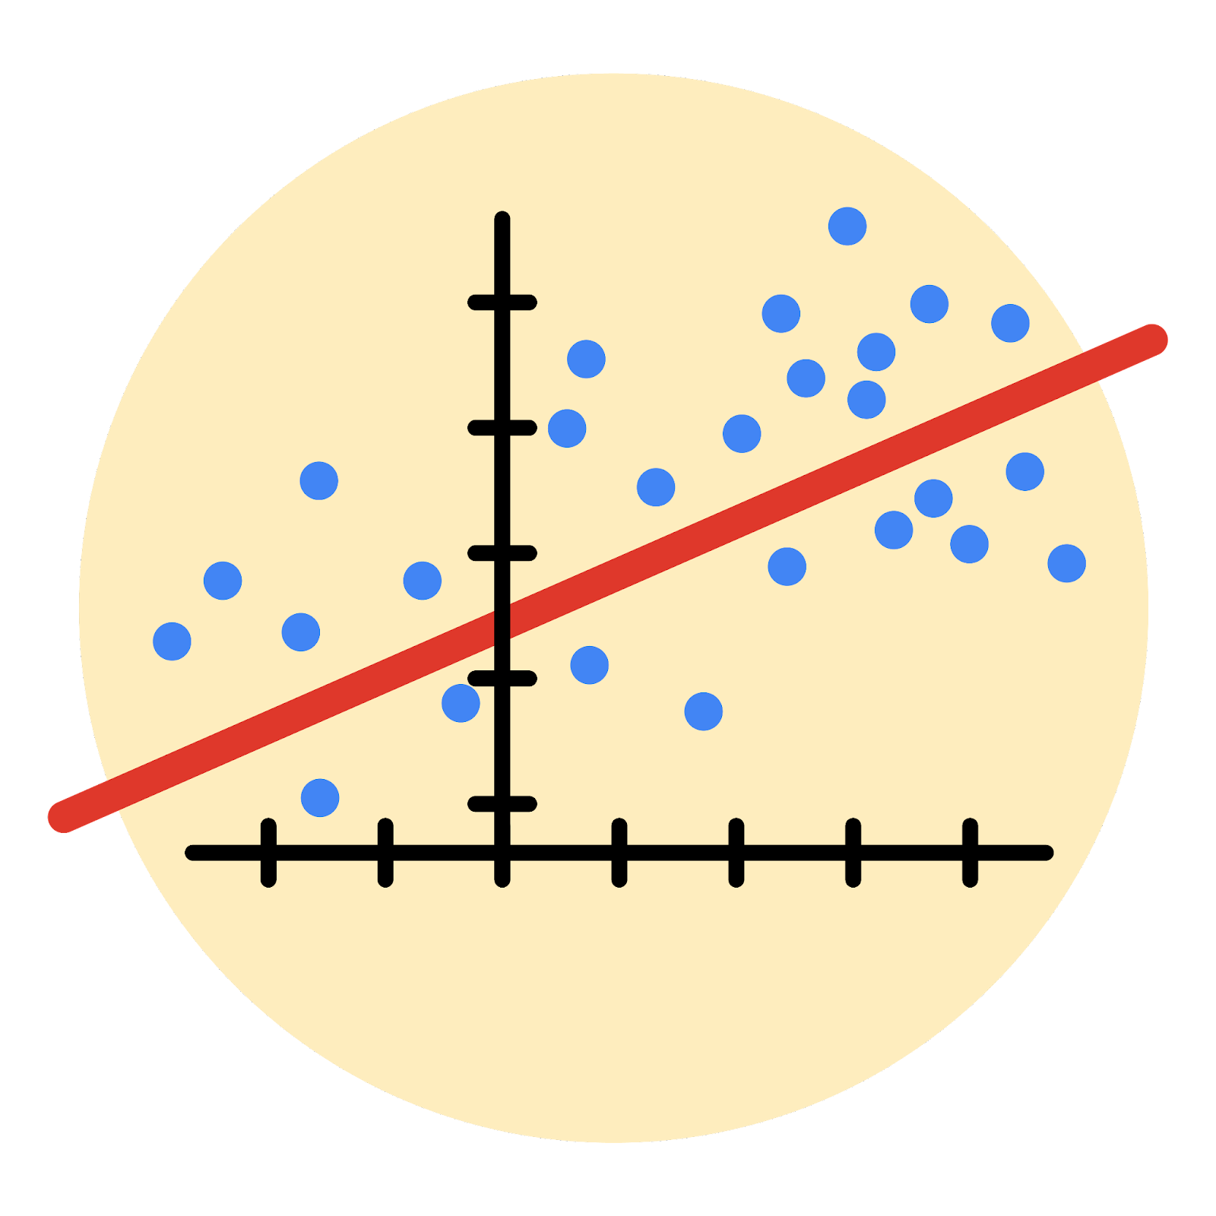

Instructions
Use this PACE strategy document to record decisions and reflections as you work through this end-of-course project. As a reminder, this document is a resource that you can reference in the future, and a guide to help you consider responses and reflections posed at various points throughout projects.

Course Project Recap
Regardless of which track you have chosen to complete, your goals for this project are:
- Complete the questions in the Course 4 PACE strategy document
- Answer the questions in the Jupyter notebook project file
- Build a multiple linear regression model
- Evaluate the model
- Create an executive summary for team members

Relevant Interview Questions
Completing the end-of-course project will empower you to respond to the following interview topics:
- Describe the steps you would take to run a regression-based analysis
- List and describe the critical assumptions of linear regression
- What is the primary difference between R² and adjusted R²?
- How do you interpret a Q-Q plot in a linear regression model?
- What is the bias-variance tradeoff? How does it relate to building a multiple linear regression model? Consider variable selection and adjusted R².
Reference Guide
This project has seven tasks; the visual below identifies how the stages of PACE are incorporated across those tasks.
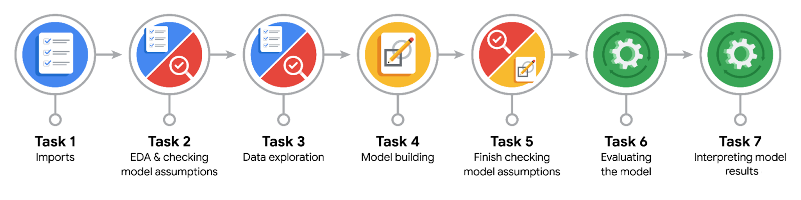

Data Project Questions & Considerations
PACE: Plan Stage
- Who are your external stakeholders for this project?
Juliana Soto, Finance and Administration Department Head
Titus Nelson, Operations Manager

- What are you trying to solve or accomplish?
Build a Multiple Linear Regression (MLR) model to accurately predict taxi fares based on collected variables.

- What are your initial observations when you explore the data?
It contains no duplicates nor empty values. With 18 columns and 22699 rows it offers a large data set. It does have some categorical data. The data presented outliers and illogical values, so it must be cleaned before performing a more extensive analysis.

- What resources do you find yourself using as you complete this stage?
To perform the EDA the following tools have been used: Python’s packages pandas, seaborn, datetime; data transformation (object to datetime to float), exploratory analysis for min and max values, for relevant variables, boxplots, data types, empty value and duplicates removal, outlier correction. Creating a new data point based on the mean of known data, creating a new column of mean distance based on the recorded distances for certain pickup and dropoff points.

PACE: Analyze Stage
- What are some purposes of EDA before constructing a multiple linear regression model?
Comprehend the data, transform variables into useful types or new variables, clean up empty values, duplicates and outliers, and before performing an MLR confirm the required assumptions are met.

- Do you have any ethical considerations at this stage?
My main concern is some data points were distance was absurd was taken in by the modal, cause they were just a few outliers, while I would argue that’s why I would delete those.

PACE: Construct Stage
- Do you notice anything odd?
The model’s R2 is the same as the adjusted R2, meaning that for the picked variables the model is technically as good as it can be. The P-value for VendorID is 0.2 which means VendorID doesn’t have a strong correlation with the “y”variable, fare amount.

- Can you improve it? Is there anything you would change about the model?
By adding variables such as ratecode and toll amount, the R2 value should increase. At the risk of overfitting the model. This is because distance, duration and tolls are related.
I would remove related variables to stop a strong multicollinearity even though the R2 would be lower.

- What resources do you find yourself using as you complete this stage?
To make and test the model the sklearn python package was used, along with p-value, R2, intercept and coef interpretation. Also variable selection, numpy for math operations on df and train test split, to test the model.

PACE: Execute Stage
- What key insights emerged from your model(s)?
The fare amount can be explained by the independent variables by 87%. The amount of variables selected influences the precision of the model. It was determined through the coefficients that the most impact to the fare amount is the retecode which changes the type of the trip, which is very related to the distance and duration followed by distance and duration.

- What business recommendations do you propose based on the models built?
By implementing the model we can accurately predict the fare amount based on the derived information from pick up and drop off locations.

- To interpret model results, why is it important to interpret the beta coefficients?
The beta coefficients help to understand the impact of the independent variables over the dependent variable. The larger the absolute value of the coefficient; the larger the impact.

- What potential recommendations would you make?
Maybe compare other models using more variables and a more strict application of the MLR assumptions.
- Do you think your model could be improved? Why or why not? How?
Yes, it can be improved. It takes into consideration correlated dependent variables which can lead to overfitting the data meaning a different enough trip (just by a bit) can throw off the model. By studying more carefully the relationship between the variables and using tools such as the VIF metric.
- What business/organizational recommendations would you propose based on the models built?
Based on the model's results, the business should consider the model’s predictions when making decisions regarding trip distance and fares.

- Given what you know about the data and the models you were using, what other questions could you address for the team?
I would ask about the outliers and the data points that made no sense.

- Do you have any ethical considerations at this stage?
I would worry about not testing further for more precise models, experimenting with different variables.

